Talend Job: CO_Debtor_TrueUp

Overview
Loads a full snapshot of CO (site code) debtor records from a local tab-delimited extract file (C:/Data/CO_DIMDEBTOR.txt) into the Snowflake raw staging table CUBS_DEBTOR_RAW_CO_CURRENT, truncating and reloading the table every run. The source schema carries roughly 100 named debtor fields (identity, address, SSN, balance/assignment/collection amounts, letter and promise-to-pay history) typical of the CUBS collections system, but the row is routed through a field-level encryption component before it's mapped and loaded, and the destination schema itself is captured only as 500 generically named columns (COL1-COL500) rather than the real business field names — see Issues observed. Unlike the debtor load referenced from CO_Master_Load (CUBS_Raw_CO_Debtor_Load), this job is not called by any tRunJob in this project's orchestration graph; given its "TrueUp" name, it looks like a standalone reconciliation load run on its own rather than part of the regular nightly pipeline.

Detail table
Field | Value
Job name | CO_Debtor_TrueUp
Version | 0.1
Project | EDW2SF
Author | jmach@harriscollect.com
Created | 2024-05-09T09:06:02.346-0700
Last Modified | 2025-09-24T11:07:40.952-0700

Step-by-step data flow
This job has no tPrejob/tPostjob/tDBConnection components in its own metadata — it's a single 4-component pipeline:
- tFileInputDelimited_1 reads C:/Data/CO_DIMDEBTOR.txt (tab-separated, header row present, ISO-8859-15 encoding, DIE_ON_ERROR=false) using a repository schema whose label is just an opaque ID plus "- metadata" (not a descriptive name), covering roughly 100 debtor business columns (DebtorNumber, LOGON, DimLogon, DimClient, DEBTOR_IDX, CLIENT, NAME1/NAME2, address fields, plus ~80 underscore-prefixed fields such as _SSN, _DOB, _TOTAL_BAL, _PROM_DT, and letter-history fields).
- FLOW to tDataEncrypt_1, which runs each row through an AES-based encryption/decryption step keyed by a crypto file at C:/Data/dimdbtr.crypt (secret type, key, and password all ***REDACTED***); the schema is identical going in and out, so this step transforms field values in place rather than adding or removing columns.
- FLOW to tMap_1 (DIE_ON_ERROR=true), which maps the row to an output schema of 500 generically named columns (FILENAME, FILEDATE, COL1...COL500).
- FLOW to tDBOutput_1 (tSnowflakeOutput) — TRUNCATE table action, INSERT output action, writing into CUBS_DEBTOR_RAW_CO_CURRENT.
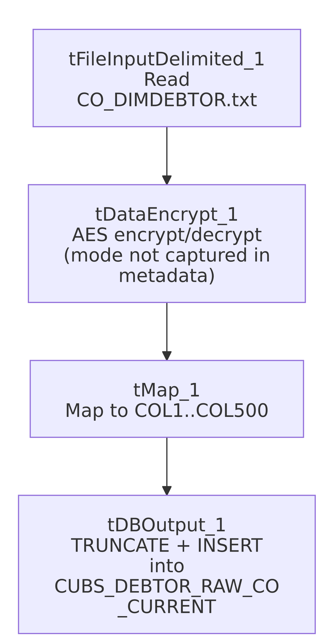

Settings tables

Source: `tFileInputDelimited_1`
Setting | Value | What it means
FILENAME | "C:/Data/CO_DIMDEBTOR.txt" | Hardcoded local path to the CO site's debtor extract file — not a context.sourceDir-style reference.
FIELDSEPARATOR / HEADER | \t / 1 header row | Tab-delimited file with the header row skipped.
SCHEMA | Repository schema "_cg_VMA4fEe-4IfbB_0n8ZA - metadata" | The schema's label doesn't name the business content, unlike e.g. CREATE_RAW_CUBS_CLIENT's clearly-named repository schema.
DIE_ON_ERROR | false | Malformed rows don't fail the job...
Reject flow / SCHEMA_REJECT | Not wired; no reject schema defined at all | ...and unlike ADP_Payroll_Load (which at least has a mislabeled reject schema), this component defines no reject schema at all — rejected rows are silently dropped with zero visibility.
TEMP_DIR | "C:/Talend-Studio-20211109_1610-V8.0.1/workspace" | Hardcoded developer-workstation path, the same portability risk documented project-wide in 05_operational_runbook.md.

Transform: `tDataEncrypt_1`
Setting | Value | What it means
CRYPTO_METHOD | AES | Symmetric encryption algorithm used for whichever field(s) this step processes.
CRYPTO_FILE_PATH | "C:/Data/dimdbtr.crypt" | Local crypto key/config file read from disk, not a context-variable path.
SECRET_TYPE / SECRET_KEY / PASSWORD_M1 | ***REDACTED*** | Preserved as redacted — not guessable from this metadata.
GEN_CRYPTO_FILE_CONTROLLER | false | This run reads an existing crypto file rather than generating a new one.
Mode (encrypt vs. decrypt) | Not captured in this metadata | See Issues observed.

Target: `tDBOutput_1` (`tSnowflakeOutput`)
Setting | Value | What it means
Table | CUBS_DEBTOR_RAW_CO_CURRENT | Destination raw staging table for CO debtor data.
Output action | INSERT | Appends rows, relying on the preceding truncate.
Table action | TRUNCATE | Same truncate-then-reload pattern used by most CUBS_Raw_* jobs project-wide.
Target schema | FILENAME, FILEDATE, COL1...COL500 | Generic placeholder column names rather than the real business columns named on the source side — see Issues observed.

Dependencies & configuration
- Triggers/depends on other jobs: none — no tRunJob links found in this job, and this job is not listed as a tRunJob target of CO_Master_Load or any other calling job in 06_dependency_matrix.md (the analogous per-run CO debtor load in that orchestration is the differently named CUBS_Raw_CO_Debtor_Load).
- Context variables used: none — context_vars_referenced is empty for this job; every path (source file, crypto file, temp dir) is hardcoded rather than parameterized via context, unlike almost every other job in this project.
- Hardcoded paths: tFileInputDelimited_1.TEMP_DIR is in the formal hardcoded_path_findings list; in addition (present in the job's own parameters, though not flagged by that extraction pass) tFileInputDelimited_1.FILENAME ("C:/Data/CO_DIMDEBTOR.txt") and tDataEncrypt_1.CRYPTO_FILE_PATH ("C:/Data/dimdbtr.crypt") are both local, drive-letter paths rather than context.sourceDir-style references.

Glossary
Component type | Plain-English meaning
tFileInputDelimited | Reads a delimited (CSV/TSV-style) text file according to a schema.
tDataEncrypt | Talend's field-level encryption/decryption component, driven by a crypto key file.
tMap | Maps/transforms columns from one schema to another.
tSnowflakeOutput | Writes rows to a Snowflake table, optionally truncating or recreating it first.

Issues observed
- No `tPrejob`/`tPostjob` or explicit `tDBConnection`/`tDBClose` components in this job, unlike nearly every other job in this project. tDBOutput_1's own parameters object is empty, so it's not visible in this metadata where or how its Snowflake connection is actually defined — verify directly in Talend Studio.
- The destination schema is captured only as 500 generic `COL1`..`COL500` placeholder columns (plus FILENAME/FILEDATE), even though the source schema names its fields explicitly (DebtorNumber, NAME1, _SSN, etc.). This may simply be how this extraction captured tMap_1's output schema, or the mapping in Talend Studio may genuinely use generic column names. Unable to determine which from this metadata — if the latter, anyone querying CUBS_DEBTOR_RAW_CO_CURRENT downstream would need to reverse-engineer which COLnn holds which real value.
- No reject schema or reject flow at all on `tFileInputDelimited_1` (not even a mislabeled one, unlike ADP_Payroll_Load) — malformed rows are silently dropped with zero record of what or how many failed.
- `tDataEncrypt_1`'s mode (encrypt vs. decrypt) isn't visible in this metadata. Given the job runs right after reading a raw text extract and before writing to a raw staging table, it's plausible this step is protecting a sensitive field (e.g. _SSN) as it lands in Snowflake — but that's an inference, not something the extracted parameters confirm.
- Every path in this job (source file, crypto file, temp dir) is hardcoded rather than driven by a context variable, unlike almost every other job in this project (which typically use context.sourceDir/archiveDir, etc.). This job would need manual editing to run against any environment other than the one baked into its component settings.
- Not part of any documented `tRunJob` orchestration (see 06_dependency_matrix.md). Given the "TrueUp" name, this looks like a standalone/ad hoc reconciliation job; how and when it's actually triggered is unable to determine from metadata — verify with the team.

