Talend Job: CO_E_Media_Load

Overview
Loads electronic-media/letter-status tracking records for the CO site from an MSSQL table into a Snowflake staging table, then merges those staged rows into a corresponding DW.CO_ELECTRONICSMEDIA table via an UPDATEKEY/EMID_IDX-driven upsert. The data represents the status "waterfall" of collection letters/communications (LETTER_NAME, STATUS_DATE/TIME, STATUS_TEXT, WATERFALL, etc.) associated with debtor accounts. Like i3_CallDetail_40_Load, this job computes the maximum already-loaded key from Snowflake before reading the source, suggesting an intended incremental-load design — but as with that job, the captured query text doesn't confirm the filter is actually applied (see Issues observed).

Detail table
Field | Value
Job name | CO_E_Media_Load
Version | 0.1
Project | EDW2SF
Author | jmach@harriscollect.com
Created | 2022-05-13T14:10:46.398-0700
Last Modified | 2025-09-24T11:06:52.343-0700

Step-by-step data flow
Setup subjob: tPrejob_1 → tDBConnection_1 opens the MSSQL connection using context.EDWProdHH_* variables → tDBConnection_2 opens a Snowflake connection → tDBConnection_3 opens a second, separate Snowflake connection (see Issues observed).
Main subjob:
- tDBInput_2 (tSnowflakeInput) runs SELECT CAST(COALESCE(MAX(UPDATEKEY),0) AS VARCHAR(10)) AS MAXUPDATEKEY FROM DW.CO_ELECTRONICSMEDIA; against Snowflake.
- tJavaRow_1 captures that result into context.maxUpdateKey.
- On tDBInput_2's subjob success, tDBInput_1 (tMSSqlInput, reusing tDBConnection_1) runs a fixed SELECT of 18 named columns from the MSSQL table "DC-ElectronicsMedia" — note the table name says DC, not CO, despite this being the CO job (see Issues observed). The captured query text is truncated after the column list and does not visibly reference `context.maxUpdateKey`.
- tMap_1 (DIE_ON_ERROR=true) passes all columns through largely unchanged (renaming only UpdateKey → UPDATEKEY) to tFlowMeter_2 (labeled "MyLabel", not renamed for this job), which counts rows before tDBOutput_1 truncates and inserts into the Snowflake staging table CO_ELECTRONICSMEDIA.
- Separately, once tDBInput_1's subjob succeeds, tDBRow_1 (tSnowflakeRow) runs a MERGE INTO DW.CO_ELECTRONICSMEDIA statement — matching on EMID_IDX, updating matched rows and inserting unmatched ones — reading its source rows explicitly FROM STAGING.CO_ELECTRONICSMEDIA (matching the STAGING.-prefix convention seen in CO_Master_Load's merge calls).
Teardown subjob: tPostjob_1 → tDBClose_2 (close MSSQL) → tDBClose_1 (close first Snowflake connection) → tDBClose_3 (close second Snowflake connection).
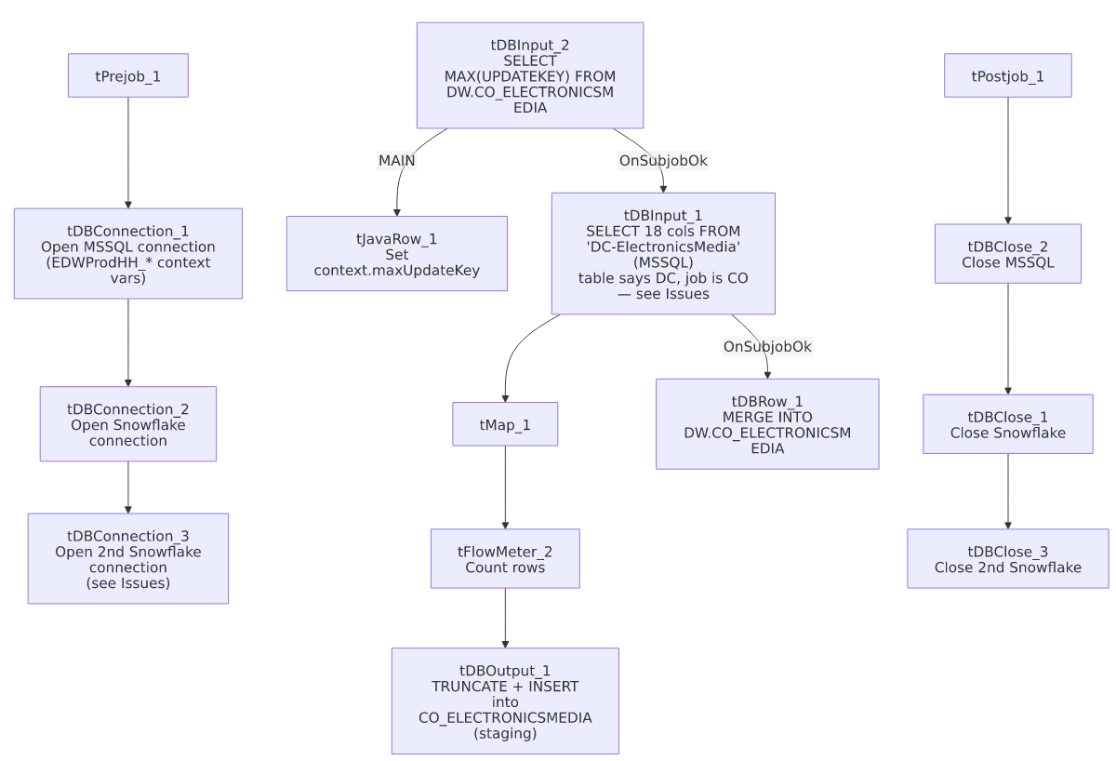

Settings tables

Source: `tDBInput_1` (`tMSSqlInput`)
Setting | Value | What it means
Connection | Shared tDBConnection_1 | Reuses the job's MSSQL connection.
Table | "DC-ElectronicsMedia" | Source table name literally says "DC" — see Issues observed.
Query | Fixed SELECT of 18 named columns (letter/status/waterfall fields, UpdateKey) | The visible portion of the query text does not show a WHERE UpdateKey > ...-style clause referencing context.maxUpdateKey — same uncertainty documented in i3_CallDetail_40_Load.

Incremental key check: `tDBInput_2` / `tJavaRow_1`
Setting | Value | What it means
Query | SELECT CAST(COALESCE(MAX(UPDATEKEY),0) AS VARCHAR(10)) AS MAXUPDATEKEY FROM DW.CO_ELECTRONICSMEDIA; | Finds the highest UpdateKey already loaded into the DW table.
Result handling | MAXUPDATEKEY → context.maxUpdateKey | Computed before the MSSQL read — intended for incremental filtering (see Issues observed on whether it's actually applied).

Staging target: `tDBOutput_1` (`tSnowflakeOutput`)
Setting | Value | What it means
Table | CO_ELECTRONICSMEDIA | Snowflake staging table.
Output action | INSERT | Appends rows.
Table action | TRUNCATE | Clears the staging table before each load.

Merge step: `tDBRow_1` (`tSnowflakeRow`)
Setting | Value | What it means
Query | MERGE INTO DW.CO_ELECTRONICSMEDIA AS tgt USING (SELECT ... FROM STAGING.CO_ELECTRONICSMEDIA) AS src ON (tgt.EMID_IDX = src.EMID_IDX) WHEN MATCHED THEN UPDATE ... WHEN NOT MATCHED THEN INSERT ... | Classic upsert keyed on EMID_IDX (electronic-media record ID) — updates every business column on match, inserts new rows otherwise. Explicitly reads FROM STAGING.CO_ELECTRONICSMEDIA, so it depends on tDBOutput_1 having just loaded that staging table in the same run.

Dependencies & configuration
- Triggers/depends on other jobs: none — no tRunJob links found. This job is also not listed as a tRunJob target of CO_Master_Load in 06_dependency_matrix.md — that orchestrator instead calls a differently named CUBS_Raw_EM_Load for "EM" data. Unable to determine from metadata whether CO_E_Media_Load and CUBS_Raw_EM_Load are related or fully independent pipelines.
- Context variables used: EDWProdHH_Server, EDWProdHH_Port, EDWProdHH_Schema, EDWProdHH_Database, EDWProdHH_Login (MSSQL connection details) plus maxUpdateKey (computed internally).
- No hardcoded developer-workstation paths found in this job (hardcoded_path_findings is empty).

Glossary
Component type | Plain-English meaning
tMSSqlConnection / tMSSqlInput / tMSSqlClose | Open a Microsoft SQL Server connection, run a query against it, and close it.
tSnowflakeConnection / tSnowflakeInput / tSnowflakeOutput / tSnowflakeRow / tSnowflakeClose | Open/close a Snowflake connection, read rows, write rows, or run an arbitrary SQL statement/stored-procedure call against Snowflake.
tMap | Maps/transforms columns from one schema to another.
tFlowMeter | Counts rows passing a point in the flow for logging/monitoring.
tJavaRow | Runs custom Java code once per input row — here used to unpack a single query result into a context variable.

Issues observed
- The MSSQL source table is named `"DC-ElectronicsMedia"`, not `"CO-ElectronicsMedia"` or similar, even though this job is CO_E_Media_Load and everything downstream (Snowflake staging/DW tables, merge query) is named CO_ELECTRONICSMEDIA. This strongly suggests either (a) a single shared "DC" source table actually holds electronic-media data for multiple sites including CO, and only the job's naming is inconsistent, or (b) this job was copied from a DC-specific job and the source TABLE parameter was never repointed. Unable to determine which from metadata — worth confirming with the team before assuming CO's e-media data is correctly sourced.
- Two separate Snowflake connections are opened back-to-back (tDBConnection_2 and tDBConnection_3) in the setup subjob, and closed as two separate connections (tDBClose_1, tDBClose_3) in teardown, rather than reusing a single one throughout. Both have empty captured parameters, so it's unable to determine from metadata whether they point to the same or different Snowflake accounts/warehouses — if identical, this is a redundant connection open/close pair.
- Same incremental-load uncertainty documented in `i3_CallDetail_40_Load`: context.maxUpdateKey is computed from Snowflake before the MSSQL read, but the captured tDBInput_1.QUERY text is truncated after the column list and does not show a filtering WHERE clause. Unable to confirm from this metadata whether the load is genuinely incremental or re-reads the full source table every run — the TRUNCATE+INSERT on the staging table prevents duplicate accumulation there regardless, but a non-incremental read would mean wasted read volume every run.
- No error/row-count logging specific to this job's business outcome (no tWarn/tDie/tSendMail) — a load or merge failure here would only surface as a generic Talend execution error.

