Talend Job: CREATE_RAW_CUBS_CLIENT

Overview
This is a DDL-only setup job, not a data load: it drops and recreates the Snowflake table CUBS_CLIENT using a repository-defined schema of roughly 160 client/business columns (identity and address, MTD/YTD/total assignment and collection amounts, statement/invoice/letter frequency flags, scoring/dialer/legal-routing flags, and more). It does not populate the table with any data — it only establishes or resets CUBS_CLIENT's structure, presumably ahead of whatever load job (not present in this batch) actually populates it.

Detail table
Field | Value
Job name | CREATE_RAW_CUBS_CLIENT
Version | 0.1
Project | EDW2SF
Author | jmach@harriscollect.com
Created | 2022-03-25T12:38:59.216-0700
Last Modified | 2025-09-24T11:07:27.514-0700

Step-by-step data flow
Setup subjob: tPrejob_1 → tDBConnection_1 opens the job's Snowflake connection.
Table-definition step: tCreateTable_1, configured with TABLEACTION=DROP_IF_EXIST_CREATE against table CUBS_CLIENT (repository schema "_71WboKxXEeysS7G80LSq2A - CUBS_CLIENT"), references the Snowflake connection through its own CONNECTION_SNOWFLAKE parameter — but per this job's own connections metadata, there is no trigger link (`OnSubjobOk`/`OnComponentOk`) wiring `tDBConnection_1` to `tCreateTable_1`, nor any trigger leading away from it. See Issues observed — as captured, tCreateTable_1 appears to run as its own independent, ungated subjob rather than after the connection is confirmed open.
Teardown subjob: tPostjob_1 → tDBClose_1 closes the Snowflake connection.
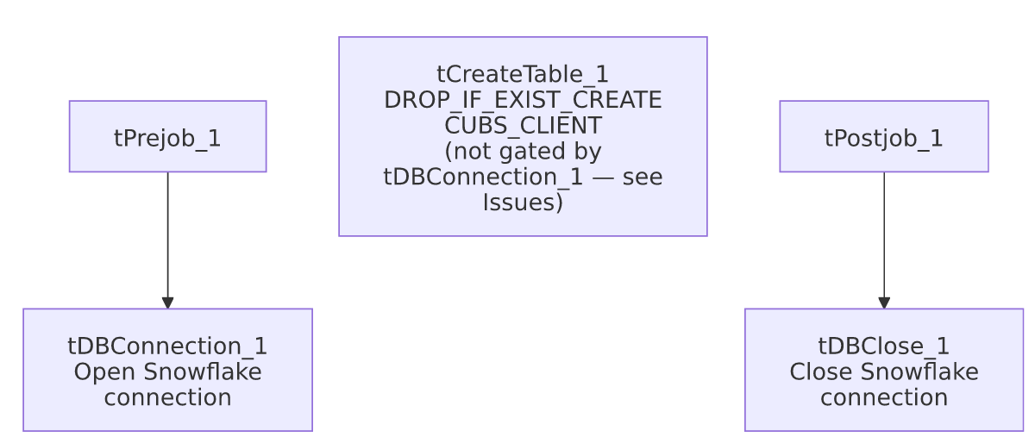

Settings tables

DDL step: `tCreateTable_1`
Setting | Value | What it means
DBTYPE | SNOWFLAKE | Targets a Snowflake table.
TABLEACTION | DROP_IF_EXIST_CREATE | Drops CUBS_CLIENT if it already exists, then creates it fresh from the repository schema — destructive by design; any existing data in CUBS_CLIENT is lost every time this job runs.
TABLE | "CUBS_CLIENT" | Target table name.
SCHEMA | Repository schema "_71WboKxXEeysS7G80LSq2A - CUBS_CLIENT" (~160 columns) | Client identity/address, assignment & collection MTD/YTD/TOT amounts, statement/invoice/letter frequency flags, scoring/dialer/legal-routing flags, etc.
JDBC_URL / PASS / MSSQL_ACTIVE_DIR_AUTH | ***REDACTED*** | Preserved as-is.
CONNECTION_SNOWFLAKE | tDBConnection_1 | References the job's Snowflake connection component by name — but see Issues observed regarding whether execution actually waits for it.
Other DBFILE_*/DB_*_VERSION parameters | Default/inert values for database types this job doesn't use (Access, Firebird, SQLite, MySQL, Oracle, PostgreSQL, Sybase, Vertica) | Standard tCreateTable boilerplate left at defaults — not evidence this job touches those other databases.

Dependencies & configuration
- Triggers/depends on other jobs: none — no tRunJob links found.
- Context variables used: none — context_vars_referenced is empty; this job's connection and table settings are resolved through the referenced repository connection/schema rather than context variables.
- Hardcoded paths: 3 findings, all default/inert DB-file paths on tCreateTable_1 for database types this job doesn't use — DBFILE_ACCESS ("C:/Talend-Studio-20211109_1610-V8.0.1/workspace/in.mdb"), DBFILE_FIREBIRD (".../in.FDB"), DBFILE_SQLITE (".../talend.db"). These use the same Talend workspace path documented project-wide in 05_operational_runbook.md, but here they are tCreateTable's unused defaults for other DB engines rather than paths this job actually reads or writes.

Glossary
Component type | Plain-English meaning
tCreateTable | Issues a CREATE TABLE statement (optionally preceded by a DROP) against a database, using a repository-defined column schema — moves no data itself.
tSnowflakeConnection / tSnowflakeClose | Open and close the job's Snowflake connection.

Issues observed
- `tCreateTable_1` has no incoming or outgoing trigger connection in this job's metadata. The only two connections captured are tPrejob_1 → tDBConnection_1 and tPostjob_1 → tDBClose_1; tCreateTable_1 isn't wired as a target of tDBConnection_1's OnSubjobOk/OnComponentOk, nor does anything trigger after it. In Talend, a component with no incoming trigger runs as its own independent subjob at job start — so tCreateTable_1 would plausibly execute in parallel with (not strictly after) tDBConnection_1 opening the very connection it's configured to reuse (CONNECTION_SNOWFLAKE: tDBConnection_1). If tCreateTable_1 starts before that connection finishes opening, it could fail outright or behave unpredictably. Worth confirming this wiring directly in Talend Studio — the visual canvas may show a trigger this extraction didn't capture, or the job may genuinely have this gap.
- This job is purely destructive-then-empty: DROP_IF_EXIST_CREATE means any existing CUBS_CLIENT data is dropped and the table recreated empty — this job never loads data into it. Running this job unintentionally (e.g., instead of whatever job actually populates CUBS_CLIENT) would silently wipe the table with no load step to follow it up. Unable to determine from this metadata which other job(s) populate CUBS_CLIENT afterward — verify with the team.
- No error handling of any kind (no tWarn/tDie/tLogRow) — a DDL failure here would only surface as a generic Talend execution error.

