Talend Job: CRPLoad

Overview
Loads a flat list of Social Security Numbers from a local CSV file (C:/Data/CRPData.csv) through a field-level encryption step and into a Snowflake table CRPDATA, dropping and recreating that table on every run. The single-column schema and the "CRP" job name suggest a narrow, purpose-built extract for some external reporting or credit-related process — "CRP" is not otherwise defined anywhere in this job's metadata, verify with the team. This job uses the same crypto file (dimdbtr.crypt) as CO_Debtor_TrueUp (also in this batch), suggesting the two jobs share an encryption configuration for protecting SSN-type identifiers.

Detail table
Field | Value
Job name | CRPLoad
Version | 0.1
Project | EDW2SF
Author | jmach@harriscollect.com
Created | 2023-07-11T07:55:41.227-0700
Last Modified | 2023-07-11T09:28:16.397-0700

Step-by-step data flow
This job has no tPrejob/tPostjob/tDBConnection components at all in its metadata — just a 3-component pipeline:
- tFileInputDelimited_1 reads C:/Data/CRPData.csv (comma-delimited, header row present, DIE_ON_ERROR=false) using a schema of a single business column, SSN (listed twice in the extracted schema — likely this extraction capturing main and reject schema together, the same pattern seen in ADP_Payroll_Load).
- FLOW to tDataEncrypt_1, running the SSN value through the same AES/crypto-file setup as CO_Debtor_TrueUp (CRYPTO_FILE_PATH="C:/Data/dimdbtr.crypt"), leaving the schema unchanged.
- FLOW to tDBOutput_1 (tSnowflakeOutput), which drops and recreates CRPDATA (DROP_IF_EXISTS_AND_CREATE) then inserts the encrypted rows.
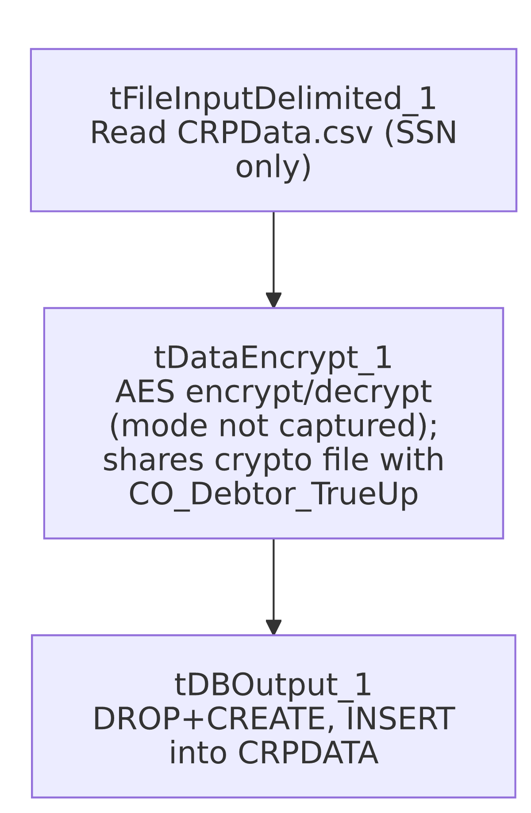

Settings tables

Source: `tFileInputDelimited_1`
Setting | Value | What it means
FILENAME | "C:/Data/CRPData.csv" | Hardcoded local path, not a context variable.
FIELDSEPARATOR / HEADER | , / 1 header row | Standard comma-delimited CSV with a header row.
Schema | Single column SSN (id_String), listed twice in the extraction | Consistent with this project's pattern of main+reject schema being captured together (see ADP_Payroll_Load).
DIE_ON_ERROR / Reject flow | false / not wired, no SCHEMA_REJECT defined | Malformed rows are silently dropped — no record kept of what or how many failed.
TEMP_DIR | "C:/Talend-Studio-20211109_1610-V8.0.1/workspace" | Hardcoded developer-workstation path, the same portability risk documented project-wide in 05_operational_runbook.md.

Transform: `tDataEncrypt_1`
Setting | Value | What it means
CRYPTO_METHOD | AES | Symmetric encryption algorithm.
CRYPTO_FILE_PATH | "C:/Data/dimdbtr.crypt" | Identical path to CO_Debtor_TrueUp's tDataEncrypt_1 — the same key/config file is reused across at least these two jobs.
SECRET_TYPE / SECRET_KEY / PASSWORD_M1 | ***REDACTED*** | Preserved as-is.
Mode (encrypt vs. decrypt) | Not captured in this metadata | See Issues observed.

Target: `tDBOutput_1` (`tSnowflakeOutput`)
Setting | Value | What it means
Table | CRPDATA | Destination table.
Output action | INSERT | Appends the encrypted rows.
Table action | DROP_IF_EXISTS_AND_CREATE | The table is fully dropped and recreated (not just truncated) every run — a different pattern than the TRUNCATE-only approach used elsewhere in this project (e.g. CO_E_Media_Load, CO_Debtor_TrueUp) — see Issues observed.

Dependencies & configuration
- Triggers/depends on other jobs: none — no tRunJob links found.
- Context variables used: none — context_vars_referenced is empty; the source file, crypto file, and temp dir are all hardcoded.
- Hardcoded paths: tFileInputDelimited_1.TEMP_DIR is in the formal hardcoded_path_findings list; in addition (present in the job's own parameters but not flagged by that extraction pass), tFileInputDelimited_1.FILENAME and tDataEncrypt_1.CRYPTO_FILE_PATH are both local drive-letter paths rather than context.sourceDir-style references.

Glossary
Component type | Plain-English meaning
tFileInputDelimited | Reads a delimited (CSV-style) text file according to a schema.
tDataEncrypt | Talend's field-level encryption/decryption component, driven by a crypto key file.
tSnowflakeOutput | Writes rows to a Snowflake table, optionally dropping/recreating or truncating it first.

Issues observed
- No `tPrejob`/`tPostjob` or explicit Snowflake connection component in this job — the same gap documented in CO_Debtor_TrueUp. tDBOutput_1's own parameters object is empty, so where its Snowflake connection is actually defined isn't visible in this metadata; verify directly in Talend Studio.
- `CRPDATA`'s table action is `DROP_IF_EXISTS_AND_CREATE` rather than `TRUNCATE` — the table is fully recreated (not just emptied) every run. If any downstream process depends on the table's structure staying stable between runs (grants, dependent views, or column order), a schema change made outside this job wouldn't survive the next run; and while the job is running, the table briefly doesn't exist at all rather than merely being empty.
- What "CRP" stands for, and what downstream process consumes `CRPDATA`, isn't explained anywhere in this job's own metadata — unable to determine from metadata; verify with the team.
- No error/row-count logging specific to this job's business outcome (no tWarn/tDie/tSendMail) — a failure here would only show as a generic Talend execution error.
- Shares its crypto file (`C:/Data/dimdbtr.crypt`) with `CO_Debtor_TrueUp` (both in this batch) — if that file's location or content changes for one job, the other is also affected; this shared dependency isn't documented anywhere as intentional.

