Talend Job: CUBS_EMail_Address_Load

Overview
Loads a per-logon email/electronic-media extract file (debtor number, media type, address, authorization status, and related notes/balance fields) into the Snowflake DIM_ELECTRONIC_MEDIA dimension table via an UPSERT. The job waits for a per-logon "EDW complete" semaphore file before reading, then archives and deletes the source file once processed. Unlike some other file-load jobs in this project (e.g. ADP_Payroll_Load), this job's reject flow is fully wired to a dedicated rejects file rather than silently dropped.

Detail table
Field | Value
Job name | CUBS_EMail_Address_Load
Version | 0.1
Project | EDW2SF
Author | jmach@harriscollect.com
Created | 2023-01-27T11:11:58.161-0800
Last Modified | 2026-02-04T07:13:12.918-0800

Step-by-step data flow
Setup subjob: tPrejob_1 → tJava_1 opens a per-run log file at context.logDir+context.currentLogon+"_"+jobName+"_"+<timestamp>+".log" → on success, tDBConnection_1 opens the Snowflake connection.
Main subjob — runs independently of the setup subjob, gated on a semaphore file:
- tWaitForFile_1 polls context.sourceDir every 30 seconds, up to context.loopCount iterations, for a file named context.currentLogon+"-EDW-COMPLETE.txt" (or proceeds immediately if already present — INCLUDE_PRESENT=true). Same gating pattern as CO_Master_Load's tWaitForFile_4, but keyed on a per-logon filename rather than a fixed site code.
- On success, tJava_2 logs "Processing " + context.sourceDir+context.currentLogon+context.sourceFile to the console/log.
- On success, tFileInputDelimited_1 reads the comma-delimited file at context.sourceDir+context.currentLogon+context.sourceFile (header row present, DIE_ON_ERROR=false) using a repository schema labeled "...- email" — the same label is used for both the main and reject schemas, unlike ADP_Payroll_Load's mismatched reject-schema labeling.
- Well-formed rows (FLOW): tMap_1 (DIE_ON_ERROR=true) maps the 18 raw input columns to an 18-column uppercase target schema (LOGON, DEBTORNUMBER, DEBTOR_IDX, MEDIA, ADDRESS_TYPE, MEDIA_ADDRESS, ADDR_SOURCE, SRC_NAME, AUTH_STATUS, AUTH_DATE, STATUS, STATUS_DT, ENTRY_DT, NT_DATE, NT_TIME, NT_WHO, NOTE_TEXT, PL_GROUP, TOTAL_BAL) → tFlowMeter_2 counts rows (labeled "MyLabel", not renamed) → tDBOutput_1 UPSERTs into Snowflake DIM_ELECTRONIC_MEDIA.
- Rejected rows (REJECT): routed to tFileOutputDelimited_1, which writes them (with header) to context.logDir+context.currentLogon+"_EMAIL_REJECTS_"+<date>+".csv" — a dated, per-logon reject file, so malformed rows are recorded rather than silently dropped.
- Once tFileInputDelimited_1 completes (SUBJOB_OK, independent of the FLOW/REJECT row outcomes), tFileArchive_1 tar-gzips the source file to context.archiveDir+"/"+<date>+"/"+context.currentLogon+context.sourceFile+".tar.gz", then on success tFileDelete_1 deletes the original source file at context.sourceDir+context.currentLogon+context.sourceFile.
Teardown subjob: tPostjob_1 → tDBClose_1 closes the Snowflake connection.
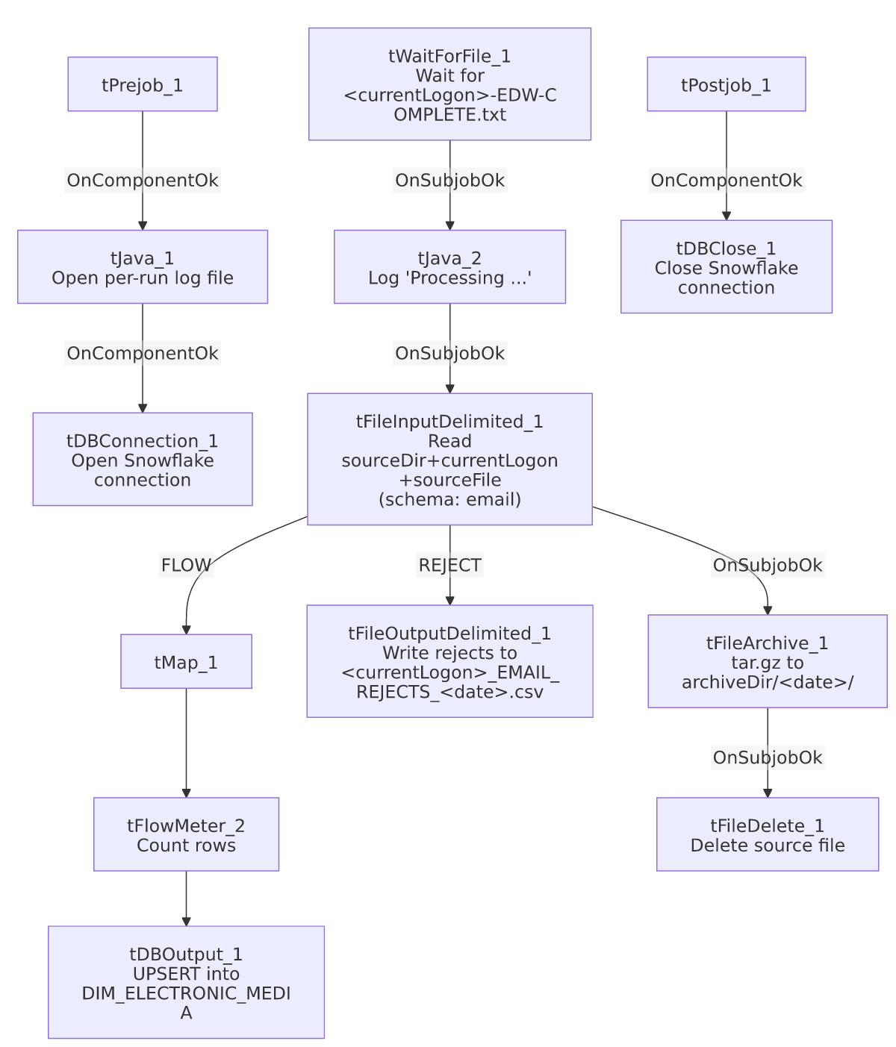

Settings tables

Gate: `tWaitForFile_1`
Setting | Value | What it means
DIRECTORY / FILEMASK | context.sourceDir / context.currentLogon+"-EDW-COMPLETE.txt" | Waits for a per-logon completion semaphore, rather than a single fixed site file.
WAIT / MAX_ITERATIONS | 30 (seconds) / context.loopCount | Same polling shape as CO_Master_Load's tWaitForFile_4.
INCLUDE_PRESENT | true | Proceeds immediately if the semaphore file is already there.

Source: `tFileInputDelimited_1`
Setting | Value | What it means
FILENAME | context.sourceDir+context.currentLogon+context.sourceFile | Per-logon input file path assembled from three context variables.
FIELDSEPARATOR / HEADER | , / 1 header row | Standard comma-delimited CSV.
SCHEMA / SCHEMA_REJECT | Both labeled repository schema "...- email" | Main and reject schemas share the same label — consistent, unlike ADP_Payroll_Load's mismatched reject schema.
DIE_ON_ERROR | false | Malformed rows do not fail the job...
Reject flow | Wired to tFileOutputDelimited_1 | ...and are captured to a dated CSV file rather than silently dropped.

Reject output: `tFileOutputDelimited_1`
Setting | Value | What it means
FILENAME | context.logDir+context.currentLogon+"_EMAIL_REJECTS_"+TalendDate.getDate("CCYY-MM-DD")+".csv" | Dated, per-logon rejects file.
INCLUDEHEADER | true | Rejects file includes a header row for readability.

Archive / cleanup: `tFileArchive_1` / `tFileDelete_1`
Setting | Value | What it means
SOURCE / TARGET (tFileArchive_1) | context.sourceDir / context.archiveDir+"/"+<date>+"/"+context.currentLogon+context.sourceFile+".tar.gz" | Archives the processed file into a dated subfolder under archiveDir.
SOURCE_FILE (tFileArchive_1, hardcoded) | "C:/Talend-Studio-20211109_1610-V8.0.1/workspace/source.csv" | A hardcoded placeholder unrelated to the actual per-logon file being archived (TARGET is correctly context-driven) — see Issues observed.
FILENAME (tFileDelete_1) | context.sourceDir+context.currentLogon+context.sourceFile | Deletes the original source file after it's archived.

Target: `tDBOutput_1` (`tSnowflakeOutput`)
Setting | Value | What it means
Table | DIM_ELECTRONIC_MEDIA | Destination dimension table — name suggests it covers electronic-media addresses generally (email being one media type), not an email-specific table.
Output action | UPSERT | Inserts new rows or updates matching existing ones — no truncate/staging step, consistent with an incremental dimension load.
Table action | NONE | Table is not recreated/altered by this job.

Dependencies & configuration
- Triggers/depends on other jobs: none — no tRunJob links found in this job's own metadata, and this job does not appear as a call target anywhere in 06_dependency_matrix.md's 65-link tRunJob table either.
- Context variables used: archiveDir, currentLogon, logDir, loopCount, sourceDir, sourceFile.
- 4 hardcoded developer-workstation paths in tFileInputDelimited_1.TEMP_DIR, tFileArchive_1.SOURCE_FILE, and tFileDelete_1.DIRECTORY/PATH (all C:/Talend-Studio-20211109_1610-V8.0.1/workspace/...) — same project-wide portability risk documented in 05_operational_runbook.md.

Glossary
Component type | Plain-English meaning
tWaitForFile | Polls a directory for a specific file to appear, for up to a configured number of attempts, before letting the job continue.
tFileInputDelimited | Reads a delimited (CSV-style) text file according to a schema.
tMap | Maps/transforms columns from one schema to another.
tFlowMeter | Counts rows passing through a point in the flow, for logging/monitoring.
tFileOutputDelimited | Writes rows to a delimited text file — here used both as the (unused in this job) main output type pattern and specifically to capture rejected rows.
tSnowflakeOutput / tSnowflakeConnection / tSnowflakeClose | Write rows to a Snowflake table / open and close the Snowflake connection used by the job.
tFileArchive / tFileDelete | Zip a processed file to an archive location, then delete the original from the source directory.
tJava | Runs custom Java code — here used to open a log file and to print a status message.

Issues observed
- This job is not called by any `tRunJob` link captured in the project's metadata (it doesn't appear in 06_dependency_matrix.md's 65-link orchestration table), yet its file path, log filename, and archive path all depend on context.currentLogon varying per run. Unable to determine from this job's own metadata how or where currentLogon is set for each invocation (e.g., a per-site scheduled task, or a context value set outside this extraction) — verify with the team.
- `tFileArchive_1.SOURCE_FILE` is a hardcoded placeholder path (C:/Talend-Studio-20211109_1610-V8.0.1/workspace/source.csv) unrelated to the actual file being archived — the component's TARGET parameter is correctly built from context variables, so this looks like inert Talend-generated boilerplate rather than a functional bug, but it's part of the same widespread hardcoded-path pattern flagged project-wide in 05_operational_runbook.md.
- `tDBOutput_1`'s schema includes a `LOAD_DT` column that is not present in `tMap_1`'s mapped output schema. Unable to determine from this metadata whether LOAD_DT is populated by a Snowflake-side default expression (e.g., a load timestamp) or left null on every upsert — verify directly in the Talend Studio schema/expression settings.

