Talend Job: CUBS_PostDates_Load

Overview
This job refreshes the CUBS "post-dates" feed (post-dated collection/payment-plan dates keyed by DEBTOR/CLIENT, alongside a large set of debtor demographic and balance columns inherited from the same legacy LEGACY_DIMDEBTOR schema used elsewhere in the project). It truncates the staging table, waits in parallel for five sites' daily-extract completion markers (CHI, CO, DC, HH, PRE), runs CUBS_Raw_PostDate_Load once per site once its marker appears, and then merges the combined staging rows forward. Notably, the final fact-table merge and its result-handling logic are all disabled in this version of the job — see Issues observed.

Detail table
Field | Value
Job name | CUBS_PostDates_Load
Version | 0.2
Project | EDW2SF
Author | jmach@harriscollect.com
Created | 2023-03-07T20:54:09.510-0800
Last Modified | 2025-11-04T11:08:12.709-0800

Step-by-step data flow
Setup subjob: tPrejob_1 → tJava_1 opens a per-run log file (context.logDir + jobName + <timestamp> + ".log") → on success, tSetKeystore_1 configures SSL trust/keystore from context.keystorePath (passwords redacted) → tDBConnection_1 opens the Snowflake connection. Per Talend's tPrejob semantics, this setup subjob always completes before any other subjob starts, even though the main flow below isn't directly wired off tDBConnection_1.
Main subjob:
- tDBRow_1 runs TRUNCATE TABLE STAGING.CUBS_POSTDATE_RAW_CURRENT; — this is a top-level starting component (no incoming link in this job's own connections), so it fires as soon as the setup subjob finishes.
- On success, tParallelize_1 starts five tWaitForFile branches simultaneously, each polling for a different site's completion marker (30-second interval, up to MAX_ITERATIONS=720, INCLUDE_PRESENT=true so an already-present file is accepted immediately):
- tWaitForFile_1 → context.sourceDir + "CHI-EDW-COMPLETE.txt" → on success, tRunJob_1
- tWaitForFile_2 → context.sourceDir + "CO-EDW-COMPLETE.txt" → tRunJob_2
- tWaitForFile_3 → context.sourceDCDir + "DC-EDW-COMPLETE.txt" (note the DC-specific directory variable — see Issues observed) → tRunJob_3
- tWaitForFile_4 → context.sourceDir + "HH-EDW-COMPLETE.txt" → tRunJob_4
- tWaitForFile_5 → context.sourceDir + "PRE-EDW-COMPLETE.txt" → tRunJob_5
- All five tRunJob_* components call the same child job, CUBS_Raw_PostDate_Load, with identical CONTEXT_NAME=Default and TRANSMIT_ORIGINAL_CONTEXT=true settings — nothing in this job's own metadata shows a per-site context override being passed to any of the five calls (see Issues observed). DIE_ON_CHILD_ERROR=true on all five, so any one site's load failing fails this orchestrator too.
- tParallelize_2 synchronizes all five tRunJob branches (WAIT_FOR=All) before continuing.
- tDBRow_2 runs CALL MERGE_INTO_CUBS_POSTDATE_RAW(); to merge the combined staging rows.
- On success, tDBRow_3 would run CALL MERGE_INTO_FACTPOSTDATES();, feeding tJavaRow_1 (captures RETVALUE into context.rowCount) which branches to tWarn_1 (success message) or tDie_1 (failure) — but all four of these components (`tDBRow_3`, `tJavaRow_1`, `tWarn_1`, `tDie_1`) have `ACTIVATE=false` in this job's metadata, meaning this entire final stage is disabled and does not run. See Issues observed.
Teardown subjob: tPostjob_1 → tDBClose_1 closes the Snowflake connection.
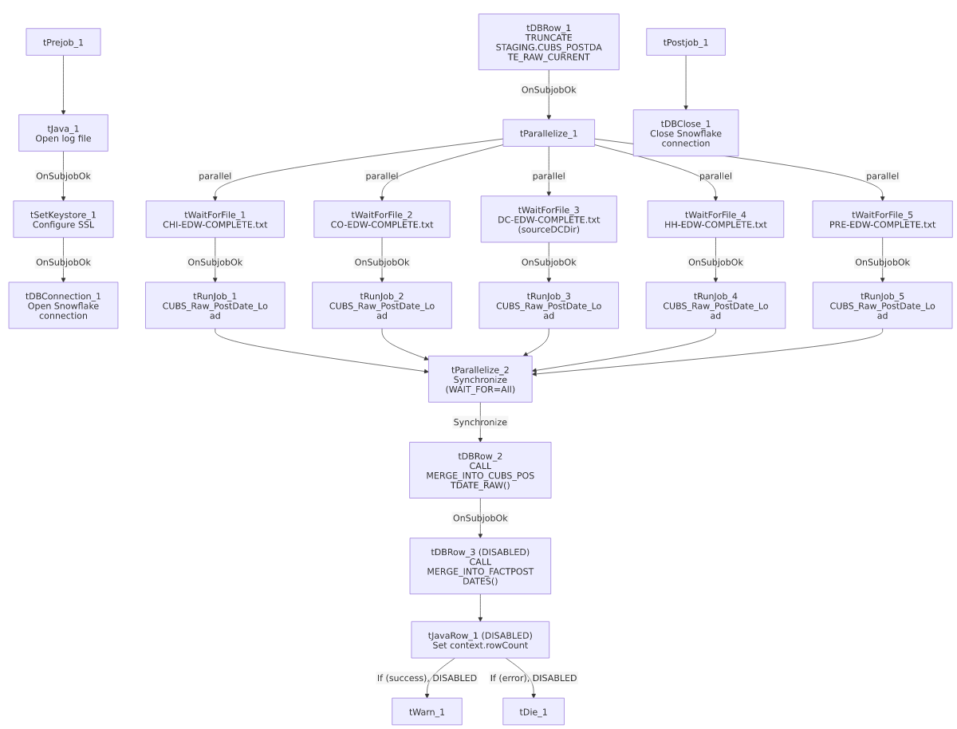

Settings tables

Staging reset: `tDBRow_1`
Setting | Value | What it means
Query | TRUNCATE TABLE STAGING.CUBS_POSTDATE_RAW_CURRENT; | Clears the staging table before any site data is loaded, so each run starts from empty.

Gates: `tWaitForFile_1`–`tWaitForFile_5`
Setting | Value | What it means
WAIT / MAX_ITERATIONS | 30 seconds / 720 | Polls for up to 6 hours (30s × 720) before giving up.
DIRECTORY | context.sourceDir (CHI/CO/HH/PRE) or context.sourceDCDir (DC) | Each branch watches a different directory variable — note the DC branch uses a distinct variable name from the other four.
FILEMASK | "<SITE>-EDW-COMPLETE.txt" | Site-specific completion marker, same convention used by Semaphore_Check and CO_Master_Load.
ACTION_ON / THEN / INCLUDE_PRESENT | filecreated / exitloop / true | Proceeds as soon as the file appears, or immediately if it's already there.

Orchestration: `tRunJob_1`–`tRunJob_5`
Setting | Value | What it means
PROCESS | CUBS_Raw_PostDate_Load (all 5) | All five branches call the identical child job — confirmed against 06_dependency_matrix.md, which shows CUBS_PostDates_Load → CUBS_Raw_PostDate_Load called 5 times.
CONTEXT_NAME | Default (all 5) | No per-call context override is visible in this job's own metadata.
DIE_ON_CHILD_ERROR | true (all 5) | Any one site's child-job failure fails this orchestrator.
USE_INDEPENDENT_PROCESS | true (all 5) | Each child job runs in its own JVM process.

Merge steps: `tDBRow_2` / `tDBRow_3` (disabled)
Setting | Value | What it means
tDBRow_2 query | CALL MERGE_INTO_CUBS_POSTDATE_RAW(); | Merges the five sites' staged rows — this step is active and runs every execution.
tDBRow_3 query | CALL MERGE_INTO_FACTPOSTDATES(); | Would merge into the FACTPOSTDATES fact table, but ACTIVATE=false — this step does not execute.
tJavaRow_1 / tWarn_1 / tDie_1 | All ACTIVATE=false | The row-count capture and success/failure logging built around the fact-table merge are likewise disabled.

SSL setup: `tSetKeystore_1`
Setting | Value | What it means
SSL_KEYSTORE | context.keystorePath | Client keystore path for the Snowflake connection.
SSL_KEYSTORE_PASSWORD / SSL_TRUSTSERVER_PASSWORD / NEED_CLIENT_AUTH | ***REDACTED*** | Preserved as redacted — actual values not present in source metadata.
SSL_TRUSTSERVER_TRUSTSTORE | "C:/clientTrustStore.trustStore" | Hardcoded developer-workstation path — see Dependencies & configuration.

Dependencies & configuration
- Calls other jobs: CUBS_Raw_PostDate_Load, 5 times (once per site branch) — confirmed in 06_dependency_matrix.md.
- Not called by any job in this export's tRunJob matrix; presumably scheduled independently.
- Context variables used: keystorePath, logDir, rowCount (set only if the disabled tJavaRow_1 were active), sourceDCDir, sourceDir.
- Hardcoded path finding: tSetKeystore_1.SSL_TRUSTSERVER_TRUSTSTORE = "C:/clientTrustStore.trustStore" — same project-wide pattern documented in 05_operational_runbook.md.

Glossary
Component type | Plain-English meaning
tPrejob / tPostjob | Run once before/after the rest of the job, regardless of other wiring.
tJava | Runs a block of custom Java code — here, opening a per-run log file.
tSnowflakeConnection / tSnowflakeClose | Open/close the shared Snowflake connection used by other components.
tSnowflakeRow | Runs an arbitrary SQL statement or stored-procedure call against Snowflake.
tWaitForFile | Polls a directory for a specific file to appear, for up to a configured number of attempts.
tParallelize | Runs its downstream branches at the same time; can also synchronize (wait for all branches) before continuing.
tRunJob | Runs another Talend job as a sub-process, optionally waiting for it to finish.
tJavaRow | Runs custom Java code once per input row — here, to unpack a stored procedure's return value.
tWarn / tDie | Log a warning without failing the job / fail the job with a specific message and exit code.
tSetKeystore | Configures the SSL keystore/truststore used by subsequent secure connections.

Issues observed
- The `FACTPOSTDATES` merge and its entire result-handling chain are disabled (`ACTIVATE=false`) on tDBRow_3, tJavaRow_1, tWarn_1, and tDie_1. As currently configured, this job only refreshes STAGING.CUBS_POSTDATE_RAW_CURRENT via tDBRow_2; the fact table merge that would presumably follow never actually runs. Unable to determine from metadata whether FACTPOSTDATES is refreshed by some other job/process or is simply stale — verify with the team before assuming it's kept in sync.
- TOL is not among the five sites this job waits for or loads (only CHI, CO, DC, HH, PRE), despite being one of the six site codes documented project-wide in 01_system_architecture.md. Unable to determine from metadata whether TOL's post-dates are loaded by a separate, undocumented process or simply aren't loaded.
- Context variable naming inconsistency for the DC site path: this job uses context.sourceDCDir, while Semaphore_Check (a different job in this project) uses context.sourceDirDC for the apparently equivalent DC-specific source directory. Unable to confirm from metadata whether these are actually the same underlying value under two names, or genuinely different paths — verify with the team.
- All five `tRunJob` calls invoke the identical child job with `CONTEXT_NAME=Default` and no visible per-site override. How the single CUBS_Raw_PostDate_Load child job differentiates which site's data to process on each of the five calls is not visible in this job's own metadata — verify directly in Talend Studio (the child job may resolve its own source path from a context variable set at the environment/run level rather than passed explicitly here).

