Talend Job: CUBS_Raw_Activity_Load

Overview
Loads CUBS collection "activity" records (per-debtor activity log entries: logon, debtor ID, activity code, date, type, description, dollar amount, and match/notice flags) from a delimited export file into the Snowflake CUBS_ACTIVITY_RAW_CURRENT staging table, then archives and deletes the source file. Structurally this follows the same read → map → count → insert → archive → delete shape used throughout the CUBS_Raw_* family, but several of its settings (context variable names, reject schema) appear to reference the "Trans" export rather than "Activity" — see Issues observed.

Detail table
Field | Value
Job name | CUBS_Raw_Activity_Load
Version | 0.1
Project | EDW2SF
Author | jmach@harriscollect.com
Created | 2023-01-06T11:29:30.090-0800
Last Modified | 2025-11-04T11:08:06.074-0800

Step-by-step data flow
Setup subjob: tPrejob_1 → tJava_1 opens a per-run log file at context.logDir + context.currentLogon + "_" + jobName + <timestamp> + ".log" → on success, tSetKeystore_1 configures SSL trust/keystore from context.keystorePath (passwords redacted) → tDBConnection_1 opens the Snowflake connection.
Main subjob:
- tFileInputDelimited_1 reads context.sourceDir + context.EXPORT_TRANS_File — note this file-load job uses the EXPORT_TRANS_* context variable family (EXPORT_TRANS_RowSeparator, EXPORT_TRANS_FieldSeparator, EXPORT_TRANS_Header, EXPORT_TRANS_Encoding) even though the job is CUBS_Raw_Activity_Load, not a transaction load — see Issues observed. Main schema is the repository's CUBS_ACTIVITY schema (11 business columns: _LOGON, _DEBTOR, _DEBTOR_IDX, _ACTIVITY, _DATE, _TYPE, _DESCRIPTION, _AMOUNT, _MATCH_FLG, _NTC_FLG, _CUSTOM_DATE); reject schema is labeled CUBS_TRANSACTION. DIE_ON_ERROR=false, but no reject flow is wired anywhere in this job.
- On FLOW, tMap_1 passes the row through to a generic output schema (FILENAME, FILEDATE, COL1–COL11) — the meaningful business column names from step 1 are not preserved past this point.
- tFlowMeter_2 counts rows (label "MyLabel", not customized for this job).
- tDBOutput_1 inserts the rows into Snowflake table CUBS_ACTIVITY_RAW_CURRENT (INSERT, tableAction=NONE) — there is no TRUNCATE step anywhere in this job and no merge call afterward, despite the table name implying a full "current" refresh. See Issues observed.
- Separately, off tFileInputDelimited_1's own SUBJOB_OK (not the DB insert's success): tFileArchive_1 zips the source file to context.archiveDir + "/" + <date> + "/" + context.EXPORT_TRANS_File + ".tar.gz" (password redacted, though ENCRYPT_FILES=false so the password is not actually applied), then on success tFileDelete_1 deletes the original source file.
Teardown subjob: tPostjob_1 → tDBClose_1 closes the Snowflake connection.
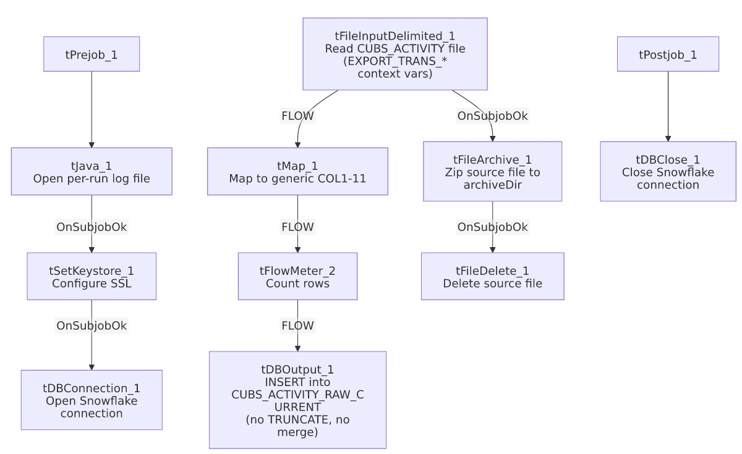

Settings tables

Source: `tFileInputDelimited_1`
Setting | Value | What it means
FILENAME | context.sourceDir + context.EXPORT_TRANS_File | The file path is built from EXPORT_TRANS_File, not an EXPORT_ACTIVITY_File-style variable — see Issues observed.
Main schema | Repository CUBS_ACTIVITY (11 columns: _LOGON, _DEBTOR, _DEBTOR_IDX, _ACTIVITY, _DATE, _TYPE, _DESCRIPTION, _AMOUNT, _MATCH_FLG, _NTC_FLG, _CUSTOM_DATE) | Correctly Activity-specific, unlike the surrounding context variables.
Reject schema | Repository CUBS_TRANSACTION | Mislabeled — a transaction schema used as the reject path for an activity file.
DIE_ON_ERROR / reject flow | false / not wired | Malformed rows don't fail the job but are silently dropped — no reject connection exists.
TEMP_DIR | "C:/Talend-Studio-20211109_1610-V8.0.1/workspace" | Hardcoded developer-workstation path — see Dependencies & configuration.

Target: `tDBOutput_1` (`tSnowflakeOutput`)
Setting | Value | What it means
Table | CUBS_ACTIVITY_RAW_CURRENT | Destination staging table.
Output action | INSERT | Appends rows; no TRUNCATE precedes it and no merge stored procedure follows it in this job.
Table action | NONE | Table is not recreated/altered.

Archive/Delete: `tFileArchive_1` / `tFileDelete_1`
Setting | Value | What it means
TARGET (tFileArchive_1) | context.archiveDir + "/" + <CCYYMMDD> + "/" + context.EXPORT_TRANS_File + ".tar.gz" | Archives under a date-stamped subfolder.
PASSWORD (tFileArchive_1) | ***REDACTED*** | Set but unused, since ENCRYPT_FILES=false.
Trigger | Off tFileInputDelimited_1's SUBJOB_OK, not off tDBOutput_1 | Archive+delete happens as soon as the file is read, before the Snowflake insert is confirmed — see Issues observed.

Dependencies & configuration
- Triggers/depends on other jobs: none — runjob_targets is empty, and this job does not appear as a tRunJob target in 06_dependency_matrix.md, so its trigger mechanism (standalone schedule vs. an undocumented caller) is not visible in this export.
- Context variables used: EXPORT_TRANS_Encoding, EXPORT_TRANS_FieldSeparator, EXPORT_TRANS_File, EXPORT_TRANS_Header, EXPORT_TRANS_RowSeparator, archiveDir, currentLogon, keystorePath, logDir, sourceDir.
- 5 hardcoded developer-workstation path findings: tFileInputDelimited_1.TEMP_DIR, tFileArchive_1.SOURCE_FILE, tFileDelete_1.DIRECTORY, tFileDelete_1.PATH (all C:/Talend-Studio-20211109_1610-V8.0.1/workspace/...), and tSetKeystore_1.SSL_TRUSTSERVER_TRUSTSTORE (C:/clientTrustStore.trustStore) — same project-wide risk documented in 05_operational_runbook.md.

Glossary
Component type | Plain-English meaning
tFileInputDelimited | Reads a delimited (CSV-style) text file according to a schema.
tMap | Maps/transforms columns from one schema to another.
tFlowMeter | Counts rows passing through a point in the flow, for logging/monitoring.
tSnowflakeOutput / tSnowflakeConnection / tSnowflakeClose | Write rows to a Snowflake table / open and close the shared Snowflake connection.
tFileArchive / tFileDelete | Zip a processed file to an archive location, then delete the original from the source directory.
tSetKeystore | Configures the SSL keystore/truststore used by subsequent secure connections.
tPrejob / tPostjob | Run once before/after the rest of the job.
tJava | Runs a block of custom Java code — here, opening a per-run log file.

Issues observed
- This job's context variables and file schema are all under the `EXPORT_TRANS_*` naming family (EXPORT_TRANS_File, EXPORT_TRANS_FieldSeparator, EXPORT_TRANS_Header, EXPORT_TRANS_RowSeparator, EXPORT_TRANS_Encoding) even though this is CUBS_Raw_Activity_Load, not a transaction load. This looks like it was copied from a Trans-load job template without renaming the context group reference. Whether EXPORT_TRANS_File is separately configured (via context override) to actually point at the activity export file is unable to be determined from this job's own metadata — verify directly in Talend Studio.
- The reject schema on `tFileInputDelimited_1` is labeled `CUBS_TRANSACTION`, not activity-specific. Same class of mislabeled-reject-schema issue seen elsewhere in this project (e.g. ADP_Payroll_Load's roster-labeled reject schema); unclear whether a malformed activity row would parse cleanly against a transaction-shaped schema.
- Archive and delete of the source file are triggered by the file read succeeding (`tFileInputDelimited_1` `SUBJOB_OK`), not by the Snowflake insert succeeding. A failure anywhere in tMap_1 → tFlowMeter_2 → tDBOutput_1 after a successful read would still result in the source file being archived and deleted, leaving no original file to reprocess if the Snowflake load actually failed.
- No `TRUNCATE` step and no merge call anywhere in this job, despite the target table being named CUBS_ACTIVITY_RAW_CURRENT. Every run appears to INSERT-append without ever clearing prior rows. Unable to confirm from this metadata whether deduplication/refresh happens elsewhere (e.g., a merge stored procedure invoked by a different job) or whether this table simply accumulates duplicate rows across runs.
- No `tDie`/`tWarn` logic — consistent with 05_operational_runbook.md's note that most jobs outside its list of 16 only surface failures as generic Talend execution errors.
- Column names in the raw source schema carry inconsistent leading underscores (_LOGON, _DEBTOR, etc.) and are renamed to generic COL1–COL11 by tMap_1, making it hard to trace what a given output column represents without cross-referencing this job's own schema definitions.

