Talend Job: CUBS_Raw_CHI_Client_Load

Overview
Loads CUBS client master records (agency/creditor client accounts — name, address, phone, statement/invoice frequency settings, commission/interest rate fields, and a long tail of site- and client-level flags such as CityOfChi, SCR_LTR_MIN/SCR_EML_MIN/SCR_TXT_MIN thresholds) for the CHI site from a delimited export file into the Snowflake CUBS_CLIENT_RAW_CURRENT staging table. It is structurally identical to CUBS_Raw_Activity_Load (same setup/teardown, same archive-then-delete pattern, same missing truncate/merge step) — the only thing distinguishing this job as CHI-specific is its name; nothing CHI-specific appears in its own component parameters. See Issues observed.

Detail table
Field | Value
Job name | CUBS_Raw_CHI_Client_Load
Version | 0.1
Project | EDW2SF
Author | jmach@harriscollect.com
Created | 2023-09-26T11:15:19.237-0700
Last Modified | 2025-11-04T11:08:08.583-0800

Step-by-step data flow
Setup subjob: tPrejob_1 → tJava_1 opens a per-run log file at context.logDir + context.currentLogon + "_" + jobName + <timestamp> + ".log" → on success, tSetKeystore_1 configures SSL trust/keystore from context.keystorePath (passwords redacted) → tDBConnection_1 opens the Snowflake connection.
Main subjob:
- tFileInputDelimited_1 reads context.sourceDir + context.EXPORT_CLIENT_File. Field separator, header flag, and encoding all correctly use the EXPORT_CLIENT_* context family (EXPORT_CLIENT_FieldSeparator, EXPORT_CLIENT_Header, EXPORT_CLIENT_Encoding, EXPORT_CLIENT_RowSeparator) — except `CSVROWSEPARATOR`, which is set to `context.EXPORT_TRANS_RowSeparator` instead of an EXPORT_CLIENT_* variable, a copy-paste inconsistency (see Issues observed; only relevant if CSV_OPTION is ever turned on — it is currently false, so ROWSEPARATOR, not CSVROWSEPARATOR, is the value actually applied). The main schema is labeled generically "metadata" in the repository (not a client-specific name), with ~165 client business columns (LOGON, CLIENT, CLIENT_IDX, NAME, ADD1/ADD2, CITY, ST, ZIP, rate/commission fields, statement/invoice settings, scoring thresholds, etc. — the extracted schema lists them twice, likely an artifact of how main+reject schema fields were captured together). Reject schema is labeled CUBS_TRANSACTION (same mislabeling pattern seen in CUBS_Raw_Activity_Load). TRIMALL=true here (vs. false in CUBS_Raw_Activity_Load) — all fields are whitespace-trimmed. DIE_ON_ERROR=false, with no reject flow wired.
- On FLOW, tMap_1 passes the row through to a generic output schema (FILENAME, FILEDATE, COL1–COL100+) — meaningful client column names are not preserved past this point.
- tFlowMeter_2 counts rows (label "MyLabel", not customized).
- tDBOutput_1 inserts the rows into Snowflake table CUBS_CLIENT_RAW_CURRENT (INSERT, tableAction=NONE) — no TRUNCATE step anywhere in this job and no merge call afterward, despite the _RAW_CURRENT table name.
- Separately, off tFileInputDelimited_1's own SUBJOB_OK (not the DB insert's success): tFileArchive_1 zips the source file to context.archiveDir + "/" + <date> + "/" + context.EXPORT_CLIENT_File + ".tar.gz" (password redacted, ENCRYPT_FILES=false), then on success tFileDelete_1 deletes the original source file.
Teardown subjob: tPostjob_1 → tDBClose_1 closes the Snowflake connection.
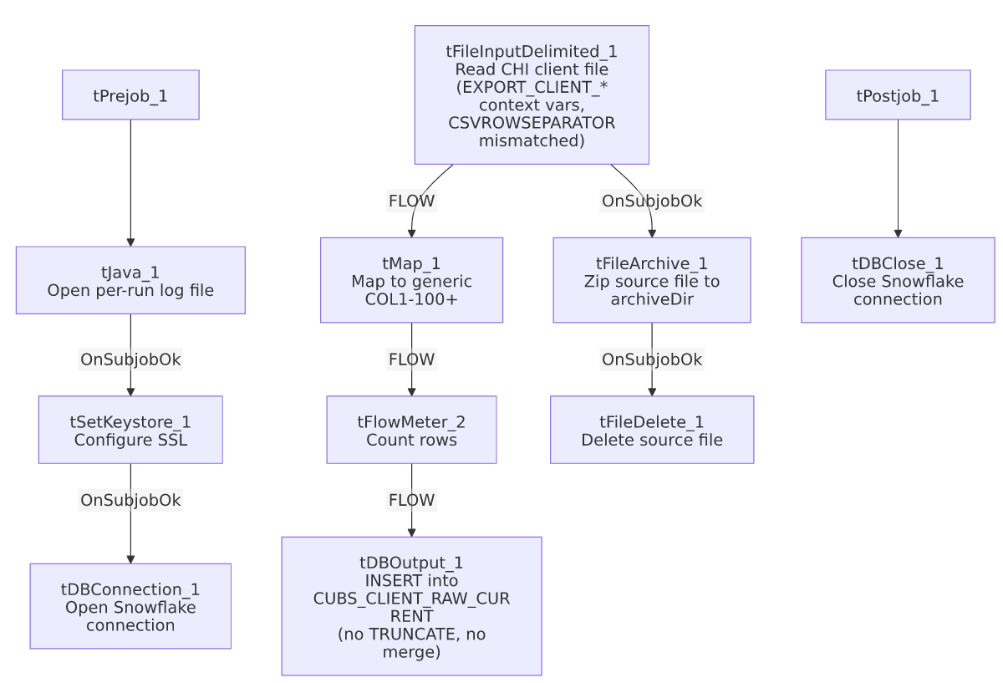

Settings tables

Source: `tFileInputDelimited_1`
Setting | Value | What it means
FILENAME | context.sourceDir + context.EXPORT_CLIENT_File | Path built from the correctly-scoped EXPORT_CLIENT_File variable.
ROWSEPARATOR / FIELDSEPARATOR / HEADER / ENCODING | context.EXPORT_CLIENT_RowSeparator / context.EXPORT_CLIENT_FieldSeparator / context.EXPORT_CLIENT_Header / context.EXPORT_CLIENT_Encoding | Correctly scoped to the CLIENT export context group.
CSVROWSEPARATOR | context.EXPORT_TRANS_RowSeparator | Mismatched — references the Trans export's row separator instead of EXPORT_CLIENT_RowSeparator; only takes effect if CSV_OPTION is enabled (currently false). See Issues observed.
TRIMALL | true | Differs from CUBS_Raw_Activity_Load (false) — all field values are trimmed of leading/trailing whitespace.
Main schema | Repository "metadata" (generic label, ~165 client columns) | Not a client-specific schema name in the repository, unlike CUBS_Raw_Activity_Load's correctly labeled CUBS_ACTIVITY schema.
Reject schema | Repository CUBS_TRANSACTION | Mislabeled, same issue class as CUBS_Raw_Activity_Load.
TEMP_DIR | "C:/Talend-Studio-20211109_1610-V8.0.1/workspace" | Hardcoded developer-workstation path.

Target: `tDBOutput_1` (`tSnowflakeOutput`)
Setting | Value | What it means
Table | CUBS_CLIENT_RAW_CURRENT | Destination staging table.
Output action | INSERT | Appends rows; no TRUNCATE precedes it and no merge stored procedure follows it.
Table action | NONE | Table is not recreated/altered.

Archive/Delete: `tFileArchive_1` / `tFileDelete_1`
Setting | Value | What it means
TARGET (tFileArchive_1) | context.archiveDir + "/" + <CCYYMMDD> + "/" + context.EXPORT_CLIENT_File + ".tar.gz" | Archives under a date-stamped subfolder.
Trigger | Off tFileInputDelimited_1's SUBJOB_OK, not off tDBOutput_1 | Archive+delete happens before the Snowflake insert is confirmed — see Issues observed.

Dependencies & configuration
- Triggers/depends on other jobs: none — runjob_targets is empty. This job also does not appear as a tRunJob target anywhere in 06_dependency_matrix.md. Notably, the Debtor and ETL per-site job families do have a generic dispatcher (CUBS_Raw_Debtor_Load → CUBS_Raw_CHI_Debtor_Load, etc.; CUBS_Raw_ETL_Load → CUBS_Raw_CHI_ETL_Load, etc.), but no equivalent generic CUBS_Raw_Client_Load dispatcher calling this job is present in this export — its actual trigger mechanism (standalone schedule vs. an undocumented caller) is unclear.
- Context variables used: EXPORT_CLIENT_Encoding, EXPORT_CLIENT_FieldSeparator, EXPORT_CLIENT_File, EXPORT_CLIENT_Header, EXPORT_CLIENT_RowSeparator, EXPORT_TRANS_RowSeparator (mismatched — see Issues observed), archiveDir, currentLogon, keystorePath, logDir, sourceDir.
- 5 hardcoded developer-workstation path findings: tFileInputDelimited_1.TEMP_DIR, tFileArchive_1.SOURCE_FILE, tFileDelete_1.DIRECTORY, tFileDelete_1.PATH (all C:/Talend-Studio-20211109_1610-V8.0.1/workspace/...), and tSetKeystore_1.SSL_TRUSTSERVER_TRUSTSTORE (C:/clientTrustStore.trustStore) — same project-wide pattern documented in 05_operational_runbook.md.

Glossary
Component type | Plain-English meaning
tFileInputDelimited | Reads a delimited (CSV-style) text file according to a schema.
tMap | Maps/transforms columns from one schema to another.
tFlowMeter | Counts rows passing through a point in the flow, for logging/monitoring.
tSnowflakeOutput / tSnowflakeConnection / tSnowflakeClose | Write rows to a Snowflake table / open and close the shared Snowflake connection.
tFileArchive / tFileDelete | Zip a processed file to an archive location, then delete the original from the source directory.
tSetKeystore | Configures the SSL keystore/truststore used by subsequent secure connections.
tPrejob / tPostjob | Run once before/after the rest of the job.
tJava | Runs a block of custom Java code — here, opening a per-run log file.

Issues observed
- `CSVROWSEPARATOR` on `tFileInputDelimited_1` references `context.EXPORT_TRANS_RowSeparator`, not an EXPORT_CLIENT_* variable, while every other separator/header/encoding setting on the same component is correctly scoped to EXPORT_CLIENT_*. This looks like a copy-paste leftover from a Trans-load template. It only matters if CSV_OPTION is ever switched on (it is currently false, so ROWSEPARATOR — which is correctly context.EXPORT_CLIENT_RowSeparator — is the value actually used); flagging it now so it doesn't silently misbehave if that setting changes later.
- The main input schema is labeled generically `"metadata"` in the repository, not a client-specific name, and the reject schema is labeled CUBS_TRANSACTION — the same mislabeled-reject-schema pattern seen in CUBS_Raw_Activity_Load and ADP_Payroll_Load. Unable to determine whether a rejected client row would parse cleanly against a transaction-shaped schema.
- Nothing in this job's own metadata (no hardcoded string, no site-specific parameter) actually identifies it as CHI-specific beyond the job name itself. The site-specific behavior must come entirely from a per-job context override (e.g., a CHI-specific value bound to context.sourceDir or context.EXPORT_CLIENT_File) that is not captured in this extraction — verify directly in Talend Studio's context settings for this job before assuming what differentiates it from its CO/DC/HH/PRE/TOL siblings (not in this batch).
- No visible caller. Unlike the Debtor and ETL per-site job families, which are each dispatched by a generic umbrella job (CUBS_Raw_Debtor_Load, CUBS_Raw_ETL_Load — see 06_dependency_matrix.md), there is no equivalent generic Client-load dispatcher calling CUBS_Raw_CHI_Client_Load in this export.
- Archive and delete of the source file are triggered by the file read succeeding, not by the Snowflake insert succeeding — same ordering risk as CUBS_Raw_Activity_Load: a downstream failure in tMap_1/tFlowMeter_2/tDBOutput_1 would still result in the source file being archived and deleted.
- No `TRUNCATE` step and no merge call anywhere in this job, despite the target table being named CUBS_CLIENT_RAW_CURRENT — same missing-refresh-step concern as CUBS_Raw_Activity_Load.

