Talend Job: CUBS_Raw_CHI_Debtor_Load

Overview
Loads raw debtor (collections-account) extract files for the "CHI" site out of a source directory into the Snowflake staging table CUBS_DEBTOR_RAW_CHI_CURRENT, then appends that batch into a shared cumulative table STAGING.CUBS_DEBTOR_RAW. The source rows carry debtor identity, address, phone, balance, legal/violation, and other collections-account fields from the legacy CUBS system, one file per iteration of tFileList_1. One field is passed through an encryption step before load (the specific column isn't named in this metadata — see Issues observed), and the target schema stores the data under fully generic COL1...COL500 column names rather than the original business names. This is one of (at least) five near-identical per-site siblings — CUBS_Raw_CHI_Debtor_Load, CUBS_Raw_CO_Debtor_Load, CUBS_Raw_DC_Debtor_Load, CUBS_Raw_HH_Debtor_Load, CUBS_Raw_PRE_Debtor_Load — all invoked once each by the orchestrator CUBS_Raw_Debtor_Load (see 06_dependency_matrix.md).

Detail table
Field | Value
Job name | CUBS_Raw_CHI_Debtor_Load
Version | 0.1
Project | EDW2SF
Author | jmach@harriscollect.com
Created | 2022-05-06T09:15:05.849-0700
Last Modified | 2022-06-13T14:33:19.755-0700

Step-by-step data flow
Setup subjob: tPrejob_1 →(OnComponentOk)→ tDBConnection_1 opens the job's Snowflake connection.
Main subjob (no explicit trigger link feeds tDBRow_1; it begins as soon as Talend's built-in prejob-then-everything-else ordering allows, i.e. after the setup subjob completes):
- tDBRow_1 runs TRUNCATE TABLE STAGING.CUBS_DEBTOR_RAW_CHI_CURRENT; against Snowflake, clearing the CHI-site staging table.
- On SUBJOB_OK, tFileList_1 lists files (non-recursive) in context.sourceRoot+context.currentLogon. An EXCLUDEFILEMASK of "*.txt" is configured but IFEXCLUDE=false, so the exclusion is not actually applied — every file in the directory is picked up, the same copy-paste pattern documented for ADP_Payroll_Load.
- For each file (ITERATE), tJava_3 sets context.currentFile from tFileList_1's current file path and prints "Processing file " + context.currentFile".
- ITERATE continues to tFileInputDelimited_1, which reads context.currentFile using the repository schema "CUBS-DEBTOR-CHI" (308 named debtor columns — name, address, phone, SSN, balance, legal/violation fields, etc.), with row/field separators, header flag, and encoding all driven by context.EXPORT_DEBTOR_* context variables. DIE_ON_ERROR=false. Its configured reject schema is the repository schema "CUBS_DEBTOR_HH" — a different site's schema than the one this job (CHI) reads — and, regardless, no connection wires the reject flow anywhere. See Issues observed.
- FLOW (link row1) to tDataEncrypt_1, which passes the same 308-column debtor schema through an encryption routine (PASSWORD_M1 and SECRET_TYPE both ***REDACTED***, ALGO_VERSION=2, crypto key file at context.cryptoPath). The extracted metadata shows only the full pass-through schema, not which specific column(s) are targeted for encryption — likely SSN given the schema, but that can't be confirmed from this metadata.
- FLOW (link row2) to tMap_1, which maps the (now partly encrypted) debtor row onto a fully generic 502-column target schema: FILENAME, FILEDATE, COL1 ... COL500. DIE_ON_ERROR=true, so a mapping/lookup failure here fails the job outright. The actual per-field mapping expressions (which named debtor column feeds which COLn) are not captured in this metadata — only the resulting column names are visible.
- FLOW (link CHI_DBTR — the only renamed link in this job; the others keep default row1/row2/row3 names) to tFlowMeter_3, which counts rows passing through (METTERLABEL="MyLabel", the unrenamed default, ABSOLUTE mode).
- FLOW (link row3) to tDBOutputBulkExec_1, which bulk-inserts (outputAction=INSERT, tableAction=NONE) the generic-column rows into Snowflake table CUBS_DEBTOR_RAW_CHI_CURRENT — the same table truncated in step 1.
- After tFileList_1 finishes iterating every file in the directory, SUBJOB_OK triggers tDBRow_2, which runs INSERT INTO STAGING.CUBS_DEBTOR_RAW SELECT * FROM STAGING.CUBS_DEBTOR_RAW_CHI_CURRENT; — appending this run's full CHI-site batch into the shared, cumulative CUBS_DEBTOR_RAW table.
Teardown subjob: tPostjob_1 →(OnComponentOk)→ tDBClose_1 closes the Snowflake connection.
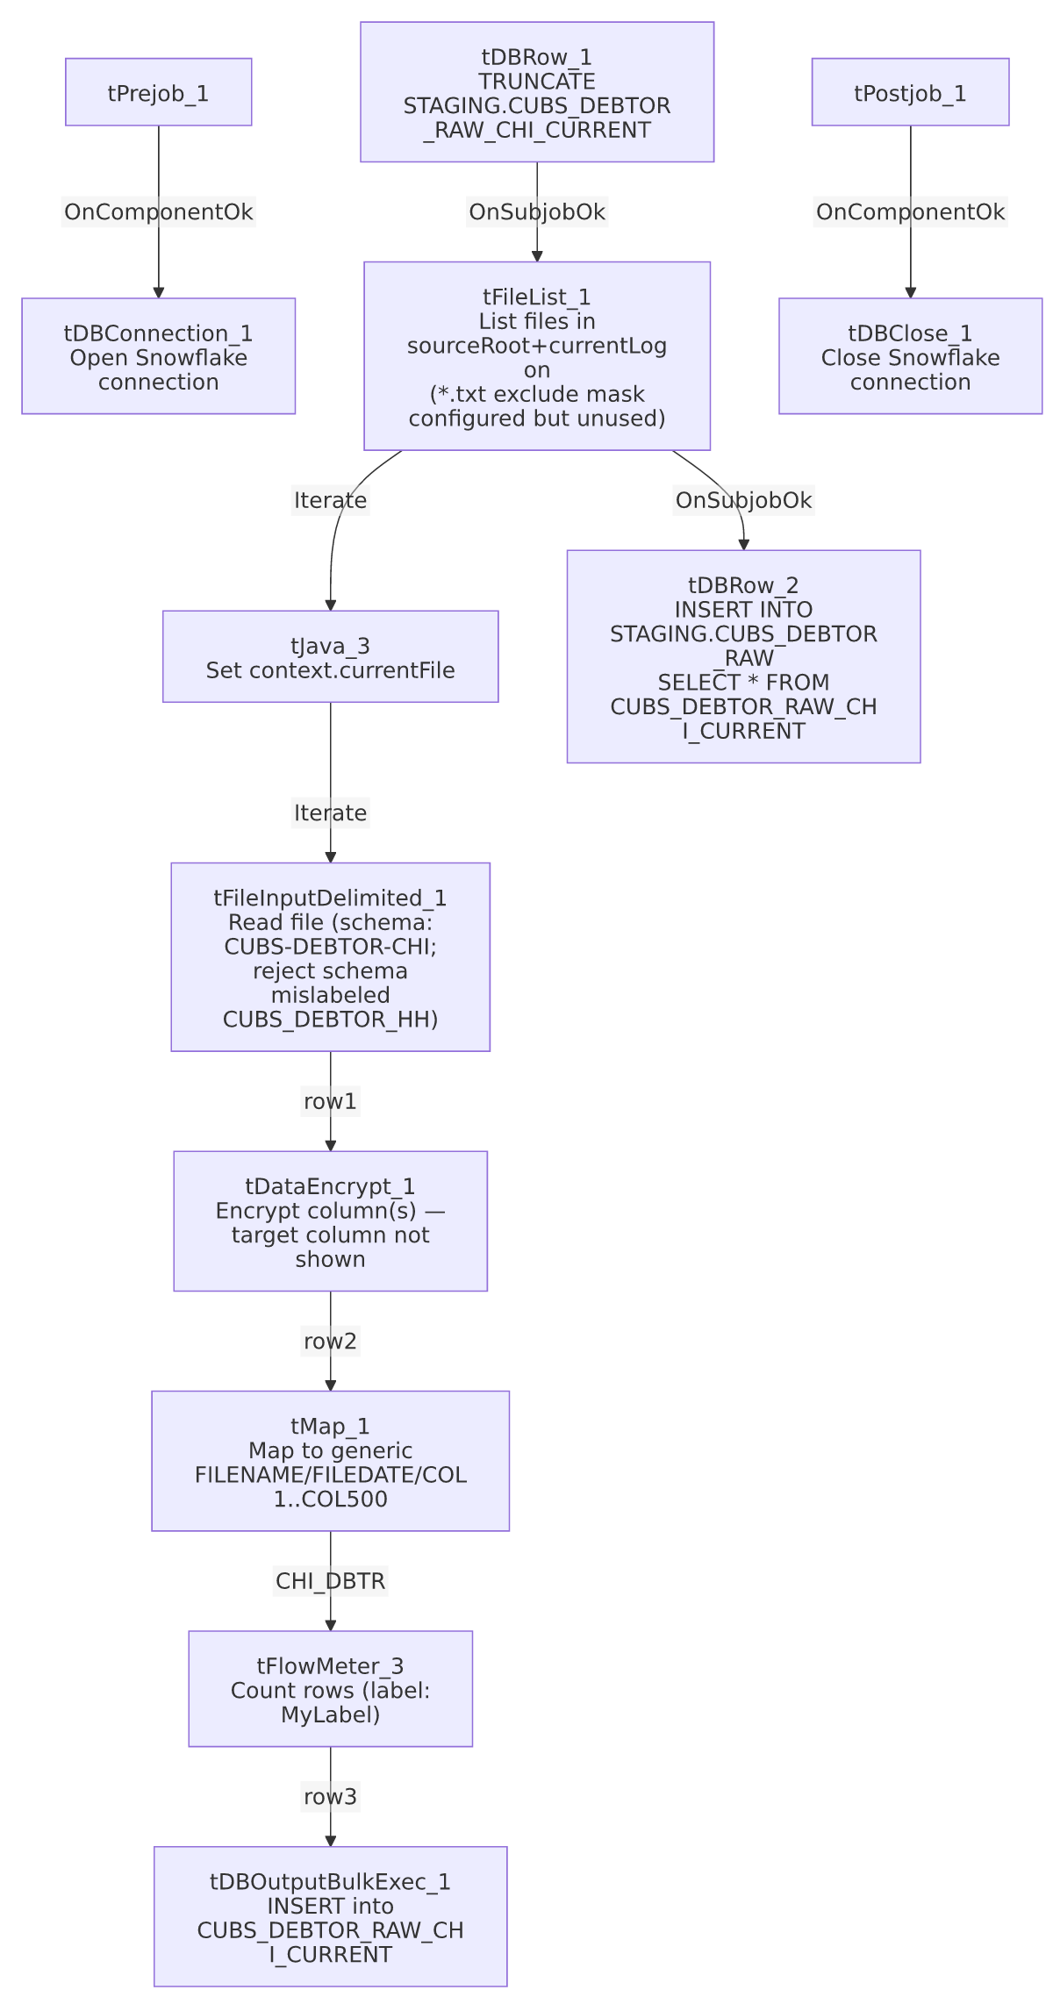

Settings tables

Source: `tFileList_1`
Setting | Value | What it means
DIRECTORY | context.sourceRoot+context.currentLogon | Directory scanned for debtor extract files; both variables are set outside this job (see Dependencies & configuration).
LIST_MODE | FILES | Lists files only, not subdirectories.
EXCLUDEFILEMASK / IFEXCLUDE | "*.txt" / false | The exclude mask is configured but IFEXCLUDE=false means it is never applied — every file in the directory is iterated, .txt or not.
CASE_SENSITIVE | YES | File name matching is case-sensitive (has no practical effect here since no mask is actually applied).

Source: `tFileInputDelimited_1`
Setting | Value | What it means
FILENAME | context.currentFile | The file currently being iterated by tFileList_1, set by tJava_3.
SCHEMA (main) | Repository schema "CUBS-DEBTOR-CHI" (308 columns) | The expected CHI-site debtor column layout (name, address, phone, DOB, SSN, balances, legal/violation fields, notice/letter tracking, etc.).
ROWSEPARATOR / FIELDSEPARATOR / HEADER / ENCODING | context.EXPORT_DEBTOR_RowSeparator / context.EXPORT_DEBTOR_FieldSeparator / context.EXPORT_DEBTOR_Header / context.EXPORT_DEBTOR_Encoding | Driven by the EXPORT_DEBTOR_0.1 context group (default values: \n, \t, header row present, US-ASCII) — see _shared_context.json. That group's EXPORT_DEBTOR_File default value is an HH-site path and is not referenced by this job, since the actual filename comes from context.currentFile instead.
SCHEMA_REJECT | Repository schema "CUBS_DEBTOR_HH" | Mislabeled for this job — this is the CHI debtor loader, but its reject schema points to the HH debtor schema. See Issues observed.
DIE_ON_ERROR | false | Malformed rows do not fail the job...
Reject flow | Not wired | ...but no connection carries rejected rows anywhere in this job — they are silently dropped with no record.
TEMP_DIR | "C:/Talend-Studio-20211109_1610-V8.0.1/workspace" | Hardcoded developer-workstation path — part of the 210/289-job project-wide pattern flagged in 05_operational_runbook.md.

Transform: `tDataEncrypt_1`
Setting | Value | What it means
PASSWORD_M1 | ***REDACTED*** | Encryption key/password — preserved as redacted; not guessable from metadata.
SECRET_TYPE | ***REDACTED*** | Encryption secret-type setting — also redacted in the source data.
CRYPTO_FILE_PATH | context.cryptoPath | Points to an external crypto key/config file; context.cryptoPath isn't defined in any context group visible in _shared_context.json — see Issues observed.
ALGO_VERSION | 2 | Encryption algorithm version used.
GEN_CRYPTO_FILE_CONTROLLER | false | Does not (re)generate the crypto controller file on this run.
Target column(s) | Not visible in metadata | The component's schema is a straight 308-column pass-through of the debtor schema; which specific column(s) it actually encrypts isn't captured by this extraction — verify directly in Talend Studio.

Transform: `tMap_1`
Setting | Value | What it means
DIE_ON_ERROR | true | A mapping or lookup failure here fails the job outright (unlike the earlier file-read step).
Output schema | FILENAME, FILEDATE, COL1...COL500 (502 columns) | The named/business debtor columns are mapped into fully generic column names. The mapping expressions themselves (which source field feeds which COLn) are not captured in this metadata.
ROWS_BUFFER_SIZE | 2000000 | tMap disk-mode buffer size setting; not evidence the job runs in disk mode, just the configured threshold.

Target: `tDBOutputBulkExec_1` (`tSnowflakeOutputBulkExec`)
Setting | Value | What it means
Table | CUBS_DEBTOR_RAW_CHI_CURRENT | Snowflake staging table for this run's CHI-site batch — the same table truncated by tDBRow_1 at job start.
outputAction | INSERT | Appends rows; relies on the prior TRUNCATE to avoid duplicate accumulation within a run.
tableAction | NONE | Table is not recreated/altered by this job.
Schema | FILENAME, FILEDATE, COL1...COL500, plus reject-flow error columns (columnName, rowNumber, category, character, errorMessage, byteOffset, line, sqlState, code) | The reject/error schema is defined on the component but, as with the file input above, no `REJECT` connection is wired — bulk-load rejects are not captured anywhere in this job. See Issues observed.

Truncate / append steps: `tDBRow_1` / `tDBRow_2` (`tSnowflakeRow`)
Setting | Value | What it means
Query 1 (tDBRow_1) | TRUNCATE TABLE STAGING.CUBS_DEBTOR_RAW_CHI_CURRENT; | Clears the CHI-site staging table before the file loop starts.
Query 2 (tDBRow_2) | INSERT INTO STAGING.CUBS_DEBTOR_RAW SELECT * FROM STAGING.CUBS_DEBTOR_RAW_CHI_CURRENT; | Appends this run's staged CHI batch into the shared, cumulative CUBS_DEBTOR_RAW table — no explicit dedup/merge logic is visible; every run's rows are simply appended.

Dependencies & configuration
- Called by: CUBS_Raw_Debtor_Load (once), per 06_dependency_matrix.md, alongside sibling calls to CUBS_Raw_CO_Debtor_Load, CUBS_Raw_DC_Debtor_Load, CUBS_Raw_HH_Debtor_Load, and CUBS_Raw_PRE_Debtor_Load. This job's own runjob_targets list is empty — it does not call any other jobs itself.
- Context variables used: EXPORT_DEBTOR_Encoding, EXPORT_DEBTOR_FieldSeparator, EXPORT_DEBTOR_Header, EXPORT_DEBTOR_RowSeparator (resolved via the EXPORT_DEBTOR_0.1 context group in _shared_context.json), cryptoPath, currentFile, currentLogon, sourceRoot. `sourceRoot` and `currentLogon` do not appear in any context group in `_shared_context.json`, and cryptoPath doesn't match any variable there either (the closest name, crytographicFilePath, is spelled differently and lives in a different context group) — these are presumably set by the calling orchestrator (CUBS_Raw_Debtor_Load) or a CUBS-specific context group not captured in this extraction. Unable to determine from this job's own metadata — verify with team.
- Hardcoded path: tFileInputDelimited_1.TEMP_DIR = "C:/Talend-Studio-20211109_1610-V8.0.1/workspace" — part of the project-wide pattern (210 of 289 jobs) documented in 05_operational_runbook.md.

Glossary
Component type | Plain-English meaning
tFileList | Lists files in a directory for the job to iterate over one at a time.
tFileInputDelimited | Reads a delimited (CSV-style) text file according to a schema.
tDataEncrypt | Encrypts one or more fields of a row using a configured algorithm/key before it continues downstream.
tMap | Maps/transforms columns from one schema to another.
tFlowMeter | Counts rows passing through a point in the flow, for logging/monitoring.
tSnowflakeOutputBulkExec | Bulk-loads rows into a Snowflake table (higher-throughput variant of a plain tSnowflakeOutput).
tSnowflakeRow | Runs an arbitrary SQL statement against Snowflake (here, TRUNCATE and a plain INSERT ... SELECT).
tSnowflakeConnection / tSnowflakeClose | Open and close the Snowflake connection shared by other components in the job.
tJava | Runs a block of custom Java code once (here, to capture the current file path into a context variable and log it).

Issues observed
- The reject schema on `tFileInputDelimited_1` is labeled for a different site. This is the CHI debtor loader, reading the "CUBS-DEBTOR-CHI" main schema, but its SCHEMA_REJECT points to the repository schema "CUBS_DEBTOR_HH". This looks like a copy-paste artifact from an HH-site sibling job that wasn't fully repointed when this CHI variant was created — the same class of mislabeling documented for ADP_Payroll_Load's payroll/roster reject schema mismatch. Whether this would cause an actual column-count/type mismatch if the reject flow were ever wired depends on how similar the CHI and HH debtor schemas are — unable to determine from this metadata.
- No reject flow is wired anywhere in this job — neither from tFileInputDelimited_1 (DIE_ON_ERROR=false, so malformed rows don't fail the job but are silently dropped) nor from tDBOutputBulkExec_1 (which has a defined error-info schema — columnName, rowNumber, category, errorMessage, sqlState, code, etc. — but no REJECT connection routing rows to it). A parsing or bulk-load failure on individual rows leaves no record of how many rows, or which ones, were skipped.
- `tFileList_1`'s exclude mask is configured but never applied. EXCLUDEFILEMASK="*.txt" with IFEXCLUDE=false means every file in context.sourceRoot+context.currentLogon is picked up regardless of extension — the same non-functional-exclude pattern seen in ADP_Payroll_Load, suggesting a shared job template across the project rather than a one-off mistake.
- The final target schema uses fully generic `COL1`...`COL500` column names rather than the 308 named business columns read from the source file. The actual field-to-COLn mapping performed inside tMap_1 is not captured in this extraction (only column names are visible on both sides) — anyone querying CUBS_DEBTOR_RAW_CHI_CURRENT or STAGING.CUBS_DEBTOR_RAW downstream would need to open tMap_1 directly in Talend Studio to know what a given COLn actually contains. This is a materially higher documentation risk than the named-column pattern used in jobs like ADP_Payroll_Load.
- `tDataEncrypt_1`'s target column(s) aren't identifiable from metadata. The component carries the full 308-column debtor schema as a pass-through; without the underlying column-level encryption configuration (not part of this extraction), it's not possible to confirm which field (most likely SSN, given the schema) is actually being encrypted, or whether any others are. Verify directly in Talend Studio.
- `context.sourceRoot`, `context.currentLogon`, and `context.cryptoPath` are not defined in any context group present in `_shared_context.json`. They are presumably supplied by the calling orchestrator (CUBS_Raw_Debtor_Load) or by a CUBS-specific context group outside this extraction's scope, but that can't be confirmed from this job's own metadata — verify with the team, particularly for cryptoPath, since an unresolved encryption key path would fail the job at tDataEncrypt_1.
- `tDBRow_2`'s append into `STAGING.CUBS_DEBTOR_RAW` has no visible dedup/merge logic — it's a plain INSERT ... SELECT * from the just-loaded current-batch table. Since CUBS_DEBTOR_RAW_CHI_CURRENT itself is truncated and reloaded each run, re-running this job is likely safe with respect to the *_CURRENT table, but whether STAGING.CUBS_DEBTOR_RAW (the cumulative table) can end up with duplicate CHI-site rows across reruns is unable to determine from metadata — verify with the team before assuming a simple rerun is safe if a prior run partially completed.

