Talend Job: CUBS_Raw_CHI_ETL_Load

Overview
Loads CUBS "ETL" per-debtor scoring and attribute records (Attune/propensity scores, deciles/percentiles, bankruptcy-disposition flags, and revolving/installment/auto/mortgage/lease balance and credit-line fields) for the CHI site from tab-delimited files dropped in context.sourceDir into the Snowflake CUBS_ETL_RAW_CURRENT staging table. Unlike the single-file CUBS_Raw_*_Client_Load jobs, this job loops over every file currently sitting in the source directory (via tFileList), so it can process a batch of files in one run, then runs a second, separate pass over the same directory to delete whatever files are still there. It is one of the per-site jobs dispatched by the generic CUBS_Raw_ETL_Load job (see 06_dependency_matrix.md).

Detail table
Field | Value
Job name | CUBS_Raw_CHI_ETL_Load
Version | 0.1
Project | EDW2SF
Author | jmach@harriscollect.com
Created | 2022-12-15T10:12:24.866-0800
Last Modified | 2025-11-11T22:54:21.810-0800

Step-by-step data flow
Setup subjob: tPrejob_1 → tJava_1 opens a per-run log file at context.logDir + jobName + "_" + <timestamp> + ".log" (note: unlike sibling jobs' tJava_1, this filename does not include context.currentLogon) → on SUBJOB_OK, tSetKeystore_1 configures SSL trust/keystore from context.keystorePath (passwords redacted) → on SUBJOB_OK, tDBConnection_1 opens the Snowflake connection. There is no `tPostjob`/`tDBClose` anywhere in this job — see Issues observed.
Main subjob — pass 1 (load, one file at a time):
- tFileList_1 lists files in context.sourceDir, ordered by modified date ascending (EXCLUDEFILEMASK="*.txt" is configured but IFEXCLUDE=false, so the exclusion is not actually applied — every file is picked up, same non-functional-exclude pattern as ADP_Payroll_Load).
- For each file (ITERATE), tJava_2 sets context.currentFile/context.fileName/context.filePath from the current iteration.
- tFileInputDelimited_1 reads context.currentFile (tab-delimited, header row present, ISO-8859-15 encoding, repository schema labeled "chi_etl" — correctly named for this job, unlike the generic "metadata" label seen on the sibling client-load jobs). DIE_ON_ERROR=false, and no reject flow is wired.
- tMap_1 maps the ~63 named business columns (LOGON, DEBTOR, DEBTOR_IDX, dollar/score/date attribute fields, bankruptcy disposition flags, balance/credit-line fields, Attune_Score, Propen_Score, Decile, Percentile, Dialer_group, etc.) to a generic output schema of FILENAME, FILEDATE, COL1…COL80 — the meaningful column names are not preserved past this point.
- tFlowMeter_2 counts rows passing through (label "MyLabel", not customized for this job).
- tDBOutput_1 inserts the rows into Snowflake table CUBS_ETL_RAW_CURRENT (INSERT, tableAction=NONE — no TRUNCATE step anywhere in this job despite the _RAW_CURRENT table name).
- On tDBOutput_1's COMPONENT_OK, tFileArchive_1 archives context.filePath (the current file) to context.archiveDir + "/" + <CCYYMMDD> + "/" + context.fileName + ".tar.gz" (password redacted, per-file, inside the same loop iteration).
Main subjob — pass 2 (delete, after pass 1 has iterated every file): once tFileList_1's loop finishes (SUBJOB_OK), tFileList_2 re-lists `context.sourceDir` independently → ITERATE → tJava_3 sets context.currentFile/fileName/filePath again → ITERATE → tFileDelete_1 deletes context.currentFile → on COMPONENT_OK, tJava_4 logs the delete status/error message. See Issues observed regarding this second, independent directory listing.
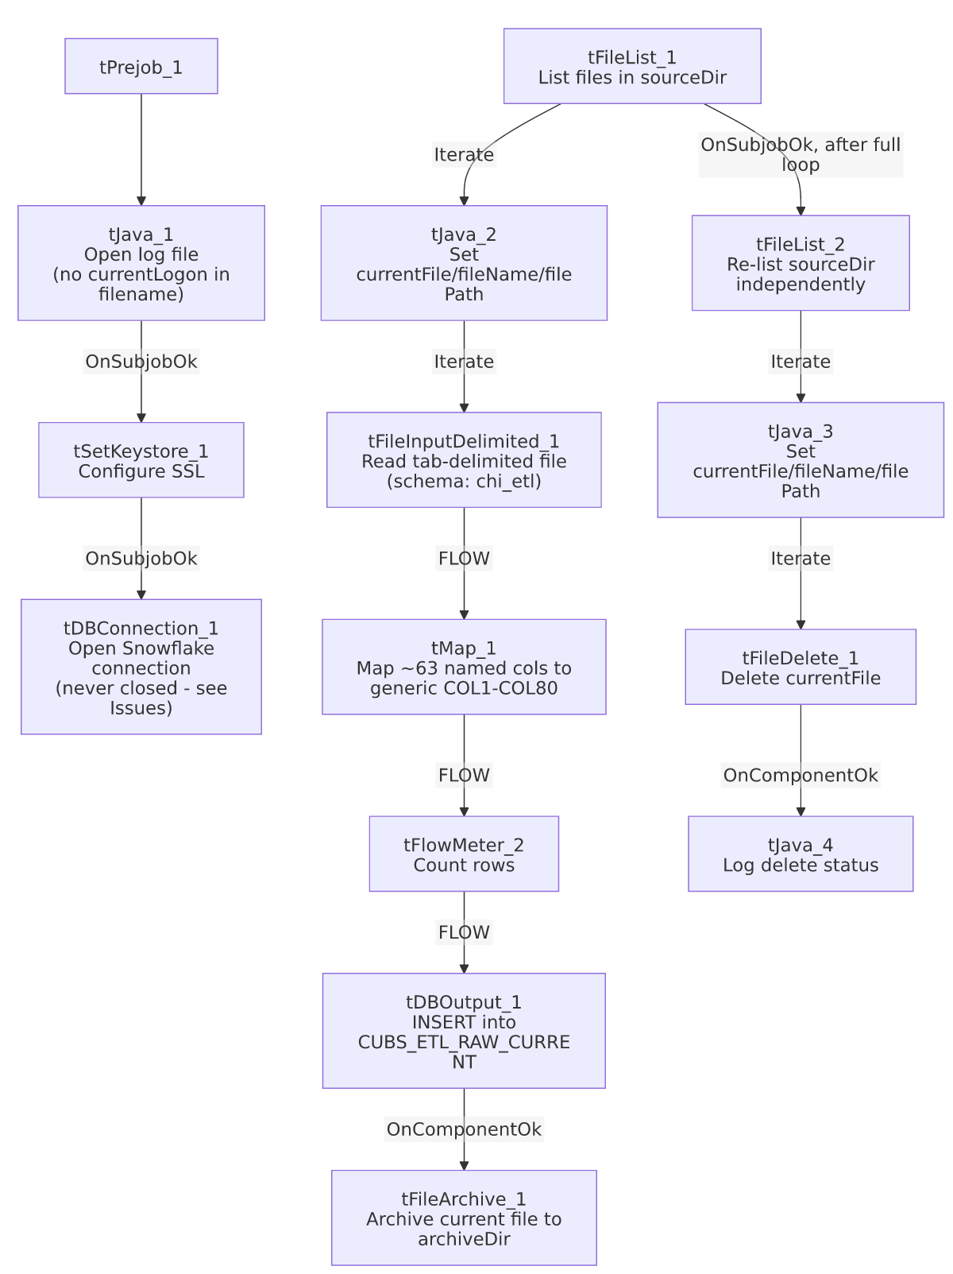

Settings tables

Source loop: `tFileList_1` / `tFileList_2`
Setting | Value | What it means
DIRECTORY | context.sourceDir (both) | Same directory listed twice, independently, in two separate passes.
ORDER_BY_MODIFIEDDATE / ASC | true / true | Processes (and later deletes) the oldest files first.
EXCLUDEFILEMASK / IFEXCLUDE | "*.txt" / false | Exclusion configured but not applied — every file in the directory is picked up by both passes.

Read: `tFileInputDelimited_1`
Setting | Value | What it means
FILENAME | context.currentFile | The file currently being iterated by tFileList_1/tJava_2.
FIELDSEPARATOR / ROWSEPARATOR / HEADER | "\t" / "\n" / 1 | Tab-delimited, one header row.
ENCODING | ISO-8859-15 | Fixed (not context-driven, unlike the client-load siblings' context.EXPORT_CLIENT_Encoding).
SCHEMA | Repository "chi_etl" (~63 business columns) | Correctly named for this job — LOGON/DEBTOR identifiers, scoring outputs, and balance/credit-line attribute fields.
DIE_ON_ERROR / reject flow | false / not wired | Malformed rows do not fail the job and are silently dropped (no reject file, log, or table).
TEMP_DIR | "C:/Talend-Studio-20211109_1610-V8.0.1/workspace" | Hardcoded developer-workstation path.

Transform: `tMap_1`
Setting | Value | What it means
Output schema | FILENAME, FILEDATE, COL1–COL80 (82 columns) | All 63 named source columns are flattened into generic positional columns — meaningful field names (Attune_Score, Dialer_group, etc.) are lost past this point; recovering them requires a separate column-position mapping.
DIE_ON_ERROR | true | A mapping/lookup failure here fails the job outright.

Target: `tDBOutput_1` (`tSnowflakeOutput`)
Setting | Value | What it means
Table | CUBS_ETL_RAW_CURRENT | Destination staging table.
Output action / Table action | INSERT / NONE | Appends rows; table is not truncated or recreated by this job.
Schema width | 91 columns (82 from tMap_1 + 9 Snowflake reject-metadata columns: columnName, rowNumber, category, character, errorMessage, byteOffset, line, sqlState, code) | The extra 9 columns are Snowflake-output reject/error metadata fields captured alongside the main schema.

Archive / Delete: `tFileArchive_1` / `tFileDelete_1`
Setting | Value | What it means
SOURCE / TARGET (tFileArchive_1) | context.filePath / context.archiveDir + "/" + <CCYYMMDD> + "/" + context.fileName + ".tar.gz" | Archives the just-loaded file under a date-stamped subfolder; PASSWORD is set (***REDACTED***) but ENCRYPT_FILES=false, so the password isn't actually applied to the archive.
FILENAME (tFileDelete_1) | context.currentFile | The value actually used to identify what to delete — takes precedence over the component's own DIRECTORY/PATH fields.
DIRECTORY / PATH (tFileDelete_1) | "C:/Talend-Studio-20211109_1610-V8.0.1/workspace/delete_folder" / "...delete_folder or delete_file" | Hardcoded developer-workstation defaults left in place; not actually used since FILENAME drives the delete.

`tSetKeystore_1`
Setting | Value | What it means
SSL_KEYSTORE | context.keystorePath | Context-driven keystore location.
SSL_TRUSTSERVER_TRUSTSTORE | "C:/clientTrustStore.trustStore" | Hardcoded developer-workstation path.
SSL_TRUSTSERVER_PASSWORD / SSL_KEYSTORE_PASSWORD / NEED_CLIENT_AUTH | ***REDACTED*** (all) | Preserved as redacted — not guessed here.

Dependencies & configuration
- Called by: CUBS_Raw_ETL_Load, the generic per-site ETL dispatcher (1 call — see 06_dependency_matrix.md, alongside its CO, DC, and HH siblings).
- Calls no other jobs — runjob_targets is empty.
- Context variables used: archiveDir, currentFile, fileName, filePath, keystorePath, logDir, sourceDir.
- 5 hardcoded developer-workstation path findings (tFileInputDelimited_1.TEMP_DIR, tFileArchive_1.SOURCE_FILE, tFileDelete_1.DIRECTORY/PATH, tSetKeystore_1.SSL_TRUSTSERVER_TRUSTSTORE) — same project-wide pattern documented in 05_operational_runbook.md (210 of 289 jobs).

Glossary
Component type | Plain-English meaning
tFileList | Lists files in a directory for the job to iterate over one at a time.
tFileInputDelimited | Reads a delimited (CSV/TSV-style) text file according to a schema.
tMap | Maps/transforms columns from one schema to another.
tFlowMeter | Counts rows passing through a point in the flow, for logging/monitoring.
tSnowflakeOutput / tSnowflakeConnection | Write rows to a Snowflake table / open the shared Snowflake connection used by the job.
tFileArchive / tFileDelete | Zip a processed file to an archive location / delete a file from disk.
tSetKeystore | Configures the SSL keystore/truststore used by the job's secure connections.
tPrejob / tJava | Run once before the rest of the job / run a block of custom Java code.

Issues observed
- No `tPostjob`/`tDBClose` anywhere in this job's metadata. Every other job examined in this batch (and the reference docs) explicitly closes its Snowflake connection in a teardown subjob; here, tDBConnection_1 is opened in the setup subjob and never explicitly closed within this job. This may be relied upon (e.g., independent-process JVM teardown implicitly releasing the connection), or it may be a genuine gap — unable to determine from metadata; verify with the team.
- Pass 2's file list is independent of what pass 1 actually loaded. tFileList_2 re-lists context.sourceDir fresh rather than deleting specifically the files that were just archived in pass 1. If a new file lands in sourceDir after pass 1 starts but before pass 2 runs, tFileDelete_1 could delete it before it is ever read by tFileInputDelimited_1 — there is no visible guard against this race condition in the job's own metadata.
- `EXCLUDEFILEMASK="*.txt"` is configured but inert (IFEXCLUDE=false) on both tFileList_1 and tFileList_2 — same non-functional-exclude-mask pattern seen in ADP_Payroll_Load's tFileList_1.
- No reject flow wired on `tFileInputDelimited_1` (DIE_ON_ERROR=false) — malformed rows are silently dropped with no record of how many or which ones failed to parse.
- Named business columns do not survive past `tMap_1`. CUBS_ETL_RAW_CURRENT only stores generic COL1–COL80 positional columns, so interpreting any given column in that table requires an external mapping back to this job's tMap_1 configuration (not itself queryable from the warehouse) — same generic-positional-column pattern used by the sibling CUBS_Raw_*_Client_Load jobs.
- `tJava_1`'s log filename omits `context.currentLogon`, unlike the equivalent tJava_1/tJava_2 setup step in the client-load siblings (context.logDir + context.currentLogon + "_" + jobName + ...). Not a functional issue since a valid filename is still produced, but it's a naming inconsistency across otherwise-similar per-site job templates.

