Talend Job: CUBS_Raw_CO_Debtor_Load_No_Delete

Overview
This job loads CUBS debtor extract files for the CO site code into Snowflake: it lists every file sitting in context.sourceRoot, reads each one as a delimited file against a repository schema labeled "CUBS-DEBTOR-CO", encrypts one or more fields with tDataEncrypt, maps the result through tMap, and writes it to a Snowflake table via tSnowflakeOutput, then runs a Snowflake stored-procedure/SQL call after all files are processed (presumably a merge from staging into the target debtor table, though the exact SQL text isn't captured in this job's own metadata). It is one of three CO-debtor-load variants in this project (the plain CUBS_Raw_CO_Debtor_Load and CUBS_Raw_CO_Debtor_Load_Upsert); as detailed below, this variant is distinguished not by its main load logic but by which post-load housekeeping steps are switched off.

Detail table
Field | Value
Job name | CUBS_Raw_CO_Debtor_Load_No_Delete
Version | 0.4
Project | EDW2SF
Author | jmach@harriscollect.com
Created | 2022-12-06T12:04:35.276-0800
Last Modified | 2025-09-24T11:08:31.455-0700

Step-by-step data flow
Setup subjob: tPrejob_1 → tJava_4 opens a per-run log file at context.logDir + context.currentLogon + "_" + jobName + "_" + <timestamp> + ".log" and redirects System.out to it (code truncated at 253 characters in this extraction, so the full body — e.g. whether System.err is also redirected — can't be confirmed) → on success, tDBConnection_1 opens the job's Snowflake connection (component has no captured parameters, so the connection label/target it's wired to is unable to determine from metadata — see Issues observed).
Main subjob — begins independently of the setup subjob (no incoming trigger to tDBRow_1 is captured in this job's connection list):
- tDBRow_1 runs a Snowflake SQL statement (text not captured — parameters are empty in this job's metadata; based on the project-wide truncate-then-reload pattern documented in 05_operational_runbook.md, this is likely a staging-table truncate, but that is not confirmed here).
- On success (OnSubjobOk), tFileList_1 lists every file in context.sourceRoot (see Settings table — its exclude-mask setting is effectively inert).
- tFileList_1 iterates into tJava_3, which copies the current file's path/name/directory from globalMap into context.currentFile, context.fileName, and context.filePath (code also truncated at 253 characters).
- tJava_3 iterates into tFileInputDelimited_1, which reads context.currentFile as a delimited file using the "CUBS-DEBTOR-CO" repository schema.
- Each row flows (FLOW) into tDataEncrypt_1, which encrypts data using an AES cipher keyed from context.cryptoPath (secret type, secret key, and password all redacted in the source metadata).
- tDataEncrypt_1 flows into tMap_1 (no field-level mapping expressions were captured in this metadata, only its engine settings).
- tMap_1's output (connector labeled CO_DBTR) flows into tFlowMeter_3, which counts rows passing through (still using the generic default label "MyLabel").
- tFlowMeter_3 flows into tDBOutput_1 (tSnowflakeOutput), which writes the rows to a Snowflake table (component has no captured parameters — target table name, schema, and load action are unable to determine from metadata).
- On success, tDBOutput_1 would trigger tFileArchive_1 to tar/gzip the just-loaded file into context.archiveDir — but `tFileArchive_1` is deactivated (`ACTIVATE=false`), so this step does not actually run (see Issues observed).
- Once the whole tFileList_1 iteration completes, tFileList_1 also triggers (OnSubjobOk, in parallel with the per-file loop above) tDBRow_2, a second Snowflake SQL call (text not captured) — by project convention this is likely the merge step following the load.
- tDBRow_2 would, on success, re-list context.sourceRoot (tFileList_2) and iterate into tJava_2 → tFileDelete_1 (deleting each processed file) → tJava_1 (logs the delete result) — but all four of these components (`tFileList_2`, `tJava_2`, `tFileDelete_1`, `tJava_1`) are deactivated (`ACTIVATE=false`), so no file deletion actually happens. This is the behavior the job's name refers to.
Teardown subjob: tPostjob_1 → tDBClose_1 closes the Snowflake connection.
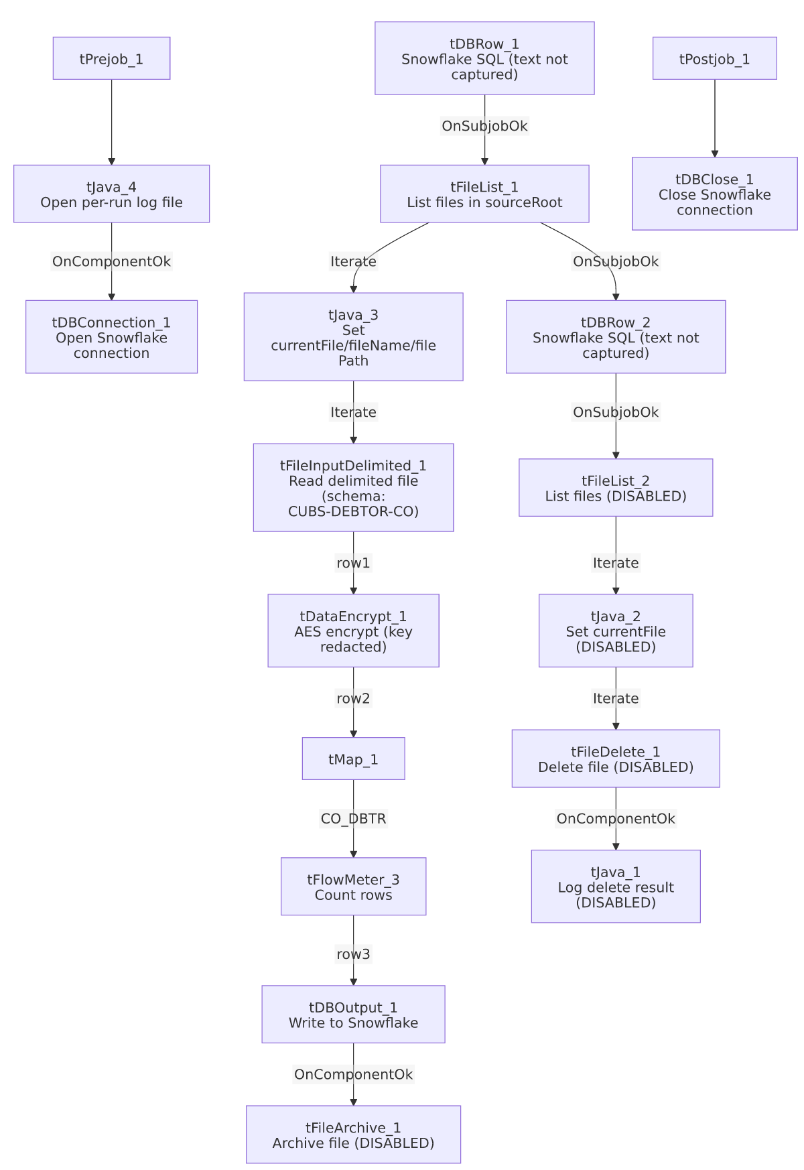

Settings tables

Source listing: `tFileList_1`
Setting | Value | What it means
DIRECTORY | context.sourceRoot | Directory scanned for input files each run.
LIST_MODE | FILES | Lists files only (no subdirectories).
INCLUDSUBDIR | false | Does not recurse into subfolders.
EXCLUDEFILEMASK / IFEXCLUDE | "*.txt" / false | An exclude mask of *.txt is configured, but IFEXCLUDE=false means it is not actually applied — every file in sourceRoot is listed regardless of extension.
GLOBEXPRESSIONS | true | Uses glob-style (not regex) matching for any active mask.

Read: `tFileInputDelimited_1`
Setting | Value | What it means
FILENAME | context.currentFile | Reads whichever file tJava_3 just set from the current tFileList_1 iteration.
SCHEMA (main) | Repository schema "CUBS-DEBTOR-CO" | Well-formed rows are parsed against a CO-specific debtor schema.
SCHEMA_REJECT | Repository schema "CUBS_DEBTOR_HH" | Mismatched — this is a CO-site job but its reject schema is labeled for HH. See Issues observed.
FIELDSEPARATOR / ROWSEPARATOR / HEADER / ENCODING | context.EXPORT_DEBTOR_FieldSeparator / context.EXPORT_DEBTOR_RowSeparator / context.EXPORT_DEBTOR_Header / context.EXPORT_DEBTOR_Encoding | Format settings driven by the shared EXPORT_DEBTOR context group rather than hardcoded per-site values.
DIE_ON_ERROR | false | A malformed row does not abort the job; it is expected to be routed to the (mislabeled) reject flow, though no reject-row connection appears in this job's own connections list — unable to confirm a reject output is actually wired.
TEMP_DIR | "C:/Talend-Studio-20211109_1610-V8.0.1/workspace" | Hardcoded developer-workstation path — same project-wide pattern flagged in 05_operational_runbook.md (210 of 289 jobs).

Field-level encryption: `tDataEncrypt_1`
Setting | Value | What it means
CRYPTO_METHOD | AES | Symmetric encryption applied to one or more fields (which fields is defined in the component's internal mapping, not captured in this metadata).
SECRET_TYPE / SECRET_KEY / PASSWORD_M1 | ***REDACTED*** (all three) | Preserved as redacted — do not guess the real values.
CRYPTO_FILE_PATH | context.cryptoPath | Path to a supporting cryptographic file; cryptoPath is not defined in _shared_context.json's captured context groups, so its actual default value is unable to determine from metadata.
ALGO_VERSION | 2 | Encryption algorithm version used by the component.

Transform: `tMap_1`
Setting | Value | What it means
DIE_ON_ERROR | true | A mapping error fails the job outright (unlike the upstream file read, which is configured to tolerate errors).
ROWS_BUFFER_SIZE | 2000000 | Buffer size for large in-memory joins/lookups, if any are configured (no lookup inputs are visible in this job's component list).
Output row name | CO_DBTR | The mapped output flow is explicitly named for the CO debtor data, consistent with the job's purpose.

Load: `tDBOutput_1` (tSnowflakeOutput)
Setting | Value | What it means
(all) | Not captured — parameters are empty in this job's metadata | Target table name, schema, and load action (insert/update/upsert) are unable to determine from metadata; verify directly in Talend Studio or the Snowflake target.

Post-load housekeeping (both disabled): `tFileArchive_1`, `tFileList_2` → `tJava_2` → `tFileDelete_1` → `tJava_1`
Setting | Value | What it means
tFileArchive_1: ACTIVATE | false | Archiving the source file to context.archiveDir + "/" + <date> + "/" + context.fileName + ".tar.gz" is configured but does not run.
tFileArchive_1: SOURCE_FILE | "C:/Talend-Studio-20211109_1610-V8.0.1/workspace/source.csv" | Hardcoded developer-workstation path (component disabled, so not actually reached at runtime, but still present as dead configuration).
tFileDelete_1: ACTIVATE | false | Deleting the processed source file does not run — this is the behavior the job name refers to.
tFileDelete_1: DIRECTORY / PATH | "C:/Talend-Studio-20211109_1610-V8.0.1/workspace/delete_folder" / "...delete_folder or delete_file" | Hardcoded developer-workstation paths (also dead configuration since the component is disabled).

Merge/post steps: `tDBRow_1`, `tDBRow_2` (tSnowflakeRow)
Setting | Value | What it means
(all) | Not captured — parameters are empty in this job's metadata | The actual SQL/stored-procedure text run before and after the file-load loop is unable to determine from metadata; verify directly in Talend Studio.

Dependencies & configuration
- `runjob_targets` is empty — this job does not call any other Talend job.
- No job in `06_dependency_matrix.md` lists `CUBS_Raw_CO_Debtor_Load_No_Delete` as a `tRunJob` target. The matrix shows CO_Master_Load and CUBS_Raw_Debtor_Load both calling the *plain* CUBS_Raw_CO_Debtor_Load instead. This job therefore appears to be an orphan in the extracted orchestration graph — likely a manually-triggered variant for ad hoc/backfill runs rather than part of the scheduled pipeline. See Issues observed.
- Context variables referenced: EXPORT_DEBTOR_Encoding, EXPORT_DEBTOR_FieldSeparator, EXPORT_DEBTOR_Header, EXPORT_DEBTOR_RowSeparator (from the shared EXPORT_DEBTOR context group), archiveDir, cryptoPath, currentFile, currentLogon, fileName, filePath, logDir, sourceRoot. Of these, archiveDir, cryptoPath, currentLogon, fileName, filePath, logDir, and sourceRoot do not appear in any context group captured in _shared_context.json — their default values are unable to determine from metadata.
- Hardcoded paths found (4, all pointing at a developer workstation path): tFileInputDelimited_1.TEMP_DIR, tFileArchive_1.SOURCE_FILE, tFileDelete_1.DIRECTORY, tFileDelete_1.PATH — all C:/Talend-Studio-20211109_1610-V8.0.1/workspace/..., matching the project-wide pattern in 05_operational_runbook.md. The latter three sit inside components that are currently disabled, so they are dormant risk rather than active risk, unless someone re-enables archiving/deletion without updating these paths first.

Glossary
Component type | Plain-English meaning
tPrejob / tPostjob | Marks the setup/teardown subjobs that run once regardless of the main flow's outcome.
tDBConnection / tDBClose (Snowflake) | Opens/closes the Snowflake connection used throughout the job.
tDBRow (Snowflake) | Runs an arbitrary SQL statement or stored-procedure call against Snowflake.
tFileList | Lists files in a directory matching (optional) include/exclude criteria, for iteration.
tJava | Runs arbitrary Java code — here used to copy tFileList iteration variables into context variables, or to write log output.
tFileInputDelimited | Reads a delimited (e.g. CSV/TSV) file against a defined schema.
tDataEncrypt | Encrypts one or more fields in the data flow using a configured cipher and key.
tMap | Transforms/maps input columns to output columns, optionally joining against lookup flows.
tFlowMeter | Counts rows passing through a point in the flow, for logging/monitoring.
tSnowflakeOutput | Writes rows to a Snowflake table.
tFileArchive | Compresses a file (here, tar.gz) into an archive location.
tFileDelete | Deletes a file or folder.

Issues observed
- Both post-load housekeeping steps are disabled, not just deletion. The job's name (_No_Delete) implies files are simply not deleted after processing, but this job's own metadata shows tFileArchive_1 is *also* deactivated (ACTIVATE=false), alongside the delete chain (tFileList_2, tJava_2, tFileDelete_1, tJava_1). Comparing this job's JSON to its CUBS_Raw_CO_Debtor_Load_Upsert sibling (where all of these same components are active) confirms this is a deliberate difference in this specific job, not a missing extraction. Net effect: processed files are left untouched in context.sourceRoot with no archive copy and no cleanup.
- Because nothing removes, renames, or archives processed files, and `tFileList_1`'s exclude mask is inert (`IFEXCLUDE=false`), every run of this job will re-list and reprocess every file still sitting in `context.sourceRoot`, including files from previous runs. Whether that's intentional (e.g., this job is meant for one-off reprocessing where re-ingesting the same file is fine because the target table is truncated first) or a gap depends on what tDBRow_1's uncaptured SQL actually does — unable to determine from metadata; worth confirming with the team before scheduling this job to run unattended.
- The reject schema on `tFileInputDelimited_1` is labeled `"CUBS_DEBTOR_HH"`, not a CO-specific schema. This job is CO-site-specific (main schema is correctly labeled "CUBS-DEBTOR-CO"), but its reject schema appears to have been copied from an HH-site debtor job and never repointed. The same mismatch exists in the plain CUBS_Raw_CO_Debtor_Load job's own metadata, suggesting this is a copy-paste artifact carried through both variants rather than unique to this one. Whether this causes an actual column-mismatch on a rejected row is unable to determine from metadata; verify directly in the Talend repository. Note also that no reject-flow connection appears in this job's own connections list, so it's unclear a reject output is even wired downstream.
- This job is not referenced anywhere in `06_dependency_matrix.md`, either as a caller or as a `tRunJob` target, unlike the plain CUBS_Raw_CO_Debtor_Load, which both CO_Master_Load and CUBS_Raw_Debtor_Load call. This strongly suggests it is a manually-run, ad hoc variant (e.g., for backfills or reprocessing without disturbing already-archived files) rather than part of the regular scheduled pipeline — worth confirming its actual usage pattern with the team, since an unreferenced job with disabled cleanup steps left in a "runnable" state is an easy source of accidental duplicate loads if triggered by mistake.
- `tDBRow_1`, `tDBRow_2`, `tDBConnection_1`, and `tDBOutput_1` all have empty captured parameters, so the actual SQL text, connection label, and target table name are unable to determine from this metadata. This is a project-wide extraction limitation (confirmed against other jobs' metadata, e.g. ADP_Payroll_Load), not unique to this job — see 05_operational_runbook.md's note on connection labels living only in hand-set component labels, and verify these specifics directly in Talend Studio.
- Beyond the above, no other job-specific anomalies were found; the hardcoded-path pattern in the disabled archive/delete components is the same project-wide issue already documented in 05_operational_runbook.md.

