Talend Job: CUBS_Raw_CO_Debtor_Load_Upsert

Overview
Loads CUBS collections debtor master-file extracts for the CO site (per-debtor demographic and account fields — name, address, phone, client, agency-code, trip/IOC/letter-cycle flags, etc., per the CUBS-DEBTOR-CO repository schema) from a local drop directory into Snowflake. Each file's rows are encrypted (PII fields) in flight, flattened into a generic COL1-COL500 staging schema, and loaded into CUBS_DEBTOR_RAW_CO_CURRENT (UPSERT output action). Once every file in the batch has loaded, a single MERGE statement inserts any not-already-present rows from that staging table into the cross-site raw table EDWPRODHH.STAGING.CUBS_DEBTOR_RAW, after which processed source files are archived (as .tar.gz) and then deleted from the source directory.

Detail table
Field | Value
Job name | CUBS_Raw_CO_Debtor_Load_Upsert
Version | 0.4
Project | EDW2SF
Author | jmach@harriscollect.com
Created | 2024-07-11T11:58:50.212-0700
Last Modified | 2025-09-24T11:09:09.267-0700

Step-by-step data flow
Setup subjob: tPrejob_1 →(OnComponentOk)→ tJava_4 opens a per-run log file at context.logDir + context.currentLogon + "_" + jobName + "_" + <timestamp> + ".log" and redirects System.out to it (code truncated at 253 characters in the extracted metadata; remainder not recoverable from this JSON) →(OnComponentOk)→ tDBConnection_1 opens the job's Snowflake connection.
Main subjob — file-load loop (runs once per file in `context.sourceRoot`):
- tFileList_1 lists files in context.sourceRoot (files only, no subdirectories, ordered by... nothing — ORDER_BY_NOTHING=true, so no explicit sort order is applied; EXCLUDEFILEMASK="*.txt" is configured but no IFEXCLUDE flag is present in this component's captured parameters to confirm it's active).
- tFileList_1 →(ITERATE)→ tJava_3 copies the current iteration's file path/name/directory from globalMap into context.currentFile / context.fileName / context.filePath (code truncated in metadata after the System.out.println("Proc... line).
- →(ITERATE)→ tFileInputDelimited_1 reads the file as delimited text using repository schema CUBS-DEBTOR-CO (462 business columns), with FIELDSEPARATOR="\t", ROWSEPARATOR="\n", HEADER=1, ENCODING="ISO-8859-15" all hardcoded literals on this component (not context variables — see Issues observed); DIE_ON_ERROR=false. No SCHEMA_REJECT parameter is present in this component's metadata at all (unlike the sibling CHI job).
- →(FLOW, link row1)→ tDataEncrypt_1 AES-encrypts the row (secret type, secret key, and password all ***REDACTED*** in source metadata). Its own schema carries only 436 of the 462 upstream columns — see Issues observed.
- →(FLOW, link row2)→ tMap_1 maps the row down to a generic 502-column output shape: FILENAME, FILEDATE, COL1...COL500 (DIE_ON_ERROR=true, so a mapping failure fails the job).
- →(FLOW, link co)→ tDBOutput_2 (tSnowflakeOutput) writes to table CUBS_DEBTOR_RAW_CO_CURRENT with outputAction=UPSERT, tableAction=NONE. (No tFlowMeter row-counting component is present in this job, unlike the CHI sibling — see Issues observed.)
- →(OnComponentOk)→ tFileArchive_1 archives the just-processed file to context.archiveDir + "/" + <today's date CCYYMMDD> + "/" + context.fileName + ".tar.gz".
After the entire file-load loop subjob completes successfully (not per file): tFileList_1 →(OnSubjobOk)→ tDBRow_2 (tSnowflakeRow) runs a single MERGE from STAGING.CUBS_DEBTOR_RAW_CO_CURRENT into EDWPRODHH.STAGING.CUBS_DEBTOR_RAW, matching on FILEDATE + COL3, inserting only rows with WHEN NOT MATCHED (no WHEN MATCHED clause — see Issues observed).
Cleanup loop (runs after the merge, once per file in `context.sourceRoot` again):
- tDBRow_2 →(OnSubjobOk)→ tFileList_2 re-lists files in context.sourceRoot →(ITERATE)→ tJava_2 re-sets context.currentFile/fileName/filePath from this second listing →(ITERATE)→ tFileDelete_1 deletes context.currentFile →(OnComponentOk)→ tJava_1 logs the delete status/path/error from globalMap.
Teardown subjob: tPostjob_1 →(OnComponentOk)→ tDBClose_1 closes the Snowflake connection.
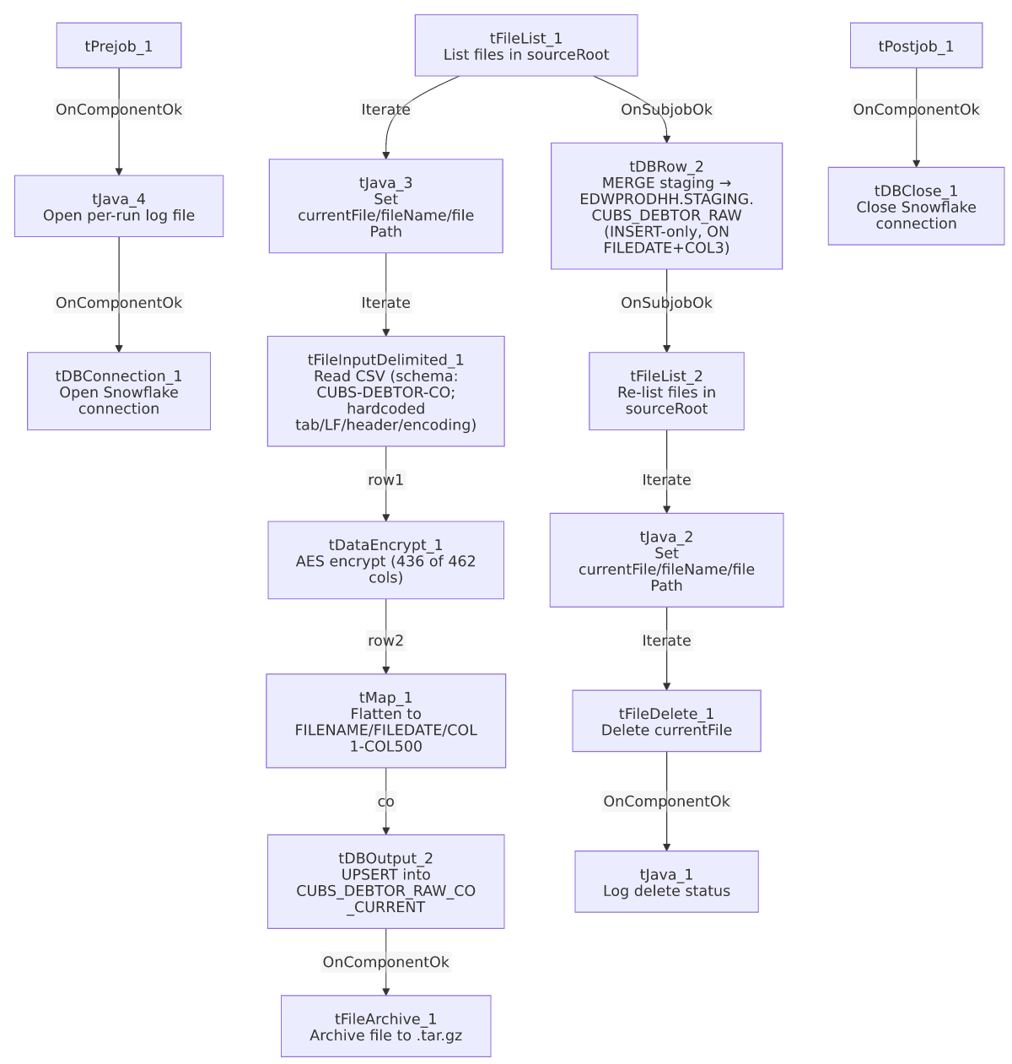

Settings tables

Source listing: `tFileList_1` / `tFileList_2`
Setting | Value | What it means
DIRECTORY | context.sourceRoot | Both loops (load and cleanup) scan the same source directory.
LIST_MODE | FILES | Only files, no subdirectories (INCLUDSUBDIR=false).
ORDER_BY_NOTHING | true | No explicit sort order is applied to the file list (unlike the CHI sibling, which sorts by modified date ascending).
EXCLUDEFILEMASK | "*.txt" | An exclusion mask is configured, but no IFEXCLUDE/enable flag was present in this component's captured parameters to confirm it's active.

Source: `tFileInputDelimited_1`
Setting | Value | What it means
FILENAME | context.currentFile | The current file from tFileList_1's iteration.
FIELDSEPARATOR | "\t" | Hardcoded tab-delimited, not a context variable — differs from the CHI sibling, which externalizes this to context.EXPORT_DEBTOR_FieldSeparator.
ROWSEPARATOR | "\n" | Hardcoded, same pattern as above.
HEADER | 1 | Hardcoded 1 header row.
ENCODING | "ISO-8859-15" | Hardcoded.
SCHEMA (main) | Repository schema CUBS-DEBTOR-CO | 462 business columns (LOGON through CELL_PHONE_F83: demographic, client, agency, trip/IOC/letter-cycle fields) plus errorCode/errorMessage reject columns.
SCHEMA_REJECT | Not present | No SCHEMA_REJECT repository-schema parameter appears in this component's captured metadata at all — unlike the CHI sibling, which has one (mismatched to an HH-labeled schema).
DIE_ON_ERROR | false | Malformed rows don't fail the job...
Reject flow | Not wired | ...but no connection in this job routes rejected rows anywhere — they are silently dropped.
TEMP_DIR | "C:/Talend-Studio-20211109_1610-V8.0.1/workspace" | Hardcoded developer-workstation path (see hardcoded_path_findings).

Transform: `tDataEncrypt_1`
Setting | Value | What it means
CRYPTO_METHOD | AES | Symmetric encryption of column values.
SECRET_TYPE / SECRET_KEY / PASSWORD_M1 | ***REDACTED*** | Encryption key material — preserved as redacted, not guessable from this metadata.
CRYPTO_FILE_PATH | context.cryptoPath | Externalized crypto-config file path (variable not found in any extracted context group — see Issues observed).
Schema | 436 columns (LOGON ... XD_ACCT_NUMBER) | Only the first 436 of the upstream 462 business columns are present in this component's schema; the trailing 26 (VAL_LTR_DT, TRIP_DT_2, TRIP_CERT, TRIP_ERROR, TRIP_RECON, ..., LETTERABLE, EMAILABLE, TEXTABLE, CELL_PHONE_F83) are absent — see Issues observed.

Transform: `tMap_1`
Setting | Value | What it means
DIE_ON_ERROR | true | Any mapping/lookup error here fails the job outright (unlike the upstream file-read step).
Output schema | FILENAME, FILEDATE, COL1...COL500 (502 columns) | Business field names are discarded in favor of a fixed, generically-numbered column layout — matches tDBOutput_2's target schema exactly.

Target: `tDBOutput_2` (`tSnowflakeOutput`)
Setting | Value | What it means
Table | CUBS_DEBTOR_RAW_CO_CURRENT | Per-run staging table for this file batch (CO site).
Output action | UPSERT | Row-level upsert into the staging table (merge key not shown in this component's own metadata).
Table action | NONE | Table is not recreated/altered by this job.
Schema | FILENAME, FILEDATE, COL1...COL500, plus reject-flow columns (columnName, rowNumber, category, character, errorMessage, byteOffset, line, sqlState, code) — COL3 is the only column marked non-nullable | A reject schema exists on this component, but (per connections) no reject flow is wired out of it — see Issues observed. COL3 being the sole non-nullable column corroborates that it's the merge/business key used downstream.

Archive/cleanup: `tFileArchive_1` / `tFileDelete_1`
Setting | Value | What it means
TARGET (tFileArchive_1) | context.archiveDir + "/" + TalendDate.getDate("CCYYMMDD") + "/" + context.fileName + ".tar.gz" | Archives each processed file into a date-stamped subfolder.
SOURCE_FILE (tFileArchive_1) | "C:/Talend-Studio-20211109_1610-V8.0.1/workspace/source.csv" | Hardcoded developer-workstation path (see hardcoded_path_findings); actual SOURCE param is context.filePath, so this hardcoded value appears to be an unused/default placeholder rather than the active source.
ENCRYPT_FILES / PASSWORD (tFileArchive_1) | false / ***REDACTED*** | Archive encryption is disabled, so the redacted password is configured but not currently used.
DIRECTORY / PATH (tFileDelete_1) | "C:/Talend-Studio-20211109_1610-V8.0.1/workspace/delete_folder" / "...delete_folder or delete_file" | Hardcoded developer-workstation paths (see hardcoded_path_findings); actual FILENAME param used is context.currentFile.

Merge step: `tDBRow_2` (`tSnowflakeRow`)
Setting | Value | What it means
Query | MERGE INTO EDWPRODHH.STAGING.CUBS_DEBTOR_RAW AS tgt USING STAGING.CUBS_DEBTOR_RAW_CO_CURRENT AS src ON tgt.FILEDATE = src.FILEDATE AND tgt.COL3 = src.COL3 WHEN NOT MATCHED THEN INSERT (FILENAME, FILEDATE, COL1...COL500) VALUES (src.FILENAME, src.FILEDATE, src.COL1...src.COL500); | Copies rows not already present (by FILEDATE+COL3) from the per-run CO staging table into the shared cross-site raw table. There is no `WHEN MATCHED THEN UPDATE` clause — see Issues observed.
Runs when | OnSubjobOk from tFileList_1 | Fires once after the entire file-load loop finishes successfully, not once per file.

Dependencies & configuration
- Triggers/depends on other jobs: none — runjob_targets is empty; this job contains no tRunJob components.
- Called by: not found as a tRunJob target anywhere in 06_dependency_matrix.md. The matrix shows the CUBS_Raw_Debtor_Load orchestrator calling a differently-named job, CUBS_Raw_CO_Debtor_Load (without the _Upsert suffix), for the CO site — the same is also separately called by CO_Master_Load. See Issues observed.
- Context variables used: sourceRoot, cryptoPath, currentLogon (none of these three appear in any context group in _shared_context.json — the closest named variables, sourceDir/sourceDCDir in StandardFolders_0.1, are different names), plus archiveDir and logDir (defined in StandardFolders_0.1, with two candidate values each — /archive///logs/ vs. C:/Data//C:/Data/ — the metadata doesn't indicate which corresponds to which environment), and currentFile, fileName, filePath (set internally by tJava_2/tJava_3 from tFileList_* iteration state). Unlike the CHI sibling, this job does not reference any EXPORT_DEBTOR_* context variables — its delimiter/header/encoding settings are hardcoded instead (see Issues observed).
- 4 hardcoded developer-workstation paths (C:/Talend-Studio-20211109_1610-V8.0.1/workspace/...) in tFileInputDelimited_1.TEMP_DIR, tFileArchive_1.SOURCE_FILE, and tFileDelete_1.DIRECTORY/PATH — the same portability risk pattern documented project-wide in 05_operational_runbook.md.

Glossary
Component type | Plain-English meaning
tPrejob / tPostjob | Marks the setup/teardown subjobs that run once before/after the rest of the job, regardless of how many times the main flow iterates.
tSnowflakeConnection / tSnowflakeClose | Opens / closes the Snowflake connection used throughout the job.
tFileList | Lists files in a directory for the job to iterate over one at a time.
tJava | Runs a block of custom Java code once (not per row).
tFileInputDelimited | Reads a delimited (CSV-style) text file according to a schema.
tDataEncrypt | Encrypts specified column values in the row using a configured algorithm/key.
tMap | Maps/transforms columns from one schema to another.
tSnowflakeOutput | Writes rows to a Snowflake table (insert/update/upsert/etc., per outputAction).
tSnowflakeRow | Runs an arbitrary SQL statement (here, a MERGE) against Snowflake.
tFileArchive / tFileDelete | Archives a processed file to a compressed location, then deletes the original from the source directory.

Issues observed
- Job name says "Upsert," but the merge is insert-only. tDBRow_2's MERGE statement has a WHEN NOT MATCHED THEN INSERT clause and no WHEN MATCHED THEN UPDATE clause — rows already present in EDWPRODHH.STAGING.CUBS_DEBTOR_RAW (matched by FILEDATE+COL3) are left untouched, not updated. Functionally this is a dedup-insert/append pattern, not a true upsert. This is the same naming/behavior mismatch already documented for the CHI sibling (CUBS_Raw_CHI_Debtor_Load_Upsert), so it appears to be a systemic template characteristic rather than a one-off mistake in this job.
- Schema drift between `tFileInputDelimited_1` and `tDataEncrypt_1`. The file-read schema carries 462 business columns (CUBS-DEBTOR-CO), but tDataEncrypt_1's schema stops at column 436 (XD_ACCT_NUMBER) — the trailing 26 source columns (VAL_LTR_DT, TRIP_DT_2, TRIP_CERT, TRIP_ERROR, TRIP_RECON, TRIP_ERRCD, TRIP_ADD, TRIP_BAL, IOC_IW_NBR, IOC_STATUS, OFFSET_AMT, OFFSET_DT, TRIP_LTR, TRIP_DEL, IOC_AMT_HELD, IOC_AMT_PAID, IOC_DEL, AGENCY_CODE, IOC_MTBALL, IOC_FROMDT, IOC_MOD, TRIP_LTR_DT, LETTERABLE, EMAILABLE, TEXTABLE, CELL_PHONE_F83) are not present in tDataEncrypt_1's schema and therefore not available to the downstream tMap_1. This is the same schema-drift pattern seen in the CHI sibling job (there it was 668→328, a ~340-column gap; here it is a smaller but still real 462→436, a 26-column gap), which suggests both jobs' tDataEncrypt steps were not kept in sync when their respective source file formats were last extended.
- No `SCHEMA_REJECT` parameter at all, and file-format settings are hardcoded rather than externalized. Unlike the CHI sibling, this job's tFileInputDelimited_1 has no SCHEMA_REJECT repository-schema reference in its captured parameters, and its FIELDSEPARATOR/ROWSEPARATOR/HEADER/ENCODING are literal hardcoded values ("\t", "\n", 1, "ISO-8859-15") instead of the context.EXPORT_DEBTOR_* variables the CHI job uses. This means the CO job avoids the CHI job's site-mismatched-reject-schema issue, but at the cost of losing the flexibility (and consistency with other sites) that externalizing these settings would provide — if the CO file format ever needs to change, it requires a code change here rather than a context-value change.
- No `tFlowMeter` row-counting component. The CHI sibling counts rows with a tFlowMeter_3 component between tMap_1 and its Snowflake output; this CO job wires tMap_1 directly to tDBOutput_2 with no equivalent row-count instrumentation. Not necessarily a defect, but a monitoring-coverage gap relative to the sibling job.
- Not referenced by any orchestrator job under its own name. 06_dependency_matrix.md shows both CUBS_Raw_Debtor_Load and CO_Master_Load calling CUBS_Raw_CO_Debtor_Load (without the _Upsert suffix), not this job. Unable to determine from metadata whether CUBS_Raw_CO_Debtor_Load_Upsert is a newer replacement not yet wired into either orchestrator, a manually/ad-hoc-triggered job, or a separate job that happens to share almost the same name — verify with the team before assuming either job is dead code.
- Several referenced context variables have no defined default anywhere in the extracted project context groups. context.sourceRoot, context.cryptoPath, and context.currentLogon are all read by this job's components but do not appear in any of the context groups captured in _shared_context.json (the closest match, sourceDir/sourceDCDir in StandardFolders_0.1, is a different variable name). Either this job carries its own job-level context defaults that weren't captured by this extraction, or these are unresolved references — verify with the team.
- 4 hardcoded developer-workstation paths (C:/Talend-Studio-20211109_1610-V8.0.1/workspace/...) in tFileInputDelimited_1.TEMP_DIR, tFileArchive_1.SOURCE_FILE, and tFileDelete_1.DIRECTORY/PATH — the same project-wide portability risk already documented in 05_operational_runbook.md; none of these override the actual active FILENAME/SOURCE parameters (which correctly use context.currentFile/context.filePath), so they appear to be inert leftover defaults rather than active bugs, but should still be cleaned up.
- The merge's natural key (`FILEDATE` + `COL3`) is opaque. Because tMap_1/tDBOutput_2 use the generic COL1-COL500 naming scheme instead of business field names, COL3's real meaning (the only one of the 500 marked non-nullable in tDBOutput_2's schema, suggesting it's a business key such as an account or debtor ID) cannot be determined from this metadata.

