Talend Job: CUBS_Raw_Cellphone_Load

Overview
Loads a single per-logon CUBS cellphone-number export file — one row per debtor phone number, with dial-attempt counts, ownership-check codes/dates, and debtor authorization date/initials — into the Snowflake table CUBS_CELLPHONE_RAW, then archives and deletes the source file. Unlike CUBS_Raw_CO_ETL_Load (which iterates every file in a directory), this job is driven entirely by context.currentLogon and reads exactly one fixed-name file, implying it is invoked once per site/logon by its calling job(s) with a different context value each time.

Detail table
Field | Value
Job name | CUBS_Raw_Cellphone_Load
Version | 0.1
Project | EDW2SF
Author | jmach@harriscollect.com
Created | 2023-03-23T20:16:15.139-0700
Last Modified | 2026-01-28T09:27:06.855-0800

Step-by-step data flow
Setup subjob: tPrejob_1 → tJava_1 (OnComponentOk) opens a per-run log file at context.logDir + context.currentLogon + "_" + jobName + "_" + <timestamp> + ".log" (note: includes context.currentLogon in the filename, unlike CUBS_Raw_CO_ETL_Load's equivalent step) → tSetKeystore_1 (OnSubjobOk) configures SSL trust/keystore from context.keystorePath (passwords redacted) → tDBConnection_1 (OnSubjobOk) opens the Snowflake connection.
Main subjob:
- tFileInputDelimited_1 reads context.sourceDir + context.currentLogon + "-EDW-EXPORT-CELLPHONES.txt", tab-delimited, header row present, UTF-8 encoded, with CSVROWSEPARATOR driven by context.EXPORT_TRANS_RowSeparator (borrowed from the EXPORT_TRANS_0.1 context group, not a cellphone-specific one — see Issues observed). Uses repository schema "...- cellphone" (14 named columns: LOGON, DEBTOR, DEBTOR_IDX, PHONE_NUMBER, SOURCE, CUR_STS, CUR_STS_CHG_DT, OWNER_CHK_DT, OWNER_CHK_CD, _UNATT_DIAL_ATT, FILL01, FILL02, DEBTOR_AUTH_DATE, DEBTOR_AUTH_INIT). DIE_ON_ERROR=false; the reject schema is labeled "...- CUBS_TRANSACTION", not cellphone-specific (see Issues observed).
- tMap_1 (row1, FLOW) maps to a same-shaped 16-column target (FILENAME, FILEDATE, plus the 14 business columns, renaming _UNATT_DIAL_ATT to NUM_UNATT_DIAL_ATT) — real column names are preserved here, unlike CUBS_Raw_CO_ETL_Load's generic COL1...COL80 flattening.
- tFlowMeter_2 (cellphone, FLOW) counts rows passing through.
- tDBOutput_1 (row2, FLOW) inserts the rows into Snowflake CUBS_CELLPHONE_RAW (INSERT, tableAction=NONE).
- On the input file's OnSubjobOk (a parallel trigger off tFileInputDelimited_1, not chained from the DB insert), tFileArchive_1 archives context.sourceDir (the whole directory, not the specific file — see Issues observed) to context.archiveDir + "/" + <YYYYMMDD> + "/" + context.currentLogon + "-EDW-EXPORT-CELLPHONES.txt.tar.gz" (password redacted).
- On archive OnSubjobOk, tFileDelete_1 deletes context.sourceDir + context.currentLogon + "-EDW-EXPORT-CELLPHONES.txt".
Teardown subjob: tPostjob_1 → tDBClose_1 (OnComponentOk) closes the Snowflake connection.
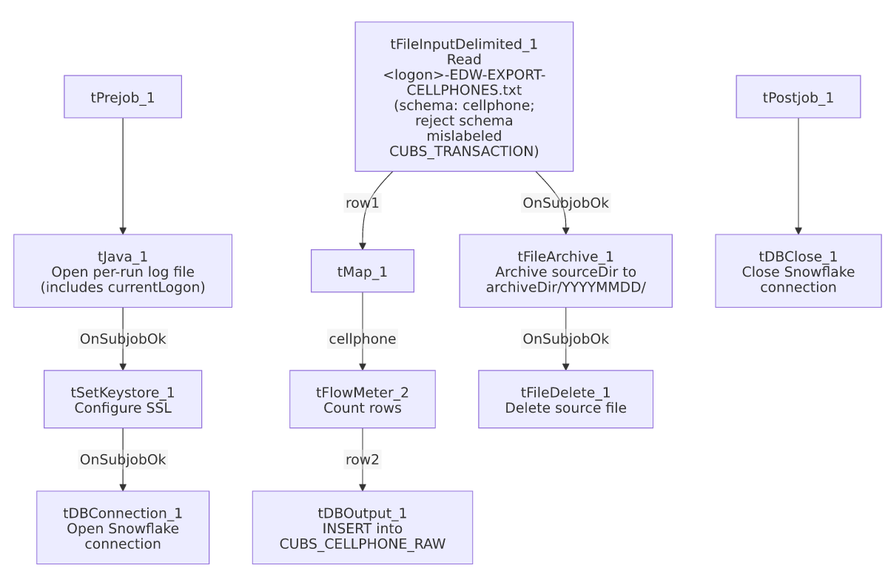

Settings tables

Source: `tFileInputDelimited_1`
Setting | Value | What it means
FILENAME | context.sourceDir + context.currentLogon + "-EDW-EXPORT-CELLPHONES.txt" | A fixed, single per-logon file — no directory iteration.
FIELDSEPARATOR / ENCODING | \t / UTF-8 | Tab-delimited, UTF-8 — differs from CUBS_Raw_CO_ETL_Load's ISO-8859-15.
CSVROWSEPARATOR | context.EXPORT_TRANS_RowSeparator | Pulled from the transaction-export context group rather than a cellphone-specific variable — see Issues observed.
SCHEMA (main) | Repository schema "...- cellphone" | 14 named columns covering debtor phone number, source, status, dial-attempt count, and authorization fields.
SCHEMA_REJECT | Repository schema "...- CUBS_TRANSACTION" | Mislabeled — not a cellphone-specific reject schema. See Issues observed.
DIE_ON_ERROR | false | Malformed rows don't fail the job, but no reject flow is wired — rejected rows are silently dropped.

Target: `tDBOutput_1` (`tSnowflakeOutput`)
Setting | Value | What it means
Table | CUBS_CELLPHONE_RAW | Destination table for the loaded phone-number rows.
Output action | INSERT | Appends rows; no truncate step in this job.
Table action | NONE | Table not recreated/altered by this job.

`tFileArchive_1`
Setting | Value | What it means
SOURCE | context.sourceDir | Points at the whole source directory, not the specific cellphone file — see Issues observed.
TARGET | context.archiveDir + "/" + <YYYYMMDD> + "/" + context.currentLogon + "-EDW-EXPORT-CELLPHONES.txt.tar.gz" | Per-logon, dated archive filename.
ALL_FILES | false | Only files matching the archive component's own pattern are archived, mitigating the directory-level SOURCE.
PASSWORD | ***REDACTED*** | Preserved as redacted.

`tSetKeystore_1`
Setting | Value | What it means
SSL_KEYSTORE | context.keystorePath | Externalized to context.
SSL_TRUSTSERVER_TRUSTSTORE | "C:/clientTrustStore.trustStore" | Hardcoded truststore path.
SSL_TRUSTSERVER_PASSWORD / SSL_KEYSTORE_PASSWORD / NEED_CLIENT_AUTH | ***REDACTED*** | Preserved as redacted.

Dependencies & configuration
- Triggers/depends on other jobs: runjob_targets is empty — this job does not call any other job.
- Called by: DimCellphone_Load (6 calls) and CO_Master_Load (1 call), per 06_dependency_matrix.md — this same job apparently services two different orchestrators, presumably parameterized by a different context.currentLogon value per call.
- Context variables used: EXPORT_TRANS_RowSeparator, archiveDir, currentLogon, keystorePath, logDir, sourceDir.
- 5 hardcoded developer-workstation paths, same pattern and locations as CUBS_Raw_CO_ETL_Load — see 05_operational_runbook.md.

Glossary
Component type | Plain-English meaning
tPrejob / tPostjob | Guaranteed-first / guaranteed-last setup and teardown subjobs.
tJava | Runs a block of custom Java code once.
tFileInputDelimited | Reads a delimited text file according to a schema.
tMap | Maps/transforms columns from one schema to another.
tFlowMeter | Counts rows passing a point in the flow for logging/monitoring.
tSnowflakeOutput / tSnowflakeConnection / tSnowflakeClose | Write rows to Snowflake / open and close the shared Snowflake connection.
tFileArchive / tFileDelete | Zip a processed file to an archive location, then delete the original.
tSetKeystore | Configures SSL client keystore/truststore ahead of an encrypted database connection.

Issues observed
- Reject schema mislabeled `"...- CUBS_TRANSACTION"` instead of a cellphone-specific reject schema — the same mislabeling pattern documented in ADP_Payroll_Load (roster vs. payroll). Whether this causes an actual column-mismatch on a rejected row depends on schema similarity, which can't be determined from this metadata; verify directly in the Talend repository.
- No reject flow is wired despite `DIE_ON_ERROR=false` — malformed cellphone rows are silently dropped with no record of how many or which ones failed to parse.
- `CSVROWSEPARATOR` is set from `context.EXPORT_TRANS_RowSeparator` (the transaction-export context group) rather than a cellphone-specific row-separator variable. Both currently default to "\n" in _shared_context.json, so this is functionally harmless today, but the naming suggests this job's input parsing was copied from a transaction-file-loading job and never fully repointed to its own context group.
- `tFileArchive_1.SOURCE` is `context.sourceDir` (the entire directory) rather than a specific file or filePath variable, unlike the pattern used elsewhere in this batch (CUBS_Raw_CO_ETL_Load points SOURCE at context.filePath, the specific file's directory). ALL_FILES=false limits actual archiving to files matching the component's own target pattern, but this is a looser configuration than its siblings; unable to confirm from metadata whether it behaves identically in practice.
- Called by two different orchestrators (DimCellphone_Load and CO_Master_Load) with no evidence in this job's own metadata of how context.currentLogon differs per call — verify the call-site context overrides directly in Talend Studio.

