Talend Job: CUBS_Raw_Client_Load

Overview
Loads a single CUBS client master-file export — one row per collection-agency client, with ~100 columns covering client ID, name/address, billing and statement settings, commission/interest rates, collection-status flags, and dialer/skip-trace routing flags — into the Snowflake table CUBS_CLIENT_RAW_CURRENT, then archives and deletes the source file. The filename comes entirely from context.EXPORT_CLIENT_File, which defaults to "HH-EDW-EXPORT-CLIENT.txt" per _shared_context.json's EXPORT_CLIENT_0.1 group — meaning this job is normally run against the HH site's client export even though its own name carries no site suffix (see Issues observed). It has a near-duplicate sibling in this batch, CUBS_Raw_DC_Client_Load, which loads into the exact same target table.

Detail table
Field | Value
Job name | CUBS_Raw_Client_Load
Version | 0.1
Project | EDW2SF
Author | jmach@harriscollect.com
Created | 2022-09-15T12:02:14.269-0700
Last Modified | 2025-09-24T11:09:23.572-0700

Step-by-step data flow
Setup subjob: tPrejob_1 → tJava_1 (OnComponentOk) opens a per-run log file at context.logDir + context.currentLogon + "_" + jobName + "_" + <timestamp> + ".log" → tDBConnection_1 (OnComponentOk, not OnSubjobOk — see Issues observed) opens the Snowflake connection directly. This job has no `tSetKeystore_1` component at all, unlike its sibling CUBS_Raw_DC_Client_Load and the other two jobs in this batch, all of which configure SSL trust/keystore before connecting (see Issues observed).
Main subjob:
- tFileInputDelimited_1 reads context.sourceDir + context.EXPORT_CLIENT_File, with RowSeparator/FieldSeparator/Header/Encoding all driven by the EXPORT_CLIENT_0.1 context group. Uses repository schema "...- CUBS_CLIENT" (~100 named columns, all with a leading-underscore naming convention, e.g. _LOGON, _CLIENT, _NAME, _ADD1, _ZIP, _STATUS, _CLI_TYPE, _DLR_GROUP, _ON_DIALER). DIE_ON_ERROR=false; reject schema mislabeled "...- CUBS_TRANSACTION" (same pattern as the other three jobs in this batch — see Issues observed).
- tMap_1 (row1, FLOW) re-maps every business column positionally onto a generic 202-column target shape (FILENAME, FILEDATE, COL1...COL200) — same "flatten to generic columns" pattern used in CUBS_Raw_CO_ETL_Load.
- tFlowMeter_2 (cli, FLOW) counts rows passing through.
- tDBOutput_1 (row2, FLOW) inserts the rows into Snowflake CUBS_CLIENT_RAW_CURRENT (INSERT, tableAction=NONE).
- On the input file's OnSubjobOk, tFileArchive_1 archives context.sourceDir to context.archiveDir + "/" + <YYYYMMDD> + "/" + context.EXPORT_CLIENT_File + ".tar.gz" (password redacted).
- On archive OnSubjobOk, tFileDelete_1 deletes context.sourceDir + context.EXPORT_CLIENT_File.
Teardown subjob: tPostjob_1 → tDBClose_1 (OnComponentOk) closes the Snowflake connection.
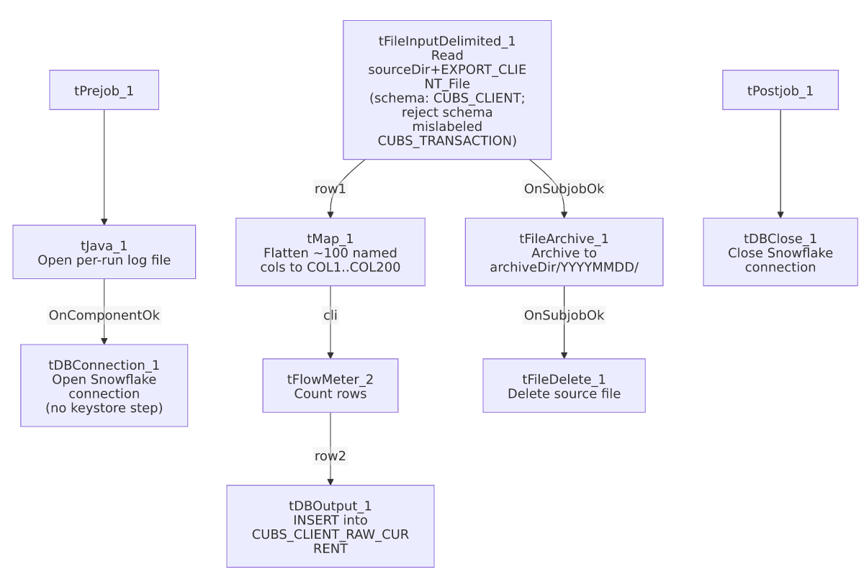

Settings tables

Source: `tFileInputDelimited_1`
Setting | Value | What it means
FILENAME | context.sourceDir + context.EXPORT_CLIENT_File | EXPORT_CLIENT_File defaults to "HH-EDW-EXPORT-CLIENT.txt" per _shared_context.json.
ROWSEPARATOR / FIELDSEPARATOR / HEADER / ENCODING | All from EXPORT_CLIENT_0.1 context group | Defaults: \n, \t, header row 1, US-ASCII.
SCHEMA (main) | Repository schema "...- CUBS_CLIENT" | ~100 named columns, leading-underscore naming convention (e.g. _CLIENT, _NAME, _STATUS).
SCHEMA_REJECT | Repository schema "...- CUBS_TRANSACTION" | Mislabeled — not a client-specific reject schema. See Issues observed.
DIE_ON_ERROR | false | Malformed rows don't fail the job, but no reject flow is wired — rejected rows are silently dropped.

Target: `tDBOutput_1` (`tSnowflakeOutput`)
Setting | Value | What it means
Table | CUBS_CLIENT_RAW_CURRENT | Destination raw landing table — identical to `CUBS_Raw_DC_Client_Load`'s target. See Issues observed.
Output action | INSERT | Appends rows; no truncate step precedes it in this job.
Table action | NONE | Table not recreated/altered by this job.

`tFileArchive_1` / `tFileDelete_1`
Setting | Value | What it means
TARGET (archive) | context.archiveDir + "/" + <YYYYMMDD> + "/" + context.EXPORT_CLIENT_File + ".tar.gz" | Per-run, dated archive named after the export file.
PASSWORD | ***REDACTED*** | Preserved as redacted.
FILENAME (delete) | context.sourceDir + context.EXPORT_CLIENT_File | Deletes the exact file that was loaded.

Dependencies & configuration
- Triggers/depends on other jobs: runjob_targets is empty — this job does not call any other job.
- Called by: not found as a tRunJob target anywhere in 06_dependency_matrix.md — no orchestrator in the captured metadata calls this job. It may be scheduled independently or called by a Master job not present in this export; see that doc's own caveat that only CO has a documented _Master_Load orchestrator even though the same per-site pattern repeats elsewhere.
- Context variables used: EXPORT_CLIENT_Encoding, EXPORT_CLIENT_FieldSeparator, EXPORT_CLIENT_File, EXPORT_CLIENT_Header, EXPORT_CLIENT_RowSeparator, EXPORT_TRANS_RowSeparator, archiveDir, currentLogon, logDir, sourceDir.
- 4 hardcoded developer-workstation paths (tFileInputDelimited_1.TEMP_DIR, tFileArchive_1.SOURCE_FILE, tFileDelete_1.DIRECTORY/PATH) — one fewer than its siblings since there is no tSetKeystore_1 component (and therefore no hardcoded truststore path) in this job.

Glossary
Component type | Plain-English meaning
tPrejob / tPostjob | Guaranteed-first / guaranteed-last setup and teardown subjobs.
tJava | Runs a block of custom Java code once.
tFileInputDelimited | Reads a delimited text file according to a schema.
tMap | Maps/transforms columns from one schema to another.
tFlowMeter | Counts rows passing a point in the flow for logging/monitoring.
tSnowflakeOutput / tSnowflakeConnection / tSnowflakeClose | Write rows to Snowflake / open and close the Snowflake connection.
tFileArchive / tFileDelete | Zip a processed file to an archive location, then delete the original.

Issues observed
- No `tSetKeystore_1` component in this job, unlike CUBS_Raw_DC_Client_Load (its otherwise near-identical sibling) and the other two jobs in this batch, all of which configure SSL trust/keystore before opening the Snowflake connection. tJava_1 connects directly to tDBConnection_1 via OnComponentOk. Unable to determine from metadata whether this job's Snowflake connection profile requires mutual-TLS/keystore auth the way the others do — if it does, this job may rely on a different auth path, or the keystore step may have been dropped by omission; verify with the team.
- `tJava_1 → tDBConnection_1` uses an `OnComponentOk` trigger, not OnSubjobOk like the equivalent step in the other three jobs in this batch — functionally equivalent here since tJava_1 is a single component, but an inconsistent wiring style across otherwise near-identical jobs.
- This job and `CUBS_Raw_DC_Client_Load` both write to the same target table, CUBS_CLIENT_RAW_CURRENT, with INSERT/tableAction=NONE (no truncate). If both jobs can run against the same table without either one clearing it first, rows from both site exports accumulate together on every run cycle rather than being replaced. No site/source identifier column is visible in the generic COL1...COL202 target schema, so it's unclear from metadata alone whether a downstream merge step can distinguish rows by site of origin; verify with the team.
- The job name carries no explicit site suffix (unlike the CHI/CO/DC/HH/PRE/TOL pattern documented in 01_system_architecture.md for other CUBS_Raw_* families), but its context default (EXPORT_CLIENT_File = "HH-EDW-EXPORT-CLIENT.txt") points at the HH site specifically. The job's actual scope is not obvious from its name alone.
- Reject schema mislabeled `"...- CUBS_TRANSACTION"`, not a client-specific reject schema — same pattern flagged in the other three jobs in this batch and in ADP_Payroll_Load. No reject flow is wired despite DIE_ON_ERROR=false.
- Not found as a `tRunJob` target anywhere in `06_dependency_matrix.md` — what schedules or triggers this job is unclear from the captured metadata; verify with the team so its pipeline isn't assumed to be dormant.

