Talend Job: CUBS_Raw_DC_Client_Load

Overview
Near-duplicate of CUBS_Raw_Client_Load: same client master-file load pattern, same target table CUBS_CLIENT_RAW_CURRENT, same overall load-archive-delete flow. It differs from its sibling in three concrete ways visible in the metadata: (1) it includes an SSL/keystore setup step (tSetKeystore_1) before opening its Snowflake connection, which CUBS_Raw_Client_Load lacks; (2) its input repository schema is labeled generically "...- metadata" rather than "...- CUBS_CLIENT"; and (3) its column-naming convention has no leading underscore (NAME, CLIENT, ZIP) versus CUBS_Raw_Client_Load's (_NAME, _CLIENT, _ZIP). Despite the "DC" in its name, nothing else in this job's own metadata — its source path expression, filename, or a DC-specific context variable — actually differentiates it from the generic Client_Load job (see Issues observed).

Detail table
Field | Value
Job name | CUBS_Raw_DC_Client_Load
Version | 0.1
Project | EDW2SF
Author | jmach@harriscollect.com
Created | 2023-09-26T11:16:22.325-0700
Last Modified | 2025-11-04T11:08:04.185-0800

Step-by-step data flow
Setup subjob: tPrejob_1 → tJava_1 (OnComponentOk) opens a per-run log file at context.logDir + context.currentLogon + "_" + jobName + "_" + <timestamp> + ".log" → tSetKeystore_1 (OnSubjobOk) configures SSL trust/keystore from context.keystorePath (settings identical to CUBS_Raw_CO_ETL_Load/CUBS_Raw_Cellphone_Load, passwords redacted) → tDBConnection_1 (OnSubjobOk) opens the Snowflake connection.
Main subjob:
- tFileInputDelimited_1 reads context.sourceDir + context.EXPORT_CLIENT_File — byte-for-byte identical to `CUBS_Raw_Client_Load`'s FILENAME expression, not context.sourceDCDir or any DC-prefixed filename (see Issues observed). RowSeparator/FieldSeparator/Header/Encoding are all driven by the same EXPORT_CLIENT_0.1 context group. Uses repository schema "...- metadata" (a generic, non-descriptive label — see Issues observed) with ~100 named columns representing the same business fields as CUBS_Raw_Client_Load's schema but without the leading-underscore naming convention (e.g. LOGON, CLIENT, CLIENT_IDX, NAME, ADD1, ZIP, STATUS, DIALER_GRP, HAL_ACTIVE). DIE_ON_ERROR=false; reject schema mislabeled "...- CUBS_TRANSACTION" (same pattern as the other three jobs in this batch).
- tMap_1 (row1, FLOW) maps to the same generic 202-column COL1...COL202 target shape used by CUBS_Raw_Client_Load.
- tFlowMeter_2 (cli, FLOW) counts rows passing through.
- tDBOutput_1 (row2, FLOW) inserts the rows into Snowflake CUBS_CLIENT_RAW_CURRENT (INSERT, tableAction=NONE) — the same target table as `CUBS_Raw_Client_Load`.
- On the input file's OnSubjobOk, tFileArchive_1 archives context.sourceDir to context.archiveDir + "/" + <YYYYMMDD> + "/" + context.EXPORT_CLIENT_File + ".tar.gz" (password redacted).
- On archive OnSubjobOk, tFileDelete_1 deletes context.sourceDir + context.EXPORT_CLIENT_File.
Teardown subjob: tPostjob_1 → tDBClose_1 (OnComponentOk) closes the Snowflake connection.
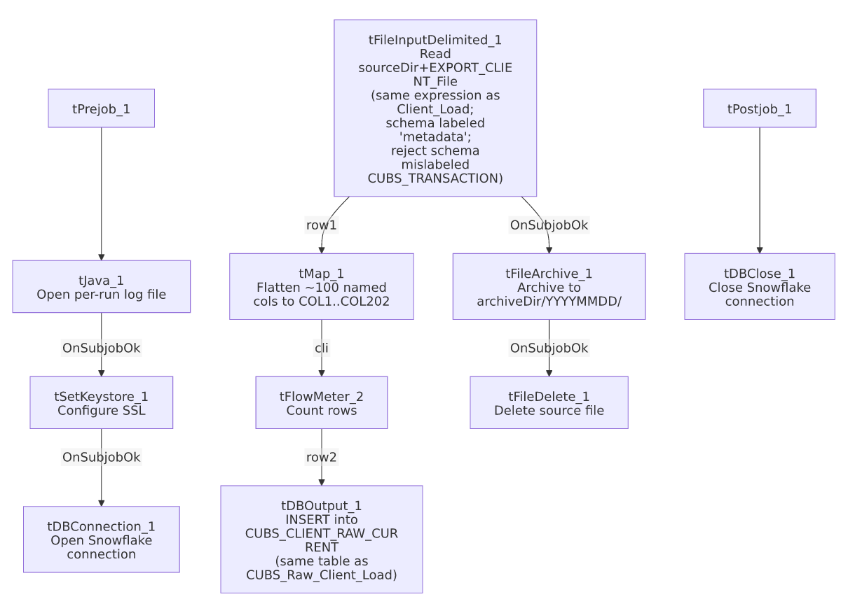

Settings tables

Source: `tFileInputDelimited_1`
Setting | Value | What it means
FILENAME | context.sourceDir + context.EXPORT_CLIENT_File | Identical expression to CUBS_Raw_Client_Load — does not use context.sourceDCDir or a DC-prefixed filename. See Issues observed.
SCHEMA (main) | Repository schema "...- metadata" | ~100 named columns, no leading-underscore naming (e.g. CLIENT, NAME, ZIP) — same business fields as CUBS_Raw_Client_Load but a differently-named, less descriptive repository schema.
SCHEMA_REJECT | Repository schema "...- CUBS_TRANSACTION" | Mislabeled — same pattern as the other three jobs in this batch.
DIE_ON_ERROR | false | Malformed rows don't fail the job, but no reject flow is wired — rejected rows are silently dropped.

Target: `tDBOutput_1` (`tSnowflakeOutput`)
Setting | Value | What it means
Table | CUBS_CLIENT_RAW_CURRENT | Identical target table to CUBS_Raw_Client_Load. See Issues observed.
Output action | INSERT | Appends rows; no truncate step in this job.
Table action | NONE | Table not recreated/altered by this job.

`tSetKeystore_1`
Setting | Value | What it means
SSL_KEYSTORE | context.keystorePath | Externalized to context — present in this job but absent from CUBS_Raw_Client_Load.
SSL_TRUSTSERVER_TRUSTSTORE | "C:/clientTrustStore.trustStore" | Hardcoded truststore path.
SSL_TRUSTSERVER_PASSWORD / SSL_KEYSTORE_PASSWORD / NEED_CLIENT_AUTH | ***REDACTED*** | Preserved as redacted.

Dependencies & configuration
- Triggers/depends on other jobs: runjob_targets is empty — this job does not call any other job.
- Called by: not found as a tRunJob target anywhere in 06_dependency_matrix.md — like CUBS_Raw_Client_Load, no orchestrator in the captured metadata calls this job.
- Context variables used: EXPORT_CLIENT_Encoding, EXPORT_CLIENT_FieldSeparator, EXPORT_CLIENT_File, EXPORT_CLIENT_Header, EXPORT_CLIENT_RowSeparator, EXPORT_TRANS_RowSeparator, archiveDir, currentLogon, keystorePath, logDir, sourceDir.
- 5 hardcoded developer-workstation paths, same pattern and locations as CUBS_Raw_CO_ETL_Load/CUBS_Raw_Cellphone_Load (includes the truststore path, since tSetKeystore_1 is present here).

Glossary
Component type | Plain-English meaning
tPrejob / tPostjob | Guaranteed-first / guaranteed-last setup and teardown subjobs.
tJava | Runs a block of custom Java code once.
tFileInputDelimited | Reads a delimited text file according to a schema.
tMap | Maps/transforms columns from one schema to another.
tFlowMeter | Counts rows passing a point in the flow for logging/monitoring.
tSnowflakeOutput / tSnowflakeConnection / tSnowflakeClose | Write rows to Snowflake / open and close the Snowflake connection.
tFileArchive / tFileDelete | Zip a processed file to an archive location, then delete the original.
tSetKeystore | Configures SSL client keystore/truststore ahead of an encrypted database connection.

Issues observed
- Despite the "DC" in its name, this job's `tFileInputDelimited_1.FILENAME` expression is byte-for-byte identical to `CUBS_Raw_Client_Load`'s (context.sourceDir + context.EXPORT_CLIENT_File). It does not reference context.sourceDCDir — a distinct DC-specific path variable defined in the StandardFolders_0.1 context group and referenced elsewhere in this project (e.g. Semaphore_Check's DC-specific check) — nor any DC-prefixed filename. Any site differentiation must come entirely from a job-level context override supplying a different EXPORT_CLIENT_File value at runtime, which is not visible in this job's own metadata; verify directly in Talend Studio which context set(s) this job actually runs under.
- Writes to the exact same target table (`CUBS_CLIENT_RAW_CURRENT`) as `CUBS_Raw_Client_Load`, with the same INSERT/no-truncate behavior. See the corresponding issue in CUBS_Raw_Client_Load's doc regarding whether both jobs' output rows can be reliably distinguished downstream.
- Input repository schema is labeled `"...- metadata"` — a generic, non-descriptive name — unlike CUBS_Raw_Client_Load's "...- CUBS_CLIENT". The column-naming convention also differs (no leading underscore), even though the same business fields appear to be represented and the tMap_1 output shape (202 generic columns) matches CUBS_Raw_Client_Load's exactly. This appears functionally compatible, but the schema-naming and column-naming inconsistency between two jobs that load into the same table is worth reconciling.
- Reject schema mislabeled `"...- CUBS_TRANSACTION"`, no reject flow wired — same pattern as the other three jobs in this batch.
- Not found as a `tRunJob` target anywhere in `06_dependency_matrix.md` — what schedules or triggers this job is unclear from the captured metadata; verify with the team.

