Talend Job: CUBS_Raw_DC_Debtor_Load

Overview
Loads the "DC" site's debtor-master export file (a fixed CUBS-collections-system flat-file extract, ~396 business columns covering debtor identity, balances, contacts, legal/skip-trace and misc client-specific fields) from a per-logon source folder into the Snowflake staging table STAGING.CUBS_DEBTOR_RAW_DC_CURRENT, encrypting sensitive fields along the way, then appends the freshly loaded rows into a shared, multi-site combined table STAGING.CUBS_DEBTOR_RAW. It is one of several near-identical per-site debtor-load jobs (CHI/CO/DC/HH/PRE/TOL) invoked by the CUBS_Raw_Debtor_Load orchestrator (see 06_dependency_matrix.md).

Detail table
Field | Value
Job name | CUBS_Raw_DC_Debtor_Load
Version | 0.1
Project | EDW2SF
Author | jmach@harriscollect.com
Created | 2022-05-05T11:15:55.555-0700
Last Modified | 2022-06-13T14:33:33.184-0700

Step-by-step data flow
Setup subjob: tPrejob_1 → tDBConnection_1 opens the Snowflake connection (no host/label/context parameters are captured on this component in this job's own metadata — see Issues observed).
Main subjob:
- tDBRow_1 runs TRUNCATE TABLE STAGING.CUBS_DEBTOR_RAW_DC_CURRENT;. This component has no incoming trigger link in the extracted connections array — it appears to be the entry point of the main subjob, starting automatically once the Prejob subjob completes (standard Talend behavior for a component with no incoming trigger), but this could not be explicitly confirmed from metadata.
- On success (OnSubjobOk), tFileList_1 lists files (not subdirectories) in context.sourceRoot + context.currentLogon. An EXCLUDEFILEMASK of "*.txt" is configured, but IFEXCLUDE is false, so the exclusion is not actually applied — every file in the directory is picked up regardless of extension (same specific misconfiguration pattern seen in ADP_Payroll_Load).
- For each file (Iterate), tJava_3 sets context.currentFile from globalMap.get("tFileList_1_CURRENT_FILEPATH") and logs "Processing file " + context.currentFile" to stdout.
- tFileInputDelimited_1 reads the file using repository schema "CUBS-DEBTOR-DC" for well-formed rows (separators/header/encoding all driven by the EXPORT_DEBTOR_* context group — see Settings table). DIE_ON_ERROR is false, and its SCHEMA_REJECT repository reference is "CUBS_DEBTOR_HH" — a different site code than this job's own DC — see Issues observed. No reject-flow connection is wired.
- tFileInputDelimited_1 → (FLOW) → tDataEncrypt_1 encrypts data using context.cryptoPath as the key-file location (PASSWORD_M1 and SECRET_TYPE both ***REDACTED***, ALGO_VERSION 2). Which of the pass-through columns are actually targeted for encryption is not captured in this metadata beyond these global algorithm/key settings.
- tDataEncrypt_1 → (FLOW) → tMap_1 remaps the ~396 named business columns onto a generic, positional target schema: FILENAME, FILEDATE, COL1…COL500. This "genericize the columns" pattern lets one wide raw staging table support source files whose exact column layout can vary by site/vendor without needing a matching physical warehouse column for every named field.
- tMap_1 → (FLOW, canvas link labeled DBTR_DC) → tFlowMeter_3 counts rows passing through. Its METTERLABEL parameter is still the unmodified default "MyLabel" even though the link itself was renamed to DBTR_DC — cosmetic only.
- tFlowMeter_3 → (FLOW) → tDBOutputBulkExec_1 bulk-loads the rows into Snowflake table CUBS_DEBTOR_RAW_DC_CURRENT (INSERT, tableAction = NONE). Its schema additionally carries Snowflake bulk-load error metadata columns (columnName, rowNumber, category, character, errorMessage, byteOffset, line, sqlState, code) appended after the 502 business/meta columns — see Issues observed regarding whether bulk-load errors are actually captured anywhere.
- Separately, once the entire file-iteration loop finishes (tFileList_1 → OnSubjobOk), tDBRow_2 runs INSERT INTO STAGING.CUBS_DEBTOR_RAW SELECT * FROM STAGING.CUBS_DEBTOR_RAW_DC_CURRENT;, appending this run's DC-site rows into the shared, multi-site STAGING.CUBS_DEBTOR_RAW table used by the other site variants of this job.
Teardown subjob: tPostjob_1 → tDBClose_1 closes the Snowflake connection.
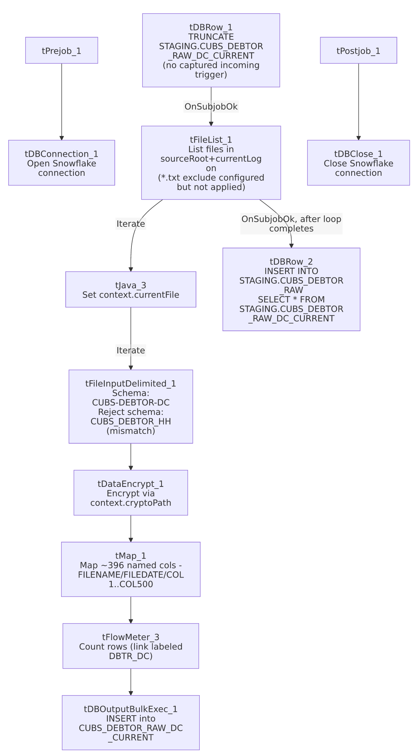

Settings tables

Control: `tFileList_1`
Setting | Value | What it means
DIRECTORY | context.sourceRoot + context.currentLogon | Source folder is built from two context variables; neither has a default captured in _shared_context.json's context groups — likely job-local context parameters.
LIST_MODE | FILES | Subdirectories are not listed.
EXCLUDEFILEMASK / IFEXCLUDE | "*.txt" / false | Exclusion mask is configured but disabled, so it has no effect — every file in the directory is iterated.
CASE_SENSITIVE | YES | File-mask matching (if it were active) would be case-sensitive.

Source: `tFileInputDelimited_1`
Setting | Value | What it means
SCHEMA (main) | Repository "CUBS-DEBTOR-DC" | ~396 unique named business columns (debtor identity, balances, contact, legal/skip-trace, client-specific misc fields); the extracted metadata lists them twice consecutively plus errorCode/errorMessage — most likely a schema-capture/extraction artifact rather than an intentional duplicate schema.
SCHEMA_REJECT | Repository "CUBS_DEBTOR_HH" | Site mismatch — this is the DC job but its reject schema is labeled for site HH. See Issues observed.
FILENAME | context.currentFile | Current file from tFileList_1's iteration.
FIELDSEPARATOR / ROWSEPARATOR / HEADER / ENCODING | context.EXPORT_DEBTOR_FieldSeparator / context.EXPORT_DEBTOR_RowSeparator / context.EXPORT_DEBTOR_Header / context.EXPORT_DEBTOR_Encoding | Driven by the shared EXPORT_DEBTOR_0.1 context group. Default values in that group are tab field-separator, \n row-separator, 1 header row, US-ASCII encoding — though that group's own EXPORT_DEBTOR_File default points to an HH-site path, reinforcing that this context group appears HH-oriented and reused across sites.
DIE_ON_ERROR | false | Malformed rows do not fail the job...
Reject flow | Not wired | ...but no connection routes rejected rows anywhere — they are silently dropped, with no record of how many or which rows failed to parse.
TEMP_DIR | "C:/Talend-Studio-20211109_1610-V8.0.1/workspace" | Hardcoded developer-workstation path — same project-wide portability risk documented in 05_operational_runbook.md.

Transform: `tDataEncrypt_1`
Setting | Value | What it means
PASSWORD_M1 | ***REDACTED*** | Encryption password — preserved as redacted, not guessable from metadata.
CRYPTO_FILE_PATH | context.cryptoPath | Key-file location supplied via context variable; job-local, no default captured.
SECRET_TYPE | ***REDACTED*** | Also redacted in source metadata.
ALGO_VERSION | 2 | Encryption algorithm version used by the component.
Target field(s) | Unable to determine from metadata | The component's parameters only capture global algorithm/key settings, not which specific columns (e.g. SSN, DOB) are actually encrypted — verify directly in Talend Studio.

Target: `tDBOutputBulkExec_1` (`tSnowflakeOutputBulkExec`)
Setting | Value | What it means
Table | CUBS_DEBTOR_RAW_DC_CURRENT | Per-run staging table for this site's raw debtor extract (truncated at the start of the job by tDBRow_1).
Output action | INSERT | Appends rows; safe because the table was truncated earlier in the same run.
Table action | NONE | Table is not recreated/altered by this job.
Schema tail columns | columnName, rowNumber, category, character, errorMessage, byteOffset, line, sqlState, code | Snowflake bulk-load error/reject metadata fields built into this component's schema; whether these are actually captured (e.g. via a reject output) or simply unused is unable to determine from metadata — no separate reject connection appears in the connections array.

Combine step: `tDBRow_2` (`tSnowflakeRow`)
Setting | Value | What it means
Query | INSERT INTO STAGING.CUBS_DEBTOR_RAW SELECT * FROM STAGING.CUBS_DEBTOR_RAW_DC_CURRENT; | Appends this run's DC-site rows into a shared, multi-site combined raw table. Fires once, after the whole file-iteration loop completes — not per file.

Dependencies & configuration
- Triggered by: CUBS_Raw_Debtor_Load (per 06_dependency_matrix.md, which calls this job alongside sibling per-site jobs CUBS_Raw_CHI_Debtor_Load, CUBS_Raw_CO_Debtor_Load, CUBS_Raw_HH_Debtor_Load, CUBS_Raw_PRE_Debtor_Load). A related sibling, CUBS_Raw_DC_Debtor_Load_No_Delete, is triggered separately by CUBS_Raw_Debtor_Load_Test — not part of this job's own metadata, but worth knowing it exists as a variant.
- Triggers/depends on other jobs: none — runjob_targets is empty; this job does not call other jobs itself.
- Context variables used: EXPORT_DEBTOR_Encoding, EXPORT_DEBTOR_FieldSeparator, EXPORT_DEBTOR_Header, EXPORT_DEBTOR_RowSeparator (from the shared EXPORT_DEBTOR_0.1 context group — see _shared_context.json), cryptoPath, currentFile, currentLogon, sourceRoot (none of these last four appear in the extracted shared context groups — likely job-local context parameters whose DC-specific default values could not be verified from available metadata).
- Hardcoded path finding: tFileInputDelimited_1.TEMP_DIR = "C:/Talend-Studio-20211109_1610-V8.0.1/workspace" — one of the 210 project-wide occurrences of this developer-workstation path documented in 05_operational_runbook.md.

Glossary
Component type | Plain-English meaning
tPrejob / tPostjob | Standard Talend bookend components that run setup/teardown logic before and after the job's main subjobs.
tSnowflakeConnection / tSnowflakeClose | Open/close a Snowflake database connection shared by other components in the job.
tSnowflakeRow | Runs an arbitrary SQL statement (here, a TRUNCATE and an INSERT...SELECT) against Snowflake with no result set returned to the flow.
tFileList | Lists files in a directory for the job to iterate over one at a time.
tJava | Runs a block of custom Java code once (here, used to capture the current file path from tFileList's iteration and log it).
tFileInputDelimited | Reads a delimited (CSV/TSV-style) text file according to a schema.
tDataEncrypt | Encrypts one or more fields in the flow using a key file and configured algorithm.
tMap | Maps/transforms columns from one schema to another.
tFlowMeter | Counts rows passing a point in the flow for logging/monitoring.
tSnowflakeOutputBulkExec | Bulk-loads rows into a Snowflake table (typically faster than row-by-row tSnowflakeOutput for large volumes), with built-in schema fields for capturing bulk-load errors.

Issues observed
- Reject-schema site mismatch on `tFileInputDelimited_1`. The main input schema is correctly labeled "CUBS-DEBTOR-DC", but its SCHEMA_REJECT repository reference is "CUBS_DEBTOR_HH" — a different site code. This looks like a copy-paste artifact from an HH-site template job that was never repointed. Whether this actually causes a column-mismatch problem on a rejected row depends on how similar the two repository schemas are — unable to determine from this metadata; verify directly in the Talend repository.
- No reject flow is wired from `tFileInputDelimited_1`. DIE_ON_ERROR is false, so malformed rows don't fail the job, but there is also no connection carrying rejected rows anywhere — they are silently dropped with no record of how many rows, or which ones, failed to parse. This is the same pattern flagged in ADP_Payroll_Load and documented as a project-wide risk in 05_operational_runbook.md.
- `tFileList_1`'s file exclusion mask is configured but not enabled. EXCLUDEFILEMASK is "*.txt" but IFEXCLUDE is false, so the exclusion has no effect and every file in the source directory is picked up and fed into the DC-schema parser — the identical specific misconfiguration seen in ADP_Payroll_Load, suggesting this may be a shared job-template defect rather than isolated to one job.
- `tDBRow_1` (the job's `TRUNCATE`) has no captured incoming trigger. It is presumably the root component of the main subjob (auto-starting once the Prejob subjob finishes), but the connections array doesn't show an explicit link into it — worth a quick visual check in Studio if this job's start sequencing is ever in question.
- Bulk-load error columns on `tDBOutputBulkExec_1` don't appear to be routed anywhere. The component's schema carries Snowflake bulk-load error metadata fields (columnName, rowNumber, errorMessage, sqlState, code, etc.), but no separate reject/error connection exists in this job's connections array — unable to determine from metadata whether bulk-load errors are surfaced anywhere or simply cause the whole bulk operation to fail.
- Encryption target fields are not specified in the extracted metadata. tDataEncrypt_1's captured parameters cover only algorithm version and key-file location; which of the ~396 pass-through columns (e.g., SSN, DOB) are actually encrypted cannot be confirmed from this metadata alone.
- No other job-specific error handling (tDie/tWarn/tSendMail) is present — a failure in this job surfaces only as a generic Talend execution error, consistent with the majority of non-orchestrator jobs described in 05_operational_runbook.md.

