Talend Job: CUBS_Raw_DC_Debtor_Load_Upsert

Overview
This job loads the CUBS collections-system debtor extract file(s) for the DC site from a local source directory into Snowflake. Each row is a debtor record (name, address, phone, SSN, balances, assignment dates, etc.); sensitive fields are AES-encrypted before the row is flattened into a generic, wide landing schema (COL1...COL500) and staged into a DC-specific Snowflake table. A subsequent MERGE moves the newly staged rows into a shared, cross-site raw debtor table, after which the source file is archived and deleted. It follows the same overall CUBS_Raw_<site>_Debtor_Load_Upsert template used for the project's other site codes (CHI, CO, HH, PRE — see 01_system_architecture.md's site-code glossary entry).

Detail table
Field | Value
Job name | CUBS_Raw_DC_Debtor_Load_Upsert
Version | 0.4
Project | EDW2SF
Author | jmach@harriscollect.com
Created | 2024-07-11T11:59:19.311-0700
Last Modified | 2025-09-24T11:06:57.198-0700

Step-by-step data flow
Setup subjob: tPrejob_1 →(OnComponentOk)→ tJava_4 builds a per-run log file path (context.logDir + context.currentLogon + "_" + jobName + "_" + <timestamp> + ".log") and redirects output to it (code is truncated in the extracted metadata beyond this point — see Issues observed) →(OnComponentOk)→ tDBConnection_1 opens the job's Snowflake connection.
Main subjob — load, encrypt, land, merge:
- tFileList_1 lists files in context.sourceRoot.
- For each file (Iterate), tJava_3 sets context.currentFile / context.fileName / context.filePath from tFileList_1's globalMap iteration variables (code truncated mid-statement past this point in the metadata).
- (Iterate) tFileInputDelimited_1 reads the file using the repository schema CUBS-DEBTOR-DC (≈419 named debtor columns), with field/row separators, header flag, and encoding all driven by context.EXPORT_DEBTOR_* variables rather than hardcoded. DIE_ON_ERROR=false, and its configured reject schema is CUBS_DEBTOR_HH — see Issues observed.
- (FLOW, label row1) tDataEncrypt_1 AES-encrypts fields in the row using a key file at context.cryptoPath (secret/key/password fields are ***REDACTED*** in the metadata). Output schema narrows to 413 columns.
- (FLOW, label row2) tMap_1 maps the encrypted row into a generic wide schema: FILENAME, FILEDATE, COL1...COL500. DIE_ON_ERROR=true here, so a mapping failure fails the job outright.
- (FLOW, label DBTR_DC) tFlowMeter_3 counts rows passing through (label left at its default, "MyLabel").
- (FLOW, label row3) tDBOutput_1 (tSnowflakeOutput) UPSERTs the rows into the DC-specific staging table CUBS_DEBTOR_RAW_DC_CURRENT.
- (OnComponentOk) tFileArchive_1 tar-gzips the source file to context.archiveDir + "/" + <CCYYMMDD> + "/" + context.fileName + ".tar.gz".
Then, once the whole `tFileList_1` iteration subjob completes successfully (SUBJOB_OK from tFileList_1):
- tDBRow_2 (tSnowflakeRow) runs a MERGE INTO EDWPRODHH.STAGING.CUBS_DEBTOR_RAW from STAGING.CUBS_DEBTOR_RAW_DC_CURRENT, matching on FILEDATE and COL3, with a WHEN NOT MATCHED THEN INSERT clause only — see Issues observed.
- (SUBJOB_OK) tFileList_2 independently re-lists context.sourceRoot.
- For each file (Iterate), tJava_2 sets context.currentFile / context.fileName / context.filePath from tFileList_2's iteration variables.
- (Iterate) tFileDelete_1 deletes the file identified by context.currentFile.
- (OnComponentOk) tJava_1 logs the deletion status and path from globalMap (code truncated in metadata past this point).
Teardown subjob: tPostjob_1 →(OnComponentOk)→ tDBClose_1 closes the Snowflake connection.
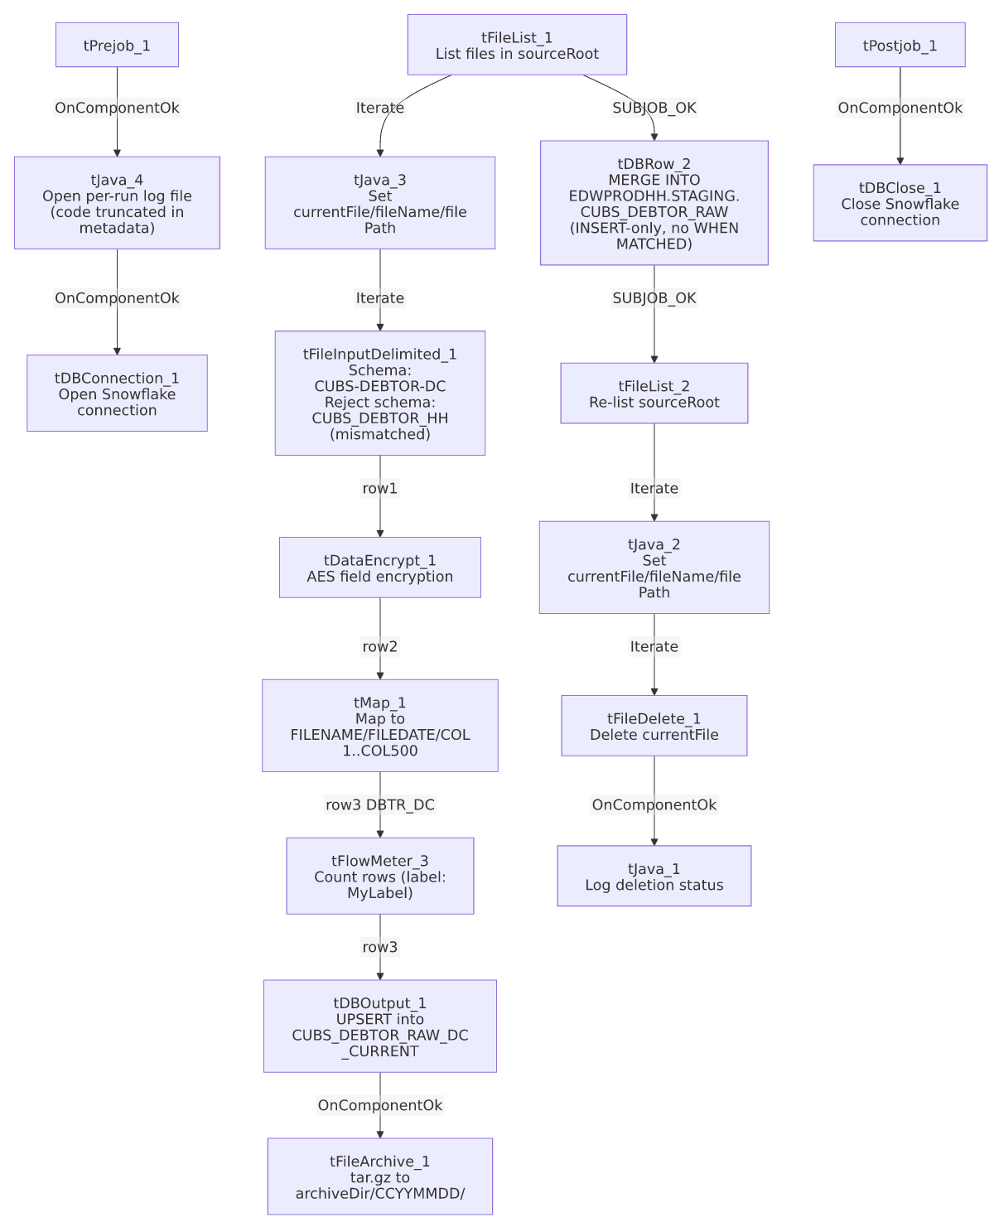

Settings tables

Source: `tFileInputDelimited_1`
Setting | Value | What it means
FILENAME | context.currentFile | The current file path from tFileList_1's iteration (set by tJava_3).
SCHEMA (main) | Repository schema CUBS-DEBTOR-DC (id _GDvAIMyiEey68bfiIIIBcg) | ~419 named debtor columns (LOGON, DEBTOR, NAME1/NAME2, ADD1/ADD2, SSN, balance/date fields, etc.) expected for a well-formed DC debtor row.
SCHEMA_REJECT | Repository schema CUBS_DEBTOR_HH (id _P5bI4GQVEeyyeeshWCVUmg) | Mislabeled for a different site (HH, not DC) — see Issues observed.
FIELDSEPARATOR / ROWSEPARATOR / HEADER / ENCODING | context.EXPORT_DEBTOR_FieldSeparator / _RowSeparator / _Header / _Encoding | Delimiter and header handling are driven entirely by context values rather than hardcoded; actual runtime values aren't present in this job's own metadata.
ESCAPE_CHAR / TEXT_ENCLOSURE | " / " | Standard double-quote text qualifier.
DIE_ON_ERROR | false | Malformed rows do not fail the job.
Reject flow | Not wired | No connection carries rejected rows anywhere in this job — they are silently dropped. See Issues observed.
TEMP_DIR | "C:/Talend-Studio-20211109_1610-V8.0.1/workspace" | Hardcoded developer-workstation path — project-wide risk documented in 05_operational_runbook.md.

Transform: `tDataEncrypt_1`
Setting | Value | What it means
CRYPTO_METHOD | AES | Symmetric encryption applied to the row's fields.
SECRET_TYPE / SECRET_KEY / PASSWORD_M1 | ***REDACTED*** | Key material — preserved exactly as redacted in the source metadata, not guessable.
CRYPTO_FILE_PATH | context.cryptoPath | Key/config file location supplied via context, not hardcoded.
ALGO_VERSION | 2 | Encryption algorithm version identifier.
Which columns are encrypted | Not captured in this component's extracted parameters | Only algorithm-level settings were captured; the per-column encryption selection isn't visible in this metadata. Output schema narrows from ~419 to 413 columns between the file read and this step — unable to fully reconcile the exact column-level change from metadata alone. Verify directly in Talend Studio.

Transform: `tMap_1`
Setting | Value | What it means
DIE_ON_ERROR | true | Any mapping/lookup failure fails the job outright (unlike the upstream file-read step).
Output schema | FILENAME, FILEDATE, COL1...COL500 (500 generic columns) | Flattens the ~413 named, encrypted debtor columns positionally into a generic wide landing schema — a raw-dump pattern rather than a business-named target schema.
ROWS_BUFFER_SIZE | 2000000 | In-memory row buffer size used by the map's lookup/join processing.

Monitor: `tFlowMeter_3`
Setting | Value | What it means
METTERLABEL | "MyLabel" | Left at its Talend default, not renamed for this job — cosmetic only.

Target: `tDBOutput_1` (`tSnowflakeOutput`)
Setting | Value | What it means
Table | CUBS_DEBTOR_RAW_DC_CURRENT | DC-site-specific staging table that receives this run's parsed file rows.
Output action | UPSERT | Talend-level upsert into the staging table itself — distinct from the cross-site MERGE that follows.
Table action | NONE | Table is not recreated/altered by this job.

Merge step: `tDBRow_2` (`tSnowflakeRow`)
Setting | Value | What it means
Query | MERGE INTO EDWPRODHH.STAGING.CUBS_DEBTOR_RAW AS tgt USING STAGING.CUBS_DEBTOR_RAW_DC_CURRENT AS src ON tgt.FILEDATE = src.FILEDATE AND tgt.COL3 = src.COL3 WHEN NOT MATCHED THEN INSERT (FILENAME, FILEDATE, COL1...COL500) VALUES (src.FILENAME, src.FILEDATE, src.COL1...src.COL500); | Merges this run's staged DC rows into the shared, cross-site CUBS_DEBTOR_RAW table. No `WHEN MATCHED` clause is present — see Issues observed.
Match keys | FILEDATE, COL3 | COL3 is a positionally-mapped generic column from tMap_1's COL1...COL500 scheme; its real business meaning isn't stated anywhere in this job's own metadata.
Result schema | errorCode, errorMessage only | No RETVALUE/row-count capture is wired after this step, unlike the RETVALUE → context.mergeResult pattern seen in ADP_Payroll_Load.

Archive & cleanup: `tFileArchive_1` / `tFileDelete_1`
Setting | Value | What it means
TARGET (tFileArchive_1) | context.archiveDir+"/"+TalendDate.getDate("CCYYMMDD")+"/"+context.fileName+".tar.gz" | Archives the source file into a date-stamped subfolder.
SOURCE_FILE (tFileArchive_1) | "C:/Talend-Studio-20211109_1610-V8.0.1/workspace/source.csv" | Hardcoded default value that coexists with the real SOURCE=context.filePath parameter — likely an inert leftover template value. See Issues observed.
PASSWORD (tFileArchive_1) | ***REDACTED*** | Present but ENCRYPT_FILES=false, so it is not actually applied to the archive.
DIRECTORY / PATH (tFileDelete_1) | "C:/Talend-Studio-20211109_1610-V8.0.1/workspace/delete_folder" / ".../delete_folder or delete_file" | Hardcoded, placeholder-looking default text; FILENAME=context.currentFile is the value that actually drives which file is deleted. See Issues observed.

Dependencies & configuration
- No `tRunJob` components in this job (runjob_targets is empty), and this job does not appear as a target anywhere in 06_dependency_matrix.md either — it does not appear to be triggered by, or trigger, any other Talend job in this project's captured metadata. Its scheduling/trigger mechanism is external to Talend orchestration — verify with the team.
- Context variables used: EXPORT_DEBTOR_Encoding, EXPORT_DEBTOR_FieldSeparator, EXPORT_DEBTOR_Header, EXPORT_DEBTOR_RowSeparator, archiveDir, cryptoPath, currentFile, currentLogon, fileName, filePath, logDir, sourceRoot.
- 4 hardcoded developer-workstation paths — tFileInputDelimited_1.TEMP_DIR, tFileArchive_1.SOURCE_FILE, tFileDelete_1.DIRECTORY, tFileDelete_1.PATH (all C:/Talend-Studio-20211109_1610-V8.0.1/workspace/...) — same project-wide portability risk documented in 05_operational_runbook.md.
- The target database EDWPRODHH is used across many site-specific jobs (CHI, CO, DC, HH, PRE, TOL), so it is the shared production Snowflake database, not something specific to the "HH" site code — no naming conflict there despite the coincidental initials.

Glossary
Component type | Plain-English meaning
tPrejob / tPostjob | Bracket the job's real setup and teardown logic; run once before/after everything else.
tJava | Runs a block of custom Java code once.
tFileList | Lists files in a directory for the job to iterate over one at a time.
tFileInputDelimited | Reads a delimited (CSV-style) text file according to a schema.
tDataEncrypt | Encrypts one or more fields in the row using a configured algorithm and key.
tMap | Maps/transforms columns from one schema to another.
tFlowMeter | Counts rows passing through a point in the flow, for logging/monitoring.
tSnowflakeOutput / tSnowflakeRow / tSnowflakeConnection / tSnowflakeClose | Write rows to a Snowflake table / run an arbitrary SQL statement (including MERGE) against Snowflake / open and close the Snowflake connection used throughout the job.
tFileArchive / tFileDelete | Archive a processed file to a target location, then delete a file from the source directory.

Issues observed
- The reject schema on `tFileInputDelimited_1` is labeled `CUBS_DEBTOR_HH`, not `CUBS_DEBTOR_DC`. This is the DC variant of the job template, but its reject schema appears to reference the HH site's schema instead — the same kind of copy-paste-and-not-repointed pattern documented for ADP_Payroll_Load's roster/payroll mismatch. Compounding this, no reject flow is actually wired from tFileInputDelimited_1 (DIE_ON_ERROR=false, but no connection carries rejected rows anywhere), so malformed rows are silently dropped with no record of how many or which ones failed to parse.
- The final `MERGE INTO EDWPRODHH.STAGING.CUBS_DEBTOR_RAW` has only a `WHEN NOT MATCHED THEN INSERT` clause — no `WHEN MATCHED THEN UPDATE`. Despite the job's name ending in _Upsert, this specific SQL statement is insert-only for any (FILEDATE, COL3) combination that already exists in the target table; the "upsert" behavior only happens one step earlier, at the Talend-level UPSERT action into the DC staging table (tDBOutput_1). If a row for an existing (FILEDATE, COL3) needs to be corrected after its first load, this merge step as written would not update it — verify with the team whether that is intentional.
- Two-phase list-then-delete introduces a possible race window. tFileList_1 captures the file listing used for load + archive; independently, tFileList_2 re-lists the same context.sourceRoot directory afterward, and every file it finds is deleted via tFileDelete_1. Any file that lands in sourceRoot between the two listing passes would be picked up by tFileList_2 and deleted without ever having been loaded into Snowflake.
- The merge's join key `COL3` is not traceable to a business column name from this job's own metadata. Because tMap_1 flattens all named debtor columns into generic COL1...COL500 positions, confirming what COL3 actually represents (e.g., a debtor ID) requires checking tMap_1's actual column mapping order directly in Talend Studio — unable to determine from metadata alone.
- `tJava_1`, `tJava_3`, and `tJava_4`'s `CODE` values are all truncated at exactly 253 characters in the extracted metadata, cutting off mid-statement in each case. The full logic of the per-file processing message, the file-deletion status logging, and the log-file setup code beyond what's shown here is not available — unable to determine from metadata; verify directly in Talend Studio if the exact logic matters.
- `tFileArchive_1.SOURCE_FILE` and `tFileDelete_1.DIRECTORY`/`PATH` hold hardcoded, template-looking default values (.../workspace/source.csv, .../workspace/delete_folder) that coexist with the real, context-driven parameters that appear to actually govern behavior (SOURCE=context.filePath, FILENAME=context.currentFile). These are very likely inert leftover defaults rather than active settings, but that can't be fully confirmed from metadata alone — flagged here per the project-wide hardcoded-path pattern in 05_operational_runbook.md.

