Talend Job: CUBS_Raw_Debtor_Load_Test

Overview
A minimal test/wrapper job that does not load any business data itself — it exists solely to call `CUBS_Raw_DC_Debtor_Load_No_Delete` (a _No_Delete variant of the DC-site debtor loader, not part of this batch) via tRunJob and print a completion message. Based on its name and the single job it triggers, this appears to be a developer test harness for exercising the DC debtor load without the file-deletion side effect of the production job, rather than a job that runs as part of the regular pipeline.

Detail table
Field | Value
Job name | CUBS_Raw_Debtor_Load_Test
Version | 0.4
Project | EDW2SF
Author | jmach@harriscollect.com
Created | 2022-12-05T17:12:25.316-0800
Last Modified | 2025-08-28T08:57:13.850-0700

Step-by-step data flow
Setup subjob: tPrejob_1 → tJava_2 opens a per-run log file at context.logDir + jobName + "_" + <timestamp> + ".log" and redirects System.out/System.err to it.
Main subjob: tRunJob_2 calls `CUBS_Raw_DC_Debtor_Load_No_Delete` (DIE_ON_CHILD_ERROR=true, USE_INDEPENDENT_PROCESS=true, TRANSMIT_ORIGINAL_CONTEXT=true). On success, tSystem_3 runs a shell echo command printing "job <jobName> complete." to the console — a no-op confirmation step with no real system effect.
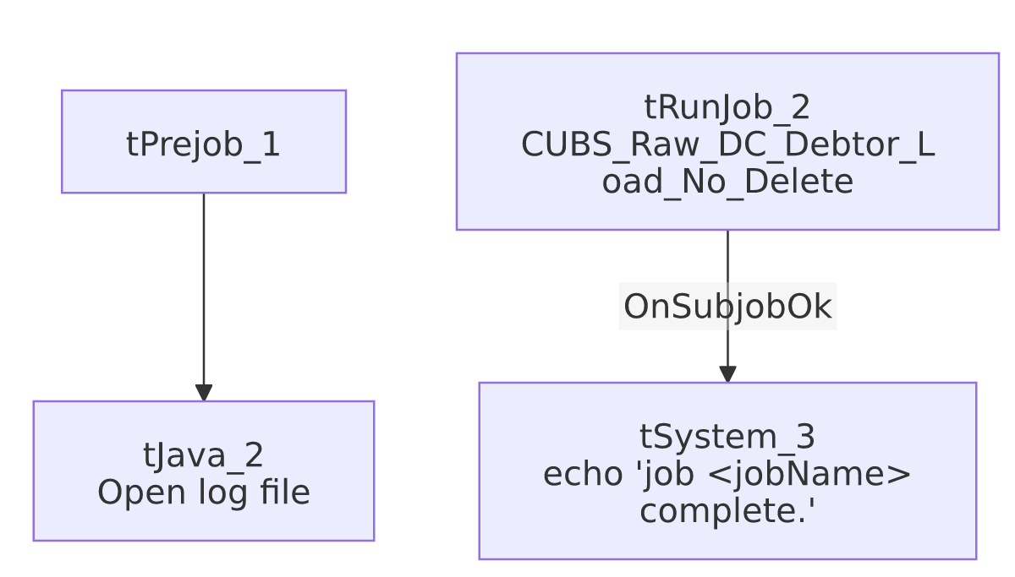

Settings tables

Orchestration: `tRunJob_2`
Setting | Value | What it means
PROCESS | CUBS_Raw_DC_Debtor_Load_No_Delete | The only job this wrapper calls — a DC-site debtor loader variant that (per its name) skips a delete step present in the standard CUBS_Raw_DC_Debtor_Load.
DIE_ON_CHILD_ERROR | true | If the child job fails, this job fails too.
USE_INDEPENDENT_PROCESS | true | Child runs in its own JVM.
TRANSMIT_ORIGINAL_CONTEXT | true | Child receives this job's context values.

Confirmation: `tSystem_3`
Setting | Value | What it means
DIRECTORY | "C:/Talend-Studio-20211109_1610-V8.0.1/workspace" | Hardcoded developer workspace path — see Issues observed and 05_operational_runbook.md.
COMMAND | "echo 'job " + jobName + " complete.'" | Purely cosmetic console output; does not affect any file or database.

Dependencies & configuration
- Triggers/depends on other jobs: calls CUBS_Raw_DC_Debtor_Load_No_Delete (once). This job itself is not called by any other job in the extracted tRunJob metadata (see 06_dependency_matrix.md) — consistent with it being a standalone test harness.
- Context variables used: logDir only.
- 1 hardcoded developer-workstation path (tSystem_3.DIRECTORY, C:/Talend-Studio-20211109_1610-V8.0.1/workspace) — same project-wide risk documented in 05_operational_runbook.md.

Glossary
Component type | Plain-English meaning
tRunJob | Runs another Talend job as a sub-process, optionally waiting for it to finish before continuing.
tSystem | Runs an arbitrary OS shell command — here used only to print a completion message to the console.

Issues observed
- This job's name suggests it belongs to the `CUBS_Raw_Debtor_Load` family, but it does not call any of the same jobs `CUBS_Raw_Debtor_Load` calls (that job triggers 5 site debtor loaders: DC, HH, CO, CHI, PRE). Instead it calls a single, differently-named variant (CUBS_Raw_DC_Debtor_Load_No_Delete) that isn't called by CUBS_Raw_Debtor_Load or any other job in this metadata. This looks like a one-off test/debug job kept in the repository alongside the production orchestrator rather than a part of the regular pipeline — worth confirming with the team whether it is still needed or safe to remove.
- No actual data movement, error handling, or logging beyond a log file and a cosmetic echo — if CUBS_Raw_DC_Debtor_Load_No_Delete fails, this job's own error message will not add any diagnostic detail beyond what that child job already reports.
- No other job-specific risks beyond the project-wide patterns already documented in 05_operational_runbook.md.

