Talend Job: CUBS_Raw_DeskInfo_Load

Overview
Backfills CUBS "desk" (collector workstation/team) configuration and month-to-date/year-to-date performance data — desk names, WIP limits, assignment/collection routing rules, and MTD/YTD assignment-and-collection counts and dollar amounts — into the Snowflake table CUBS_DESKINFO_RAW. Unlike the single-file-per-run loaders elsewhere in this project, this job walks a date range (context.startDate through context.endDate, defaulting to "today" for both if unset) and, for each day, loops over a list of logons, reading one file per day-per-logon from context.sourceRoot/<yyyy-MM-dd>/<logon>/. It is called once by CO_Master_Load (see 06_dependency_matrix.md).

Detail table
Field | Value
Job name | CUBS_Raw_DeskInfo_Load
Version | 0.1
Project | EDW2SF
Author | jmach@harriscollect.com
Created | 2022-04-08T10:14:27.817-0700
Last Modified | 2022-04-11T13:39:02.160-0700

Step-by-step data flow
Setup subjob: tPrejob_1 → tDBConnection_1 (OnComponentOk) opens the Snowflake connection directly — no `tSetKeystore_1` component in this job (see Issues observed).
Date-range subjob — starts independently (no incoming connection into tJava_1):
- tJava_1 defaults context.startDate/context.endDate to today if either is null, sets context.currentDate = context.startDate, and computes context.dateDiff = TalendDate.diffDate(endDate, startDate, "dd").
- On success, tLoop_1 (a WHILELOOP, i from 0 while i<=context.dateDiff) iterates once per day in the range.
- Each iteration, tForeach_1 (ITERATE) loops over a fixed list of values (the logon list itself is not captured in this metadata — same limitation noted in Semaphore_Check).
- tJava_2 sets context.currentLogon from the current tForeach_1 value.
- tFileList_1 lists files (non-recursive) in context.sourceRoot + <currentDate as yyyy-MM-dd> + "/" + context.currentLogon.
- tJava_3 (ITERATE) sets context.currentFile to the listed file's path.
- tFileInputDelimited_1 (ITERATE) reads that file against repository schema "metadata" — tab-separated, header row 1, ISO-8859-15, TRIMALL=true, DIE_ON_ERROR=false. ~41 named desk-configuration/performance columns (LOGON, DESK, NAME, MAX_WIP_PRINT, MIN_WIP, BEGIN_TIME/END_TIME, MTD_NUM_ASGN/YTD_NUM_ASGN, MTD_AMT_PMTS/YTD_AMT_PMTS, etc.), listed twice in the extracted metadata (main+reject capture artifact).
- tMap_1 (row1, FLOW) flattens onto a generic FILENAME, FILEDATE, COL1...COL41 shape.
- tDBOutput_1 (DESK_RAW, FLOW) inserts the rows into Snowflake CUBS_DESKINFO_RAW (INSERT, tableAction=NONE).
- When tLoop_1's loop body finishes for the day, tJava_4 (OnComponentOk) advances context.currentDate by one day, and the loop re-evaluates its while-condition.
Teardown: tPostjob_1 → tDBClose_1 (OnComponentOk) closes the Snowflake connection.
Not present in this job: no per-run log-file setup (tJava writing to context.logDir), no tSetKeystore_1, and no tFileArchive/tFileDelete step — source files are never archived or deleted after load. See Issues observed.
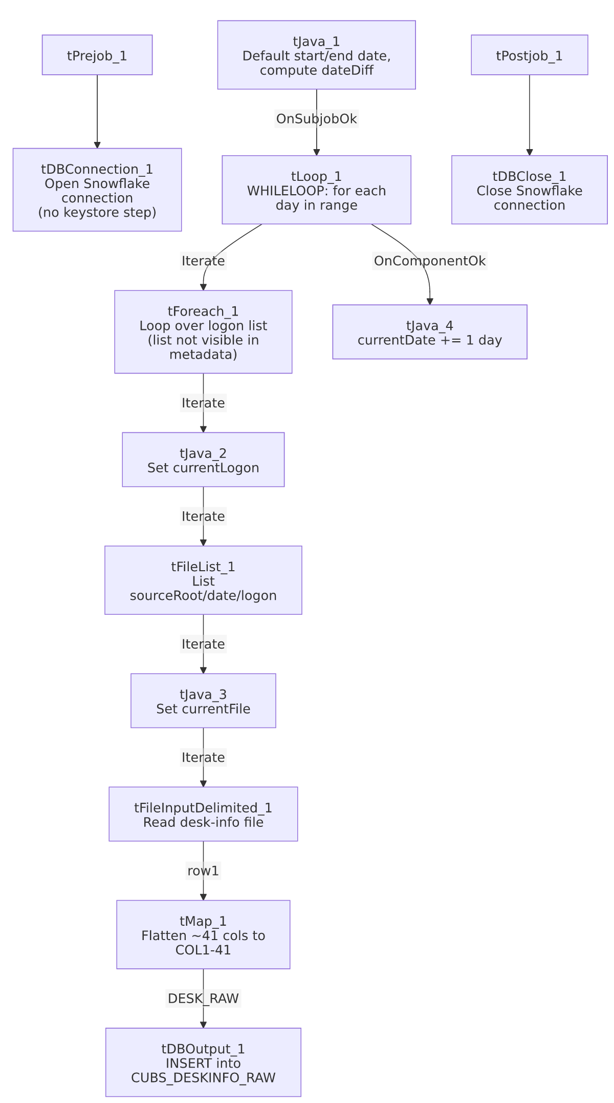

Settings tables

Date range: `tJava_1` / `tLoop_1`
Setting | Value | What it means
Default start/end | TalendDate.getCurrentDate() if unset | If not overridden by the caller's context, this job processes only "today".
tLoop_1 condition | i<=context.dateDiff | Runs once per calendar day from startDate to endDate inclusive.

Source: `tFileList_1` / `tFileInputDelimited_1`
Setting | Value | What it means
DIRECTORY | context.sourceRoot + <yyyy-MM-dd> + "/" + context.currentLogon | Per-day, per-logon subdirectory structure — a backfill-friendly layout distinct from the flat sourceDir used by the single-file loaders.
Main schema | Repository "metadata" (generic label, ~41 desk columns) | Not a desk-specific schema name in the repository.
TRIMALL | true | All fields trimmed of whitespace.
DIE_ON_ERROR | false | Malformed rows don't fail the job; no reject flow is wired.
TEMP_DIR | "C:/Talend-Studio-20211109_1610-V8.0.1/workspace" | Hardcoded developer-workstation path.

Target: `tDBOutput_1` (`tSnowflakeOutput`)
Setting | Value | What it means
Table | CUBS_DESKINFO_RAW | Note: no _CURRENT suffix, unlike most sibling staging tables in this project (CUBS_EM_RAW_CURRENT, CUBS_EMPINFO_RAW_CURRENT, CUBS_ETL_RAW_CURRENT, CUBS_CLIENT_RAW_CURRENT).
Output action | INSERT | Appends; no truncate precedes it in this job.
Table action | NONE | Table not recreated/altered here.

Dependencies & configuration
- Called by: CO_Master_Load, once — see 06_dependency_matrix.md.
- Triggers/depends on other jobs: none — runjob_targets is empty.
- Context variables used: currentDate, currentFile, currentLogon, dateDiff, endDate, sourceRoot, startDate. Note sourceRoot is distinct from the sourceDir variable used by most other StandardFolders_0.1-driven jobs in this project — this job appears to use its own root-directory variable for the date/logon folder structure.
- 1 hardcoded developer-workstation path: tFileInputDelimited_1.TEMP_DIR.

Glossary
Component type | Plain-English meaning
tLoop | Repeats its downstream branch a fixed or conditional number of times — here, a while-loop over a date range.
tForeach | Loops over a fixed list of values, running the same downstream steps once per value.
tFileList | Lists files in a directory, one at a time, for a downstream loop to process.
tFileInputDelimited | Reads a delimited text file according to a schema.
tMap | Maps/transforms columns from one schema to another.
tSnowflakeOutput / tSnowflakeConnection / tSnowflakeClose | Write rows to Snowflake / open and close the Snowflake connection.
tPrejob / tPostjob | Guaranteed-first / guaranteed-last setup and teardown subjobs.
tJava | Runs a block of custom Java code.

Issues observed
- No per-run log file is opened anywhere in this job. Every other CUBS_Raw_* file-loader in this batch (and most of the project) opens a context.logDir-based log file via a dedicated tJava component early in the run; this job has no such component. Diagnosing a failed run would rely entirely on the Talend Studio/scheduler's own execution log rather than this job's own per-run file.
- No `tSetKeystore_1` component, unlike CUBS_Raw_EM_Load, CUBS_Raw_Empinfo_Load, CUBS_Raw_HH_Client_Load, and CUBS_Raw_DC_ETL_Load in this same batch, all of which configure SSL trust/keystore before opening the Snowflake connection. tPrejob_1 connects to tDBConnection_1 directly. Unable to determine from metadata whether this job's Snowflake connection profile requires mutual-TLS the way the others do; verify with the team (same open question already flagged for CUBS_Raw_Client_Load).
- No archive/delete step for processed source files — unlike every single-file loader in this batch, this job never wires a tFileArchive/tFileDelete after the load. Combined with the date-range/backfill design, source files under sourceRoot/<date>/<logon>/ accumulate indefinitely unless cleaned up by some process outside this job.
- The `tForeach_1` logon list is not captured in this metadata (same limitation as Semaphore_Check) — unable to determine which or how many logons are processed per day; verify directly in Talend Studio.
- Target table `CUBS_DESKINFO_RAW` has no `_CURRENT` suffix and no visible truncate/merge step, unlike the _RAW_CURRENT naming and orchestrator-level truncate/merge pattern seen in the ETL family (CUBS_Raw_DC_ETL_Load → CUBS_Raw_ETL_Load). Because this job also defaults to processing only "today" if no explicit date range is supplied, and always appends (INSERT, no truncate), re-running it for the same day/logon combination would very likely duplicate rows in CUBS_DESKINFO_RAW — worth confirming with the team whether a downstream process deduplicates, or whether reruns need to be handled carefully.

