Talend Job: CUBS_Raw_EM_Load

Overview
Loads a single CUBS "electronic media" export — letter/notice status records per debtor account (letter name, status/status-type/status-text, series and waterfall tracking, source of the status update) — for one site logon into the Snowflake staging table CUBS_EM_RAW_CURRENT, then archives and deletes the source file. It follows the same single-file, context.EXPORT_EM_*-context-group-driven template used by CUBS_Raw_Empinfo_Load in this same batch. It is called once by CO_Master_Load (see 06_dependency_matrix.md).

Detail table
Field | Value
Job name | CUBS_Raw_EM_Load
Version | 0.1
Project | EDW2SF
Author | jmach@harriscollect.com
Created | 2022-10-06T10:20:12.441-0700
Last Modified | 2025-11-04T11:08:13.798-0800

Step-by-step data flow
Setup subjob: tPrejob_1 → tJava_1 (OnComponentOk) opens a per-run log file at context.logDir + context.currentLogon + "_" + jobName + "_" + <timestamp> + ".log" → on success, tSetKeystore_1 configures SSL trust/keystore from context.keystorePath (passwords redacted) → tDBConnection_1 opens the Snowflake connection.
Main subjob — starts independently of the setup subjob:
- tFileInputDelimited_1 reads context.sourceDir + context.EXPORT_EM_File, with row/field separator, header flag, and encoding all driven by the EXPORT_EM_0.1 context group (defaults: \n row separator, \t field separator, header row 1, US-ASCII encoding, default filename Q:/HH-EDW-EXPORT-EM.txt per _shared_context.json). Uses repository schema "em" (~18 named columns: LOGON, EMID, LETTER_NAME, STATUS_DATE, STATUS, STATUS_TEXT, STATUS_TYPE, WATERFALL, UPDATE_DT, CURR_SERIES/NEW_SERIES, SOURCE, SRC_NAME, etc.). CSVROWSEPARATOR is set to context.EXPORT_TRANS_RowSeparator rather than an EXPORT_EM_* variable (only relevant if CSV_OPTION is turned on — currently false — same copy-paste pattern flagged in the CHI/HH Client Load siblings). DIE_ON_ERROR=false; reject schema mislabeled "CUBS_TRANSACTION".
- tMap_1 (row1, FLOW) flattens the ~18 named columns onto a generic FILENAME, FILEDATE, COL1...COL20 shape.
- tFlowMeter_2 (em, FLOW) counts rows.
- tDBOutput_1 (row2, FLOW) inserts the rows into Snowflake CUBS_EM_RAW_CURRENT (INSERT, tableAction=NONE).
- On the input file's OnSubjobOk, tFileArchive_1 archives context.sourceDir to context.archiveDir + "/" + <YYYYMMDD> + "/" + context.EXPORT_EM_File + ".tar.gz" (password redacted).
- On archive OnSubjobOk, tFileDelete_1 deletes context.sourceDir + context.EXPORT_EM_File.
Teardown subjob: tPostjob_1 → tDBClose_1 (OnComponentOk) closes the Snowflake connection.
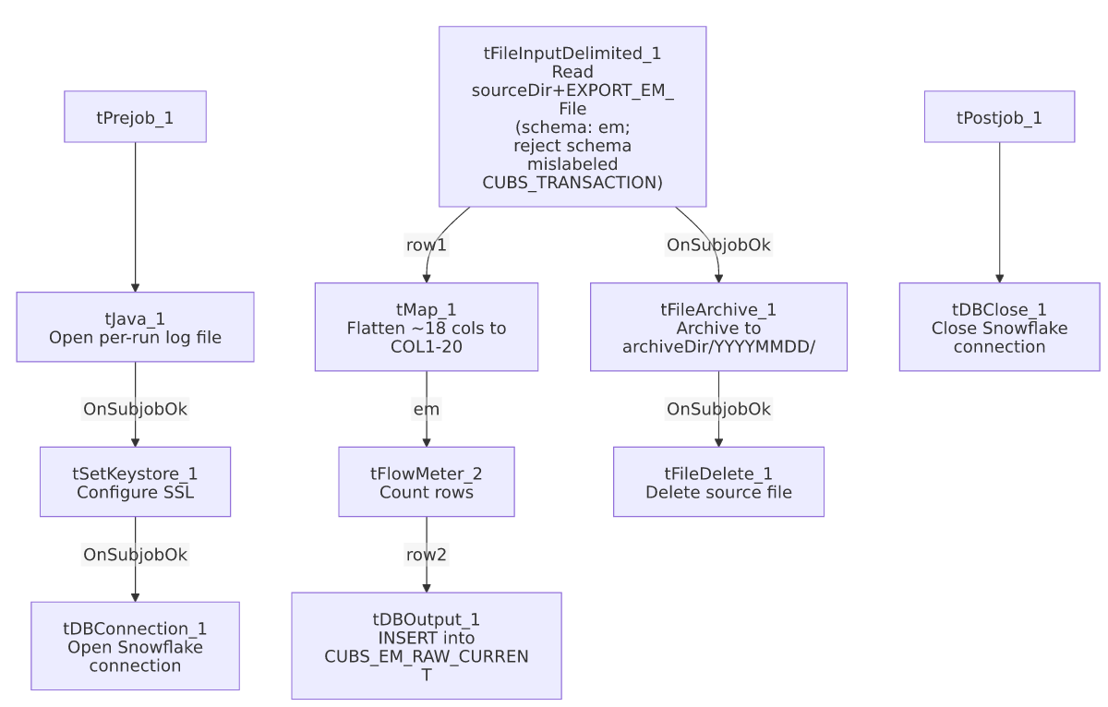

Settings tables

Source: `tFileInputDelimited_1`
Setting | Value | What it means
FILENAME | context.sourceDir + context.EXPORT_EM_File | EXPORT_EM_File defaults to Q:/HH-EDW-EXPORT-EM.txt per _shared_context.json.
ROWSEPARATOR / FIELDSEPARATOR / HEADER / ENCODING | All from EXPORT_EM_0.1 context group | Defaults: \n, \t, header row 1, US-ASCII.
CSVROWSEPARATOR | context.EXPORT_TRANS_RowSeparator | Mismatched context family (only applies if CSV_OPTION=true, currently false) — same class of copy-paste artifact as in CUBS_Raw_HH_Client_Load.
SCHEMA (main) | Repository "em" | ~18 electronic-media status columns.
SCHEMA_REJECT | Repository "CUBS_TRANSACTION" | Mislabeled — not an EM-specific reject schema, same pattern seen throughout this project.
DIE_ON_ERROR | false | Malformed rows don't fail the job; no reject flow is wired.
TEMP_DIR | "C:/Talend-Studio-20211109_1610-V8.0.1/workspace" | Hardcoded developer-workstation path.

Target: `tDBOutput_1` (`tSnowflakeOutput`)
Setting | Value | What it means
Table | CUBS_EM_RAW_CURRENT | Destination raw landing table.
Output action | INSERT | Appends rows; no truncate step precedes it in this job.
Table action | NONE | Table not recreated/altered by this job.

`tFileArchive_1` / `tFileDelete_1`
Setting | Value | What it means
TARGET (archive) | context.archiveDir + "/" + <YYYYMMDD> + "/" + context.EXPORT_EM_File + ".tar.gz" | Per-run, dated archive named after the export file.
PASSWORD | ***REDACTED*** | Preserved as redacted.
FILENAME (delete) | context.sourceDir + context.EXPORT_EM_File | Deletes the exact file that was loaded.

Dependencies & configuration
- Called by: CO_Master_Load, once — see 06_dependency_matrix.md.
- Triggers/depends on other jobs: none — runjob_targets is empty.
- Context variables used: EXPORT_EM_Encoding, EXPORT_EM_FieldSeparator, EXPORT_EM_File, EXPORT_EM_Header, EXPORT_EM_RowSeparator, EXPORT_TRANS_RowSeparator (mismatched — see Issues observed), archiveDir, currentLogon, keystorePath, logDir, sourceDir.
- 5 hardcoded developer-workstation paths: tFileInputDelimited_1.TEMP_DIR, tFileArchive_1.SOURCE_FILE, tFileDelete_1.DIRECTORY/PATH, tSetKeystore_1.SSL_TRUSTSERVER_TRUSTSTORE — same project-wide pattern documented in 05_operational_runbook.md.

Glossary
Component type | Plain-English meaning
tFileInputDelimited | Reads a delimited text file according to a schema.
tMap | Maps/transforms columns from one schema to another.
tFlowMeter | Counts rows passing a point in the flow.
tSnowflakeOutput / tSnowflakeConnection / tSnowflakeClose | Write rows to Snowflake / open and close the Snowflake connection.
tFileArchive / tFileDelete | Zip a processed file to an archive location, then delete the original.
tSetKeystore | Configures the SSL keystore/truststore used by the Snowflake connection.
tPrejob / tPostjob | Guaranteed-first / guaranteed-last setup and teardown subjobs.
tJava | Runs a block of custom Java code.

Issues observed
- `CSVROWSEPARATOR` references `context.EXPORT_TRANS_RowSeparator`, not an EXPORT_EM_* variable, while every other separator/header/encoding setting on the same component is correctly scoped to EXPORT_EM_*. Same copy-paste-from-a-Trans-template pattern already flagged in CUBS_Raw_HH_Client_Load/CUBS_Raw_CHI_Client_Load; only matters if CSV_OPTION is ever switched on (currently false).
- Reject schema mislabeled `"CUBS_TRANSACTION"`, not an EM-specific reject schema — same pattern flagged across most CUBS_Raw_* file loaders in this project. No reject flow is wired despite DIE_ON_ERROR=false, so malformed rows are silently dropped.
- No `TRUNCATE` step and no merge call anywhere in this job, despite the target table being named CUBS_EM_RAW_CURRENT — same missing-refresh-step concern flagged for the Client-load family. Re-running this job for the same logon/day would append duplicate rows rather than replace them, unless a downstream process (not visible in this job's own metadata) truncates or merges CUBS_EM_RAW_CURRENT.
- Archive and delete are triggered by the file read's own `SUBJOB_OK`, not by the Snowflake insert's success — a failure downstream in tMap_1/tFlowMeter_2/tDBOutput_1 would still result in the source file being archived and deleted, same ordering risk flagged in CUBS_Raw_CHI_Client_Load.

