Talend Job: CUBS_Raw_EMail_Address_Load

Overview
Loads per-debtor email/electronic-media address records (media type, address, authorization status/date, source, notes, and balance) for one site logon directly into the Snowflake dimension table DIM_ELECTRONIC_MEDIA via UPSERT — unlike most other CUBS_Raw_* loaders in this project, which land rows into a generic *_RAW_CURRENT staging table with a plain INSERT. It waits for a per-logon completion semaphore file before reading, and it is the only job in this batch with a correctly-wired reject-row output. Per 06_dependency_matrix.md, a generic dispatcher job named EMail_Address_Load calls this job 6 times — almost certainly once per site logon (CHI/CO/DC/HH/PRE/TOL).

Detail table
Field | Value
Job name | CUBS_Raw_EMail_Address_Load
Version | 0.1
Project | EDW2SF
Author | jmach@harriscollect.com
Created | 2023-02-06T15:10:49.463-0800
Last Modified | 2024-02-22T09:02:20.996-0800

Step-by-step data flow
Setup subjob: tPrejob_1 → tJava_1 (OnComponentOk) opens a per-run log file at context.logDir + context.currentLogon + "_" + jobName + "_" + <timestamp> + ".log" → on success, tDBConnection_1 opens the Snowflake connection directly (no tSetKeystore_1 in this job — see Issues observed).
Main subjob — starts independently of the setup subjob:
- tWaitForFile_1 polls context.sourceDir every 30 seconds, up to context.loopCount iterations, for a file named context.currentLogon + "-EDW-COMPLETE.txt" (or proceeds immediately if already present, INCLUDE_PRESENT=true) — the same semaphore-gate pattern used by CO_Master_Load's tWaitForFile_4, but scoped per logon here rather than per fixed site name.
- On success, tJava_2 logs "Processing <sourceDir><currentLogon><sourceFile>" then, on OnSubjobOk, tFileInputDelimited_1 reads context.sourceDir + context.currentLogon + context.sourceFile — note this uses the generic context.sourceFile variable, not an EXPORT_EMAIL_*-family variable, even though a matching EXPORT_EMAIL_0.1 context group exists in _shared_context.json (see Issues observed). Comma-separated, header row 1, US-ASCII, CHECK_FIELDS_NUM=true, DIE_ON_ERROR=false. Schema "email" (18 columns: Account_Media_Address, Media, Add_Type, Address, Source, Src_Name, Authorization, Auth_Dt, Status, Status_Dt, Entry_Dt, Inherit_From, Nt_Date/Nt_Time/Nt_Who, Note_Text, PL_GROUP, TOTAL_BAL, DNUM); the reject schema is also correctly `"email"`, not the mislabeled CUBS_TRANSACTION schema seen elsewhere in this project.
- On the input's FLOW, tMap_1 maps the named columns to LOGON, DEBTORNUMBER, DEBTOR_IDX, MEDIA, ADDRESS_TYPE, MEDIA_ADDRESS, ADDR_SOURCE, SRC_NAME, AUTH_STATUS, AUTH_DATE, STATUS, STATUS_DT, ENTRY_DT, NT_DATE/NT_TIME/NT_WHO, NOTE_TEXT, PL_GROUP, TOTAL_BAL — a real business-name target schema, not a generic COL1...COLn flatten.
- On the input's REJECT output, rejected rows are written to tFileOutputDelimited_1 at context.logDir + context.currentLogon + "_EMAIL_REJECTS_" + <date> + ".csv" — the only reject flow actually wired to a file in this batch of 7 jobs.
- tFlowMeter_2 (email, FLOW) counts accepted rows.
- tDBOutput_1 (row2, FLOW) upserts the rows into Snowflake DIM_ELECTRONIC_MEDIA (UPSERT, tableAction=NONE) — writing directly to a dimension table rather than a raw staging table.
- On the input's SUBJOB_OK, tFileArchive_1 archives context.sourceDir to context.archiveDir + "/" + <YYYYMMDD> + "/" + context.currentLogon + context.sourceFile + ".tar.gz" (password redacted), then on success tFileDelete_1 deletes context.sourceDir + context.currentLogon + context.sourceFile.
Teardown subjob: tPostjob_1 → tDBClose_1 (OnComponentOk) closes the Snowflake connection.
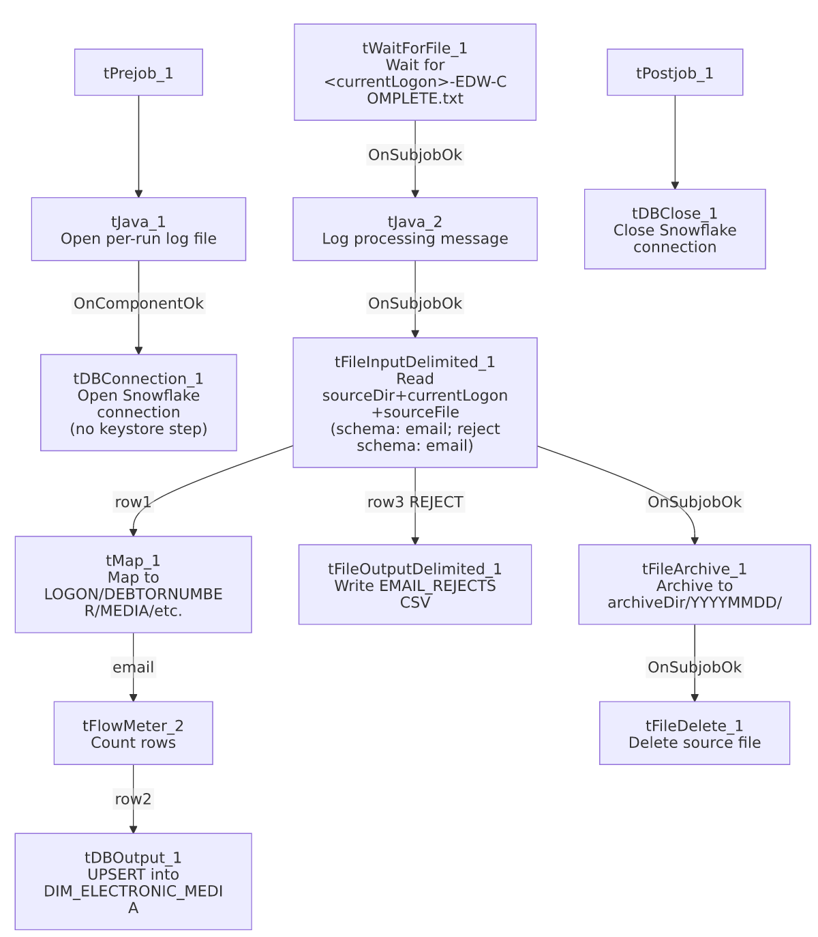

Settings tables

Gate: `tWaitForFile_1`
Setting | Value | What it means
DIRECTORY / FILEMASK | context.sourceDir / context.currentLogon + "-EDW-COMPLETE.txt" | Per-logon completion semaphore, checked before reading the actual data file.
WAIT / MAX_ITERATIONS | 30 (seconds) / context.loopCount | Total wait time depends on loopCount, not fixed in this job's own metadata.

Source: `tFileInputDelimited_1`
Setting | Value | What it means
FILENAME | context.sourceDir + context.currentLogon + context.sourceFile | Uses generic sourceFile, not an EXPORT_EMAIL_* variable — see Issues observed.
FIELDSEPARATOR / HEADER / ENCODING | "," / 1 / US-ASCII | Comma-separated, unlike the tab-separated EXPORT_* family used elsewhere.
CHECK_FIELDS_NUM | true | Rejects rows whose field count doesn't match the schema — stricter than most other loaders in this project (false elsewhere).
SCHEMA (main) / SCHEMA_REJECT | Both repository "email" | Correctly matched main/reject schema — unlike the mislabeled-reject pattern in most sibling jobs.
DIE_ON_ERROR | false | Malformed rows are rejected (to the wired reject flow) rather than failing the job.
TEMP_DIR | "C:/Talend-Studio-20211109_1610-V8.0.1/workspace" | Hardcoded developer-workstation path.

Reject output: `tFileOutputDelimited_1`
Setting | Value | What it means
FILENAME | context.logDir + context.currentLogon + "_EMAIL_REJECTS_" + <CCYY-MM-DD> + ".csv" | Dated, per-logon reject file written alongside the log directory.
INCLUDEHEADER | true | Reject file includes a header row for readability.

Target: `tDBOutput_1` (`tSnowflakeOutput`)
Setting | Value | What it means
Table | DIM_ELECTRONIC_MEDIA | A dimension table, not a *_RAW_CURRENT staging table.
Output action | UPSERT | Inserts new rows and updates existing ones — the only UPSERT target in this batch of 7 jobs.
Table action | NONE | Table not recreated/altered here.

`tFileArchive_1` / `tFileDelete_1`
Setting | Value | What it means
TARGET (archive) | context.archiveDir + "/" + <YYYYMMDD> + "/" + context.currentLogon + context.sourceFile + ".tar.gz" | Per-logon, dated archive.
PASSWORD | ***REDACTED*** | Preserved as redacted.

Dependencies & configuration
- Called by: EMail_Address_Load, 6 times — see 06_dependency_matrix.md. This strongly suggests one call per site logon (CHI/CO/DC/HH/PRE/TOL), each presumably passing a different context.currentLogon value, though the calling job's own context-override values are outside this job's metadata.
- Triggers/depends on other jobs: none — runjob_targets is empty.
- Context variables used: archiveDir, currentLogon, logDir, loopCount, sourceDir, sourceFile.
- 4 hardcoded developer-workstation paths: tFileInputDelimited_1.TEMP_DIR, tFileArchive_1.SOURCE_FILE, tFileDelete_1.DIRECTORY/PATH — one fewer than most siblings since there is no tSetKeystore_1 component (and therefore no hardcoded truststore path) in this job.

Glossary
Component type | Plain-English meaning
tWaitForFile | Polls a directory for a specific file to appear, for up to a configured number of attempts, before letting the job continue.
tFileInputDelimited | Reads a delimited text file according to a schema.
tMap | Maps/transforms columns from one schema to another.
tFileOutputDelimited | Writes rows to a delimited text file — here, rejected input rows.
tFlowMeter | Counts rows passing a point in the flow.
tSnowflakeOutput / tSnowflakeConnection / tSnowflakeClose | Write rows to Snowflake / open and close the Snowflake connection.
tFileArchive / tFileDelete | Zip a processed file to an archive location, then delete the original.
tPrejob / tPostjob | Guaranteed-first / guaranteed-last setup and teardown subjobs.
tJava | Runs a block of custom Java code.

Issues observed
- This job uses the generic `context.sourceFile` variable rather than an `EXPORT_EMAIL_*` context variable, even though _shared_context.json defines a matching EXPORT_EMAIL_0.1 group (with EXPORT_EMAIL_File defaulting to Z:/EDW/2021-11-27/HH/HH-EDW-EXPORT-EM.txt) that this job's context_vars_referenced list never touches. Every other EXPORT_*-pattern loader in this project (Client, EM, Empinfo) consistently uses its own matching EXPORT_<TYPE>_* family. Unable to determine from metadata whether EXPORT_EMAIL_0.1 is simply unused/orphaned, or whether context.sourceFile is meant to be set per-call by the EMail_Address_Load dispatcher to the same effective value — verify with the team.
- No `tSetKeystore_1` component, unlike CUBS_Raw_EM_Load, CUBS_Raw_Empinfo_Load, CUBS_Raw_HH_Client_Load, and CUBS_Raw_DC_ETL_Load in this same batch. Same open question already flagged for CUBS_Raw_Client_Load and CUBS_Raw_DeskInfo_Load about whether this job's Snowflake profile needs mutual-TLS.
- This is the only job in this 7-job batch with a correctly-wired reject flow and a matching main/reject schema — a notable positive contrast to the mislabeled-CUBS_TRANSACTION-reject-schema pattern seen in CUBS_Raw_EM_Load, CUBS_Raw_Empinfo_Load, and the Client-load family. No further action needed here; flagged only for contrast when reviewing the rest of the project.
- Writing directly to `DIM_ELECTRONIC_MEDIA` via `UPSERT` (rather than to a *_RAW_CURRENT staging table with a separate merge step) means there is no raw/staging copy of this data preserved for reprocessing or audit within this job — if the upsert logic or source file has an error, there's no intermediate staging table to inspect before it lands in the dimension table.

