Talend Job: CUBS_Raw_ETL_Load

Overview
This is the orchestrator for the site-specific "ETL" extract family: it waits for each site's completion semaphore file, runs that site's CUBS_Raw_<SITE>_ETL_Load job (DC, HH, CO, CHI, PRE, and — currently disabled — TOL), and once all of them finish, merges the shared STAGING.CUBS_ETL_RAW_CURRENT staging table into its final target via a stored procedure. Unlike CO_Master_Load (which chains many *different* job types together), this job fans out to six near-identical site loaders and re-converges before a single merge step — it's the ETL family's counterpart to CUBS_Raw_Debtor_Load's per-site dispatch pattern (see 06_dependency_matrix.md). CUBS_Raw_DC_ETL_Load, one of the six site loaders it calls, is also documented in this batch.

Detail table
Field | Value
Job name | CUBS_Raw_ETL_Load
Version | 0.4
Project | EDW2SF
Author | jmach@harriscollect.com
Created | 2022-12-12T15:13:07.135-0800
Last Modified | 2026-08-07T14:16:23.103-0700

Step-by-step data flow
Setup subjob: tPrejob_1 → tJava_2 (OnComponentOk) opens a per-run log file at context.logDir + jobName + "_" + <timestamp> + ".log" → on success, tSetKeystore_1 configures SSL trust/keystore (passwords redacted) → tDBConnection_1 opens the Snowflake connection.
Main orchestration subjob — starts independently of the setup subjob:
- tDBRow_1 runs TRUNCATE TABLE STAGING.CUBS_ETL_RAW_CURRENT; — clears the shared staging table before any site loads begin.
- On success, tParallelize_1 fires six branches at once (WAIT_FOR=All, DIE_ON_ERROR=false), each a tWaitForFile gate on a different site's completion marker in a site-specific directory:
- tWaitForFile_1 — context.rootDir / "PRE-EDW-COMPLETE.txt" → on success, tRunJob_5 (CUBS_Raw_PRE_ETL_Load)
- tWaitForFile_2 — context.rootDCDir / "DC-EDW-COMPLETE.txt" → on success, tRunJob_1 (CUBS_Raw_DC_ETL_Load)
- tWaitForFile_3 — context.rootDir / "HH-EDW-COMPLETE.txt" → on success, tRunJob_2 (CUBS_Raw_HH_ETL_Load)
- tWaitForFile_4 — context.rootDir / "CO-EDW-COMPLETE.txt" → on success, tRunJob_3 (CUBS_Raw_CO_ETL_Load)
- tWaitForFile_5 — context.rootDir / "CHI-EDW-COMPLETE.txt" → on success, tRunJob_4 (CUBS_Raw_CHI_ETL_Load)
- tWaitForFile_6 (ACTIVATE=false, i.e. disabled) — context.rootDir / "TOL-EDW-COMPLETE.txt" → would trigger tRunJob_6 (CUBS_Raw_TOL_ETL_Load, also ACTIVATE=false) if enabled
- All six tRunJob branches (DIE_ON_CHILD_ERROR=true, USE_INDEPENDENT_PROCESS=true each) converge on tParallelize_2 (SUBJOB_OK from each), which waits for all of them (WAIT_FOR=All, DIE_ON_ERROR=true) before proceeding.
- On SYNCHRONIZE, tDBRow_2 runs CALL STAGING.MERGE_INTO_CUBS_ETL_RAW(); — merges the now-populated staging table into its downstream target.
- On success, tSystem_3 runs a shell echo confirming the job name completed (output to console).
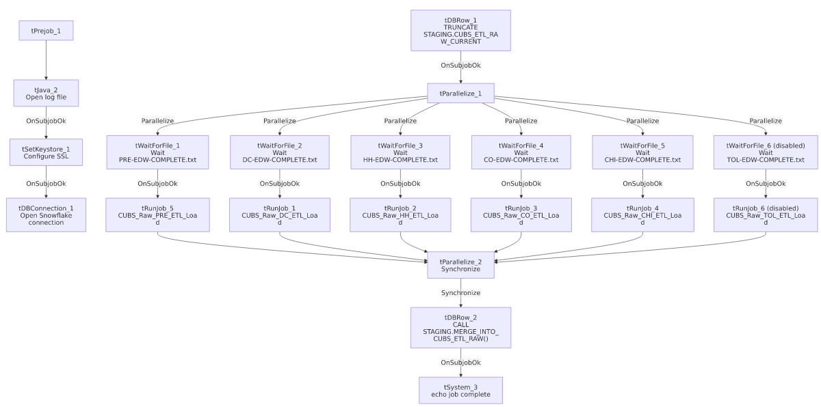

Settings tables

Gates: `tWaitForFile_1`...`tWaitForFile_6`
Setting | Value | What it means
WAIT / MAX_ITERATIONS | 30 (seconds) / 720 | Fixed timeout of up to 6 hours per site (720 x 30s), unlike CO_Master_Load's context-driven loopCount.
DIRECTORY | context.rootDir (5 of 6) / context.rootDCDir (DC only) | DC uses its own root directory variable, distinct from the other five sites.
tWaitForFile_6 (TOL) | ACTIVATE=false | Disabled — TOL's wait-and-load branch does not currently run.

Orchestration: `tRunJob_1`...`tRunJob_6`
Setting | Value | What it means
DIE_ON_CHILD_ERROR | true (all 6) | Any site's ETL load failing fails this orchestrator too.
USE_INDEPENDENT_PROCESS | true (all 6) | Each site load runs in its own JVM, unlike CO_Master_Load's one exception (DimFiscal_CO_Load).
tRunJob_6 (TOL) | ACTIVATE=false | Disabled, matching its gating tWaitForFile_6.

Truncate/Merge: `tDBRow_1` / `tDBRow_2`
Setting | Value | What it means
Query 1 | TRUNCATE TABLE STAGING.CUBS_ETL_RAW_CURRENT; | Clears the shared staging table before any site load runs — the truncate step that the six individual site loaders (e.g. CUBS_Raw_DC_ETL_Load) don't perform themselves.
Query 2 | CALL STAGING.MERGE_INTO_CUBS_ETL_RAW(); | Runs once, after all six sites have loaded, merging the combined staging data into its final target.

Dependencies & configuration
- Calls 6 jobs via `tRunJob`: CUBS_Raw_DC_ETL_Load, CUBS_Raw_HH_ETL_Load, CUBS_Raw_CO_ETL_Load, CUBS_Raw_CHI_ETL_Load, CUBS_Raw_PRE_ETL_Load, CUBS_Raw_TOL_ETL_Load (disabled) — see 06_dependency_matrix.md for the full project-wide table.
- Context variables used: keystorePath, logDir, rootDCDir, rootDir.
- 2 hardcoded developer-workstation paths: tSystem_3.DIRECTORY, tSetKeystore_1.SSL_TRUSTSERVER_TRUSTSTORE.

Glossary
Component type | Plain-English meaning
tParallelize | Runs its downstream branches at the same time rather than one after another; can also act as a synchronization/fan-in point (SYNCHRONIZE).
tWaitForFile | Polls a directory for a specific file to appear, for up to a configured number of attempts.
tRunJob | Runs another Talend job as a sub-process, optionally waiting for it to finish.
tSnowflakeRow | Runs an arbitrary SQL statement or stored-procedure call against Snowflake.
tSystem | Runs an arbitrary OS shell command from within the Talend job.
tSetKeystore | Configures the SSL keystore/truststore for the Snowflake connection.

Issues observed
- The TOL site branch (`tWaitForFile_6` / `tRunJob_6`) is explicitly disabled (`ACTIVATE=false`) while the other five sites are active. 01_system_architecture.md lists CHI/CO/DC/HH/PRE/TOL as the project's six recognized site codes, so TOL's ETL load currently never runs as part of this orchestrator — either TOL doesn't produce this particular extract, or its pipeline is intentionally paused/decommissioned. Unable to determine which from metadata; verify with the team so a genuinely-needed TOL ETL load isn't silently skipped.
- If any of the five active site loads fails, this orchestrator's own error won't say which one — same diagnostic gap already flagged for CO_Master_Load; with five parallel branches gated by independent semaphore waits, isolating the actual failure point requires checking each site load's own log.
- DC uses a different root-directory context variable (`context.rootDCDir`) than the other five sites (`context.rootDir`) — consistent with DC having its own dedicated source path elsewhere in the project (e.g. sourceDCDir in StandardFolders_0.1), but it does mean this job has two directory variables to keep in sync rather than one, and a future new site would need to decide which pattern to follow.
- A 6-hour fixed timeout (30s x 720 iterations) per site, rather than a context-configurable loopCount like CO_Master_Load uses — if any site's extract runs unusually late, this orchestrator would keep polling for up to 6 hours per gate before giving up, with no visible alerting on that specific timeout condition within this job's own components.
- No hardcoded hint of which `STAGING.MERGE_INTO_CUBS_ETL_RAW()`'s actual downstream target is — the stored procedure's own logic (what table it writes to, whether it's additive or replace) is outside this job's metadata; verify against the procedure definition itself.

