Talend Job: CUBS_Raw_Empinfo_Load

Overview
Loads a single CUBS "employee info" export — collector/employee login credentials and account metadata (LOGON, EMPPWD, EMP_NAME, EMP_INIT, LST_LOGIN, DISABLED) — for one site logon into the Snowflake staging table CUBS_EMPINFO_RAW_CURRENT, then archives and deletes the source file. It is structurally identical to CUBS_Raw_EM_Load in this same batch (same setup/teardown, same EXPORT_<TYPE>_* context-group pattern, same archive-then-delete flow), differing only in its schema, target table, and the fact that EMPPWD — an employee password/credential field — flows through this pipeline unmasked at the metadata level. It is called once by CO_Master_Load (see 06_dependency_matrix.md).

Detail table
Field | Value
Job name | CUBS_Raw_Empinfo_Load
Version | 0.1
Project | EDW2SF
Author | jmach@harriscollect.com
Created | 2022-09-27T16:20:31.190-0700
Last Modified | 2025-11-04T11:08:13.503-0800

Step-by-step data flow
Setup subjob: tPrejob_1 → tJava_1 (OnComponentOk) opens a per-run log file at context.logDir + context.currentLogon + "_" + jobName + "_" + <timestamp> + ".log" → on success, tSetKeystore_1 configures SSL trust/keystore from context.keystorePath (passwords redacted) → tDBConnection_1 opens the Snowflake connection.
Main subjob — starts independently of the setup subjob:
- tFileInputDelimited_1 reads context.sourceDir + context.EXPORT_EMPINFO_File, with row/field separator, header flag, and encoding driven by the EXPORT_EMPINFO_0.1 context group (default filename Z:/EDW/2021-11-27/HH/HH-EDW-EXPORT-EMPINFO.txt per _shared_context.json). Uses repository schema "CUBS_EMPINFO" (7 columns: LOGON, EMPPWD, EMP_IDX, EMP_NAME, EMP_INIT, LST_LOGIN, DISABLED). CSVROWSEPARATOR again set to context.EXPORT_TRANS_RowSeparator (same mismatch pattern as the EM/HH-Client jobs; inert unless CSV_OPTION is enabled — currently false). DIE_ON_ERROR=false; reject schema mislabeled "CUBS_TRANSACTION".
- tMap_1 (row1, FLOW) flattens the 7 named columns onto a generic FILENAME, FILEDATE, COL1...COL7 shape.
- tFlowMeter_2 (emp, FLOW) counts rows.
- tDBOutput_1 (row2, FLOW) inserts the rows into Snowflake CUBS_EMPINFO_RAW_CURRENT (INSERT, tableAction=NONE).
- On the input file's OnSubjobOk, tFileArchive_1 archives context.sourceDir to context.archiveDir + "/" + <YYYYMMDD> + "/" + context.EXPORT_EMPINFO_File + ".tar.gz" (password redacted).
- On archive OnSubjobOk, tFileDelete_1 deletes context.sourceDir + context.EXPORT_EMPINFO_File.
Teardown subjob: tPostjob_1 → tDBClose_1 (OnComponentOk) closes the Snowflake connection.
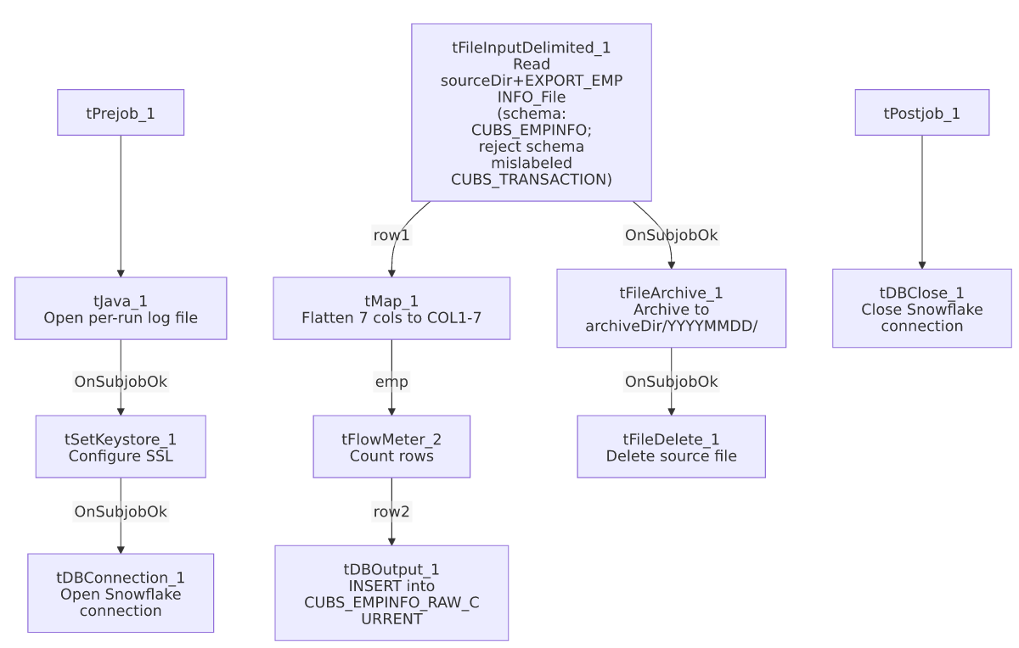

Settings tables

Source: `tFileInputDelimited_1`
Setting | Value | What it means
FILENAME | context.sourceDir + context.EXPORT_EMPINFO_File | EXPORT_EMPINFO_File defaults to Z:/EDW/2021-11-27/HH/HH-EDW-EXPORT-EMPINFO.txt.
ROWSEPARATOR / FIELDSEPARATOR / HEADER / ENCODING | All from EXPORT_EMPINFO_0.1 context group | Defaults: \n, \t, header row 1, US-ASCII.
CSVROWSEPARATOR | context.EXPORT_TRANS_RowSeparator | Mismatched context family (inert unless CSV_OPTION=true, currently false) — same recurring copy-paste artifact.
SCHEMA (main) | Repository "CUBS_EMPINFO" | 7 columns: LOGON, EMPPWD, EMP_IDX, EMP_NAME, EMP_INIT, LST_LOGIN, DISABLED.
SCHEMA_REJECT | Repository "CUBS_TRANSACTION" | Mislabeled, same pattern seen throughout this project.
DIE_ON_ERROR | false | Malformed rows don't fail the job; no reject flow is wired.
TEMP_DIR | "C:/Talend-Studio-20211109_1610-V8.0.1/workspace" | Hardcoded developer-workstation path.

Target: `tDBOutput_1` (`tSnowflakeOutput`)
Setting | Value | What it means
Table | CUBS_EMPINFO_RAW_CURRENT | Destination raw landing table.
Output action | INSERT | Appends rows; no truncate step precedes it in this job.
Table action | NONE | Table not recreated/altered by this job.

`tFileArchive_1` / `tFileDelete_1`
Setting | Value | What it means
TARGET (archive) | context.archiveDir + "/" + <YYYYMMDD> + "/" + context.EXPORT_EMPINFO_File + ".tar.gz" | Per-run, dated archive named after the export file.
PASSWORD | ***REDACTED*** | Preserved as redacted.
FILENAME (delete) | context.sourceDir + context.EXPORT_EMPINFO_File | Deletes the exact file that was loaded.

Dependencies & configuration
- Called by: CO_Master_Load, once — see 06_dependency_matrix.md.
- Triggers/depends on other jobs: none — runjob_targets is empty.
- Context variables used: EXPORT_EMPINFO_Encoding, EXPORT_EMPINFO_FieldSeparator, EXPORT_EMPINFO_File, EXPORT_EMPINFO_Header, EXPORT_EMPINFO_RowSeparator, EXPORT_TRANS_RowSeparator (mismatched — see Issues observed), archiveDir, currentLogon, keystorePath, logDir, sourceDir.
- 5 hardcoded developer-workstation paths: tFileInputDelimited_1.TEMP_DIR, tFileArchive_1.SOURCE_FILE, tFileDelete_1.DIRECTORY/PATH, tSetKeystore_1.SSL_TRUSTSERVER_TRUSTSTORE — same project-wide pattern documented in 05_operational_runbook.md.

Glossary
Component type | Plain-English meaning
tFileInputDelimited | Reads a delimited text file according to a schema.
tMap | Maps/transforms columns from one schema to another.
tFlowMeter | Counts rows passing a point in the flow.
tSnowflakeOutput / tSnowflakeConnection / tSnowflakeClose | Write rows to Snowflake / open and close the Snowflake connection.
tFileArchive / tFileDelete | Zip a processed file to an archive location, then delete the original.
tSetKeystore | Configures the SSL keystore/truststore used by the Snowflake connection.
tPrejob / tPostjob | Guaranteed-first / guaranteed-last setup and teardown subjobs.
tJava | Runs a block of custom Java code.

Issues observed
- `EMPPWD` (an employee password field) is loaded, mapped, and staged as a plain string with no masking or redaction visible anywhere in this job's own components — the schema, tMap_1, and tDBOutput_1 all pass it through unchanged into CUBS_EMPINFO_RAW_CURRENT. Whether this field is meant to be a live credential, a hashed value, or already-defunct legacy data is not determinable from this job's metadata; given the sensitivity of a field literally named "password", this is worth confirming with the team and checking whether CUBS_EMPINFO_RAW_CURRENT has appropriate access restrictions in Snowflake.
- `CSVROWSEPARATOR` references `context.EXPORT_TRANS_RowSeparator`, not an EXPORT_EMPINFO_* variable — same recurring copy-paste artifact seen in CUBS_Raw_EM_Load and the Client-load family; inert unless CSV_OPTION is ever enabled.
- Reject schema mislabeled `"CUBS_TRANSACTION"`, with no reject flow wired despite DIE_ON_ERROR=false — malformed rows are silently dropped, consistent with the project-wide pattern in 05_operational_runbook.md.
- No `TRUNCATE` step and no merge call anywhere in this job, despite the _RAW_CURRENT naming — re-running this job for the same logon/day would append duplicate rows rather than replace them, unless handled by an unseen downstream process.
- Archive and delete are triggered by the file read's own `SUBJOB_OK`, not by the Snowflake insert's success — same ordering risk flagged across this batch: a downstream failure in tMap_1/tFlowMeter_2/tDBOutput_1 would still result in the source file being archived and deleted.

