Talend Job: CUBS_Raw_File_Load

Overview
A shared utility job used by several other jobs in this project: it looks up the latest date already loaded into a given STAGING.CUBS_<stage>_RAW Snowflake table, then shells out to run a Python script (upload_cubs.py) that presumably performs the actual file upload for that stage, starting from the day after the last-loaded date. Unlike the CUBS_Raw_*_Load jobs that read files directly with Talend's own file components, this job delegates the real work to an external Python process — the file-reading/parsing logic itself is not visible in this metadata.

Detail table
Field | Value
Job name | CUBS_Raw_File_Load
Version | 0.2
Project | EDW2SF
Author | jmach@harriscollect.com
Created | 2022-04-13T15:40:05.213-0700
Last Modified | 2022-05-24T09:48:40.105-0700

Step-by-step data flow
Setup subjob: tPrejob_1 → tJava_2 opens a per-run log file at context.logDir + jobName + "_" + context.stage + "_" + <timestamp> + ".log" → on success, tDBConnection_1 opens the Snowflake connection.
Main subjob — starts independently of the setup subjob:
- tDBInput_1 runs SELECT CAST(DATEADD(DAY,1,MAX(FILEDATE)) AS VARCHAR(10)) AS START_DATE FROM STAGING.CUBS_"+StringHandling.UPCASE(context.stage)+"_RAW; — finds the day after the most recent file date already loaded, for whichever stage (subject area) this run is invoked with.
- tJavaRow_1 captures that value into context.startDate.
- On success (tDBInput_1 → tJava_1 via SUBJOB_OK), tJava_1 builds context.pyCmd, a Python 3 command line: python3 <scriptDir>upload_cubs.py --stage <stage> --file <file> --path <path> --date <startDate> --tempdir <tempDir>, and prints it to the log.
- tSystem_1 executes that command as a single shell command, streaming its stdout/stderr to the console (and therefore into the per-run log file, since tJava_2 redirected System.out/System.err earlier).
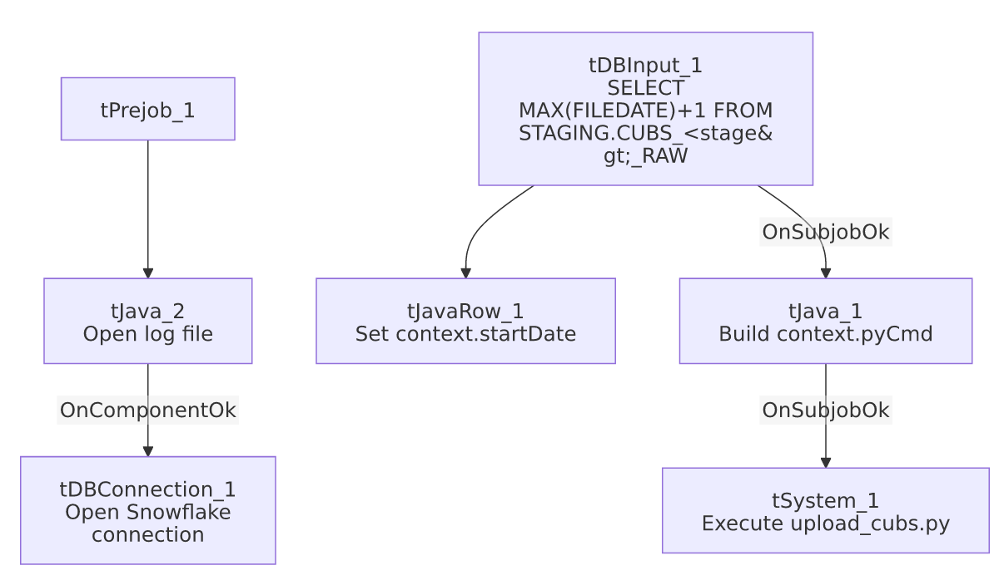

Settings tables

Source: `tDBInput_1` (`tSnowflakeInput`)
Setting | Value | What it means
Query | SELECT CAST(DATEADD(DAY,1,MAX(FILEDATE)) AS VARCHAR(10)) AS START_DATE FROM STAGING.CUBS_"+StringHandling.UPCASE(context.stage)+"_RAW; | Table name is built dynamically from context.stage, so this job is a reusable, parameterized loader rather than being hardcoded to one subject area.

External process: `tSystem_1`
Setting | Value | What it means
DIRECTORY | "C:/Talend-Studio-20211109_1610-V8.0.1/workspace" | Working directory for the shell command — hardcoded developer path (see Issues observed).
COMMAND | context.pyCmd (built in tJava_1) | python3 <scriptDir>upload_cubs.py --stage <stage> --file <file> --path <path> --date <startDate> --tempdir <tempDir>
OUTPUT / ERROROUTPUT | OUTPUT_TO_CONSOLE (both) | Both stdout and stderr from the Python script are streamed to the console/log — there is no explicit capture of the script's exit code within this job's own components.

Dependencies & configuration
- Called by 4 other jobs per 06_dependency_matrix.md: DimDeskInfo_Load, DimEmployeeInfo_Load, Fact_Electronic_Media_Load, and PaymentPlan_Load (each 1 time) — making this one of the more widely reused utility jobs in the project, despite its own metadata showing no tRunJob links out.
- Context variables used: file, logDir, path, pyCmd (set internally), scriptDir, stage, startDate (set internally), tempDir.
- 1 hardcoded developer-workstation path (tSystem_1.DIRECTORY) — same project-wide risk noted in 05_operational_runbook.md.

Glossary
Component type | Plain-English meaning
tSnowflakeInput | Runs a query against Snowflake and returns its result rows — here used once to compute a starting date.
tJavaRow | Runs custom Java code once per input row — here used to unpack a single query result into a context variable.
tJava | Runs a block of custom Java code once (not per row) — here used to build a shell command string.
tSystem | Runs an arbitrary OS shell command from within the Talend job — here used to hand off the actual file upload to an external Python script.

Issues observed
- The actual file-loading logic lives entirely outside Talend, in an external upload_cubs.py script not captured in this metadata. This job's own components only compute a start date and invoke that script — verifying what the script actually does (which files it reads, which table it writes, how it handles errors) requires reviewing the script itself, not just this job.
- No explicit success/failure check on the Python script's exit code. tSystem_1 streams output to the console but this job has no visible tDie/tWarn component reacting to whether upload_cubs.py succeeded or failed — a script failure would likely only surface as non-zero output in the log, not as an obvious job failure, unless Talend's own tSystem component fails the job on a non-zero exit code by default (not confirmed from this metadata; verify with the team).
- `context.file` and `context.path` are referenced in the constructed Python command but neither is set anywhere within this job's own components — both must be supplied by the calling job's context (consistent with this being a shared parameterized utility), but that dependency is not self-documenting from this job alone. Unable to determine their expected values from this job's metadata; verify with the calling jobs (DimDeskInfo_Load, DimEmployeeInfo_Load, Fact_Electronic_Media_Load, PaymentPlan_Load).

