Talend Job: CUBS_Raw_HH_Client_Load

Overview
Loads the HH site's CUBS client master-file export — one row per collection-agency client, with ~165 columns covering client ID, name/address, billing/statement settings, commission/interest rates, collection-status flags, scoring thresholds, and dialer/skip-trace routing flags — into the Snowflake staging table CUBS_CLIENT_RAW_CURRENT, then archives and deletes the source file. It is structurally identical to CUBS_Raw_CHI_Client_Load (same setup/teardown with tSetKeystore_1, same CSVROWSEPARATOR mismatch, same generically-labeled "metadata" schema, same missing truncate/merge step) — the site-specific behavior comes entirely from the caller's context values, not from anything in this job's own component parameters. Notably, its EXPORT_CLIENT_File default ("HH-EDW-EXPORT-CLIENT.txt") is identical to the default used by the unsuffixed CUBS_Raw_Client_Load job, and both write to the same target table — see Issues observed.

Detail table
Field | Value
Job name | CUBS_Raw_HH_Client_Load
Version | 0.1
Project | EDW2SF
Author | jmach@harriscollect.com
Created | 2023-09-26T11:17:31.689-0700
Last Modified | 2025-11-04T11:08:10.082-0800

Step-by-step data flow
Setup subjob: tPrejob_1 → tJava_1 (OnComponentOk) opens a per-run log file at context.logDir + context.currentLogon + "_" + jobName + "_" + <timestamp> + ".log" → on success, tSetKeystore_1 configures SSL trust/keystore from context.keystorePath (passwords redacted) → tDBConnection_1 opens the Snowflake connection.
Main subjob — starts independently of the setup subjob:
- tFileInputDelimited_1 reads context.sourceDir + context.EXPORT_CLIENT_File. ROWSEPARATOR/FIELDSEPARATOR/HEADER/ENCODING are correctly scoped to the EXPORT_CLIENT_0.1 context group, but CSVROWSEPARATOR is set to context.EXPORT_TRANS_RowSeparator instead (same copy-paste inconsistency as CUBS_Raw_CHI_Client_Load; inert unless CSV_OPTION is enabled — currently false). The main schema is labeled generically "metadata" in the repository (not client-specific), with ~165 client business columns (LOGON, CLIENT, CLIENT_IDX, NAME, ADD1/ADD2, CITY, ST, ZIP, rate/commission fields, statement/invoice settings, scoring thresholds like SCR_LTR_MIN/SCR_EML_MIN/SCR_TXT_MIN, CityOfChi, PL_GROUP, ON_DIALER, etc. — listed twice in the extracted metadata, a main+reject capture artifact). Reject schema is mislabeled "CUBS_TRANSACTION". TRIMALL=true; DIE_ON_ERROR=false, with no reject flow wired.
- tMap_1 (row1, FLOW) flattens the ~165 named columns onto a generic FILENAME, FILEDATE, COL1...COL202 shape (202 schema columns on tMap_1) — meaningful client column names are not preserved past this point.
- tFlowMeter_2 (cli, FLOW) counts rows (label "MyLabel", not customized).
- tDBOutput_1 (row2, FLOW) inserts the rows into Snowflake CUBS_CLIENT_RAW_CURRENT (INSERT, tableAction=NONE) — no TRUNCATE step anywhere in this job and no merge call afterward, despite the _RAW_CURRENT table name.
- On tFileInputDelimited_1's own SUBJOB_OK (not the DB insert's success), tFileArchive_1 zips the source file to context.archiveDir + "/" + <YYYYMMDD> + "/" + context.EXPORT_CLIENT_File + ".tar.gz" (password redacted), then on success tFileDelete_1 deletes the original source file.
Teardown subjob: tPostjob_1 → tDBClose_1 (OnComponentOk) closes the Snowflake connection.
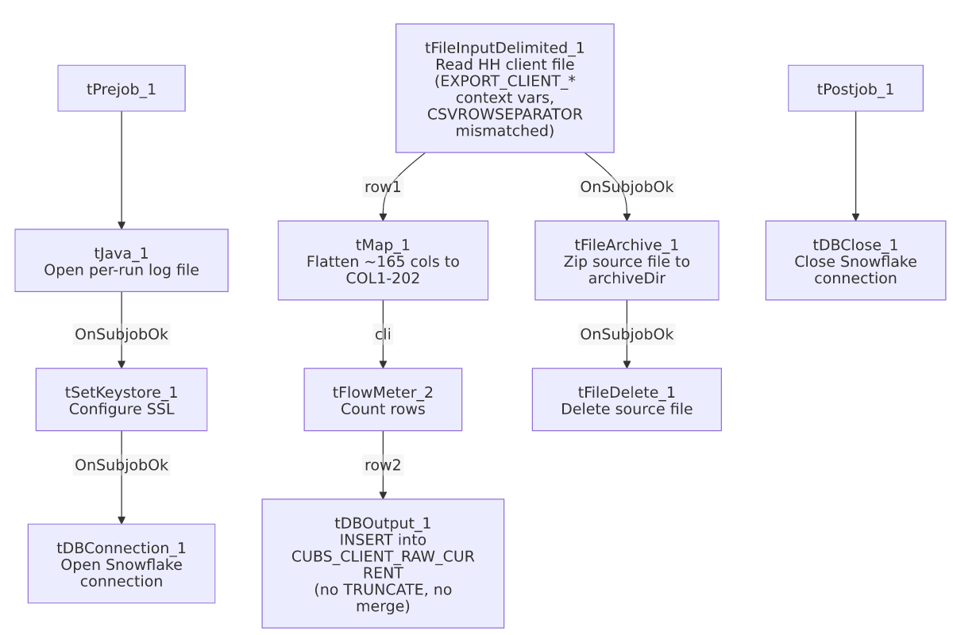

Settings tables

Source: `tFileInputDelimited_1`
Setting | Value | What it means
FILENAME | context.sourceDir + context.EXPORT_CLIENT_File | EXPORT_CLIENT_File defaults to "HH-EDW-EXPORT-CLIENT.txt" per _shared_context.json — matching this job's own site.
ROWSEPARATOR / FIELDSEPARATOR / HEADER / ENCODING | context.EXPORT_CLIENT_RowSeparator / context.EXPORT_CLIENT_FieldSeparator / context.EXPORT_CLIENT_Header / context.EXPORT_CLIENT_Encoding | Correctly scoped to the CLIENT export context group.
CSVROWSEPARATOR | context.EXPORT_TRANS_RowSeparator | Mismatched — references the Trans export's row separator instead of EXPORT_CLIENT_RowSeparator; only takes effect if CSV_OPTION is enabled (currently false).
TRIMALL | true | All fields whitespace-trimmed.
Main schema | Repository "metadata" (generic label, ~165 client columns) | Not a client-specific schema name in the repository.
Reject schema | Repository "CUBS_TRANSACTION" | Mislabeled, same pattern as CUBS_Raw_CHI_Client_Load.
TEMP_DIR | "C:/Talend-Studio-20211109_1610-V8.0.1/workspace" | Hardcoded developer-workstation path.

Target: `tDBOutput_1` (`tSnowflakeOutput`)
Setting | Value | What it means
Table | CUBS_CLIENT_RAW_CURRENT | Destination staging table — identical target to `CUBS_Raw_Client_Load` and `CUBS_Raw_DC_Client_Load`. See Issues observed.
Output action | INSERT | Appends rows; no TRUNCATE precedes it and no merge stored procedure follows it.
Table action | NONE | Table is not recreated/altered.

Archive/Delete: `tFileArchive_1` / `tFileDelete_1`
Setting | Value | What it means
TARGET (tFileArchive_1) | context.archiveDir + "/" + <CCYYMMDD> + "/" + context.EXPORT_CLIENT_File + ".tar.gz" | Archives under a date-stamped subfolder.
Trigger | Off tFileInputDelimited_1's SUBJOB_OK, not off tDBOutput_1 | Archive+delete happens before the Snowflake insert is confirmed — see Issues observed.

Dependencies & configuration
- Triggers/depends on other jobs: none — runjob_targets is empty. Not found as a tRunJob target anywhere in 06_dependency_matrix.md either — same "no visible caller" situation as CUBS_Raw_Client_Load and CUBS_Raw_CHI_Client_Load. Unlike the Debtor and ETL per-site families, which each have a generic umbrella dispatcher, there is no equivalent generic Client-load dispatcher calling this job in this export.
- Context variables used: EXPORT_CLIENT_Encoding, EXPORT_CLIENT_FieldSeparator, EXPORT_CLIENT_File, EXPORT_CLIENT_Header, EXPORT_CLIENT_RowSeparator, EXPORT_TRANS_RowSeparator (mismatched — see Issues observed), archiveDir, currentLogon, keystorePath, logDir, sourceDir.
- 5 hardcoded developer-workstation path findings: tFileInputDelimited_1.TEMP_DIR, tFileArchive_1.SOURCE_FILE, tFileDelete_1.DIRECTORY/PATH, and tSetKeystore_1.SSL_TRUSTSERVER_TRUSTSTORE — same project-wide pattern documented in 05_operational_runbook.md.

Glossary
Component type | Plain-English meaning
tFileInputDelimited | Reads a delimited (CSV-style) text file according to a schema.
tMap | Maps/transforms columns from one schema to another.
tFlowMeter | Counts rows passing through a point in the flow, for logging/monitoring.
tSnowflakeOutput / tSnowflakeConnection / tSnowflakeClose | Write rows to a Snowflake table / open and close the shared Snowflake connection.
tFileArchive / tFileDelete | Zip a processed file to an archive location, then delete the original from the source directory.
tSetKeystore | Configures the SSL keystore/truststore used by subsequent secure connections.
tPrejob / tPostjob | Run once before/after the rest of the job.
tJava | Runs a block of custom Java code — here, opening a per-run log file.

Issues observed
- `CUBS_Raw_HH_Client_Load` and `CUBS_Raw_Client_Load` (the unsuffixed job, not in this batch's naming but already documented) share the same `EXPORT_CLIENT_File` default (`"HH-EDW-EXPORT-CLIENT.txt"`) and the same target table (`CUBS_CLIENT_RAW_CURRENT`, `INSERT`/`tableAction=NONE`, no truncate). If both jobs are ever run against the same default context in the same environment, they would load the same file into the same table twice, doubling HH's client rows for that run cycle — the same "two jobs, one table, no truncate" concern already flagged for CUBS_Raw_Client_Load vs. CUBS_Raw_DC_Client_Load, now extended to a third job pointing at the identical default file. Unable to determine from metadata whether per-environment context overrides prevent this in practice; verify with the team.
- `CSVROWSEPARATOR` references `context.EXPORT_TRANS_RowSeparator`, not an EXPORT_CLIENT_* variable — same copy-paste-from-a-Trans-template pattern as CUBS_Raw_CHI_Client_Load; inert unless CSV_OPTION is ever switched on.
- Main schema labeled generically `"metadata"`, reject schema mislabeled `"CUBS_TRANSACTION"` — same issue class as CUBS_Raw_CHI_Client_Load and ADP_Payroll_Load. No reject flow is wired despite DIE_ON_ERROR=false, so malformed rows are silently dropped.
- No visible caller — unlike the Debtor and ETL per-site job families (each dispatched by a generic umbrella job), there is no equivalent generic Client-load dispatcher calling CUBS_Raw_HH_Client_Load in this export; its actual trigger mechanism is unclear from the captured metadata.
- Archive and delete of the source file are triggered by the file read succeeding, not by the Snowflake insert succeeding — a downstream failure in tMap_1/tFlowMeter_2/tDBOutput_1 would still result in the source file being archived and deleted, same ordering risk as CUBS_Raw_CHI_Client_Load.
- No `TRUNCATE` step and no merge call anywhere in this job, despite the target table being named CUBS_CLIENT_RAW_CURRENT — same missing-refresh-step concern as its siblings.

