Talend Job: CUBS_Raw_HH_Debtor_Load

Overview
Loads debtor records for the "HH" site out of one or more delimited text files delivered to a per-logon source folder, encrypts the row data in transit, and bulk-inserts it into the Snowflake staging table CUBS_DEBTOR_RAW_HH_CURRENT, then appends that freshly loaded batch into a shared, multi-site raw table CUBS_DEBTOR_RAW. This is one job in a per-site family of debtor loaders (site codes CHI/CO/DC/HH/PRE — see 01_system_architecture.md and 04_data_lineage_map.md) triggered from the shared orchestrator CUBS_Raw_Debtor_Load, and is itself the "plain" member of an HH-specific trio of near-identical jobs (CUBS_Raw_HH_Debtor_Load, CUBS_Raw_HH_Debtor_Load_No_Delete, CUBS_Raw_HH_Debtor_Load_Upsert — per 04_data_lineage_map.md, all three target CUBS_DEBTOR_RAW_HH_CURRENT); the sibling jobs' own JSON wasn't in this batch, so their specific differences aren't verified here.

Detail table
Field | Value
Job name | CUBS_Raw_HH_Debtor_Load
Version | 0.1
Project | EDW2SF
Author | jmach@harriscollect.com
Created | 2022-05-02T08:40:17.876-0700
Last Modified | 2022-06-13T14:33:36.072-0700

Step-by-step data flow
Setup subjob: tPrejob_1 → tDBConnection_1 opens the job's Snowflake connection. Unlike ADP_Payroll_Load/CO_Master_Load, there is no tJava step here opening a per-run log file — see Issues observed.
Main subjob — runs independently of the setup subjob (its root component, tDBRow_1, has no incoming trigger from the setup chain in this job's metadata):
- tDBRow_1 runs TRUNCATE TABLE STAGING.CUBS_DEBTOR_RAW_HH_CURRENT;, clearing the HH staging table before this run's load.
- On success, tFileList_1 lists files (not subdirectories) in context.sourceRoot + context.currentLogon, excluding nothing in practice (EXCLUDEFILEMASK="*.txt" is set but IFEXCLUDE=false, so the exclusion doesn't actually apply — every file in the directory is picked up, same pattern flagged in ADP_Payroll_Load).
- For each file (ITERATE), tJava_3 sets context.currentFile from tFileList_1's current filepath and prints "Processing file " + context.currentFile" to the log.
- tFileInputDelimited_1 reads that file using the repository schema CUBS_DEBTOR_HH (984 columns) for both its main and reject schema (same repository schema ID for both — unlike ADP_Payroll_Load's mismatched reject schema). Field/row separators, header-row count, and encoding are all driven by context variables (EXPORT_DEBTOR_FieldSeparator, EXPORT_DEBTOR_RowSeparator, EXPORT_DEBTOR_Header, EXPORT_DEBTOR_Encoding) rather than hardcoded. DIE_ON_ERROR=false.
- tDataEncrypt_1 encrypts the row data (algorithm version 2; secret type and password both ***REDACTED*** in the source metadata) before it reaches the map, reading its crypto key/file from context.cryptoPath.
- tMap_1 maps the row into a differently-shaped target schema: FILENAME, FILEDATE, and 500 generically-named columns COL1...COL500 (502 columns total). DIE_ON_ERROR=true, so a mapping failure fails the job outright.
- tFlowMeter_3 counts rows passing through, labeled "HH_DBTR" (site-specific label, unlike the unrenamed "MyLabel" seen in some other jobs in this project).
- tDBOutputBulkExec_1 bulk-inserts the rows into Snowflake table CUBS_DEBTOR_RAW_HH_CURRENT (INSERT, tableAction=NONE).
- After tFileList_1's iteration completes over all files (OnSubjobOk), tDBRow_2 runs INSERT INTO STAGING.CUBS_DEBTOR_RAW SELECT * FROM STAGING.CUBS_DEBTOR_RAW_HH_CURRENT;, appending the just-loaded HH batch into the shared, multi-site raw debtor table.
Teardown subjob: tPostjob_1 → tDBClose_1 closes the Snowflake connection.
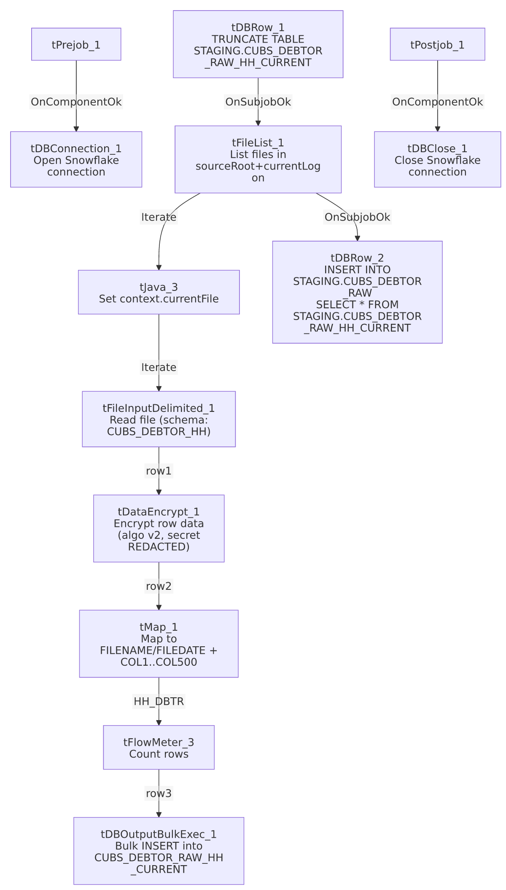

Settings tables

Staging reset: `tDBRow_1` (`tSnowflakeRow`)
Setting | Value | What it means
Query | TRUNCATE TABLE STAGING.CUBS_DEBTOR_RAW_HH_CURRENT; | Clears the HH staging table at the start of every run, before any file is loaded.

Source directory: `tFileList_1`
Setting | Value | What it means
DIRECTORY | context.sourceRoot + context.currentLogon | Both parts are context variables — actual resolved path is unable to determine from this job's own metadata (not defined in _shared_context.json's context groups either).
LIST_MODE | FILES (no subdirectories) | Only top-level files in that directory are picked up.
EXCLUDEFILEMASK / IFEXCLUDE | "*.txt" / false | The exclusion mask is configured but not applied (IFEXCLUDE=false), so .txt files are not actually excluded — every file in the directory is listed.
CASE_SENSITIVE | YES | Filename matching is case-sensitive.

Per-file setup: `tJava_3`
Setting | Value | What it means
CODE | context.currentFile = (String)globalMap.get("tFileList_1_CURRENT_FILEPATH") + a log line | Captures the current iteration's full file path into a context variable used by the next component.

Source: `tFileInputDelimited_1`
Setting | Value | What it means
FILENAME | context.currentFile | The file set by tJava_3 for the current iteration.
FIELDSEPARATOR / ROWSEPARATOR / HEADER / ENCODING | context.EXPORT_DEBTOR_FieldSeparator (tab, "\t") / context.EXPORT_DEBTOR_RowSeparator ("\n") / context.EXPORT_DEBTOR_Header (1 header row) / context.EXPORT_DEBTOR_Encoding (US-ASCII) | All driven by the shared EXPORT_DEBTOR_* context group (values confirmed in _shared_context.json) rather than hardcoded per job.
SCHEMA (main) | Repository schema CUBS_DEBTOR_HH (984 columns) | The expected wide debtor-record layout for this site's export file.
SCHEMA_REJECT | Same repository schema ID (CUBS_DEBTOR_HH) as the main schema | Correctly matches this job's own data, unlike the mismatched reject schema found in ADP_Payroll_Load.
DIE_ON_ERROR | false | Malformed rows don't fail the job...
Reject flow | Not wired | ...but no connection routes rejected rows anywhere — they are silently dropped with no count or record, same unwired-reject pattern as ADP_Payroll_Load.
TEMP_DIR | "C:/Talend-Studio-20211109_1610-V8.0.1/workspace" | Hardcoded developer-workstation path — part of the 210-job project-wide pattern documented in 05_operational_runbook.md.

Transform: `tDataEncrypt_1`
Setting | Value | What it means
PASSWORD_M1 | ***REDACTED*** | Encryption password/key material — preserved as redacted; not guessable from metadata.
SECRET_TYPE | ***REDACTED*** | The type of secret/key used — also redacted in the source metadata.
CRYPTO_FILE_PATH | context.cryptoPath | Points to a crypto key/config file via a context variable not defined in the shared context groups available to this generation run.
ALGO_VERSION | 2 | Encryption algorithm version 2 (specific algorithm not shown in this metadata).

Transform: `tMap_1`
Setting | Value | What it means
Input columns | 491 named debtor columns (from tDataEncrypt_1) | Business-named fields (LOGON, DEBTOR, CLIENT, NAME1, ... OLD_CLIENT_ID4, etc.).
Output columns | FILENAME, FILEDATE, COL1...COL500 (502 total) | Renames/re-maps the named source fields into generic, positional column names — presumably matching the target staging table's own generic column layout. The actual per-field mapping expressions aren't captured in this metadata, and the column counts don't line up 1:1 (491 in → 500 generic columns out) — unable to determine from metadata exactly which source field maps to which COLn, or why the counts differ; verify directly in Talend Studio.
DIE_ON_ERROR | true | A mapping/lookup failure here fails the job outright (unlike the upstream file-read step).

Row counter: `tFlowMeter_3`
Setting | Value | What it means
METTERLABEL | "HH_DBTR" | Site-specific label for this job's row count in the flow-meter log — correctly customized, unlike some sibling jobs' unrenamed "MyLabel".

Target: `tDBOutputBulkExec_1` (`tSnowflakeOutputBulkExec`)
Setting | Value | What it means
Table | CUBS_DEBTOR_RAW_HH_CURRENT | Destination staging table — no explicit schema prefix shown in this component's own metadata (unlike the STAGING.-prefixed SQL text in tDBRow_1/tDBRow_2); presumably resolves to the same STAGING schema via the connection's default schema.
Output action | INSERT | Appends rows — relies on the earlier TRUNCATE (tDBRow_1) to prevent duplicate accumulation within CUBS_DEBTOR_RAW_HH_CURRENT itself across runs.
Table action | NONE | Table is not recreated/altered by this job.
Reject schema | Present (columnName, rowNumber, category, character, errorMessage, byteOffset, line, sqlState, code) but not wired | Bulk-load row errors have a defined error schema but no connection captures them anywhere — same unwired-reject pattern as the file-read step.

Append step: `tDBRow_2` (`tSnowflakeRow`)
Setting | Value | What it means
Query | INSERT INTO STAGING.CUBS_DEBTOR_RAW SELECT * FROM STAGING.CUBS_DEBTOR_RAW_HH_CURRENT; | Appends this run's entire HH staging batch into the shared, multi-site CUBS_DEBTOR_RAW table. Runs once, after the full file-iteration loop finishes. See Issues observed regarding duplicate accumulation.

Dependencies & configuration
- Triggered by: CUBS_Raw_Debtor_Load (orchestrator), per 06_dependency_matrix.md's job-to-job table (CUBS_Raw_Debtor_Load → CUBS_Raw_HH_Debtor_Load, count 1).
- Triggers other jobs: none — runjob_targets is empty in this job's own metadata.
- Context variables used: sourceRoot, currentLogon (combine to form the source directory — neither is defined in the shared context groups available to this run), currentFile (set internally by tJava_3), cryptoPath (encryption key/config path), EXPORT_DEBTOR_Encoding, EXPORT_DEBTOR_FieldSeparator, EXPORT_DEBTOR_Header, EXPORT_DEBTOR_RowSeparator (all defined in the shared EXPORT_DEBTOR_0.1 context group — see _shared_context.json).
- 1 hardcoded developer-workstation path: tFileInputDelimited_1.TEMP_DIR = "C:/Talend-Studio-20211109_1610-V8.0.1/workspace" — part of the 210-job project-wide pattern documented in 05_operational_runbook.md.
- Connection label: tDBConnection_1 (tSnowflakeConnection) has no captured parameters (empty in this job's metadata — no hand-set LABEL value to cross-reference against 01_system_architecture.md's connection-label table). Unable to determine which of the project's named Snowflake connections (LEGACY_STAGING, SF_CXN, etc.) this job actually uses — verify directly in Talend Studio.

Glossary
Component type | Plain-English meaning
tSnowflakeConnection / tSnowflakeClose | Open/close the Snowflake database connection shared by other components in the job.
tSnowflakeRow | Runs an arbitrary SQL statement against Snowflake (here, a TRUNCATE and an INSERT ... SELECT).
tFileList | Lists files in a directory for the job to iterate over one at a time.
tJava | Runs custom Java code once (here, capturing the current file path from tFileList's iteration into a context variable).
tFileInputDelimited | Reads a delimited (CSV/tab-style) text file according to a schema.
tDataEncrypt | Encrypts row data using a configured algorithm and key/secret before it continues downstream.
tMap | Maps/transforms columns from one schema to another.
tFlowMeter | Counts rows passing a point in the flow, for logging/monitoring.
tSnowflakeOutputBulkExec | Bulk-loads rows into a Snowflake table (higher-throughput variant of a standard row-by-row output).

Issues observed
- No per-run log-file setup in the setup subjob. Unlike ADP_Payroll_Load and CO_Master_Load, tPrejob_1 here goes straight to tDBConnection_1 with no tJava step opening a dedicated log file. Combined with the absence of any tDie/tWarn component in this job (it isn't in the 16-job list in 05_operational_runbook.md), a failure here would surface only as a generic Talend execution error with no job-specific log output.
- Two unwired reject/error paths. tFileInputDelimited_1 has DIE_ON_ERROR=false with no reject connection (malformed source rows are silently dropped), and tDBOutputBulkExec_1 has a defined bulk-load error schema (columnName, rowNumber, errorMessage, sqlState, etc.) that also isn't wired to anything. Neither a bad input row nor a bad bulk-load row would leave any trace in this job's own flow.
- `tFileList_1`'s exclusion filter is configured but inactive. EXCLUDEFILEMASK="*.txt" is set, but IFEXCLUDE=false means it's never applied — every file in context.sourceRoot + context.currentLogon is picked up and processed, regardless of extension. If stray or non-data files land in that directory, they would be fed straight into tFileInputDelimited_1.
- The final append step has no corresponding dedup/delete against the target. tDBRow_2's INSERT INTO STAGING.CUBS_DEBTOR_RAW SELECT * FROM STAGING.CUBS_DEBTOR_RAW_HH_CURRENT; is a plain append with no DELETE/MERGE against CUBS_DEBTOR_RAW first. While CUBS_DEBTOR_RAW_HH_CURRENT itself is truncated and reloaded every run (so it can't self-duplicate), each successful run of this job adds another full copy of that batch into the shared CUBS_DEBTOR_RAW table — if the same source file(s) are reprocessed on a subsequent run (e.g., a rerun after a partial failure, since nothing here deletes/archives the source file), CUBS_DEBTOR_RAW would accumulate duplicate rows for that batch. Whether something downstream (a merge/dedup step in another job) accounts for this is unable to determine from this job's own metadata — verify with the team, especially given the existence of a same-target _Upsert sibling job that may exist specifically to handle this case.
- `tMap_1`'s column counts don't reconcile. 491 named business columns come in from tDataEncrypt_1, but the output schema has 500 generic COL1...COL500 columns (plus FILENAME/FILEDATE). The actual field-to-field mapping expressions aren't present in the extracted metadata, so it's unable to determine from metadata which source fields land in which output column, or what (if anything) populates the 9 extra COL slots that have no obvious source counterpart — verify directly in Talend Studio before relying on this job's column semantics.
- `context.sourceRoot`, `context.currentLogon`, and `context.cryptoPath` are not defined in any context group visible to this generation run (_shared_context.json's context_groups, nor referenced elsewhere in the project docs supplied). Their actual resolved values/paths are unable to determine from available metadata — verify with the team.
- Which specific debtor fields are encrypted by `tDataEncrypt_1` is not visible in this metadata. The component's schema lists all 491 passthrough columns uniformly (no per-column encryption flag captured), and its SECRET_TYPE/PASSWORD_M1 are redacted. It is unable to determine from metadata whether the component encrypts the entire row, specific PII columns only, or something else — this should not be guessed and must be confirmed directly in Talend Studio if it matters for a compliance review.

