Talend Job: CUBS_Raw_HH_Debtor_Load_Upsert

Overview
Loads the "HH" site's debtor master-file extract (one row per debtor account: name, address, SSN, balances, collector/desk assignment, and roughly 530 other legacy CUBS fields) from a delimited file in context.sourceRoot into the Snowflake staging table CUBS_DEBTOR_RAW_HH_CURRENT, then merges newly-seen rows into the warehouse table EDWPRODHH.STAGING.CUBS_DEBTOR_RAW. The source's ~537 named business columns are encrypted (selected fields) and then flattened into a generic COL1…COL515 schema before loading — the same "raw" positional-column pattern used elsewhere in this project rather than a business-named target table. This is one of three near-identical HH debtor-load job variants in the project (CUBS_Raw_HH_Debtor_Load, CUBS_Raw_HH_Debtor_Load_No_Delete, and this one); see Issues observed for what actually differs between them.

Detail table
Field | Value
Job name | CUBS_Raw_HH_Debtor_Load_Upsert
Version | 0.4
Project | EDW2SF
Author | jmach@harriscollect.com
Created | 2024-07-11T11:59:48.643-0700
Last Modified | 2026-03-24T10:17:05.158-0700

Step-by-step data flow
Setup subjob: tPrejob_1 →tJava_4 builds a per-run log file at context.logDir + context.currentLogon + "_" + jobName + "_" + <timestamp> + ".log" and redirects System.out/System.err to it (code truncated at 253 characters in the extracted metadata) → on success, tDBConnection_1 opens the job's Snowflake connection.
Main subjob — pass 1 (load + archive):
- tFileList_1 lists files in context.sourceRoot (EXCLUDEFILEMASK="*.txt" is configured but IFEXCLUDE=false, so nothing is actually excluded).
- For each file (ITERATE), tJava_3 sets context.currentFile/fileName/filePath from tFileList_1's globalMap entries and prints a status line (code also truncated in the metadata).
- tFileInputDelimited_1 reads the file against the repository schema CUBS_DEBTOR_HH (~537 named business columns), using context.EXPORT_DEBTOR_* for its row/field separators, header row count, and encoding.
- tDataEncrypt_1 encrypts selected fields using AES (secret type, secret key, and password all ***REDACTED*** in the metadata — which specific fields, e.g. SSN, are encrypted is not visible since only component-level parameters were captured, not the per-field mapping).
- tMap_1 maps the ~537 named source columns down to a generic target schema of FILENAME, FILEDATE, and COL1…COL515 (515 positional columns) — DIE_ON_ERROR=true, so a mapping failure here fails the job outright.
- tFlowMeter_3 counts rows passing through (labeled "MyLabel", not renamed for this job).
- tDBOutput_1 (tSnowflakeOutput) upserts the rows into staging table CUBS_DEBTOR_RAW_HH_CURRENT.
- On success, tFileArchive_1 archives the current source file to context.archiveDir + "/" + <CCYYMMDD> + "/" + context.fileName + ".tar.gz".
Main subjob — merge (runs once, after the entire pass-1 loop finishes):
tFileList_1 also has a separate SUBJOB_OK link straight to tDBRow_2, so once *all* files in context.sourceRoot have been iterated and loaded, tDBRow_2 runs a single MERGE INTO EDWPRODHH.STAGING.CUBS_DEBTOR_RAW statement (keyed on FILEDATE + COL3) against the staging table — see the Settings table below for why this only ever inserts, never updates.
Main subjob — pass 2 (cleanup, runs after the merge):
- On the merge's SUBJOB_OK, tFileList_2 lists context.sourceRoot again (same exclude-mask-not-applied configuration as tFileList_1).
- For each file (ITERATE), tJava_2 re-sets context.currentFile/fileName/filePath, then tFileDelete_1 deletes context.currentFile.
- On tFileDelete_1's COMPONENT_OK, tJava_1 logs the delete status, the path that was (or wasn't) deleted, and any error message.
Teardown subjob: tPostjob_1 → tDBClose_1 closes the Snowflake connection.
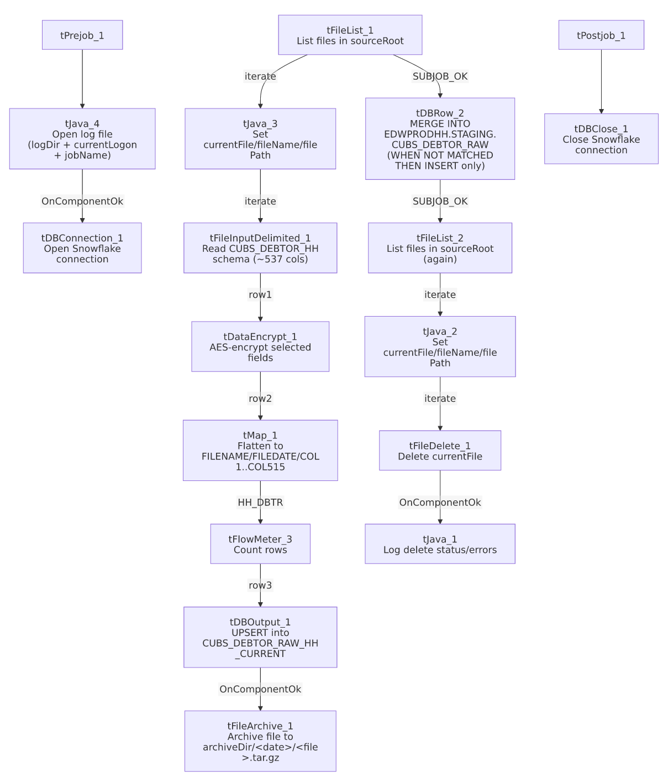

Settings tables

Source: `tFileInputDelimited_1`
Setting | Value | What it means
SCHEMA / SCHEMA_REJECT | Repository schema CUBS_DEBTOR_HH (same schema for both) | Both the main and reject schema point at the identical repository schema (~537 named columns) — the extracted schema_columns array for this component lists that column set twice in sequence plus errorCode/errorMessage, consistent with main+reject both being captured.
FILENAME | context.currentFile | The file tFileList_1's current iteration is pointing at.
ROWSEPARATOR / FIELDSEPARATOR / HEADER / ENCODING | context.EXPORT_DEBTOR_RowSeparator / FieldSeparator / Header / Encoding | Sourced from the EXPORT_DEBTOR_0.1 context group — per _shared_context.json these resolve (in the sample environment captured) to \n row separator, \t field separator, header row count 1, and US-ASCII encoding.
TEMP_DIR | "C:/Talend-Studio-20211109_1610-V8.0.1/workspace" | Hardcoded developer-workstation path — see Issues observed and 05_operational_runbook.md.
DIE_ON_ERROR | false | Malformed rows do not fail the job...
Reject flow | Not wired | ...but no connection in this job routes rejected rows anywhere — they are silently dropped.

Transform: `tDataEncrypt_1`
Setting | Value | What it means
SECRET_TYPE / SECRET_KEY / PASSWORD_M1 | ***REDACTED*** (all three) | Encryption secret configuration — preserved as redacted, not guessable from this metadata.
CRYPTO_METHOD / ALGO_VERSION | AES / 2 | Encryption algorithm and version used.
CRYPTO_FILE_PATH | context.cryptoPath | Where the crypto key/config file is read from; cryptoPath's actual value isn't set in any of the 23 project context groups captured in _shared_context.json — likely a job-level default not captured here.

Transform: `tMap_1`
Setting | Value | What it means
Output schema | FILENAME, FILEDATE, COL1…COL515 (517 columns total) | The ~537 named source business columns (post-encryption) are flattened into generic positional columns — the original column names (LOGON, NAME1, SSN, etc.) are not preserved in the target schema or in this job's own metadata's mapping expressions (tMap's per-field expressions aren't captured by this extraction, only its schema).
DIE_ON_ERROR | true | A mapping/lookup failure here fails the job outright, unlike the upstream file-read step.

Target (staging): `tDBOutput_1` (`tSnowflakeOutput`)
Setting | Value | What it means
Table | CUBS_DEBTOR_RAW_HH_CURRENT | Staging table this run's data lands in.
Output action | UPSERT | Rows are upserted into the staging table (this is the behavior the "_Upsert" job-name suffix refers to — it applies here, at the staging step, not at the final-table merge below).
Table action | NONE | Table is not recreated/altered by this job.

Merge: `tDBRow_2` (`tSnowflakeRow`)
Setting | Value | What it means
Target / source | EDWPRODHH.STAGING.CUBS_DEBTOR_RAW (tgt) / STAGING.CUBS_DEBTOR_RAW_HH_CURRENT (src) | Merges the just-loaded staging rows into the final raw table.
Match key | tgt.FILEDATE = src.FILEDATE AND tgt.COL3 = src.COL3 | COL3 corresponds to the source's DEBTOR_IDX column (third mapped field, and the only source column in this job explicitly marked non-nullable) — so the natural key is effectively (file date, debtor index).
Merge clauses | WHEN NOT MATCHED THEN INSERT only — no `WHEN MATCHED` clause | Despite the job's "_Upsert" name, this final merge never updates an existing matching row — it only inserts rows whose (FILEDATE, COL3) key doesn't already exist in the target. See Issues observed.
Inserted/selected columns | FILENAME, FILEDATE, COL1…COL510 (510 of the 515 mapped columns) | The insert list stops at COL510; COL511–COL515, which are loaded into the staging table by tDBOutput_1, are not included in this INSERT's column list. See Issues observed.

File handling: `tFileList_1` / `tFileList_2`, `tFileArchive_1`, `tFileDelete_1`
Setting | Value | What it means
DIRECTORY (tFileList_1/_2) | context.sourceRoot | Both listing passes scan the same directory.
EXCLUDEFILEMASK / IFEXCLUDE | "*.txt" / false | An exclusion mask is configured but never applied (IFEXCLUDE=false), so every file in the directory is picked up regardless of extension — same copy-paste pattern seen in ADP_Payroll_Load.
TARGET (tFileArchive_1) | context.archiveDir + "/" + TalendDate.getDate("CCYYMMDD") + "/" + context.fileName + ".tar.gz" | Archives the just-loaded file to a date-stamped subfolder.
SOURCE_FILE (tFileArchive_1) | "C:/Talend-Studio-20211109_1610-V8.0.1/workspace/source.csv" | Hardcoded developer-workstation path — see Issues observed.
ENCRYPT_FILES / PASSWORD (tFileArchive_1) | false / ***REDACTED*** | Archive encryption is disabled, yet a (redacted) password value is still configured — likely unused leftover configuration.
DIRECTORY / PATH (tFileDelete_1) | Both "C:/Talend-Studio-20211109_1610-V8.0.1/workspace/delete_folder..." | Hardcoded developer-workstation paths; the component's actual delete target is context.currentFile (FILENAME parameter), so these two fields appear to be unused leftover defaults rather than the live delete path — see Issues observed.

Dependencies & configuration
- Triggers/depends on other jobs: none — runjob_targets is empty, and this job does not appear as a target anywhere in 06_dependency_matrix.md's tRunJob table. Its sibling CUBS_Raw_HH_Debtor_Load (the base, non-upsert variant) *is* called by CUBS_Raw_Debtor_Load; this "_Upsert" variant's own trigger mechanism (manual run, separate schedule, etc.) is unable to determine from metadata.
- Context variables used: EXPORT_DEBTOR_Encoding, EXPORT_DEBTOR_FieldSeparator, EXPORT_DEBTOR_Header, EXPORT_DEBTOR_RowSeparator (from the EXPORT_DEBTOR_0.1 context group), archiveDir, logDir (from StandardFolders_0.1), and sourceRoot, cryptoPath, currentFile, currentLogon, fileName, filePath — none of these last six appear in any of the 23 context groups captured in _shared_context.json, so they are presumably job-level context defaults not visible in this extraction.
- Hardcoded path findings (4): tFileInputDelimited_1.TEMP_DIR, tFileArchive_1.SOURCE_FILE, tFileDelete_1.DIRECTORY, tFileDelete_1.PATH — all under C:/Talend-Studio-20211109_1610-V8.0.1/workspace/..., the same project-wide developer-workstation path issue documented for 210 of 289 jobs in 05_operational_runbook.md.

Glossary
Component type | Plain-English meaning
tPrejob / tPostjob | Run once before/after the rest of the job, regardless of how many times the main flow iterates.
tSnowflakeConnection / tSnowflakeClose | Open/close the Snowflake connection shared by other components in the job.
tFileList | Lists files in a directory for the job to iterate over one at a time.
tJava | Runs a block of custom Java code once (here, used to set context variables from a file-list iteration, or to open a log file).
tFileInputDelimited | Reads a delimited (CSV-style) text file according to a schema.
tDataEncrypt | Encrypts selected field values using a configured algorithm/key before they continue downstream.
tMap | Maps/transforms columns from one schema to another.
tFlowMeter | Counts rows passing a point in the flow, for logging/monitoring.
tSnowflakeOutput | Writes rows to a Snowflake table (insert/update/upsert, per its configured output action).
tSnowflakeRow | Runs an arbitrary SQL statement (here, a MERGE) against Snowflake.
tFileArchive / tFileDelete | Zip a processed file to an archive location, and separately delete a file from the source directory.

Issues observed
- The final-table merge (`tDBRow_2`) drops columns `COL511`–`COL515`. The staging table CUBS_DEBTOR_RAW_HH_CURRENT receives all 515 mapped COL fields via tDBOutput_1, but the MERGE ... THEN INSERT statement's column list stops at COL510 — the last 5 mapped fields are loaded into staging every run and then never carried into EDWPRODHH.STAGING.CUBS_DEBTOR_RAW. Since which 5 source business fields these correspond to isn't visible (tMap's per-field mapping expressions aren't captured in this metadata), this should be verified directly in Talend Studio — if those fields carry meaningful data, this is a silent, ongoing data-loss point in the final table.
- The merge has no `WHEN MATCHED` clause, despite the job's "_Upsert" name. The UPSERT behavior only applies to the intermediate tDBOutput_1 step into the staging table; the actual merge into EDWPRODHH.STAGING.CUBS_DEBTOR_RAW only ever inserts rows with a new (FILEDATE, COL3/DEBTOR_IDX) key combination — it never updates an existing row. If a source file needs to be corrected and re-run for the same file date, previously loaded debtor rows sharing that date would not be refreshed by this job.
- `context.currentLogon` is referenced in `tJava_4` (used to build the setup subjob's log filename) but is never assigned anywhere in this job's own components — the same pattern found in ADP_Payroll_Load with context.fileName. It's presumably a job-level context default not captured by this extraction; verify its actual value with the team.
- `context.sourceRoot` and `context.cryptoPath` do not appear in any of this project's 23 documented context groups (_shared_context.json), unlike archiveDir/logDir which resolve to StandardFolders_0.1. Their runtime values are unable to determine from metadata.
- No reject-row handling is wired from `tFileInputDelimited_1` — DIE_ON_ERROR=false means malformed rows won't fail the job, but there's also no connection routing rejected rows anywhere, so they're silently dropped with no count or record.
- This job is not part of the documented `tRunJob` orchestration chain (06_dependency_matrix.md), unlike its sibling CUBS_Raw_HH_Debtor_Load. Three near-identical HH debtor-load jobs exist in this project (base, _No_Delete, and this _Upsert variant); only the base is confirmed to run as part of CUBS_Raw_Debtor_Load's pipeline. How and when this variant runs is unable to determine from metadata — worth confirming with the team so it isn't assumed to be dead code or, conversely, silently double-loading data alongside the base job.
- The sibling `CUBS_Raw_HH_Debtor_Load_No_Delete` job actually contains a `tFileDelete_1` component (it deletes source files in a second pass, exactly like this job does) — so its "No_Delete" name doesn't describe its own behavior. Worth knowing when comparing these two variants, since the name alone is misleading about which one deletes its source files (both do).
- `tFileArchive_1` has `ENCRYPT_FILES=false` but still carries a configured (redacted) `PASSWORD` value — likely unused leftover configuration rather than a functional risk, but worth confirming it isn't a sign the archive was meant to be encrypted and isn't.

