Talend Job: CUBS_Raw_HH_ETL_Load

Overview
Loads a HH-site (site code, see 01_system_architecture.md) collections/credit-scoring extract file into the Snowflake staging table CUBS_ETL_RAW_CURRENT. The source columns are debtor-level attributes used for collections prioritization and dialer routing — bankruptcy dispositions (BK7_DISP/BK11_DISP/BK13_DISP), revolving/auto/mortgage/lease balances and credit lines, payment-history flags, inquiry counts, and a set of scoring fields (Attune_Score, Propen_Score, Decile, Percentile, Dialer_group). This job is one of six near-identical site variants (CHI, CO, DC, HH, PRE, TOL) called by the orchestrator CUBS_Raw_ETL_Load, which truncates the shared staging table and calls the merge procedure after all six have run — see Dependencies & configuration.

Detail table
Field | Value
Job name | CUBS_Raw_HH_ETL_Load
Version | 0.1
Project | EDW2SF
Author | jmach@harriscollect.com
Created | 2022-12-14T09:06:26.338-0800
Last Modified | 2025-11-11T22:52:34.037-0800

Step-by-step data flow
Setup subjob: tPrejob_1 → tJava_1 opens a per-run log file at context.logDir + jobName + "_" + <timestamp> + ".log" and redirects System.out/System.err to it → on subjob-ok, tSetKeystore_1 configures SSL trust/keystore from context.keystorePath (all keystore/truststore passwords ***REDACTED***) → tDBConnection_1 opens the Snowflake connection.
Main subjob (file processing, runs independently of setup):
- tFileList_1 lists files in context.sourceDir (an EXCLUDEFILEMASK of *.txt is configured but IFEXCLUDE is false, so nothing is actually excluded — every file in the directory is picked up, same as the pattern seen in ADP_Payroll_Load).
- For each file (ITERATE), tJava_2 sets context.currentFile, context.fileName, and context.filePath from the iteration's global-map values.
- tFileInputDelimited_1 reads the file (tab-delimited, 1 header row, DIE_ON_ERROR=false) using repository schema "hh_etl" — a schema unique to this job among its site siblings (see Issues observed for how this compares to the other site variants).
- tMap_1 passes the row through to a generic 80-column (COL1...COL80) plus FILENAME/FILEDATE target schema.
- tFlowMeter_2 counts rows passing through (label "MyLabel", not renamed for this job).
- tDBOutput_1 inserts the rows into Snowflake table CUBS_ETL_RAW_CURRENT (INSERT, no table-recreate action).
- On success (OnComponentOk), tFileArchive_1 tars/gzips the file from context.filePath to context.archiveDir + "/" + <today's date> + "/" + context.fileName + ".tar.gz" (AES-256 encrypted, password ***REDACTED***).
Cleanup subjob (also independent, its own `tFileList_2` re-lists the directory):
- tFileList_2 re-lists context.sourceDir (same unused *.txt exclusion mask), and for each file (ITERATE) tJava_3 re-sets context.currentFile/fileName/filePath from tFileList_2's own iteration.
- tFileDelete_1 deletes context.currentFile.
- On success, tJava_4 prints the delete status, the deleted path, and any error message to the log.
Teardown subjob: tPostjob_1 → tDBClose_1 closes the Snowflake connection.
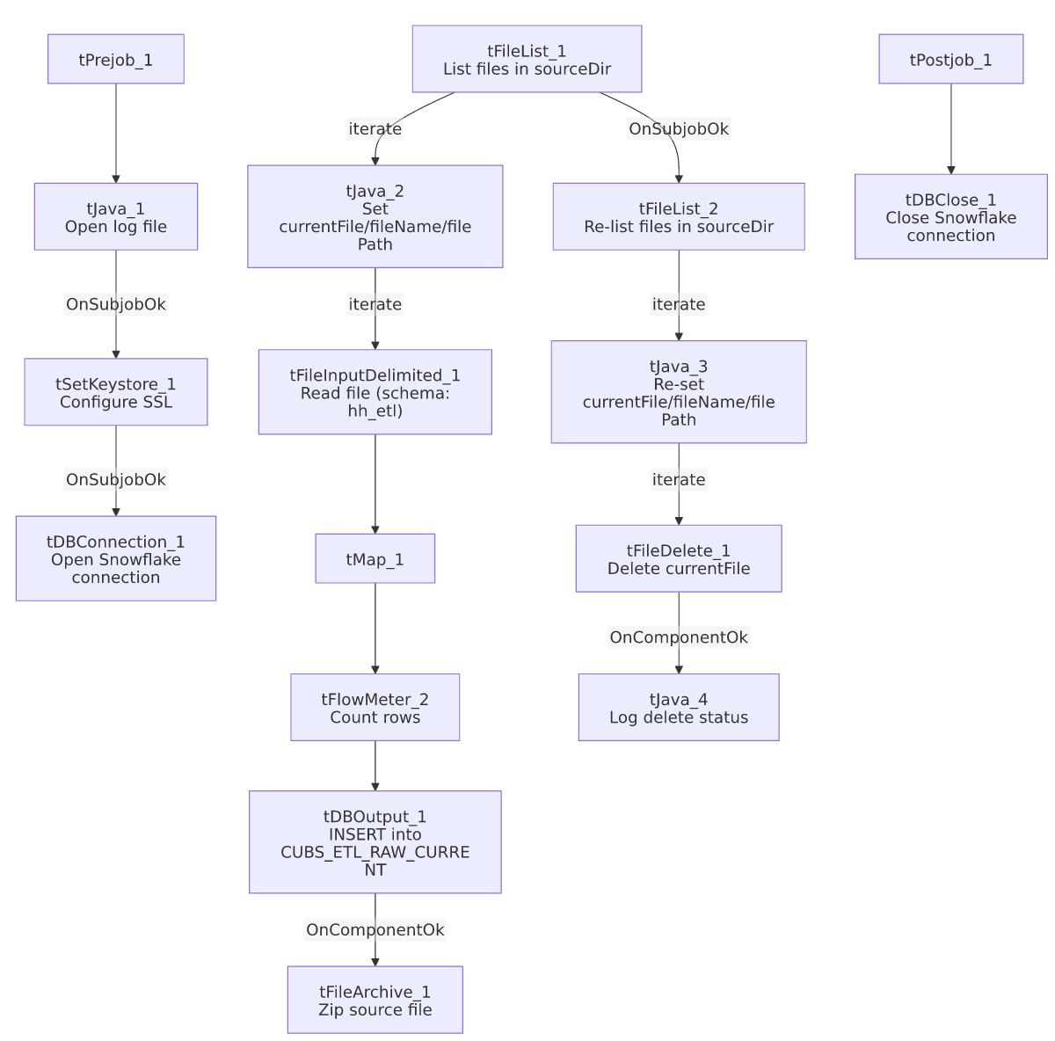

Settings tables

Source: `tFileInputDelimited_1`
Setting | Value | What it means
FILENAME | context.currentFile | The file currently being iterated by tFileList_1.
FIELDSEPARATOR / HEADER | "\t" / 1 header row | Tab-delimited, header row skipped.
SCHEMA | Repository schema "hh_etl" | HH-specific schema label, distinct from the other five site variants' own schema GUIDs (each site has its own schema entry — see Issues observed).
DIE_ON_ERROR | false | Malformed rows don't fail the job...
Reject flow | Not wired | ...but there is no SCHEMA_REJECT configured and no reject connection out of this component — rejected rows are silently dropped with no record.
ENCODING | ISO-8859-15 | Fixed encoding, not driven by a context variable (unlike the EXPORT_CLIENT_*-style jobs).

Target: `tDBOutput_1` (`tSnowflakeOutput`)
Setting | Value | What it means
Table | CUBS_ETL_RAW_CURRENT | Shared staging table — all six site variants of this job template (CHI/CO/DC/HH/PRE/TOL) insert into the same table name.
Output action | INSERT | Appends rows; the orchestrator CUBS_Raw_ETL_Load truncates this table before calling any of the six site jobs (see Dependencies & configuration).
Table action | NONE | This job itself does not recreate/alter the table.
Reject schema fields present but unwired | columnName/rowNumber/category/character/errorMessage/byteOffset/line/sqlState/code appear in the captured output schema | These are tSnowflakeOutput's reject-row fields; no reject connector is wired in this job's connections, so any row-level DB insert error would not be caught by a dedicated reject flow here.

Archive/cleanup: `tFileArchive_1` / `tFileDelete_1`
Setting | Value | What it means
SOURCE / TARGET (tFileArchive_1) | context.filePath / context.archiveDir+"/"+<CCYYMMDD>+"/"+context.fileName+".tar.gz" | Archives the just-loaded file into a date-stamped subfolder, named after the actual source filename (not a job-specific name).
PASSWORD | ***REDACTED*** | Archive encryption password — value withheld in source metadata, preserved as redacted here.
tFileDelete_1 FILENAME | context.currentFile (re-derived by the separate tFileList_2/tJava_3 cleanup pass) | Deletes the source file — see Issues observed regarding the two independent file-listing passes.

Dependencies & configuration
- Triggered by: CUBS_Raw_ETL_Load, which (per 06_dependency_matrix.md) truncates STAGING.CUBS_ETL_RAW_CURRENT and calls CALL STAGING.MERGE_INTO_CUBS_ETL_RAW(); after running this job and its five siblings (CUBS_Raw_CHI_ETL_Load, CUBS_Raw_CO_ETL_Load, CUBS_Raw_DC_ETL_Load, CUBS_Raw_PRE_ETL_Load, CUBS_Raw_TOL_ETL_Load) via tRunJob.
- Triggers/depends on other jobs: none of its own — runjob_targets is empty in this job's metadata.
- Context variables used: sourceDir, archiveDir, logDir, keystorePath (from StandardFolders_0.1 per 06_dependency_matrix.md), plus currentFile, fileName, filePath (all set internally by tJava_2/tJava_3 from the two tFileList iterations).
- 5 hardcoded developer-workstation paths, all C:/Talend-Studio-20211109_1610-V8.0.1/workspace/..., in tFileInputDelimited_1.TEMP_DIR, tFileArchive_1.SOURCE_FILE, tFileDelete_1.DIRECTORY/PATH, and tSetKeystore_1.SSL_TRUSTSERVER_TRUSTSTORE — same portability risk documented project-wide in 05_operational_runbook.md.

Glossary
Component type | Plain-English meaning
tFileList | Lists files in a directory for the job to iterate over one at a time.
tFileInputDelimited | Reads a delimited text file according to a schema.
tMap | Maps/transforms columns from one schema to another.
tFlowMeter | Counts rows passing a point in the flow, for logging/monitoring.
tSnowflakeOutput / tSnowflakeConnection / tSnowflakeClose | Write rows to Snowflake / open and close the shared Snowflake connection.
tFileArchive / tFileDelete | Zip a processed file to an archive location, then delete the original from the source directory.
tSetKeystore | Configures SSL trust/keystore settings used by the Snowflake connection.

Issues observed
- Two independent `tFileList` passes over the same directory (tFileList_1 for reading/loading, tFileList_2 for deleting) rather than deleting the file right after it's archived in the same iteration. If a new file lands in context.sourceDir between the two passes (e.g. another process drops a file while this job is running), tFileList_2's delete pass could pick up and delete a file that was never actually loaded by tFileList_1 in this run. Unable to determine from metadata whether the source directory is exclusively used by this job's own extract-drop process (which would make this safe) — verify with the team.
- No reject flow wired from either `tFileInputDelimited_1` (malformed source rows) or `tDBOutput_1` (rejected Snowflake insert rows), despite DIE_ON_ERROR=false on the input. Both failure paths are effectively silent — a bad row disappears with no file, log entry, or table record of what was dropped.
- This job's repository schema is labeled `"hh_etl"`, distinct per site (each of the six site-variant ETL jobs has its own schema GUID/label — e.g. co_etl, chi_etl), which is consistent here; however, CUBS_Raw_TOL_ETL_Load (a sibling job, not in this batch) actually reuses CO_ETL_Load's schema GUID (co_etl) rather than having its own tol_etl schema — worth flagging to the team as a likely copy-paste artifact in that sibling, even though it does not affect this HH job directly.
- `EXCLUDEFILEMASK: "*.txt"` is configured on both `tFileList_1` and `tFileList_2` but `IFEXCLUDE` is `false`, so the mask has no actual effect — every file in context.sourceDir is processed, not just non-.txt files. Likely a leftover/no-op setting rather than an intentional filter.
- No tWarn/tDie/tSendMail logic exists in this job — a load failure here would only surface as a generic Talend execution error, consistent with the majority of jobs noted in 05_operational_runbook.md. No further job-specific risk pattern beyond what's listed above was found in this job's metadata.

