Talend Job: CUBS_Raw_Letter_Load

Overview
Loads a per-logon CUBS collections-letter export file (letter ID, debtor, amount, pay-by date, print/override flags, notice sequencing) into the Snowflake staging table CUBS_LETTER_RAW_CURRENT, then archives and deletes the source file. Unlike the site-specific _Client_Load/_ETL_Load job families, this job is not itself split into per-site variants in the extracted metadata — it is a single job driven by context.currentLogon, and per 06_dependency_matrix.md it is called exactly once, by CO_Master_Load. Whether it is also invoked for other sites/logons through a mechanism outside this metadata is unclear — see Issues observed.

Detail table
Field | Value
Job name | CUBS_Raw_Letter_Load
Version | 0.1
Project | EDW2SF
Author | jmach@harriscollect.com
Created | 2022-12-20T10:17:35.422-0800
Last Modified | 2025-11-04T11:08:14.137-0800

Step-by-step data flow
Setup subjob: tPrejob_1 → tJava_1 opens a per-run log file at context.logDir + context.currentLogon + "_" + jobName + "_" + <timestamp> + ".log" (note the log filename is prefixed with currentLogon, unlike CUBS_Raw_HH_ETL_Load's job-name-only log filename) → on subjob-ok, tSetKeystore_1 configures SSL trust/keystore from context.keystorePath (passwords ***REDACTED***) → tDBConnection_1 opens the Snowflake connection.
Main subjob:
- tFileInputDelimited_1 reads context.sourceDir + context.currentLogon + "-EDW-EXPORT-LETTER.txt" (tab-delimited, 1 header row, DIE_ON_ERROR=false) using repository schema "CUBS_LETTER".
- On success (OnSubjobOk), tFileArchive_1 archives the same source file (independent of whether the load/insert below succeeded — see Issues observed).
- tMap_1 passes the row through to a 28-column (FILENAME/FILEDATE/COL1...COL26) target schema.
- tFlowMeter_2 counts rows passing through (label "MyLabel").
- tDBOutput_1 inserts the rows into Snowflake table CUBS_LETTER_RAW_CURRENT (INSERT, no table-recreate action).
- Separately, once tFileArchive_1 completes (OnSubjobOk), tFileDelete_1 deletes the original source file.
Teardown subjob: tPostjob_1 → tDBClose_1 closes the Snowflake connection.
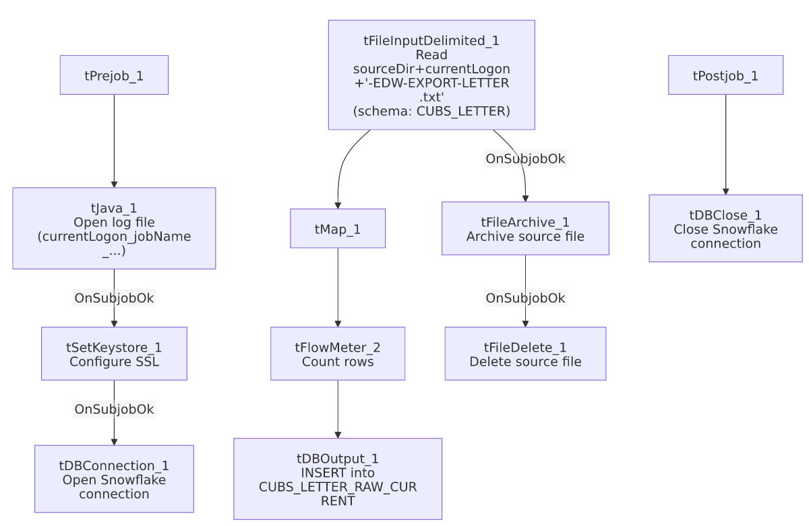

Settings tables

Source: `tFileInputDelimited_1`
Setting | Value | What it means
FILENAME | context.sourceDir + context.currentLogon + "-EDW-EXPORT-LETTER.txt" | Per-logon filename pattern — currentLogon must be set by whatever calls this job (see Issues observed, it is not set within this job's own metadata).
FIELDSEPARATOR / HEADER | "\t" / 1 header row | Tab-delimited, header row skipped.
SCHEMA | Repository schema "CUBS_LETTER" | Well-formed letter-row layout: letter ID/index, debtor, letter amount, pay-by date, print/override flags, notice sequence/rate/pay-days, series, employee initials.
DIE_ON_ERROR | false | Malformed rows do not fail the job...
Reject flow | Not wired | ...but there is no SCHEMA_REJECT configured and no reject connection — rejected rows are silently dropped, with no file, log, or table record of what failed.
ENCODING | ISO-8859-15 | Fixed encoding, not context-driven.

Target: `tDBOutput_1` (`tSnowflakeOutput`)
Setting | Value | What it means
Table | CUBS_LETTER_RAW_CURRENT | Destination staging table for raw letter export rows.
Output action | INSERT | Appends rows — there is no TRUNCATE step in this job itself; any truncate/merge into a downstream fact table would have to happen in a separate job or procedure not visible in this metadata.
Table action | NONE | Table is not recreated/altered by this job.
Reject schema fields present but unwired | columnName/rowNumber/category/character/errorMessage/byteOffset/line/sqlState/code | tSnowflakeOutput's built-in reject-row fields are present in the captured schema but no reject connector is wired — a row-level DB insert error is not caught by a dedicated reject flow here either.

Archive/cleanup: `tFileArchive_1` / `tFileDelete_1`
Setting | Value | What it means
SOURCE / TARGET (tFileArchive_1) | context.sourceDir / context.archiveDir+"/"+<CCYYMMDD>+"/"+context.currentLogon+"-EDW-EXPORT-LETTER.txt.tar.gz" | Archives into a date-stamped subfolder, named after the per-logon source filename.
PASSWORD | ***REDACTED*** | Archive encryption password — withheld in source metadata, preserved as redacted here.
Trigger for archive | tFileInputDelimited_1 OnSubjobOk, not downstream of tDBOutput_1 | The archive step runs as soon as the *read* subjob succeeds — it does not wait for the Snowflake insert to actually complete. See Issues observed.
tFileDelete_1 FILENAME | context.sourceDir + context.currentLogon + "-EDW-EXPORT-LETTER.txt" | Re-derives the same filename expression as the input step, rather than reusing a variable set once — functionally equivalent here since currentLogon/sourceDir don't change mid-run, but a second, independent point where the same string has to stay in sync if either component's path logic is ever edited.

Dependencies & configuration
- Triggered by: CUBS_Raw_Letter_Load is called once by CO_Master_Load, in Branch B of that job's transaction chain (after CUBS_Raw_Trans_Load succeeds — see job_CO_Master_Load.md and 06_dependency_matrix.md). No other calling job is recorded in the dependency matrix.
- Triggers/depends on other jobs: none — runjob_targets is empty in this job's own metadata.
- Context variables used: sourceDir, archiveDir, logDir, keystorePath (from StandardFolders_0.1), and currentLogon — see Issues observed regarding where currentLogon's value actually comes from at runtime.
- 5 hardcoded developer-workstation paths, all C:/Talend-Studio-20211109_1610-V8.0.1/workspace/..., in tFileInputDelimited_1.TEMP_DIR, tFileDelete_1.DIRECTORY/PATH, tFileArchive_1.SOURCE_FILE, and tSetKeystore_1.SSL_TRUSTSERVER_TRUSTSTORE — same portability risk documented project-wide in 05_operational_runbook.md.

Glossary
Component type | Plain-English meaning
tFileInputDelimited | Reads a delimited text file according to a schema.
tMap | Maps/transforms columns from one schema to another.
tFlowMeter | Counts rows passing a point in the flow, for logging/monitoring.
tSnowflakeOutput / tSnowflakeConnection / tSnowflakeClose | Write rows to Snowflake / open and close the Snowflake connection used throughout the job.
tFileArchive / tFileDelete | Zip a processed file to an archive location, then delete the original from the source directory.
tSetKeystore | Configures SSL trust/keystore settings used by the Snowflake connection.

Issues observed
- `context.currentLogon` is used throughout this job (log filename, source filename, archive filename, delete filename) but is never set anywhere within this job's own metadata, and it is not one of the context variables checked in _shared_context.json's context groups (no group defines a currentLogon default). This job's only recorded caller, CO_Master_Load, also does not reference or set currentLogon in its own metadata (per job_CO_Master_Load.md). Where this value is actually supplied at runtime — a scheduler-level context override, a job-level default not captured in this extraction, or something else — is unable to determine from metadata; if it is genuinely unset, every path built from it would resolve with a blank/null substitution, which would very likely make the source file lookup fail outright rather than silently misbehave. Verify directly with the team before assuming this job runs successfully as configured.
- `tFileArchive_1` runs as soon as the file read subjob succeeds, not after the Snowflake insert (`tDBOutput_1`) succeeds. If the insert into CUBS_LETTER_RAW_CURRENT were to fail after the read but before commit, the source file would still be archived (and then deleted by tFileDelete_1), leaving no easy way to identify or re-obtain the original file for a retry. This differs from ADP_Payroll_Load's pattern, where archiving is gated behind a successful merge result.
- No reject flow wired from either `tFileInputDelimited_1` or `tDBOutput_1`, despite DIE_ON_ERROR=false on the input — malformed source rows and any rejected Snowflake insert rows are both silently dropped with no record.
- This job has no site-code variant (unlike the _Client_Load/_ETL_Load/_Debtor_Load families), and is instead parameterized entirely by currentLogon. Given the currentLogon-sourcing question above, it's worth confirming with the team whether this job is meant to be called once per logon (looped by some caller not captured here) or is only ever invoked once per CO_Master_Load run as the dependency matrix currently shows.

