Talend Job: CUBS_Raw_PRE_Client_Load

Overview
Loads a PRE-site (site code, see 01_system_architecture.md) CUBS client-master export file — client identifiers, name/address, billing rates, statement/invoice frequency preferences, credit-reporting flags, and a large block of client-configuration/billing options (~170 business columns) — into the Snowflake staging table CUBS_CLIENT_RAW_CURRENT. It is one of six near-identical site variants (CHI, CO, DC, HH, PRE, TOL) of the same job template, plus a seventh, non-site-specific CUBS_Raw_Client_Load. Unlike its _ETL_Load and _Debtor_Load counterparts, no orchestrator job is recorded anywhere in the extracted metadata as calling this specific job — see Issues observed.

Detail table
Field | Value
Job name | CUBS_Raw_PRE_Client_Load
Version | 0.1
Project | EDW2SF
Author | jmach@harriscollect.com
Created | 2023-09-26T11:18:33.398-0700
Last Modified | 2025-11-04T11:08:09.399-0800

Step-by-step data flow
Setup subjob: tPrejob_1 → tJava_1 opens a per-run log file at context.logDir + context.currentLogon + "_" + jobName + "_" + <timestamp> + ".log" → on subjob-ok, tSetKeystore_1 configures SSL trust/keystore from context.keystorePath (passwords ***REDACTED***) → tDBConnection_1 opens the Snowflake connection.
Main subjob:
- tFileInputDelimited_1 reads context.sourceDir + context.EXPORT_CLIENT_File — all of its delimiter/header/encoding settings (ROWSEPARATOR, FIELDSEPARATOR, HEADER, ENCODING) are driven by the EXPORT_CLIENT_* context group rather than hardcoded, using repository schema "metadata" (a PRE-specific schema GUID; see Issues observed on the schema label itself) and TRIMALL=true (trims all field values — not seen as an explicit setting in the HH_ETL_Load/Letter_Load jobs in this batch).
- On success (OnSubjobOk), tFileArchive_1 archives the source file to context.archiveDir + "/" + <today's date> + "/" + context.EXPORT_CLIENT_File + ".tar.gz".
- tMap_1 passes the row through to a 202-column (FILENAME/FILEDATE/COL1...COL200) target schema.
- tFlowMeter_2 counts rows passing through (label "MyLabel", stream labeled "cli").
- tDBOutput_1 inserts the rows into Snowflake table CUBS_CLIENT_RAW_CURRENT (INSERT, no table-recreate action).
- Separately, once tFileArchive_1 completes (OnSubjobOk), tFileDelete_1 deletes context.sourceDir + context.EXPORT_CLIENT_File.
Teardown subjob: tPostjob_1 → tDBClose_1 closes the Snowflake connection.
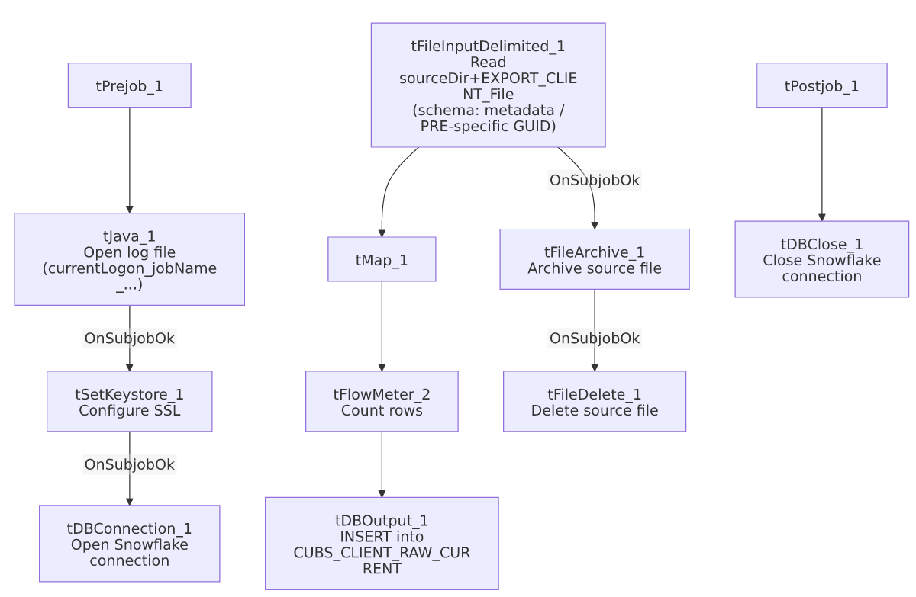

Settings tables

Source: `tFileInputDelimited_1`
Setting | Value | What it means
FILENAME | context.sourceDir + context.EXPORT_CLIENT_File | Filename is entirely context-driven — see Issues observed regarding EXPORT_CLIENT_File's stored default value.
ROWSEPARATOR / FIELDSEPARATOR / HEADER / ENCODING | context.EXPORT_CLIENT_RowSeparator / context.EXPORT_CLIENT_FieldSeparator / context.EXPORT_CLIENT_Header / context.EXPORT_CLIENT_Encoding | All read-format settings come from the shared EXPORT_CLIENT_0.1 context group rather than being fixed per job — this job is more context-parameterized than CUBS_Raw_HH_ETL_Load or CUBS_Raw_Letter_Load in this batch, both of which hardcode their delimiter/encoding values.
CSVROWSEPARATOR | context.EXPORT_TRANS_RowSeparator | Uses the transaction export group's row separator, not a client-specific one — likely a copy-paste artifact from a transaction-load job template, though this parameter only applies when CSV_OPTION=true, which is false here, so it appears to have no actual effect.
SCHEMA | Repository schema "metadata" (GUID _u_wNUFMkEe6koubybprAWA) | Same GUID/label as CUBS_Raw_HH_Client_Load? No — each site variant in this family has its own schema GUID even when the label text shown is generic ("metadata"); this job's specific GUID differs from CHI's, CO's/TOL's (which share one GUID), DC's, and HH's own schema entries. See Issues observed.
SCHEMA_REJECT | Repository schema "CUBS_TRANSACTION" | Mislabeled — this is a client-load job but its reject schema is a transaction schema, the same reject-schema mismatch pattern documented in ADP_Payroll_Load, and shared identically across all six site variants of this job family (see Issues observed).
DIE_ON_ERROR | false | Malformed rows do not fail the job...
Reject flow | Not wired | ...but there is no connection carrying rejected rows anywhere — they are silently dropped, same as CUBS_Raw_HH_ETL_Load and CUBS_Raw_Letter_Load in this batch.
TRIMALL | true | All field values are trimmed of leading/trailing whitespace on read.

Target: `tDBOutput_1` (`tSnowflakeOutput`)
Setting | Value | What it means
Table | CUBS_CLIENT_RAW_CURRENT | Shared staging table — identical table name used by all six site variants (CHI/CO/DC/HH/PRE/TOL) and the non-site-specific CUBS_Raw_Client_Load.
Output action | INSERT | Appends rows; no TRUNCATE step exists in this job itself.
Table action | NONE | Table is not recreated/altered by this job.

Archive/cleanup: `tFileArchive_1` / `tFileDelete_1`
Setting | Value | What it means
SOURCE / TARGET (tFileArchive_1) | context.sourceDir / context.archiveDir+"/"+<CCYYMMDD>+"/"+context.EXPORT_CLIENT_File+".tar.gz" | Archives into a date-stamped subfolder, named after the context-driven export filename.
PASSWORD | ***REDACTED*** | Archive encryption password — withheld in source metadata, preserved as redacted here.
tFileDelete_1 FILENAME | context.sourceDir + context.EXPORT_CLIENT_File | Same expression as the input filename, re-derived independently.

Dependencies & configuration
- Triggers/depends on other jobs: none — runjob_targets is empty in this job's own metadata.
- No calling job is recorded anywhere in `06_dependency_matrix.md`. This stands out because its sibling job families do have documented orchestrators: CUBS_Raw_ETL_Load calls all six site _ETL_Load jobs, and CUBS_Raw_Debtor_Load calls five of the six site _Debtor_Load jobs. No equivalent CUBS_Raw_Client_Load → CUBS_Raw_<site>_Client_Load orchestration exists in the extracted metadata (the base CUBS_Raw_Client_Load job is itself a leaf/file-loader job, not an orchestrator — it has the same tFileInputDelimited/tMap/tDBOutput shape as this job, just without a site suffix). The only Client_Load-family job with a known caller is CUBS_Raw_CO_Client_Load, called once by CO_Master_Load. How CUBS_Raw_PRE_Client_Load is actually triggered (a separate PRE-specific scheduler entry, a master job not present in this export, or something else) is unable to determine from metadata — verify with the team.
- Context variables used: sourceDir, archiveDir, logDir, keystorePath (from StandardFolders_0.1), currentLogon, and the full EXPORT_CLIENT_0.1 group (EXPORT_CLIENT_File, EXPORT_CLIENT_Header, EXPORT_CLIENT_FieldSeparator, EXPORT_CLIENT_RowSeparator, EXPORT_CLIENT_Encoding), plus EXPORT_TRANS_RowSeparator from the separate EXPORT_TRANS_0.1 group (see Settings tables).
- 5 hardcoded developer-workstation paths, all C:/Talend-Studio-20211109_1610-V8.0.1/workspace/..., in tFileInputDelimited_1.TEMP_DIR, tFileArchive_1.SOURCE_FILE, tFileDelete_1.DIRECTORY/PATH, and tSetKeystore_1.SSL_TRUSTSERVER_TRUSTSTORE — same portability risk documented project-wide in 05_operational_runbook.md.

Glossary
Component type | Plain-English meaning
tFileInputDelimited | Reads a delimited text file according to a schema.
tMap | Maps/transforms columns from one schema to another.
tFlowMeter | Counts rows passing a point in the flow, for logging/monitoring.
tSnowflakeOutput / tSnowflakeConnection / tSnowflakeClose | Write rows to Snowflake / open and close the Snowflake connection used throughout the job.
tFileArchive / tFileDelete | Zip a processed file to an archive location, then delete the original from the source directory.
tSetKeystore | Configures SSL trust/keystore settings used by the Snowflake connection.

Issues observed
- `context.EXPORT_CLIENT_File`'s stored default in `_shared_context.json` is `"HH-EDW-EXPORT-CLIENT.txt"` — a hardcoded HH filename — not a PRE (or generic) one. The EXPORT_CLIENT_0.1 context group has no per-site override captured anywhere in this project's metadata; every site variant of this job (CHI, CO, DC, HH, PRE, TOL) reads its filename from the same single context.EXPORT_CLIENT_File variable. If this job runs with that group's stored default rather than a job-level or execution-level override supplied at runtime (a scheduler-level context set, not visible in this metadata), it would attempt to read the HH file instead of a PRE-specific one. This could not be confirmed or ruled out from the available metadata — it is a high-priority item to verify directly with the team, since a wrong-file read would either fail outright (file not found) or, worse, silently reload HH's client data under a PRE job run.
- The `SCHEMA_REJECT` on `tFileInputDelimited_1` is labeled `"CUBS_TRANSACTION"`, not a client-reject schema — the exact same mismatch pattern as ADP_Payroll_Load's reject-schema issue, and identically present across all six site variants of this job (CHI/CO/DC/HH/PRE/TOL), which suggests it was copied once into a shared job template and never corrected in any of them, rather than being specific to this job. Combined with DIE_ON_ERROR=false and no reject connector wired at all, this schema mislabeling has no actual effect today (no rows ever flow through it), but it would need to be fixed before anyone tries to wire up a real reject-row destination.
- `CSVROWSEPARATOR` is set to `context.EXPORT_TRANS_RowSeparator` (the transaction-export group's separator) rather than context.EXPORT_CLIENT_RowSeparator. Since CSV_OPTION=false, this parameter is not actually used by the CSV parser in this configuration, so it currently has no functional effect — but it is inconsistent with the rest of the component's settings, which otherwise consistently reference EXPORT_CLIENT_* variables, and would produce wrong behavior if CSV_OPTION were ever turned on without also fixing this field.
- No job in the extracted metadata calls `CUBS_Raw_PRE_Client_Load`. Its _ETL_Load and (mostly) _Debtor_Load sibling families have documented orchestrators (CUBS_Raw_ETL_Load, CUBS_Raw_Debtor_Load); the Client_Load family does not, apart from CO_Master_Load calling CUBS_Raw_CO_Client_Load specifically. Verify with the team how/whether this job is actually scheduled to run.
- No reject flow wired from `tFileInputDelimited_1` — same silent-drop pattern as the other two jobs in this batch: malformed rows are neither logged nor routed anywhere.

