Talend Job: CUBS_Raw_PRE_Debtor_Load

Overview
This is the "PRE" site's variant of the project's per-site debtor-load template: it truncates a per-run staging table, reads every debtor export file found in a site-specific source folder, encrypts sensitive fields, maps the ~300-column wide debtor record, and bulk-loads it into a Snowflake staging table before appending the batch into the cumulative CUBS_DEBTOR_RAW history table. It is invoked as one of five (CHI/CO/DC/HH/PRE) sibling jobs from the CUBS_Raw_Debtor_Load orchestrator (see 06_dependency_matrix.md) — the debtor record itself is a very wide, decades-accreted layout spanning collection, healthcare/UB92, insurance, skip-trace, and letter-history fields, consistent with a legacy collections-system export being loaded wholesale into the warehouse.

Detail table
Field | Value
Job name | CUBS_Raw_PRE_Debtor_Load
Version | 0.1
Project | EDW2SF
Author | jmach@harriscollect.com
Created | 2022-05-06T09:15:29.214-0700
Last Modified | 2022-06-13T14:33:39.417-0700

Step-by-step data flow
Setup subjob: tPrejob_1 →(OnComponentOk)→ tDBConnection_1 opens the job's Snowflake connection. This component's parameters are entirely empty in this job's own metadata (no captured hand-set LABEL, host, or schema) — see Issues observed.
Teardown subjob: tPostjob_1 →(OnComponentOk)→ tDBClose_1 closes the Snowflake connection.
Main subjob:
- tDBRow_1 runs TRUNCATE TABLE STAGING.CUBS_DEBTOR_RAW_PRE_CURRENT; to clear the per-run current-batch staging table.
- On success (SUBJOB_OK), tFileList_1 lists every file (no include filemask configured; an EXCLUDEFILEMASK of *.txt is set but IFEXCLUDE=false, so nothing is actually excluded) in context.sourceRoot + context.currentLogon.
- For each file (ITERATE), tJava_3 sets context.currentFile from the current file path and prints a "Processing file ..." line to the log.
- tJava_3 →(ITERATE)→ tFileInputDelimited_1 reads the file using the repository schema CUBS_DEBTOR_PRE (a ~304-column debtor layout) as its main schema, with row/field separators and encoding driven by context.EXPORT_DEBTOR_* context variables and DIE_ON_ERROR=false. Its configured reject schema is CUBS_DEBTOR_HH, not CUBS_DEBTOR_PRE — see Issues observed.
- tFileInputDelimited_1 →(FLOW, row name row1)→ tDataEncrypt_1 encrypts sensitive field(s) in the record using a redacted password/secret and ALGO_VERSION=2; which specific column(s) are encrypted is not captured in this job's metadata (no FIELDS-style parameter present).
- tDataEncrypt_1 →(FLOW, row name row2)→ tMap_1 passes the record through (no field-level mapping expressions are captured in this metadata beyond the schema shapes; DIE_ON_ERROR=true on the map, so a mapping failure fails the job outright).
- tMap_1 →(FLOW, row name `PRE_DBTR` — a job-specific, hand-named output row, unlike the generic row1/row2/row3 names elsewhere in this same job)→ tFlowMeter_3 counts rows passing through.
- tFlowMeter_3 →(FLOW, row name row3)→ tDBOutputBulkExec_1 bulk-inserts the rows into Snowflake table CUBS_DEBTOR_RAW_PRE_CURRENT (outputAction=INSERT, tableAction=NONE).
- Separately, once the tFileList_1 iteration subjob completes successfully (SUBJOB_OK, not gated on any single file's success/failure), tDBRow_2 runs INSERT INTO STAGING.CUBS_DEBTOR_RAW SELECT * FROM STAGING.CUBS_DEBTOR_RAW_PRE_CURRENT;, appending the whole batch just loaded into the cumulative history table.
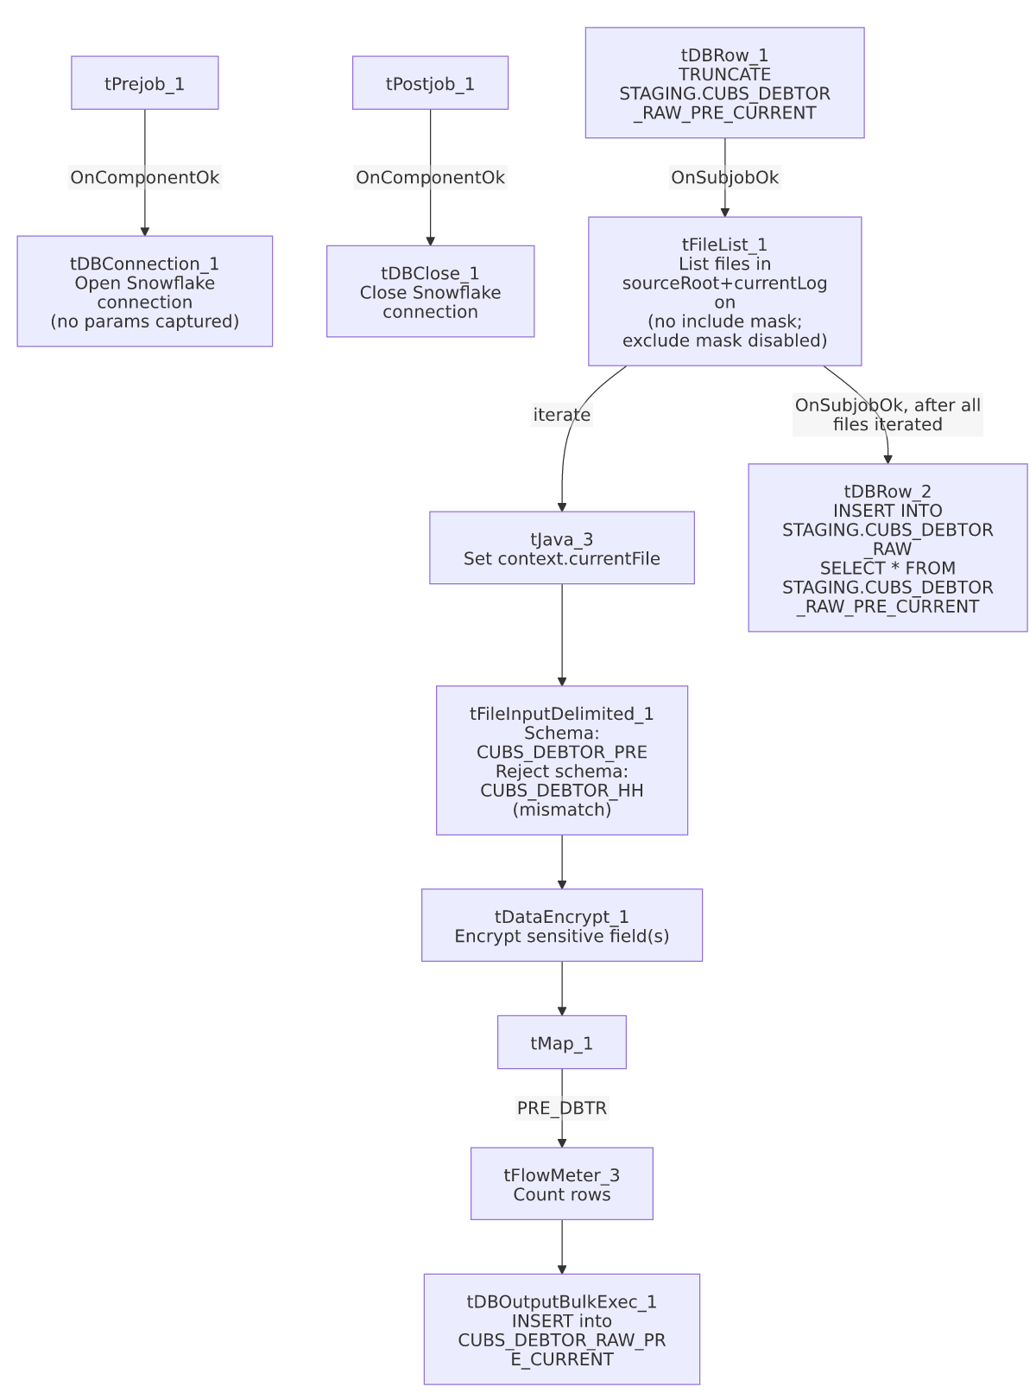

Settings tables

Staging reset: `tDBRow_1` (`tSnowflakeRow`)
Setting | Value | What it means
Query | TRUNCATE TABLE STAGING.CUBS_DEBTOR_RAW_PRE_CURRENT; | Empties the per-run current-batch staging table before the file iteration begins, so CUBS_DEBTOR_RAW_PRE_CURRENT only ever holds the rows from the current run at bulk-load time.

File discovery: `tFileList_1`
Setting | Value | What it means
DIRECTORY | context.sourceRoot + context.currentLogon | Directory is built from two context variables, neither of which appears in _shared_context.json's captured context groups — their actual runtime values can't be confirmed from metadata. See Issues observed.
LIST_MODE | FILES | Lists files only (no subdirectories; INCLUDSUBDIR=false).
Include filemask | Not set | No filemask restricts which files are picked up — every file in the directory is listed.
EXCLUDEFILEMASK / IFEXCLUDE | "*.txt" / false | An exclusion for .txt files is configured but disabled, so it has no effect — combined with no include mask, this job would iterate over any file dropped in that directory, not just debtor export files.

Source: `tFileInputDelimited_1`
Setting | Value | What it means
FILENAME | context.currentFile | The file currently being iterated by tFileList_1/tJava_3.
FIELDSEPARATOR / ROWSEPARATOR / HEADER / ENCODING | context.EXPORT_DEBTOR_FieldSeparator / context.EXPORT_DEBTOR_RowSeparator / context.EXPORT_DEBTOR_Header / context.EXPORT_DEBTOR_Encoding | Delimiter/encoding settings sourced from the shared EXPORT_DEBTOR_0.1 context group (defaults there are tab-delimited, \n row separator, header row present, US-ASCII — see _shared_context.json).
SCHEMA (main) | Repository schema CUBS_DEBTOR_PRE (~304 business columns) | The expected wide debtor layout for the PRE site — includes identity fields (LOGON, DEBTOR, CLIENT, NAME1/2, SSN, DOB), balance/collection fields, letter-history fields, and a large block of healthcare/UB92 and insurance fields (ADMIT_DIAG, FINL_CLASS, POLICY, etc.), reflecting a legacy collections-system export.
SCHEMA_REJECT | Repository schema CUBS_DEBTOR_HH | Mislabeled for this job — CUBS_Raw_PRE_Debtor_Load's reject schema points to the HH site's debtor schema, not PRE's. See Issues observed.
DIE_ON_ERROR | false | Malformed rows don't fail the job...
Reject flow | Not wired | ...but (per connections) no connection carries rejected rows anywhere — they are silently dropped with no record of count or content.
TEMP_DIR | "C:/Talend-Studio-20211109_1610-V8.0.1/workspace" | Hardcoded developer-workstation path — see 05_operational_runbook.md's project-wide finding (210 of 289 jobs share this exact path).

Transform: `tDataEncrypt_1`
Setting | Value | What it means
PASSWORD_M1 | ***REDACTED*** | Encryption key/passphrase — preserved as redacted, not guessable from metadata.
SECRET_TYPE | ***REDACTED*** | Also redacted in source metadata.
CRYPTO_FILE_PATH | context.cryptoPath | Path to a cryptographic key/config file; cryptoPath is not defined in any captured context group in _shared_context.json — its actual value is unknown from this metadata.
ALGO_VERSION | 2 | Encryption algorithm version.
Which column(s) are encrypted | Not captured | This job's metadata doesn't include a field-selection parameter for tDataEncrypt_1; likely candidates given the schema are SSN/SSN1, but this is not confirmed — verify directly in Talend Studio.

Target: `tDBOutputBulkExec_1` (`tSnowflakeOutputBulkExec`)
Setting | Value | What it means
Table | CUBS_DEBTOR_RAW_PRE_CURRENT | Destination staging table for the current run's batch (no explicit schema prefix on this component, unlike the STAGING.-prefixed queries elsewhere in this job — consistent with the connection's default schema already being STAGING, though that isn't directly confirmed by this job's own metadata since tDBConnection_1 has no captured parameters).
outputAction | INSERT | Appends rows; relies on the earlier TRUNCATE (tDBRow_1) to prevent duplicate accumulation across runs.
tableAction | NONE | Table is not recreated/altered by this job.

History append: `tDBRow_2` (`tSnowflakeRow`)
Setting | Value | What it means
Query | INSERT INTO STAGING.CUBS_DEBTOR_RAW SELECT * FROM STAGING.CUBS_DEBTOR_RAW_PRE_CURRENT; | Appends the entire just-loaded current-batch staging table into the cumulative CUBS_DEBTOR_RAW table. Runs once per job execution (wired off tFileList_1's subjob-ok, after all files have iterated), not per file.

Dependencies & configuration
- Triggered by: CUBS_Raw_Debtor_Load, which calls this job as one of five site-specific debtor loads (CUBS_Raw_CHI_Debtor_Load, CUBS_Raw_CO_Debtor_Load, CUBS_Raw_DC_Debtor_Load, CUBS_Raw_HH_Debtor_Load, CUBS_Raw_PRE_Debtor_Load) — see 06_dependency_matrix.md. This job's own runjob_targets is empty — it does not call any other job.
- Context variables used: EXPORT_DEBTOR_Encoding, EXPORT_DEBTOR_FieldSeparator, EXPORT_DEBTOR_Header, EXPORT_DEBTOR_RowSeparator (all from the shared EXPORT_DEBTOR_0.1 context group), plus cryptoPath, currentFile, currentLogon, and sourceRoot — none of these last four appear in _shared_context.json's captured context groups, so their runtime values/defaults can't be confirmed from the metadata available to this documentation effort.
- 1 hardcoded developer-workstation path in tFileInputDelimited_1.TEMP_DIR (C:/Talend-Studio-20211109_1610-V8.0.1/workspace) — same portability risk documented project-wide in 05_operational_runbook.md.

Glossary
Component type | Plain-English meaning
tFileList | Lists files in a directory for the job to iterate over one at a time.
tFileInputDelimited | Reads a delimited (CSV/tab-style) text file according to a schema.
tDataEncrypt | Encrypts one or more field values in the row using a configured algorithm and key/passphrase.
tMap | Maps/transforms columns from one schema to another.
tFlowMeter | Counts rows passing through a point in the flow, for logging/monitoring.
tSnowflakeOutputBulkExec | Bulk-loads rows into a Snowflake table (a higher-throughput variant of tSnowflakeOutput, typically staging data via an internal file/stage before a COPY INTO).
tSnowflakeRow / tSnowflakeConnection / tSnowflakeClose | Run an arbitrary SQL statement against Snowflake / open and close the Snowflake connection shared by the job's other components.
tPrejob / tPostjob | Standard Talend setup/teardown subjobs that run once before and after the main job logic, regardless of which main-subjob branches execute.

Issues observed
- The reject schema on `tFileInputDelimited_1` is labeled `CUBS_DEBTOR_HH`, not `CUBS_DEBTOR_PRE`. This is CUBS_Raw_PRE_Debtor_Load; its main input schema is correctly the PRE-site debtor layout, but the reject schema appears to point at the HH site's debtor schema instead — the same class of copy-paste/schema-mislabel issue seen in ADP_Payroll_Load. Since the reject flow isn't wired anywhere (see next finding), this mismatch has no visible runtime effect today, but it would surface immediately if someone tried to wire up reject-row handling for this job without first fixing the schema reference.
- No reject flow is wired from `tFileInputDelimited_1`. DIE_ON_ERROR=false, so malformed rows in the input file don't fail the job, but there is also no connection carrying rejected rows anywhere (no file, no log, no table) — they are silently dropped with no record of how many rows, or which ones, failed to parse against the ~304-column CUBS_DEBTOR_PRE schema.
- `tFileList_1` has no include filemask, and its exclude filemask (`*.txt`) is disabled (`IFEXCLUDE=false`). Combined, this means the job will attempt to process *every* file present in context.sourceRoot + context.currentLogon, not just debtor export files — if any unrelated file (a log, a lock file, a partial upload) lands in that directory, it would be fed into tFileInputDelimited_1 against the CUBS_DEBTOR_PRE schema and most likely rejected row-by-row (silently, per the previous finding) rather than causing an obvious job failure.
- `context.cryptoPath`, `context.currentLogon`, and `context.sourceRoot` are referenced but not defined in any context group captured in `_shared_context.json`. Their actual runtime values (and therefore the real source directory and encryption key file location this job uses in production) cannot be determined from the metadata available here — verify directly in Talend Studio or the relevant context environment files.
- `tDBConnection_1`'s parameters are completely empty in this job's own metadata — no hand-set connection LABEL, host, or schema is captured, unlike most other Snowflake-connected jobs in this project. This job's queries reference the STAGING schema by name, which is consistent with the project's LEGACY_STAGING Snowflake connection convention documented in 01_system_architecture.md, but that identification is inferred from the SQL text, not confirmed from this job's own connection component.
- Beyond the above, this job follows the same truncate-load-append shape as its CO/CHI/DC/HH siblings with no additional project-wide risk patterns beyond what's already documented in 05_operational_runbook.md (e.g. the shared hardcoded workspace path).

