Talend Job: CUBS_Raw_PRE_Debtor_Load_No_Delete

Overview
Loads a raw debtor-account export file for the "PRE" site (see 01_system_architecture.md on site codes) from a local/mounted source directory into Snowflake. The job reads a delimited file against a CUBS_DEBTOR_PRE repository schema (335 unique debtor name/address/phone/employer/letter/collection-status columns), AES-encrypts a subset of those columns, remaps everything down to a generic FILENAME/FILEDATE/COL1...COL500 layout, inserts it into the Snowflake staging table CUBS_DEBTOR_RAW_PRE_CURRENT, then merges the new rows (insert-only, no update/delete) into the shared EDWPRODHH.STAGING.CUBS_DEBTOR_RAW table used by all site loads. It is one of (at least) three job variants for PRE debtor loading found in this metadata (CUBS_Raw_PRE_Debtor_Load, this _No_Delete variant, and _Upsert) that differ in whether post-load file cleanup runs — see Issues observed.

Detail table
Field | Value
Job name | CUBS_Raw_PRE_Debtor_Load_No_Delete
Version | 0.4
Project | EDW2SF
Author | jmach@harriscollect.com
Created | 2022-12-06T15:16:11.298-0800
Last Modified | 2026-07-07T12:12:16.157-0700

Step-by-step data flow
Setup subjob: tPrejob_1 → tJava_4 opens a per-run log file at context.logDir + context.currentLogon + "_" + jobName + "_" + <timestamp> + ".log" and redirects System.out to it (code truncated in the source metadata after this point — see Issues observed) → on success (COMPONENT_OK), tDBConnection_1 opens the job's Snowflake connection (tSnowflakeConnection, no parameters captured to identify which named connection this points to — see Issues observed).
Main subjob:
- tDBRow_1 runs TRUNCATE TABLE STAGING.CUBS_DEBTOR_RAW_PRE_CURRENT; — clears the PRE-specific current-load staging table before this run.
- On success (SUBJOB_OK), tFileList_1 lists files in context.sourceRoot with no explicit ordering applied (ORDER_BY_NOTHING=true).
- For each file (ITERATE), tJava_3 sets context.currentFile, context.fileName, and context.filePath from the tFileList_1 iteration variables (code truncated in the source metadata — see Issues observed).
- tFileInputDelimited_1 reads the current file using the repository schema CUBS_DEBTOR_PRE (335 unique columns; the metadata records the schema twice for a raw total of 668 entries — see Settings tables), with DIE_ON_ERROR=false — malformed rows do not fail the job. Its configured reject schema is `CUBS_DEBTOR_HH`, not a PRE schema — see Issues observed. No connection carries rejected rows anywhere.
- tDataEncrypt_1 receives 320 of the 335 unique input columns (15 columns — including errorCode/errorMessage and business fields such as CLT_XFER_DT, GUARANTOR_EMP, HDSP_ST_DT, HDSP_ENDDT, PKT_TOTAL_60, PKT_BAL, PMT_PCT_BAL, SIG_PMT, SIG_PROC_DT, LETTERABLE, EMAILABLE, TEXTABLE, PV_FLAG — are dropped at this step) and AES-encrypts them, writing its crypto-controller file to context.cryptoPath. Secret type, secret key, and password are all ***REDACTED*** in the source metadata.
- tMap_1 maps the 320 encrypted columns into a generic 502-column target schema (FILENAME, FILEDATE, COL1...COL500); DIE_ON_ERROR=true here, so a mapping/lookup failure fails the job outright. The exact column-to-COLn mapping expressions are not captured in this metadata.
- tFlowMeter_3 counts rows passing through (labeled "MyLabel", not renamed for this job — same un-renamed default seen elsewhere in the project).
- tDBOutput_1 inserts the mapped rows into Snowflake table CUBS_DEBTOR_RAW_PRE_CURRENT (INSERT, tableAction=NONE).
- On success (COMPONENT_OK), tFileArchive_1 would zip the source file to context.archiveDir + "/" + <CCYYMMDD> + "/" + context.fileName + ".tar.gz" — but this component is disabled (`ACTIVATE=false`), so archiving does not actually happen. See Issues observed.
- After the entire tFileList_1 iteration subjob completes (SUBJOB_OK), tDBRow_2 runs a MERGE INTO EDWPRODHH.STAGING.CUBS_DEBTOR_RAW from STAGING.CUBS_DEBTOR_RAW_PRE_CURRENT, matching on FILEDATE + COL3, with a single WHEN NOT MATCHED THEN INSERT clause covering FILENAME/FILEDATE/COL1...COL500 — rows already present in the target (by that key) are left untouched; there is no update or delete branch, consistent with the job's _No_Delete name.
- On success (SUBJOB_OK), tFileList_2 would re-list context.sourceRoot, iterate (tJava_2) and delete each file (tFileDelete_1) with an ACTIVATE=false-gated tJava_1 logging the delete result afterward — the entire second listing/delete subjob (`tFileList_2`, `tJava_2`, `tFileDelete_1`, `tJava_1`) is disabled. See Issues observed.
Teardown subjob: tPostjob_1 → tDBClose_1 closes the Snowflake connection.
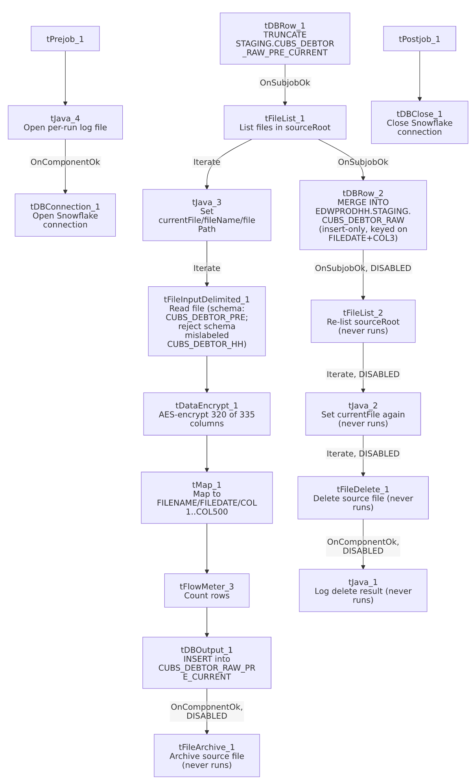

Settings tables

Setup: `tFileList_1`
Setting | Value | What it means
DIRECTORY | context.sourceRoot | Source directory scanned each run. Note: sourceRoot does not appear in the StandardFolders_0.1 shared context group (which defines sourceDir/sourceDCDir instead) — unable to confirm its actual default value from the extracted shared context; verify with team.
LIST_MODE | FILES | Lists files only (no subdirectories; INCLUDSUBDIR=false).
ORDER_BY_NOTHING | true | No ordering is applied to the file listing, despite ORDER_ACTION_ASC=true also being set — since ORDER_BY_NOTHING takes precedence, files are processed in whatever order the filesystem/OS returns them.
EXCLUDEFILEMASK / IFEXCLUDE | "*.txt" / false | An exclusion mask is configured but IFEXCLUDE=false means it is not actually applied — every file in the directory is picked up regardless of extension.

Source: `tFileInputDelimited_1`
Setting | Value | What it means
FILENAME | context.currentFile | The file currently being iterated by tFileList_1.
FIELDSEPARATOR / ROWSEPARATOR / HEADER / ENCODING | context.EXPORT_DEBTOR_FieldSeparator / context.EXPORT_DEBTOR_RowSeparator / context.EXPORT_DEBTOR_Header / context.EXPORT_DEBTOR_Encoding | Per the shared EXPORT_DEBTOR_0.1 context group these default to tab-separated, \n row separator, 1 header row, US-ASCII encoding.
SCHEMA (main) | Repository schema CUBS_DEBTOR_PRE (335 unique columns; captured twice in this job's extracted metadata for a raw count of 668) | Full raw debtor-record layout for the PRE site.
SCHEMA_REJECT | Repository schema CUBS_DEBTOR_HH | Mislabeled — this is a PRE job but its reject schema is named for HH, matching the same cross-site copy-paste mismatch documented in the CHI debtor-load job family.
DIE_ON_ERROR | false | Malformed rows do not fail the job...
Reject flow | Not wired | ...but no connection routes rejected rows anywhere — they are silently dropped with no count or record.
TEMP_DIR | "C:/Talend-Studio-20211109_1610-V8.0.1/workspace" | Hardcoded developer-workstation path — see Dependencies & configuration.

Transform: `tDataEncrypt_1`
Setting | Value | What it means
SECRET_TYPE / SECRET_KEY / PASSWORD_M1 | ***REDACTED*** | Encryption key material is redacted in the source metadata and preserved as-is here — do not guess actual values.
CRYPTO_METHOD / ALGO_VERSION | AES / 2 | AES encryption, algorithm version 2.
CRYPTO_FILE_PATH | context.cryptoPath | Where the crypto-controller file is written.
Schema | 320 of 335 unique input columns | This component drops 15 input columns before encrypting the rest: errorCode, errorMessage, CLT_XFER_DT, GUARANTOR_EMP, HDSP_ST_DT, HDSP_ENDDT, PKT_TOTAL_60, PKT_BAL, PMT_PCT_BAL, SIG_PMT, SIG_PROC_DT, LETTERABLE, EMAILABLE, TEXTABLE, PV_FLAG. Which specific remaining columns are actually encrypted (vs merely passed through) is not distinguishable from this metadata.

Transform: `tMap_1`
Setting | Value | What it means
Target schema | FILENAME, FILEDATE, COL1...COL500 (502 columns) | Generic, site-agnostic landing layout shared by the whole CUBS_Raw_*_Debtor_Load job family, letting different sites' differently-shaped source files land in the same staging table structure.
DIE_ON_ERROR | true | A mapping/lookup error here fails the job (unlike the upstream file-read step).
ROWS_BUFFER_SIZE | 2000000 | Large in-memory row buffer, consistent with a wide (500+ column) schema.

Target: `tDBRow_1` / `tDBOutput_1` (staging load)
Setting | Value | What it means
tDBRow_1 query | TRUNCATE TABLE STAGING.CUBS_DEBTOR_RAW_PRE_CURRENT; | Clears the PRE current-load staging table at the start of each run.
tDBOutput_1 table / outputAction / tableAction | CUBS_DEBTOR_RAW_PRE_CURRENT / INSERT / NONE | Appends the mapped rows into the just-truncated staging table.

Final merge: `tDBRow_2`
Setting | Value | What it means
Query | MERGE INTO EDWPRODHH.STAGING.CUBS_DEBTOR_RAW AS tgt USING STAGING.CUBS_DEBTOR_RAW_PRE_CURRENT AS src ON tgt.FILEDATE = src.FILEDATE AND tgt.COL3 = src.COL3 WHEN NOT MATCHED THEN INSERT (FILENAME, FILEDATE, COL1...COL500) VALUES (...) | Inserts rows from the PRE staging table into the shared, all-sites CUBS_DEBTOR_RAW table only when no existing row matches on FILEDATE+COL3. There is no WHEN MATCHED clause, so existing rows are never updated or deleted by this job — consistent with the "No_Delete" job name.
Target qualification | EDWPRODHH.STAGING.CUBS_DEBTOR_RAW (fully qualified) vs. unqualified STAGING.CUBS_DEBTOR_RAW_PRE_CURRENT (source) | Suggests the job's active Snowflake connection's default database is not EDWPRODHH, requiring the target to be explicitly qualified — same pattern noted in CO_Master_Load's merge steps.

Disabled cleanup: `tFileArchive_1`, `tFileList_2` / `tJava_2` / `tFileDelete_1` / `tJava_1`
Setting | Value | What it means
tFileArchive_1.ACTIVATE | false | Configured to zip the processed file to context.archiveDir + "/" + <CCYYMMDD> + "/" + context.fileName + ".tar.gz", but disabled — no archive is produced. tFileArchive_1.PASSWORD is ***REDACTED*** (preserved as-is).
tFileList_2.ACTIVATE / tJava_2.ACTIVATE / tFileDelete_1.ACTIVATE / tJava_1.ACTIVATE | all false | The entire second file-listing-and-delete subjob (which would delete the processed source file from context.sourceRoot and log the result) is disabled.
tFileDelete_1.DIRECTORY / PATH | "C:/Talend-Studio-20211109_1610-V8.0.1/workspace/delete_folder" / "C:/Talend-Studio-20211109_1610-V8.0.1/workspace/delete_folder or delete_file" | Hardcoded developer-workstation paths — see Dependencies & configuration. Pose no immediate runtime risk since the component is disabled.

Dependencies & configuration
- Triggers/depends on other jobs: runjob_targets is empty for this job (no tRunJob components) — it does not call any other job. In 06_dependency_matrix.md, the project's CUBS_Raw_Debtor_Load orchestrator calls the plain CUBS_Raw_PRE_Debtor_Load (no suffix), not this _No_Delete variant, and no other orchestrator entry references it either. This job therefore appears to run standalone/manually rather than as part of the documented orchestration chain — verify with the team how (or whether) it is actually scheduled.
- Context variables used: EXPORT_DEBTOR_Encoding, EXPORT_DEBTOR_FieldSeparator, EXPORT_DEBTOR_Header, EXPORT_DEBTOR_RowSeparator (all defined in the shared EXPORT_DEBTOR_0.1 context group), archiveDir, logDir (defined in StandardFolders_0.1, which carries two different sets of values in the extracted shared context — the one actually applied at runtime is not determinable from this job's own metadata), cryptoPath, currentFile, currentLogon, fileName, filePath, and sourceRoot (this last one is not found in any shared context group captured in _shared_context.json — likely a job-local context default; verify with the team).
- 4 hardcoded developer-workstation paths, all C:/Talend-Studio-20211109_1610-V8.0.1/workspace/...: tFileInputDelimited_1.TEMP_DIR, tFileArchive_1.SOURCE_FILE, tFileDelete_1.DIRECTORY, tFileDelete_1.PATH — same project-wide portability risk documented in 05_operational_runbook.md. Three of these (tFileArchive_1, tFileDelete_1 x2) sit on components that are currently disabled, so they pose no immediate runtime risk, but would need correcting if the archive/delete subjobs are ever re-enabled.

Glossary
Component type | Plain-English meaning
tFileList | Lists files in a directory for the job to iterate over one at a time.
tFileInputDelimited | Reads a delimited (CSV/TSV-style) text file according to a schema.
tDataEncrypt | Encrypts the values of selected columns (here, using AES) before they continue downstream.
tMap | Maps/transforms columns from one schema to another.
tFlowMeter | Counts rows passing a point in the flow, for logging/monitoring.
tSnowflakeOutput / tSnowflakeRow / tSnowflakeConnection / tSnowflakeClose | Write rows to a Snowflake table / run an arbitrary SQL statement (including MERGE) against Snowflake / open and close the Snowflake connection used throughout the job.
tFileArchive / tFileDelete | Zip a processed file to an archive location, then delete the original from the source directory (both disabled in this job — see Issues observed).
tJava | Runs custom Java code at a point in the flow (here, used to set context variables from file-list iteration state and to open the per-run log file).
tPrejob / tPostjob | Run once before/after the rest of the job, regardless of which main subjobs exist.

Issues observed
- The entire post-load file-cleanup path is disabled. Both tFileArchive_1 (archive the processed file) and the second tFileList_2/tJava_2/tFileDelete_1/tJava_1 subjob (delete the processed file) have ACTIVATE=false. This means source files in context.sourceRoot are never archived or removed by this job. Combined with tFileList_1's ORDER_BY_NOTHING=true (no ordering, and no filter excluding already-processed files), every run will re-read, re-encrypt, and re-insert every historical file still sitting in that directory into the staging table — the final MERGE step's insert-only, FILEDATE+COL3-keyed logic should prevent duplicate rows from accumulating in the final CUBS_DEBTOR_RAW table, but the job still does the full read/encrypt/map/insert work for every old file on every run, and the source directory will grow unbounded over time. Given the job's name (_No_Delete), this looks like an intentional "don't delete source files" design — but doing so via disabling the *entire* archive-and-delete subjob rather than just the delete step means archiving is also skipped, which may not be intended. Verify with the team.
- The reject schema on `tFileInputDelimited_1` is labeled `CUBS_DEBTOR_HH`, not a PRE schema. This job is PRE-specific; its main input schema is correctly CUBS_DEBTOR_PRE, but the reject schema appears to have been copied from an HH-site job and never repointed — the same cross-site mismatch pattern already documented for the CHI debtor-load job family. Whether it causes an actual failure on a rejected row depends on how similar the two repository schemas are — unable to determine from this metadata.
- No reject flow is wired from `tFileInputDelimited_1`. DIE_ON_ERROR=false, so malformed rows don't fail the job, but there is also no connection carrying rejected rows anywhere — they are silently dropped with no record of how many, or which, rows failed to parse.
- `tDataEncrypt_1` silently drops 15 of the 335 unique input columns (including the file-read component's own errorCode/errorMessage columns and business fields — CLT_XFER_DT, GUARANTOR_EMP, HDSP_ST_DT, HDSP_ENDDT, PKT_TOTAL_60, PKT_BAL, PMT_PCT_BAL, SIG_PMT, SIG_PROC_DT, LETTERABLE, EMAILABLE, TEXTABLE, PV_FLAG) before mapping. Unable to determine from metadata whether this is intentional column pruning or an out-of-date schema that hasn't been reconciled with the source file layout; verify with the team whether those dropped fields are needed downstream.
- `context.sourceRoot`, referenced by both `tFileList_1` and `tFileList_2`, is not defined in any context group captured in `_shared_context.json` (which has sourceDir/sourceDCDir under StandardFolders_0.1 instead). It may be a job-local context default not visible in this extraction — verify its actual value with the team before assuming it matches another job's sourceDir.
- The `CODE` text captured for `tJava_3`, `tJava_1`, and `tJava_4` all end mid-statement with a literal `...` in the source metadata (truncated during extraction, not by this documentation), so the full log-message wording and any code beyond what's shown here (e.g., in tJava_1's delete-status logging or tJava_4's log-file setup) cannot be verified from this job's own metadata — verify directly in Talend Studio if the exact behavior matters.
- `tDBConnection_1` (`tSnowflakeConnection`) has no captured parameters, so which named Snowflake connection/environment this job actually connects to cannot be confirmed from this job's own metadata alone — cross-reference 01_system_architecture.md's connection-label table or verify directly in the Talend repository.
- No other notable job-specific issues beyond the project-wide hardcoded-path pattern already documented in 05_operational_runbook.md.

