Talend Job: CUBS_Raw_PRE_Debtor_Load_Upsert

Overview
Loads CUBS collections debtor master-file extracts for the PRE site (per-debtor demographic and account fields — name, address, phone, client, agency-code, trip/IOC/letter-cycle flags, letterable/emailable/textable flags, etc., per the CUBS_DEBTOR_PRE repository schema) from a local drop directory into Snowflake. Each file's rows are AES-encrypted (PII fields) in flight, flattened into a generic COL1-COL500 staging schema, and loaded into CUBS_DEBTOR_RAW_PRE_CURRENT (UPSERT output action). Once every file in the batch has loaded, a single MERGE statement copies any not-already-present rows from that staging table into the cross-site raw table EDWPRODHH.STAGING.CUBS_DEBTOR_RAW, after which processed source files are archived (as .tar.gz) and then deleted from the source directory. This job is one of the CUBS_Raw_<Site>_Debtor_Load_Upsert family that repeats the same template per site code (CHI, CO, DC, HH, PRE, TOL — see 01_system_architecture.md); see Issues observed for the specific ways this PRE copy differs from its CHI/CO siblings.

Detail table
Field | Value
Job name | CUBS_Raw_PRE_Debtor_Load_Upsert
Version | 0.4
Project | EDW2SF
Author | jmach@harriscollect.com
Created | 2024-07-11T12:00:15.946-0700
Last Modified | 2026-07-07T12:12:16.609-0700

Step-by-step data flow
Setup subjob: tPrejob_1 →(OnComponentOk)→ tJava_4 opens a per-run log file at context.logDir + context.currentLogon + "_" + jobName + "_" + <timestamp> + ".log" and redirects System.out to it (code truncated at 253 characters in the extracted metadata; remainder not recoverable from this JSON) →(OnComponentOk)→ tDBConnection_1 opens the job's Snowflake connection.
Main subjob — file-load loop (runs once per file in `context.sourceRoot`):
- tFileList_1 lists files in context.sourceRoot (files only, no subdirectories; ORDER_BY_NOTHING=true, so no explicit sort order is applied; EXCLUDEFILEMASK="*.txt" is configured but IFEXCLUDE=false, so that exclusion is not actually applied — every file in the directory is picked up).
- tFileList_1 →(ITERATE)→ tJava_3 copies the current iteration's file path/name/directory from globalMap into context.currentFile / context.fileName / context.filePath (code truncated in metadata after the System.out.println("Proc... line).
- →(ITERATE)→ tFileInputDelimited_1 reads the file as delimited text using repository schema CUBS_DEBTOR_PRE (333 distinct business columns — see Issues observed on how this is captured in the metadata), with FIELDSEPARATOR=context.EXPORT_DEBTOR_FieldSeparator, ROWSEPARATOR=context.EXPORT_DEBTOR_RowSeparator, HEADER=context.EXPORT_DEBTOR_Header, ENCODING=context.EXPORT_DEBTOR_Encoding (all externalized to context, not hardcoded); DIE_ON_ERROR=false. Its SCHEMA_REJECT is set to repository schema CUBS_DEBTOR_HH — mismatched to the HH site, not PRE — see Issues observed.
- →(FLOW, link row1)→ tDataEncrypt_1 AES-encrypts the row (SECRET_TYPE, SECRET_KEY, PASSWORD_M1 all ***REDACTED*** in source metadata). Its own schema carries only 329 of the upstream 333 business columns — see Issues observed.
- →(FLOW, link row2)→ tMap_1 maps the row down to a generic 502-column output shape: FILENAME, FILEDATE, COL1...COL500 (DIE_ON_ERROR=true, so a mapping failure fails the job).
- →(FLOW, link PRE_DBTR)→ tFlowMeter_3 counts rows passing through (link explicitly named PRE_DBTR for this job, unlike the generic labels seen in some sibling jobs).
- →(FLOW, link row3)→ tDBOutput_1 (tSnowflakeOutput) writes to table CUBS_DEBTOR_RAW_PRE_CURRENT with outputAction=UPSERT, tableAction=NONE.
- →(OnComponentOk)→ tFileArchive_1 archives the just-processed file to context.archiveDir + "/" + <today's date CCYYMMDD> + "/" + context.fileName + ".tar.gz".
After the entire file-load loop subjob completes successfully (not per file): tFileList_1 →(OnSubjobOk)→ tDBRow_2 (tSnowflakeRow) runs a single MERGE from STAGING.CUBS_DEBTOR_RAW_PRE_CURRENT into EDWPRODHH.STAGING.CUBS_DEBTOR_RAW, matching on FILEDATE + COL3, inserting only rows WHEN NOT MATCHED (no WHEN MATCHED clause — see Issues observed).
Cleanup loop (runs after the merge, once per file in `context.sourceRoot` again):
- tDBRow_2 →(OnSubjobOk)→ tFileList_2 re-lists files in context.sourceRoot (same directory, same filter settings as tFileList_1) →(ITERATE)→ tJava_2 re-sets context.currentFile/fileName/filePath from this second listing →(ITERATE)→ tFileDelete_1 deletes context.currentFile →(OnComponentOk)→ tJava_1 logs the delete status/path/error from globalMap (code also truncated in metadata).
Teardown subjob: tPostjob_1 →(OnComponentOk)→ tDBClose_1 closes the Snowflake connection.
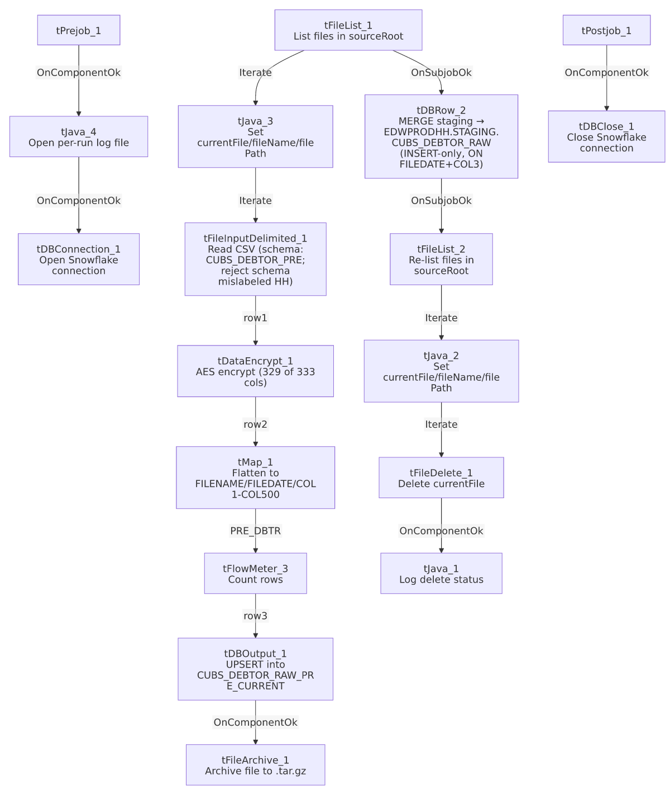

Settings tables

Source listing: `tFileList_1` / `tFileList_2`
Setting | Value | What it means
DIRECTORY | context.sourceRoot | Both loops (load and cleanup) scan the same source directory.
LIST_MODE | FILES | Only files, no subdirectories (INCLUDSUBDIR=false).
ORDER_BY_NOTHING | true | No explicit sort order is applied to the file list.
EXCLUDEFILEMASK / IFEXCLUDE | "*.txt" / false | An exclusion mask is configured but explicitly disabled (IFEXCLUDE=false) — every file in sourceRoot, including .txt files, is picked up.

Source: `tFileInputDelimited_1`
Setting | Value | What it means
FILENAME | context.currentFile | The current file from tFileList_1's iteration.
FIELDSEPARATOR | context.EXPORT_DEBTOR_FieldSeparator | Externalized to context (default "\t" per EXPORT_DEBTOR_0.1 in _shared_context.json), not hardcoded.
ROWSEPARATOR | context.EXPORT_DEBTOR_RowSeparator | Externalized (default "\n").
HEADER | context.EXPORT_DEBTOR_Header | Externalized (default 1 header row).
ENCODING | context.EXPORT_DEBTOR_Encoding | Externalized (default US-ASCII).
SCHEMA (main) | Repository schema CUBS_DEBTOR_PRE (id _e3LJsM1UEey68bfiIIIBcg) | 333 distinct business columns (LOGON through PV_FLAG: demographic, client, agency, trip/IOC/letter-cycle, letterable/emailable/textable flags) — correctly labeled for the PRE site. Note the raw extracted schema_columns list for this component contains 668 entries because the same 333-column list appears to have been captured twice back-to-back (666 rows) plus the 2 reject columns (errorCode, errorMessage); this doc counts only the distinct 333.
SCHEMA_REJECT | Repository schema CUBS_DEBTOR_HH (id _P5bI4GQVEeyyeeshWCVUmg) | Site mismatch — this is the PRE job but its reject schema is labeled for HH. See Issues observed.
DIE_ON_ERROR | false | Malformed rows don't fail the job...
Reject flow | Not wired | ...but no connection in this job routes rejected rows anywhere — they are silently dropped.
TEMP_DIR | "C:/Talend-Studio-20211109_1610-V8.0.1/workspace" | Hardcoded developer-workstation path (see hardcoded_path_findings).

Transform: `tDataEncrypt_1`
Setting | Value | What it means
CRYPTO_METHOD | AES | Symmetric encryption of column values.
SECRET_TYPE / SECRET_KEY / PASSWORD_M1 | ***REDACTED*** | Encryption key material — preserved as redacted, not guessable from this metadata.
CRYPTO_FILE_PATH | context.cryptoPath | Externalized crypto-config file path (variable not found in any extracted context group — see Issues observed).
Schema | 329 columns (LOGON ... SIG_PROC_DT) | Only the first 329 of the upstream 333 business columns are present in this component's schema; the trailing 4 (LETTERABLE, EMAILABLE, TEXTABLE, PV_FLAG) are absent — see Issues observed.

Transform: `tMap_1`
Setting | Value | What it means
DIE_ON_ERROR | true | Any mapping/lookup error here fails the job outright (unlike the upstream file-read step).
Output schema | FILENAME, FILEDATE, COL1...COL500 (502 columns) | Business field names are discarded in favor of a fixed, generically-numbered column layout — matches tDBOutput_1's target schema exactly, and the same layout used by the CHI/CO siblings.

Target: `tDBOutput_1` (`tSnowflakeOutput`)
Setting | Value | What it means
Table | CUBS_DEBTOR_RAW_PRE_CURRENT | Per-run staging table for this file batch (PRE site).
Output action | UPSERT | Row-level upsert into the staging table (merge key not shown in this component's own metadata).
Table action | NONE | Table is not recreated/altered by this job.
Schema | FILENAME, FILEDATE, COL1...COL500, plus reject-flow columns (columnName, rowNumber, category, character, errorMessage, byteOffset, line, sqlState, code) — 511 columns total; COL3 is the only column marked non-nullable | A reject schema exists on this component, but (per connections) no reject flow is wired out of it — see Issues observed. COL3 being the sole non-nullable business column corroborates that it's the merge/business key used downstream.

Archive/cleanup: `tFileArchive_1` / `tFileDelete_1`
Setting | Value | What it means
TARGET (tFileArchive_1) | context.archiveDir + "/" + TalendDate.getDate("CCYYMMDD") + "/" + context.fileName + ".tar.gz" | Archives each processed file into a date-stamped subfolder.
SOURCE (tFileArchive_1) | context.filePath | The actual source used at runtime.
SOURCE_FILE (tFileArchive_1) | "C:/Talend-Studio-20211109_1610-V8.0.1/workspace/source.csv" | Hardcoded developer-workstation path (see hardcoded_path_findings); not the active SOURCE param, so appears to be an unused default placeholder.
ENCRYPT_FILES / PASSWORD (tFileArchive_1) | false / ***REDACTED*** | Archive encryption is disabled, so the redacted password is configured but not currently used.
FILENAME (tFileDelete_1) | context.currentFile | The actual file deleted at runtime.
DIRECTORY / PATH (tFileDelete_1) | "C:/Talend-Studio-20211109_1610-V8.0.1/workspace/delete_folder" / "...delete_folder or delete_file" | Hardcoded developer-workstation paths (see hardcoded_path_findings); not the active FILENAME param.

Merge step: `tDBRow_2` (`tSnowflakeRow`)
Setting | Value | What it means
Query | MERGE INTO EDWPRODHH.STAGING.CUBS_DEBTOR_RAW AS tgt USING STAGING.CUBS_DEBTOR_RAW_PRE_CURRENT AS src ON tgt.FILEDATE = src.FILEDATE AND tgt.COL3 = src.COL3 WHEN NOT MATCHED THEN INSERT (FILENAME, FILEDATE, COL1...COL500) VALUES (src.FILENAME, src.FILEDATE, src.COL1...src.COL500); | Copies rows not already present (by FILEDATE+COL3) from the per-run PRE staging table into the shared cross-site raw table. There is no `WHEN MATCHED THEN UPDATE` clause — see Issues observed.
Runs when | OnSubjobOk from tFileList_1 | Fires once after the entire file-load loop finishes successfully, not once per file.

Dependencies & configuration
- Triggers/depends on other jobs: none — runjob_targets is empty; this job contains no tRunJob components.
- Called by: not found as a tRunJob target anywhere in 06_dependency_matrix.md. The matrix shows CUBS_Raw_Debtor_Load calling CUBS_Raw_PRE_Debtor_Load (without the _Upsert suffix) for the PRE site instead. See Issues observed.
- Context variables used: EXPORT_DEBTOR_Encoding, EXPORT_DEBTOR_FieldSeparator, EXPORT_DEBTOR_Header, EXPORT_DEBTOR_RowSeparator (all defined with defaults in the EXPORT_DEBTOR_0.1 context group — see Issues observed on that group's own HH-flavored default file path), sourceRoot, cryptoPath, currentLogon (none of these three appear in any context group in _shared_context.json — the closest named variables, sourceDir/sourceDCDir in StandardFolders_0.1, are different names), plus archiveDir and logDir (defined in StandardFolders_0.1, with two candidate values each — /archive///logs/ vs. C:/Data//C:/Data/ — the metadata doesn't indicate which corresponds to which environment), and currentFile, fileName, filePath (set internally by tJava_2/tJava_3 from tFileList_* iteration state).
- 4 hardcoded developer-workstation paths (C:/Talend-Studio-20211109_1610-V8.0.1/workspace/...) in tFileInputDelimited_1.TEMP_DIR, tFileArchive_1.SOURCE_FILE, and tFileDelete_1.DIRECTORY/PATH — the same project-wide portability risk pattern documented in 05_operational_runbook.md; none of these override the actual active FILENAME/SOURCE parameters (which correctly use context.currentFile/context.filePath), so they appear to be inert leftover defaults rather than active bugs, but should still be cleaned up.

Glossary
Component type | Plain-English meaning
tPrejob / tPostjob | Marks the setup/teardown subjobs that run once before/after the rest of the job, regardless of how many times the main flow iterates.
tSnowflakeConnection / tSnowflakeClose | Opens / closes the Snowflake connection used throughout the job.
tFileList | Lists files in a directory for the job to iterate over one at a time.
tJava | Runs a block of custom Java code once (not per row).
tFileInputDelimited | Reads a delimited (CSV-style) text file according to a schema.
tDataEncrypt | Encrypts specified column values in the row using a configured algorithm/key.
tMap | Maps/transforms columns from one schema to another.
tFlowMeter | Counts rows passing a point in the flow, for logging/monitoring.
tSnowflakeOutput | Writes rows to a Snowflake table (insert/update/upsert/etc., per outputAction).
tSnowflakeRow | Runs an arbitrary SQL statement (here, a MERGE) against Snowflake.
tFileArchive / tFileDelete | Archives a processed file to a compressed location, then deletes the original from the source directory.

Issues observed
- Job name says "Upsert," but the merge is insert-only. tDBRow_2's MERGE statement has a WHEN NOT MATCHED THEN INSERT clause and no WHEN MATCHED THEN UPDATE clause — rows already present in EDWPRODHH.STAGING.CUBS_DEBTOR_RAW (matched by FILEDATE+COL3) are left untouched, not updated. Functionally this is a dedup-insert/append pattern, not a true upsert. This is the same naming/behavior mismatch already documented for the CHI and CO siblings (CUBS_Raw_CHI_Debtor_Load_Upsert, CUBS_Raw_CO_Debtor_Load_Upsert), so it appears to be a systemic template characteristic across the whole _Upsert family rather than a one-off mistake in this job.
- Reject schema is labeled for the wrong site. tFileInputDelimited_1's SCHEMA_REJECT is the CUBS_DEBTOR_HH repository schema, not a PRE-specific one, even though this is CUBS_Raw_PRE_Debtor_Load_Upsert. The CHI sibling job has the identical defect (its reject schema is also CUBS_DEBTOR_HH), and the EXPORT_DEBTOR_0.1 context group's own EXPORT_DEBTOR_File default value (Z:/EDW/2021-11-27/HH/HH-EDW-EXPORT-DEBTOR1.txt) is also an HH path — together these strongly suggest the whole CUBS_Raw_*_Debtor_Load_Upsert template family, including its shared reject-schema and context defaults, was originally built for the HH site and cloned per-site without repointing the reject schema. Combined with the fact that no reject flow is actually wired out of tFileInputDelimited_1 (DIE_ON_ERROR=false, malformed rows are simply dropped with no record), a malformed PRE row's shape mismatch against the HH reject schema is unverifiable from this metadata — verify directly in the Talend repository.
- Schema drift between `tFileInputDelimited_1` and `tDataEncrypt_1`, though smaller than in sibling jobs. The file-read schema carries 333 distinct business columns (CUBS_DEBTOR_PRE), but tDataEncrypt_1's schema stops at column 329 (SIG_PROC_DT) — the trailing 4 columns (LETTERABLE, EMAILABLE, TEXTABLE, PV_FLAG) are not present in tDataEncrypt_1's schema and therefore not available to the downstream tMap_1. This is the same kind of schema-drift pattern seen in the CHI and CO sibling jobs (there the gaps were larger), suggesting the tDataEncrypt step across this whole job family is not reliably kept in sync when the source file format is extended — here the practical impact looks small (only 4 trailing flag columns), but it should still be confirmed whether those flags are needed downstream.
- Raw extracted schema for `tFileInputDelimited_1` appears to duplicate its 333-column list back-to-back (666 of the 668 captured schema_columns entries are an exact repeat, plus 2 reject columns). This looks like an artifact of how the main and reject-schema branches were captured together in this metadata export, not a real 666-column schema in the Talend job itself — worth being aware of when comparing raw metadata sizes across jobs in this family, since a naive column count would overstate the actual schema width by roughly 2x.
- Not referenced by any orchestrator job under its own name. 06_dependency_matrix.md shows CUBS_Raw_Debtor_Load calling CUBS_Raw_PRE_Debtor_Load (without the _Upsert suffix) for the PRE site, not this job. Unable to determine from metadata whether CUBS_Raw_PRE_Debtor_Load_Upsert is a newer replacement not yet wired into that orchestrator, a manually/ad-hoc-triggered job, or a separate job that happens to share almost the same name — verify with the team before assuming either job is dead code.
- Several referenced context variables have no defined default anywhere in the extracted project context groups. context.sourceRoot, context.cryptoPath, and context.currentLogon are all read by this job's components but do not appear in any of the context groups captured in _shared_context.json (the closest match, sourceDir/sourceDCDir in StandardFolders_0.1, is a different variable name). Either this job carries its own job-level context defaults that weren't captured by this extraction, or these are unresolved references — verify with the team.
- 4 hardcoded developer-workstation paths (C:/Talend-Studio-20211109_1610-V8.0.1/workspace/...) in tFileInputDelimited_1.TEMP_DIR, tFileArchive_1.SOURCE_FILE, and tFileDelete_1.DIRECTORY/PATH — the same project-wide portability risk already documented in 05_operational_runbook.md; each is inert (the active SOURCE/FILENAME params correctly use context.filePath/context.currentFile), but should still be cleaned up.
- The merge's natural key (`FILEDATE` + `COL3`) is opaque. Because tMap_1/tDBOutput_1 use the generic COL1-COL500 naming scheme instead of business field names, COL3's real meaning (the only one of the 500 marked non-nullable in tDBOutput_1's schema, suggesting it's a business key such as an account or debtor ID) cannot be determined from this metadata.
- The two Java logging/cleanup snippets (`tJava_1`, `tJava_3`, `tJava_4`) are truncated at 253 characters in this job's extracted metadata, each ending mid-statement with a literal .... The visible portions show what each is doing (setting context vars from tFileList iteration state, opening/redirecting a log file, printing delete status), but the full code — including any additional logic past the truncation point — is not recoverable from this JSON; verify directly in Talend Studio if the complete logic matters.

