Talend Job: CUBS_Raw_PRE_ETL_Load

Overview
Loads CUBS "ETL" credit/collections-scoring extract files for the PRE site — one row per debtor with bureau/collections attributes such as bankruptcy disposition codes (BK7_DISP, BK11_DISP, BK13_DISP), revolving/mortgage/auto trade balances, credit-card/available-credit fields, and scoring outputs (Attune_Score, Propen_Score, Decile, Percentile) — from every file found in context.sourceDir into the Snowflake raw landing table CUBS_ETL_RAW_CURRENT. All ~61 named business columns from the source file are flattened into generic COL1...COL80 positions in the target table. Every file found in the source directory is loaded, archived, and then deleted in a separate cleanup pass. This job is structurally and configurationally near-identical to CUBS_Raw_CO_ETL_Load — same component wiring, same generic COL1-COL80 target shape, same two-pass list-then-delete cleanup design — differing only in its site-specific repository schema label (pre_etl vs. co_etl) and, presumably, the context values bound to sourceDir/archiveDir at runtime (not captured in this metadata). Per 06_dependency_matrix.md, it is called by the CUBS_Raw_ETL_Load parent job, consistent with the per-site CUBS_Raw_<Site>_ETL_Load family (CHI/CO/DC/HH/PRE/TOL).

Detail table
Field | Value
Job name | CUBS_Raw_PRE_ETL_Load
Version | 0.1
Project | EDW2SF
Author | jmach@harriscollect.com
Created | 2022-12-15T16:47:17.937-0800
Last Modified | 2025-11-11T22:51:50.402-0800

Step-by-step data flow
Setup subjob: tPrejob_1 → tJava_1 (OnComponentOk) opens a per-run log file at context.logDir + jobName + "_" + <timestamp> + ".log" and redirects System.out/System.err to it → tSetKeystore_1 (OnSubjobOk) configures SSL trust/keystore from context.keystorePath (all passwords redacted) → tDBConnection_1 (OnSubjobOk) opens the Snowflake connection. This job has no `tPostjob_1`/`tDBClose` component at all — the Snowflake connection is never explicitly closed within this job's own metadata, the same gap documented in CUBS_Raw_CO_ETL_Load. See Issues observed.
Main load pass (no incoming trigger connection into tFileList_1, so per Talend's default semantics it runs as an independent top-level subjob alongside the setup subjob above):
- tFileList_1 lists files in context.sourceDir, ordered by modified date ascending. An EXCLUDEFILEMASK of "*.txt" is configured but IFEXCLUDE is false, so the exclusion never applies — every file in the directory is picked up.
- For each file (ITERATE), tJava_2 sets context.currentFile/fileName/filePath from the tFileList_1 iteration globals.
- tFileInputDelimited_1 (ITERATE) reads that file as tab-delimited, ISO-8859-15 encoded, header row present, using repository schema "...- pre_etl" (~61 named bureau/collections-scoring columns). DIE_ON_ERROR=false; TRIMALL=false.
- tMap_1 (row1, FLOW) re-maps every source column positionally onto a generic 80-column target shape (FILENAME, FILEDATE, COL1...COL80) — none of the ~61 business column names survive into the target schema.
- tFlowMeter_2 (etl, FLOW) counts rows passing through (label left at the default "MyLabel").
- tDBOutput_1 (row2, FLOW) inserts the rows into Snowflake CUBS_ETL_RAW_CURRENT (INSERT, tableAction=NONE — no truncate/recreate from within this job).
- On success (OnComponentOk), tFileArchive_1 archives the just-processed file (context.filePath) to context.archiveDir + "/" + <YYYYMMDD> + "/" + context.fileName + ".tar.gz" (password redacted).
Cleanup pass (triggered by tFileList_1's OnSubjobOk, i.e. only after every file from the main load pass has finished processing):
- tFileList_2 re-lists the same context.sourceDir directory (same unapplied EXCLUDEFILEMASK/IFEXCLUDE mismatch as step 1).
- For each file found (ITERATE), tJava_3 sets context.currentFile/fileName/filePath again.
- tFileDelete_1 (ITERATE) deletes that file from disk.
- On success (OnComponentOk), tJava_4 logs the delete outcome (CURRENT_STATUS, DELETE_PATH, error message).
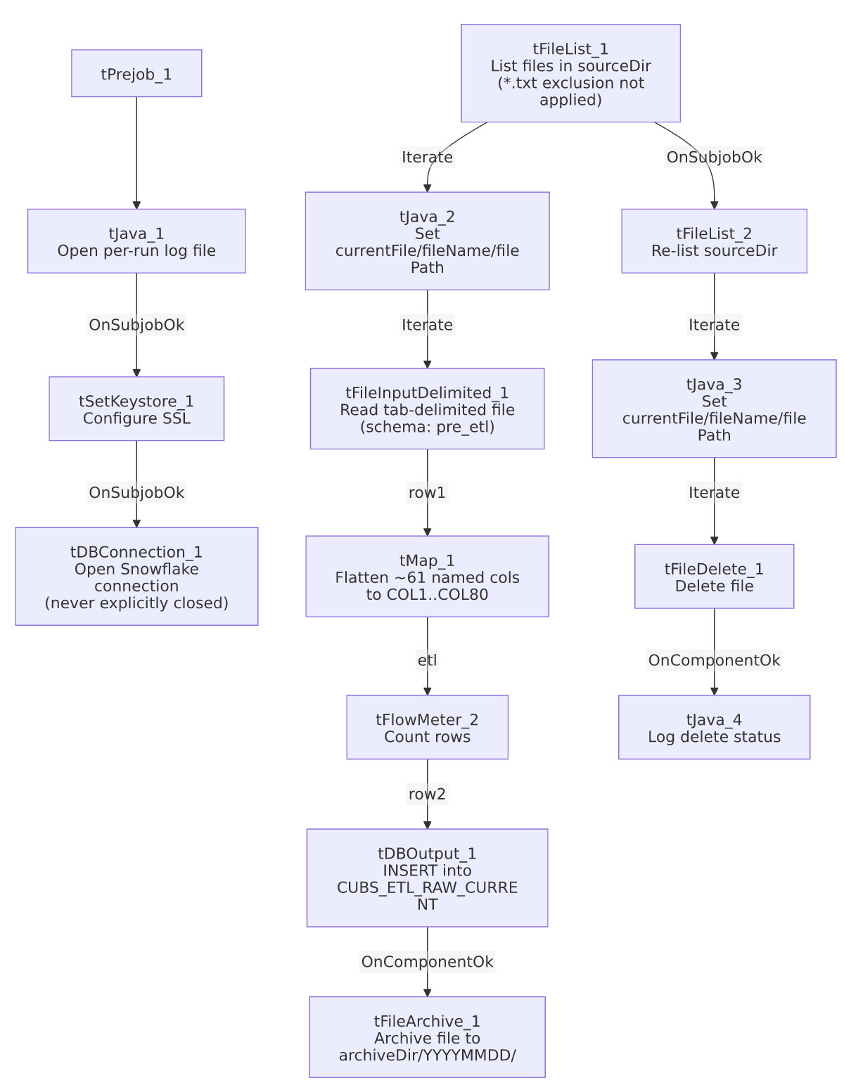

Settings tables

Source: `tFileInputDelimited_1`
Setting | Value | What it means
FILENAME | context.currentFile | The current file from tFileList_1's iteration.
FIELDSEPARATOR / ENCODING | \t / ISO-8859-15 | Tab-delimited extract, ISO-8859-15 (Latin-9) encoded.
HEADER | 1 | One header row skipped.
SCHEMA (main) | Repository schema "_YSgBwHzaEe2c-IsTynWu2Q - pre_etl" | ~61 named bureau/collections-scoring columns (e.g. DEBTOR, MORT_BAL, REV_BAL, CCARD, AUTO_BAL, BK7_DISP/BK11_DISP/BK13_DISP, Attune_Score, Propen_Score, Decile, Percentile) — identical field set to CUBS_Raw_CO_ETL_Load's co_etl schema, just a different site-specific repository label.
DIE_ON_ERROR | false | Malformed rows don't fail the job...
Reject flow | Not wired | ...but no connection routes rejected rows anywhere — silently dropped, same pattern flagged in ADP_Payroll_Load and CUBS_Raw_CO_ETL_Load.
TEMP_DIR | "C:/Talend-Studio-20211109_1610-V8.0.1/workspace" | Hardcoded developer-workstation path — see Dependencies & configuration.

Target: `tDBOutput_1` (`tSnowflakeOutput`)
Setting | Value | What it means
Table | CUBS_ETL_RAW_CURRENT | Destination raw landing table — the same table name used by CUBS_Raw_CO_ETL_Load (and presumably every other site's _ETL_Load sibling); no visible site-discriminator column in this metadata.
Output action | INSERT | Appends rows; no truncate step precedes it in this job.
Table action | NONE | Table structure is not altered by this job.

`tFileArchive_1`
Setting | Value | What it means
SOURCE | context.filePath | The directory of the just-loaded file.
TARGET | context.archiveDir + "/" + <YYYYMMDD> + "/" + context.fileName + ".tar.gz" | Per-file, dated archive.
PASSWORD | ***REDACTED*** | Archive is password-protected; actual value not present in extracted metadata.

`tFileDelete_1` (cleanup pass)
Setting | Value | What it means
FILENAME | context.currentFile | File found by the second tFileList_2 listing.
DIRECTORY / PATH | "C:/Talend-Studio-20211109_1610-V8.0.1/workspace/delete_folder" / "...delete_folder or delete_file" | Hardcoded developer-workstation defaults — see Dependencies & configuration.
FAILON | false | A missing/already-deleted file does not fail the job.

`tSetKeystore_1`
Setting | Value | What it means
SSL_KEYSTORE | context.keystorePath | Client keystore path is externalized to context.
SSL_TRUSTSERVER_TRUSTSTORE | "C:/clientTrustStore.trustStore" | Hardcoded truststore path — not context-driven, unlike the keystore itself.
SSL_TRUSTSERVER_PASSWORD / SSL_KEYSTORE_PASSWORD / NEED_CLIENT_AUTH | ***REDACTED*** | Preserved as redacted; real values not present in extracted metadata.

Dependencies & configuration
- Triggers/depends on other jobs: runjob_targets is empty — this job does not call any other job via tRunJob.
- Called by: CUBS_Raw_ETL_Load (1 call), per 06_dependency_matrix.md — consistent with the per-site CUBS_Raw_<Site>_ETL_Load family documented in 01_system_architecture.md. Unlike CUBS_Raw_CO_ETL_Load, this job is not also called by CO_Master_Load (there is no PRE_Master_Load orchestrator in this metadata — see 05_operational_runbook.md's note that only CO has a dedicated _Master_Load).
- Context variables used: archiveDir, currentFile, fileName, filePath, keystorePath, logDir, sourceDir.
- 5 hardcoded developer-workstation paths (tFileInputDelimited_1.TEMP_DIR, tFileArchive_1.SOURCE_FILE, tFileDelete_1.DIRECTORY/PATH, tSetKeystore_1.SSL_TRUSTSERVER_TRUSTSTORE), all under C:/Talend-Studio-20211109_1610-V8.0.1/workspace/... or C:/clientTrustStore.trustStore — same project-wide portability risk documented in 05_operational_runbook.md (210 of 289 jobs share this pattern).

Glossary
Component type | Plain-English meaning
tPrejob / tPostjob | Talend's guaranteed-first / guaranteed-last subjobs for setup and teardown (this job has no tPostjob).
tJava | Runs a block of custom Java code once.
tFileList | Lists files in a directory for the job to iterate over one at a time.
tFileInputDelimited | Reads a delimited (CSV/TSV-style) text file according to a schema.
tMap | Maps/transforms columns from one schema to another.
tFlowMeter | Counts rows passing through a point in the flow, for logging/monitoring.
tSnowflakeOutput / tSnowflakeConnection | Write rows to a Snowflake table / open the Snowflake connection used throughout the job.
tFileArchive / tFileDelete | Zip a processed file to an archive location, then delete the original from the source directory.
tSetKeystore | Configures SSL client keystore/truststore settings ahead of an encrypted database connection.

Issues observed
- This job is a near-exact copy of `CUBS_Raw_CO_ETL_Load` — identical component wiring, identical COL1-COL80 flattening shape, identical two-pass list-then-delete cleanup design, identical unapplied EXCLUDEFILEMASK, identical missing tPostjob/tDBClose. The only difference visible in this job's own metadata is the repository schema label (pre_etl vs. co_etl); site differentiation for sourceDir/archiveDir must come from per-job context-value overrides not captured in this extraction — verify directly in Talend Studio before assuming what actually differs between the CHI/CO/DC/HH/PRE/TOL siblings.
- No `tPostjob_1`/`tDBClose` in this job. Same gap as CUBS_Raw_CO_ETL_Load: whether the Talend runtime closes the Snowflake connection implicitly at job exit, or this represents a real resource-leak risk across repeated runs, cannot be determined from this metadata; verify with the team.
- `EXCLUDEFILEMASK="*.txt"` is configured but `IFEXCLUDE=false` on both tFileList_1 and tFileList_2 — the mask is never applied, so every file in context.sourceDir is processed and later deleted, not just the intended extract format. Same unapplied-mask pattern flagged in ADP_Payroll_Load and CUBS_Raw_CO_ETL_Load.
- Two-pass list-then-delete design. tFileList_2 re-lists context.sourceDir from scratch only after the entire main load loop finishes (OnSubjobOk), rather than deleting each file immediately after its own successful archive. If a new file lands in context.sourceDir in the window between the two listings, it would be picked up and deleted by the cleanup pass without ever having been loaded. Unable to confirm the exposure window from this metadata; verify with the team.
- `tMap_1` discards all ~61 business column names from the pre_etl schema, storing them only as generic COL1...COL80 in CUBS_ETL_RAW_CURRENT. Any downstream consumer of that table must already know the column-position-to-business-field mapping from outside this job's own metadata.
- `tFlowMeter_2`'s label is left at the default `"MyLabel"`, not renamed for this job — cosmetic only, but makes its log output indistinguishable from any other unrenamed tFlowMeter in the project (same as CUBS_Raw_CO_ETL_Load).

