Talend Job: CUBS_Raw_Payplan_Load

Overview
Loads CUBS payment-plan records (debtor payment-plan setup and status: original plan amount, balloon, payment amounts/frequency, missed-payment counts, plan balance, letter-series and due-date tracking, "IGNITE" flag) from a single fixed export file into the Snowflake CUBS_PAYPLAN_RAW_CURRENT staging table, then archives and deletes the source file. Structurally it follows the same single-file "Client_Load"-style shape used by CUBS_Raw_CO_Client_Load (one file read, FLOW into a generic staging table, archive+delete off the read's own success) rather than the directory-iteration shape used by the _ETL_Load family. It is not called by any tRunJob link visible in 06_dependency_matrix.md — see Issues observed.

Detail table
Field | Value
Job name | CUBS_Raw_Payplan_Load
Version | 0.1
Project | EDW2SF
Author | jmach@harriscollect.com
Created | 2022-10-21T10:38:12.621-0700
Last Modified | 2025-11-04T11:08:10.922-0800

Step-by-step data flow
Setup subjob: tPrejob_1 → tJava_1 (OnComponentOk) opens a per-run log file at context.logDir + context.currentLogon + "_" + jobName + "_" + <timestamp> + ".log" → on SUBJOB_OK, tSetKeystore_1 configures SSL trust/keystore from context.keystorePath (passwords redacted) → on SUBJOB_OK, tDBConnection_1 opens the Snowflake connection.
Main subjob:
- tFileInputDelimited_1 reads a single file at context.sourceDir + context.PAYPLAN_File (not a directory loop — one fixed export file per run). Separators/header are context-driven (context.PAYPLAN_RowSeparator, context.PAYPLAN_FieldSeparator, context.PAYPLAN_Header), except `CSVROWSEPARATOR`, which is set to `context.EXPORT_TRANS_RowSeparator` instead of a PAYPLAN_* variable (only relevant if CSV_OPTION is ever turned on — currently false). TRIMALL=true. The main schema is labeled "...- payplan" (~38 named payment-plan business columns: LOGON, PPLAN, PPLAN_IDX, ORIG_PLAN_AMT, BALLOON, PLAN_BALANCE, PMT_AMT, NBR_PMTS, FREQ, LTR_SERIES, IGNITE, etc.). The reject schema is labeled "...- CUBS_TRANSACTION" — a transaction-shaped schema, not payplan-shaped (same mismatched-reject-schema pattern documented in ADP_Payroll_Load and CUBS_Raw_CO_Client_Load). DIE_ON_ERROR=false, no reject flow wired.
- On SUBJOB_OK (i.e., as soon as the file read succeeds — not gated on the Snowflake insert), tFileArchive_1 archives context.sourceDir to context.archiveDir + "/" + <CCYYMMDD> + "/" + context.PAYPLAN_File + ".tar.gz" (password redacted, ENCRYPT_FILES=false), then on SUBJOB_OK, tFileDelete_1 deletes context.sourceDir + context.PAYPLAN_File.
- On FLOW, tMap_1 maps the ~38 named business columns to a generic output schema of FILENAME, FILEDATE, COL1–COL50 (52 columns) — meaningful column names are not preserved past this point.
- tFlowMeter_2 counts rows passing through (link labeled "payplan" — one of the few flow labels in this batch actually renamed from the Talend default).
- tDBOutput_1 inserts the rows into Snowflake table CUBS_PAYPLAN_RAW_CURRENT (INSERT, tableAction=NONE — no TRUNCATE step anywhere in this job and no merge call afterward, despite the _RAW_CURRENT table name).
Teardown subjob: tPostjob_1 → tDBClose_1 closes the Snowflake connection.
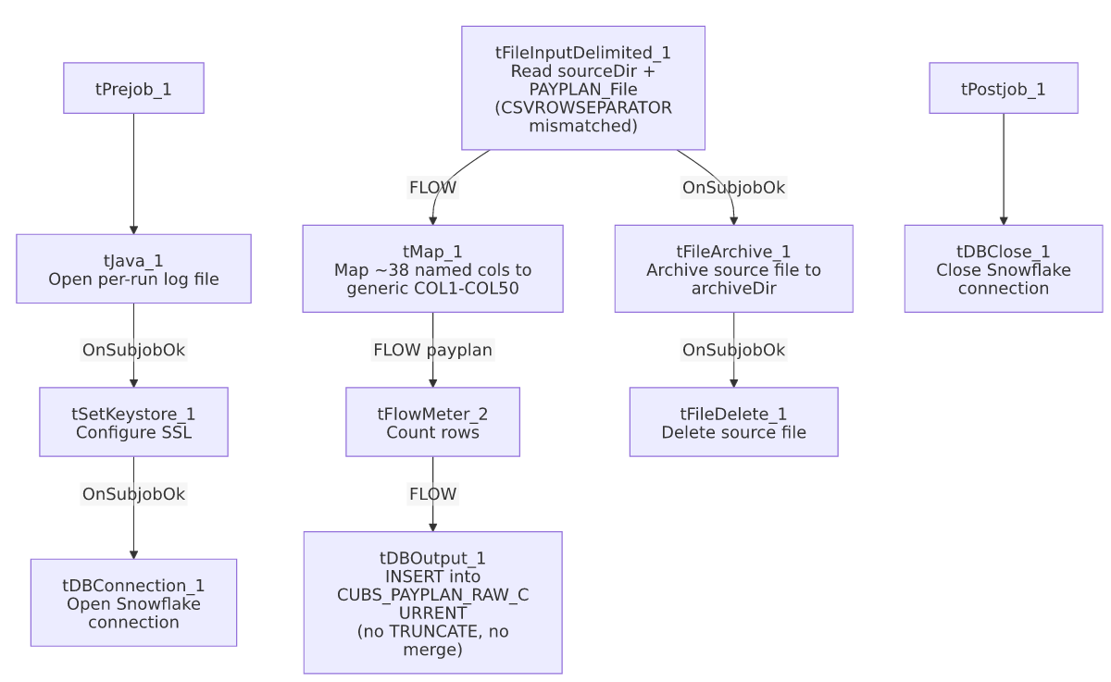

Settings tables

Source: `tFileInputDelimited_1`
Setting | Value | What it means
FILENAME | context.sourceDir + context.PAYPLAN_File | A single, fixed export file per run — no directory iteration. Per _shared_context.json, PAYPLAN_File defaults to Q:/HH_PAYPLAN.TXT (an HH-named file even though the job is site-agnostic in name — see Issues observed).
ROWSEPARATOR / FIELDSEPARATOR / HEADER | context.PAYPLAN_RowSeparator / context.PAYPLAN_FieldSeparator / context.PAYPLAN_Header | Correctly scoped to the PAYPLAN_0.1 context group.
CSVROWSEPARATOR | context.EXPORT_TRANS_RowSeparator | Mismatched — references the Trans export's row separator instead of a PAYPLAN_* variable; only takes effect if CSV_OPTION is enabled (currently false). Same class of copy-paste leftover documented in CUBS_Raw_CO_Client_Load.
TRIMALL | true | All field values are trimmed of leading/trailing whitespace.
Main schema | Repository "...- payplan" (~38 named columns) | Payment-plan specific field names: PPLAN, ORIG_PLAN_AMT, PLAN_BALANCE, NBR_PMTS_MADE, LTR_SERIES, IGNITE, etc.
Reject schema | Repository "...- CUBS_TRANSACTION" | Mislabeled — a transaction-shaped reject schema for a payplan-shaped main schema, same issue class as ADP_Payroll_Load and CUBS_Raw_CO_Client_Load.
TEMP_DIR | "C:/Talend-Studio-20211109_1610-V8.0.1/workspace" | Hardcoded developer-workstation path.

Transform: `tMap_1`
Setting | Value | What it means
Output schema | FILENAME, FILEDATE, COL1–COL50 (52 columns) | Named business columns are not preserved past this point.

Target: `tDBOutput_1` (`tSnowflakeOutput`)
Setting | Value | What it means
Table | CUBS_PAYPLAN_RAW_CURRENT | Destination staging table.
Output action / Table action | INSERT / NONE | Appends rows; no TRUNCATE precedes it and no merge stored procedure follows it, despite the _RAW_CURRENT naming convention.
Schema width | 61 columns (52 from tMap_1 + 9 Snowflake reject-metadata columns: columnName, rowNumber, category, character, errorMessage, byteOffset, line, sqlState, code).

Archive / Delete: `tFileArchive_1` / `tFileDelete_1`
Setting | Value | What it means
SOURCE / TARGET (tFileArchive_1) | context.sourceDir / context.archiveDir + "/" + <CCYYMMDD> + "/" + context.PAYPLAN_File + ".tar.gz" | Archives under a date-stamped subfolder; PASSWORD redacted, ENCRYPT_FILES=false (password not actually applied).
Trigger | Off tFileInputDelimited_1's SUBJOB_OK, not off tDBOutput_1 | Archive+delete happens as soon as the file is read, before the Snowflake insert is confirmed — a downstream failure in tMap_1/tFlowMeter_2/tDBOutput_1 would still result in the source file being archived and deleted.
FILENAME (tFileDelete_1) | context.sourceDir + context.PAYPLAN_File | The actual value used; DIRECTORY/PATH hardcoded defaults (.../workspace/delete_folder) are present but not used.

Dependencies & configuration
- Triggers/depends on other jobs: none — runjob_targets is empty.
- Called by: no job appears as a caller of CUBS_Raw_Payplan_Load in 06_dependency_matrix.md's tRunJob table — see Issues observed. (05_operational_runbook.md separately lists a PaymentPlan_Load job with explicit tDie/tWarn merge-result logic; that is a distinct job name from this one and is not confirmed to be related — do not assume they are the same job.)
- Context variables used: PAYPLAN_File, PAYPLAN_Header, PAYPLAN_RowSeparator, PAYPLAN_FieldSeparator, PAYPLAN_Encoding, EXPORT_TRANS_RowSeparator (mismatched — see Issues observed), archiveDir, currentLogon, keystorePath, logDir, sourceDir.
- 5 hardcoded developer-workstation path findings (tFileInputDelimited_1.TEMP_DIR, tFileArchive_1.SOURCE_FILE, tFileDelete_1.DIRECTORY/PATH, tSetKeystore_1.SSL_TRUSTSERVER_TRUSTSTORE) — same project-wide pattern documented in 05_operational_runbook.md (210 of 289 jobs).

Glossary
Component type | Plain-English meaning
tFileInputDelimited | Reads a delimited (CSV-style) text file according to a schema.
tMap | Maps/transforms columns from one schema to another.
tFlowMeter | Counts rows passing through a point in the flow, for logging/monitoring.
tSnowflakeOutput / tSnowflakeConnection / tSnowflakeClose | Write rows to a Snowflake table / open and close the shared Snowflake connection.
tFileArchive / tFileDelete | Zip a processed file to an archive location, then delete the original from the source directory.
tSetKeystore | Configures the SSL keystore/truststore used by subsequent secure connections.
tPrejob / tPostjob | Run once before/after the rest of the job.
tJava | Runs a block of custom Java code — here, opening a per-run log file.

Issues observed
- No caller found for this job in `06_dependency_matrix.md`. Unlike CUBS_Raw_CO_Client_Load (called by CO_Master_Load), CUBS_Raw_Payplan_Load has no incoming tRunJob link in the project-wide dependency table, and its own runjob_targets is also empty — this job appears to run standalone, triggered by an external scheduler not captured in this metadata. Verify with the team how/when it is actually invoked.
- `PAYPLAN_File`'s documented default value (`Q:/HH_PAYPLAN.TXT`, per `_shared_context.json`) is HH-specific, even though this job's name has no site suffix (unlike the CUBS_Raw_<Site>_Client_Load/_ETL_Load families). Whether this job is actually HH-only, or the context default is simply stale/unused in favor of a per-environment override, cannot be determined from this metadata; verify with the team before assuming which site's payment-plan data this job loads.
- `CSVROWSEPARATOR` on `tFileInputDelimited_1` references `context.EXPORT_TRANS_RowSeparator`, not a PAYPLAN_* variable, while every other separator/header setting on the same component is correctly scoped to PAYPLAN_*. Only matters if CSV_OPTION is ever switched on (currently false) — same copy-paste-leftover class as CUBS_Raw_CO_Client_Load.
- The reject schema is labeled `"...- CUBS_TRANSACTION"`, not a payplan-shaped schema — same mislabeling pattern as ADP_Payroll_Load and CUBS_Raw_CO_Client_Load. Unable to determine whether a rejected payplan row would parse cleanly against a transaction-shaped schema.
- No `TRUNCATE` step and no merge call anywhere in this job, despite the target table being named CUBS_PAYPLAN_RAW_CURRENT — same missing-refresh-step concern documented in CUBS_Raw_CO_Client_Load. Repeated runs without an intervening truncate/merge would accumulate duplicate rows in the staging table.
- Archive and delete are triggered by the file read succeeding, not by the Snowflake insert succeeding — a downstream failure after tFileInputDelimited_1 would still result in the source file being archived and removed from sourceDir, potentially losing the only copy of an unprocessed file outside the archive.
- Named business columns do not survive past `tMap_1` — CUBS_PAYPLAN_RAW_CURRENT only stores generic COL1–COL50 positional columns; interpreting any given column requires an external mapping back to this job's tMap_1 configuration.

