Talend Job: CUBS_Raw_PostDate_Load

Overview
Loads CUBS post-dated-check records (check number, deposit date, check amount, letter/notice tracking, NSF flag, plan-completion and check-post dates) from a single fixed export file into the Snowflake CUBS_POSTDATE_RAW_CURRENT staging table, then archives and deletes the source file. Structurally near-identical to CUBS_Raw_Payplan_Load (single-file read, FLOW into a generic staging table, archive+delete off the read's own success, tPostjob/tDBClose teardown). Per 06_dependency_matrix.md, this job is called 5 times by the CUBS_PostDates_Load parent job — see Issues observed for what "5 times" likely implies.

Detail table
Field | Value
Job name | CUBS_Raw_PostDate_Load
Version | 0.1
Project | EDW2SF
Author | jmach@harriscollect.com
Created | 2022-11-08T09:19:38.566-0800
Last Modified | 2025-11-04T11:08:11.839-0800

Step-by-step data flow
Setup subjob: tPrejob_1 → tJava_1 (OnComponentOk) opens a per-run log file at context.logDir + context.currentLogon + "_" + jobName + "_" + <timestamp> + ".log" → on SUBJOB_OK, tSetKeystore_1 configures SSL trust/keystore from context.keystorePath (passwords redacted) → on SUBJOB_OK, tDBConnection_1 opens the Snowflake connection.
Main subjob:
- tFileInputDelimited_1 reads a single file at context.sourceDir + context.POSTDATE_File (not a directory loop). Separators/header are context-driven (context.POSTDATE_RowSeparator for both ROWSEPARATOR and CSVROWSEPARATOR — correctly scoped, unlike the PAYPLAN_Load/CO_Client_Load mismatch — context.POSTDATE_FieldSeparator, context.POSTDATE_Header). TRIMALL=false. The main and reject schema are both labeled "...- postdate" — this is one of the few jobs in this batch where the reject schema is correctly matched to the main schema rather than copied from an unrelated job. Main schema has ~20 named columns (LOGON, PDCHK, PDCHK_IDX, CHECK, DEPOSIT_DATE, CHECK_AMT, COMMENT, DATE_REC, LETTER_SENT, NSF_FLAG, PLAN_COMP_DATE, CHK_POST_DATE, Q_CHECK_FLG, XEMP_INIT, etc.). DIE_ON_ERROR=false, no reject flow wired despite the (correctly labeled) reject schema existing.
- On SUBJOB_OK, tFileArchive_1 archives context.sourceDir to context.archiveDir + "/" + <CCYYMMDD> + "/" + context.POSTDATE_File + ".tar.gz" (password redacted, ENCRYPT_FILES=false), then on SUBJOB_OK, tFileDelete_1 deletes context.sourceDir + context.POSTDATE_File.
- On FLOW, tMap_1 maps the ~20 named columns to a generic output schema of FILENAME, FILEDATE, COL1–COL20 (22 columns).
- tFlowMeter_2 counts rows passing through (link labeled "pstdt"). This component also carries a leftover NOT_SYNCHRONIZED_SCHEMA reference to a repository schema labeled "...- LEGACY_DIMDEBTOR" — a debtor-dimension schema unrelated to post-dated checks, almost certainly a copy-paste artifact from a different job's tFlowMeter — see Issues observed.
- tDBOutput_1 inserts the rows into Snowflake table CUBS_POSTDATE_RAW_CURRENT (INSERT, tableAction=NONE — no TRUNCATE and no merge call afterward).
Teardown subjob: tPostjob_1 → tDBClose_1 closes the Snowflake connection.
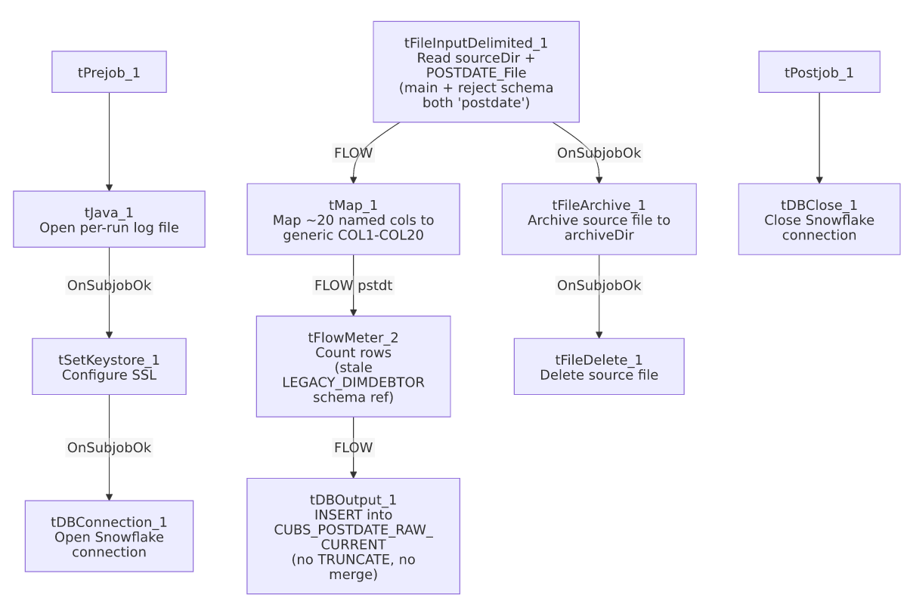

Settings tables

Source: `tFileInputDelimited_1`
Setting | Value | What it means
FILENAME | context.sourceDir + context.POSTDATE_File | A single, fixed export file per run — no directory iteration. Per _shared_context.json, POSTDATE_File defaults to X:/CHI_POSTDATE.TXT (a CHI-named file even though the job is site-agnostic in name — see Issues observed).
ROWSEPARATOR / CSVROWSEPARATOR / FIELDSEPARATOR / HEADER | all context.POSTDATE_* | Correctly and consistently scoped to the POSTDATE_0.1 context group — unlike CUBS_Raw_Payplan_Load's CSVROWSEPARATOR mismatch.
Main schema / Reject schema | Both repository "...- postdate" | Correctly matched — unlike ADP_Payroll_Load, CUBS_Raw_CO_Client_Load, and CUBS_Raw_Payplan_Load, whose reject schemas are mislabeled from a different job.
DIE_ON_ERROR | false | Malformed rows don't fail the job...
Reject flow | Not wired | ...but even with a correctly-shaped reject schema available, no connection routes rejected rows anywhere — they are still silently dropped.
TEMP_DIR | "C:/Talend-Studio-20211109_1610-V8.0.1/workspace" | Hardcoded developer-workstation path.

Transform: `tMap_1` / `tFlowMeter_2`
Setting | Value | What it means
tMap_1 output schema | FILENAME, FILEDATE, COL1–COL20 (22 columns) | Named business columns are not preserved past this point.
tFlowMeter_2 NOT_SYNCHRONIZED_SCHEMA | Repository "_m9AtkGRHEeyH09yzpUroLA - LEGACY_DIMDEBTOR" | A stale schema reference Talend retained from when this component's schema was last edited against a different (debtor-dimension) job — see Issues observed. Does not affect runtime behavior of this job's actual columns.

Target: `tDBOutput_1` (`tSnowflakeOutput`)
Setting | Value | What it means
Table | CUBS_POSTDATE_RAW_CURRENT | Destination staging table.
Output action / Table action | INSERT / NONE | Appends rows; no TRUNCATE precedes it and no merge stored procedure follows it, despite the _RAW_CURRENT naming convention.
Schema width | 31 columns (22 from tMap_1 + 9 Snowflake reject-metadata columns).

Archive / Delete: `tFileArchive_1` / `tFileDelete_1`
Setting | Value | What it means
SOURCE / TARGET (tFileArchive_1) | context.sourceDir / context.archiveDir + "/" + <CCYYMMDD> + "/" + context.POSTDATE_File + ".tar.gz" | Archives under a date-stamped subfolder; PASSWORD redacted, ENCRYPT_FILES=false (password not actually applied).
Trigger | Off tFileInputDelimited_1's SUBJOB_OK, not off tDBOutput_1 | Archive+delete happens as soon as the file is read, before the Snowflake insert is confirmed.
FILENAME (tFileDelete_1) | context.sourceDir + context.POSTDATE_File | The actual value used; DIRECTORY/PATH hardcoded defaults are present but not used.

Dependencies & configuration
- Triggers/depends on other jobs: none — runjob_targets is empty.
- Called by: CUBS_PostDates_Load, 5 times, per 06_dependency_matrix.md — the repeated call count is consistent with a parent job that invokes this same child once per site (e.g. CHI/CO/DC/HH/PRE or similar), overriding context.POSTDATE_File/sourceDir per call; the actual per-call context overrides are not visible in this job's own metadata. 05_operational_runbook.md separately notes CUBS_PostDates_Load (the parent, not this job) as one of the 16 jobs with explicit tDie/tWarn merge-result logic — that logic lives in the parent, not in this child job, which has no tDie/tWarn components of its own.
- Context variables used: POSTDATE_File, POSTDATE_Header, POSTDATE_RowSeparator, POSTDATE_FieldSeparator, POSTDATE_Encoding, archiveDir, currentLogon, keystorePath, logDir, sourceDir.
- 5 hardcoded developer-workstation path findings (tFileInputDelimited_1.TEMP_DIR, tFileArchive_1.SOURCE_FILE, tFileDelete_1.DIRECTORY/PATH, tSetKeystore_1.SSL_TRUSTSERVER_TRUSTSTORE) — same project-wide pattern documented in 05_operational_runbook.md (210 of 289 jobs).

Glossary
Component type | Plain-English meaning
tFileInputDelimited | Reads a delimited (CSV-style) text file according to a schema.
tMap | Maps/transforms columns from one schema to another.
tFlowMeter | Counts rows passing through a point in the flow, for logging/monitoring.
tSnowflakeOutput / tSnowflakeConnection / tSnowflakeClose | Write rows to a Snowflake table / open and close the shared Snowflake connection.
tFileArchive / tFileDelete | Zip a processed file to an archive location, then delete the original from the source directory.
tSetKeystore | Configures the SSL keystore/truststore used by subsequent secure connections.
tPrejob / tPostjob | Run once before/after the rest of the job.
tJava | Runs a block of custom Java code — here, opening a per-run log file.

Issues observed
- `tFlowMeter_2` carries a stale `NOT_SYNCHRONIZED_SCHEMA` reference to `"...- LEGACY_DIMDEBTOR"`, a debtor-dimension repository schema unrelated to post-dated checks. This is Talend's own bookkeeping of a component's previously-bound schema before it was last changed, and does not itself affect this job's actual runtime columns (which are the COL1-COL20 shape defined elsewhere in the component) — but it is evidence this tFlowMeter was copied from a debtor-load job rather than built fresh for PostDate_Load. No functional impact confirmed; flagged for awareness only.
- `POSTDATE_File`'s documented default value (`X:/CHI_POSTDATE.TXT`, per `_shared_context.json`) is CHI-specific, even though the job name has no site suffix. Given CUBS_PostDates_Load calls this job 5 times (likely once per site), the actual per-call POSTDATE_File values are almost certainly overridden per invocation — the X:/CHI_POSTDATE.TXT value visible here is probably just the design-time default context value, not what every call actually uses. Verify the per-call context overrides with the team before assuming any one site's data.
- Even with correctly-matched main/reject schemas (a rarer state of affairs in this project — contrast ADP_Payroll_Load, CUBS_Raw_CO_Client_Load, CUBS_Raw_Payplan_Load), no reject flow is wired, so malformed rows are still silently dropped with no record of how many, or which ones, failed to parse.
- No `TRUNCATE` step and no merge call anywhere in this job, despite the target table being named CUBS_POSTDATE_RAW_CURRENT. Since this job is called 5 times by its parent without any visible truncate between calls, each of the 5 calls' rows would simply accumulate in the same staging table unless the parent job or a downstream process handles deduplication/truncation itself (not visible in this job's own metadata).
- Archive and delete are triggered by the file read succeeding, not by the Snowflake insert succeeding — a downstream failure after tFileInputDelimited_1 would still result in the source file being archived and removed from sourceDir.
- Named business columns do not survive past `tMap_1` — CUBS_POSTDATE_RAW_CURRENT only stores generic COL1–COL20 positional columns.

