Talend Job: CUBS_Raw_TOL_Client_Load

Overview
Loads CUBS client master records (agency/creditor client accounts — name, address, phone, statement/invoice-frequency settings, commission/interest-rate fields, scoring thresholds, and a long tail of client-level flags) for the TOL site from a single delimited export file into the Snowflake CUBS_CLIENT_RAW_CURRENT staging table, then archives and deletes the source file. It is structurally and configurationally a near-exact copy of CUBS_Raw_CO_Client_Load (and, per that job's own doc, of CUBS_Raw_CHI_Client_Load) — same ~199-column-to-COL1-COL200 flattening shape, same mismatched CSVROWSEPARATOR, same generically-labeled "metadata" main schema, same mislabeled "CUBS_TRANSACTION" reject schema. Unlike its CO sibling, however, this job has no visible caller in the project's tRunJob orchestration graph — see Issues observed.

Detail table
Field | Value
Job name | CUBS_Raw_TOL_Client_Load
Version | 0.1
Project | EDW2SF
Author | jmach@harriscollect.com
Created | 2024-04-18T09:18:40.510-0700
Last Modified | 2025-11-04T11:08:07.574-0800

Step-by-step data flow
Setup subjob: tPrejob_1 → tJava_1 opens a per-run log file at context.logDir + context.currentLogon + "_" + jobName + "_" + <timestamp> + ".log" → on SUBJOB_OK, tSetKeystore_1 configures SSL trust/keystore from context.keystorePath (passwords redacted) → on SUBJOB_OK, tDBConnection_1 opens the Snowflake connection.
Main subjob:
- tFileInputDelimited_1 reads a single file at context.sourceDir + context.EXPORT_CLIENT_File (not a directory loop — one fixed export file per run). Separators/header/encoding are context-driven from the EXPORT_CLIENT_* group (EXPORT_CLIENT_RowSeparator, EXPORT_CLIENT_FieldSeparator, EXPORT_CLIENT_Header, EXPORT_CLIENT_Encoding), except `CSVROWSEPARATOR`, which is set to `context.EXPORT_TRANS_RowSeparator` instead of an EXPORT_CLIENT_* variable (only relevant if CSV_OPTION is ever turned on — currently false). TRIMALL=true. The main schema is labeled generically "...- metadata" in the repository (~199 unique client business columns: LOGON, CLIENT, CLIENT_IDX, NAME, address fields, rate/commission fields, statement/invoice settings, scoring thresholds, etc. — LOGON/CLIENT/CLIENT_IDX are marked non-nullable). The reject schema is labeled "...- CUBS_TRANSACTION". DIE_ON_ERROR=false, no reject flow wired.
- On SUBJOB_OK (as soon as the file read succeeds — not gated on the Snowflake insert), tFileArchive_1 archives context.sourceDir to context.archiveDir + "/" + <CCYYMMDD> + "/" + context.EXPORT_CLIENT_File + ".tar.gz" (password redacted, ENCRYPT_FILES=false), then on SUBJOB_OK, tFileDelete_1 deletes context.sourceDir + context.EXPORT_CLIENT_File.
- On FLOW, tMap_1 maps the ~199 named business columns to a generic output schema of FILENAME, FILEDATE, COL1–COL200 (202 columns) — meaningful column names are not preserved past this point.
- tFlowMeter_2 counts rows passing through (link labeled "cli" — renamed from the Talend default, same as CUBS_Raw_CO_Client_Load).
- tDBOutput_1 inserts the rows into Snowflake table CUBS_CLIENT_RAW_CURRENT (INSERT, tableAction=NONE — no TRUNCATE step anywhere in this job and no merge call afterward, despite the _RAW_CURRENT table name).
Teardown subjob: tPostjob_1 → tDBClose_1 closes the Snowflake connection.
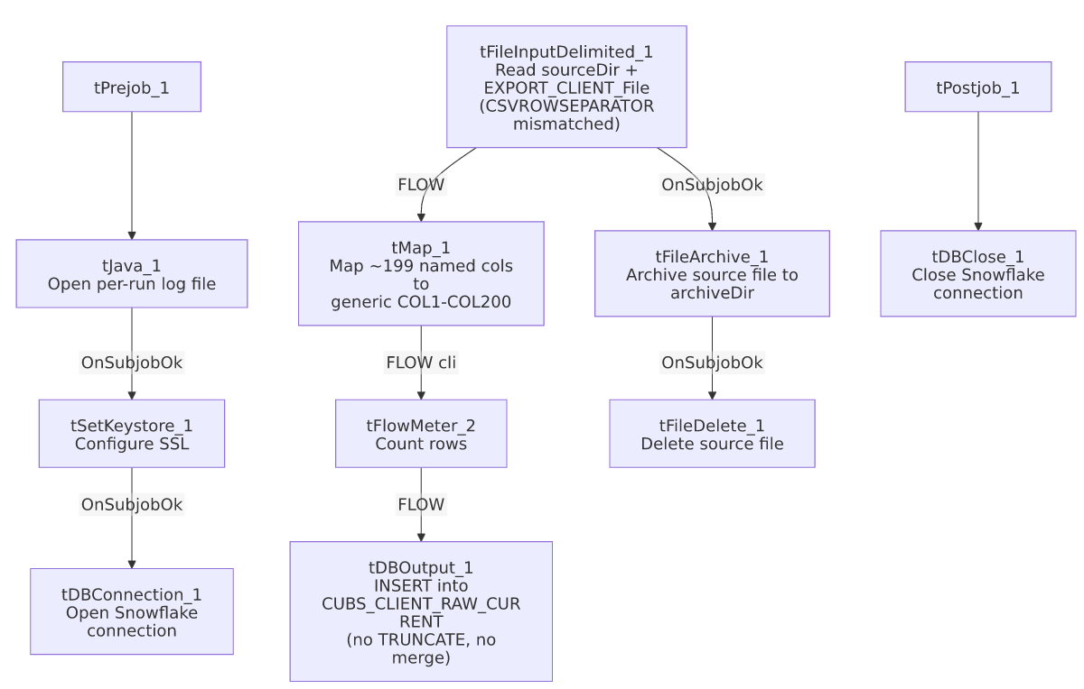

Settings tables

Source: `tFileInputDelimited_1`
Setting | Value | What it means
FILENAME | context.sourceDir + context.EXPORT_CLIENT_File | A single, fixed export file per run — no directory iteration.
ROWSEPARATOR / FIELDSEPARATOR / HEADER / ENCODING | context.EXPORT_CLIENT_RowSeparator / context.EXPORT_CLIENT_FieldSeparator / context.EXPORT_CLIENT_Header / context.EXPORT_CLIENT_Encoding | Correctly scoped to the CLIENT export context group.
CSVROWSEPARATOR | context.EXPORT_TRANS_RowSeparator | Mismatched — references the Trans export's row separator instead of an EXPORT_CLIENT_* variable; only takes effect if CSV_OPTION is enabled (currently false). Identical mismatch to CUBS_Raw_CO_Client_Load and CUBS_Raw_CHI_Client_Load.
TRIMALL | true | All field values are trimmed of leading/trailing whitespace.
Main schema | Repository "...- metadata" (~199 unique client columns) | Generic repository label, not client- or site-specific — same as CUBS_Raw_CO_Client_Load, under a different repository GUID.
Reject schema | Repository "...- CUBS_TRANSACTION" | Mislabeled — same issue class as CUBS_Raw_CO_Client_Load, CUBS_Raw_Payplan_Load, and ADP_Payroll_Load.
TEMP_DIR | "C:/Talend-Studio-20211109_1610-V8.0.1/workspace" | Hardcoded developer-workstation path.

Transform: `tMap_1`
Setting | Value | What it means
Output schema | FILENAME, FILEDATE, COL1–COL200 (202 columns) | Identical width to CUBS_Raw_CO_Client_Load's output shape. Named business columns are not preserved past this point.

Target: `tDBOutput_1` (`tSnowflakeOutput`)
Setting | Value | What it means
Table | CUBS_CLIENT_RAW_CURRENT | Destination staging table — the same table name used by CUBS_Raw_CO_Client_Load and CUBS_Raw_CHI_Client_Load; no visible site-discriminator column in this metadata.
Output action / Table action | INSERT / NONE | Appends rows; no TRUNCATE precedes it and no merge stored procedure follows it.
Schema width | 211 columns (202 from tMap_1 + 9 Snowflake reject-metadata columns).

Archive / Delete: `tFileArchive_1` / `tFileDelete_1`
Setting | Value | What it means
SOURCE / TARGET (tFileArchive_1) | context.sourceDir / context.archiveDir + "/" + <CCYYMMDD> + "/" + context.EXPORT_CLIENT_File + ".tar.gz" | Archives under a date-stamped subfolder; PASSWORD redacted, ENCRYPT_FILES=false (password not actually applied).
Trigger | Off tFileInputDelimited_1's SUBJOB_OK, not off tDBOutput_1 | Archive+delete happens as soon as the file is read, before the Snowflake insert is confirmed — a downstream failure in tMap_1/tFlowMeter_2/tDBOutput_1 would still result in the source file being archived and deleted. Same ordering as CUBS_Raw_CO_Client_Load.
FILENAME (tFileDelete_1) | context.sourceDir + context.EXPORT_CLIENT_File | The actual value used; DIRECTORY/PATH hardcoded defaults (.../workspace/delete_folder) are present but not used.

Dependencies & configuration
- Called by: no job appears as a caller of CUBS_Raw_TOL_Client_Load in 06_dependency_matrix.md's tRunJob table — see Issues observed. This is unlike CUBS_Raw_CO_Client_Load, which is called once by CO_Master_Load.
- Calls no other jobs — runjob_targets is empty.
- Context variables used: EXPORT_CLIENT_Encoding, EXPORT_CLIENT_FieldSeparator, EXPORT_CLIENT_File, EXPORT_CLIENT_Header, EXPORT_CLIENT_RowSeparator, EXPORT_TRANS_RowSeparator (mismatched — see Issues observed), archiveDir, currentLogon, keystorePath, logDir, sourceDir.
- 5 hardcoded developer-workstation path findings (tFileInputDelimited_1.TEMP_DIR, tFileArchive_1.SOURCE_FILE, tFileDelete_1.DIRECTORY/PATH, tSetKeystore_1.SSL_TRUSTSERVER_TRUSTSTORE) — same project-wide pattern documented in 05_operational_runbook.md (210 of 289 jobs).

Glossary
Component type | Plain-English meaning
tFileInputDelimited | Reads a delimited (CSV-style) text file according to a schema.
tMap | Maps/transforms columns from one schema to another.
tFlowMeter | Counts rows passing through a point in the flow, for logging/monitoring.
tSnowflakeOutput / tSnowflakeConnection / tSnowflakeClose | Write rows to a Snowflake table / open and close the shared Snowflake connection.
tFileArchive / tFileDelete | Zip a processed file to an archive location, then delete the original from the source directory.
tSetKeystore | Configures the SSL keystore/truststore used by subsequent secure connections.
tPrejob / tPostjob | Run once before/after the rest of the job.
tJava | Runs a block of custom Java code — here, opening a per-run log file.

Issues observed
- No caller found for this job in `06_dependency_matrix.md`. Of the six site-specific _Client_Load siblings implied by the project's site-code pattern (CHI/CO/DC/HH/PRE/TOL — see 01_system_architecture.md), only CUBS_Raw_CO_Client_Load has a visible tRunJob caller (CO_Master_Load). Per that project-wide note in 05_operational_runbook.md and 06_dependency_matrix.md's own Notes section, how (or whether) CUBS_Raw_TOL_Client_Load is triggered today is not visible in this metadata — verify with the team; an orphaned-looking job here could mean either an undocumented external trigger or a genuinely dead/retired job.
- This job is a near-exact copy of `CUBS_Raw_CO_Client_Load`, down to identical context-variable names (context.EXPORT_CLIENT_*), an identical CSVROWSEPARATOR mismatch, an identical generically-labeled "metadata" main schema, and an identical mislabeled "CUBS_TRANSACTION" reject schema. Nothing in this job's own component parameters is TOL-specific beyond the job name itself. Site differentiation must come entirely from per-job context-value overrides (e.g., a TOL-specific value bound to context.sourceDir or context.EXPORT_CLIENT_File) not captured in this extraction; verify directly in Talend Studio's context settings before assuming what actually differs between the CHI/CO/DC/HH/PRE/TOL siblings.
- `CSVROWSEPARATOR` on `tFileInputDelimited_1` references `context.EXPORT_TRANS_RowSeparator`, not an EXPORT_CLIENT_* variable, while every other separator/header/encoding setting on the same component is correctly scoped to EXPORT_CLIENT_*. Same copy-paste leftover as CUBS_Raw_CO_Client_Load; only matters if CSV_OPTION is ever switched on (currently false).
- The reject schema is labeled `"CUBS_TRANSACTION"`, not a client-shaped schema, and the main schema is labeled generically "metadata" rather than something client-specific — same mislabeling pattern as CUBS_Raw_CO_Client_Load and ADP_Payroll_Load.
- `CUBS_Raw_TOL_Client_Load` and `CUBS_Raw_CO_Client_Load` (and presumably `CUBS_Raw_CHI_Client_Load`) all insert into the same table, `CUBS_CLIENT_RAW_CURRENT`, with INSERT/NONE and no TRUNCATE in any of them. There is no visible site-discriminator column in the extracted schema — if multiple site jobs run against the same warehouse table without external partitioning or a later merge/dedup step, rows from different sites could co-mingle indistinguishably. Unable to confirm from metadata alone; verify with the team how (or whether) this table is expected to segregate site data.
- No `TRUNCATE` step and no merge call anywhere in this job, despite the target table being named CUBS_CLIENT_RAW_CURRENT — same missing-refresh-step concern as CUBS_Raw_CO_Client_Load.
- Archive and delete are triggered by the file read succeeding, not by the Snowflake insert succeeding — a downstream failure after tFileInputDelimited_1 would still result in the source file being archived and removed from sourceDir.
- Named business columns do not survive past `tMap_1` — CUBS_CLIENT_RAW_CURRENT only stores generic COL1–COL200 positional columns; interpreting any given column requires an external mapping back to this job's tMap_1 configuration.

