Talend Job: CUBS_Raw_TOL_Debtor_Load

Overview
Loads raw debtor (collections-account) extract files for the "TOL" site out of a source directory into the Snowflake staging table CUBS_DEBTOR_RAW_TOL_CURRENT, then merges that batch into the shared cumulative table EDWPRODHH.STAGING.CUBS_DEBTOR_RAW, and finally archives and deletes the processed source files. Each source file carries 443 named debtor columns (identity, address, phone, balances, legal/violation fields, letter/notice tracking, etc.) from the legacy CUBS system; a LAST4SSN column is computed before one or more fields are passed through an encryption step, and the target schema stores the data under generic COL1...COL500 names rather than the original business names. This is one of (at least) six per-site siblings named CUBS_Raw_<Site>_Debtor_Load (CHI/CO/DC/HH/PRE/TOL), but unlike the CHI/CO/DC/HH/PRE variants — which are called once each by the orchestrator CUBS_Raw_Debtor_Load (06_dependency_matrix.md) — this job is not among that orchestrator's tRunJob targets and is also structurally the most developed of the family (SSL client-certificate setup, an extra column-derivation step, a MERGE instead of a plain append, and file archive/cleanup steps not present in the CHI sibling). See Issues observed.

Detail table
Field | Value
Job name | CUBS_Raw_TOL_Debtor_Load
Version | 0.4
Project | EDW2SF
Author | jmach@harriscollect.com
Created | 2024-04-18T09:17:20.561-0700
Last Modified | 2026-05-18T11:08:49.610-0700

Step-by-step data flow
Setup subjob: tPrejob_1 →(OnComponentOk)→ tJava_4 opens a custom log file at context.logDir+context.currentLogon+"_"+jobName+"_"+<timestamp>+".log" and redirects System.out/presumably System.err to it (the code is truncated in the extracted metadata after ~250 characters, so the full body — including any System.setErr redirection — isn't fully visible). →(OnSubjobOk)→ tSetKeystore_1 configures SSL trust/keystore settings for the upcoming database connection. →(OnSubjobOk)→ tDBConnection_1 opens the job's Snowflake connection (no connection-name/label parameters were captured in this job's own metadata).
Main load subjob (no explicit trigger link feeds tDBRow_1; like the CHI sibling, it begins as soon as Talend's built-in prejob-then-everything-else ordering allows):
- tDBRow_1 runs TRUNCATE TABLE STAGING.CUBS_DEBTOR_RAW_TOL_CURRENT; against Snowflake.
- On SUBJOB_OK, tFileList_1 lists files (non-recursive) in context.sourceRoot — note this job does not append context.currentLogon to the directory the way the CHI sibling does (context.sourceRoot+context.currentLogon); here the directory is context.sourceRoot alone. An EXCLUDEFILEMASK of "*.txt" is configured but IFEXCLUDE=false, so — same as CHI — the exclusion is not actually applied; every file in the directory is picked up.
- For each file (ITERATE), tJava_3 sets context.currentFile, context.fileName, and context.filePath from tFileList_1's globalMap entries and logs a "Processing file..." message (code truncated in metadata).
- ITERATE continues to tFileInputDelimited_1, which reads context.currentFile against an inline 443-column schema (no repository schema name is captured in this job's metadata, unlike the CHI job's cited "CUBS-DEBTOR-CHI" reference — this extraction shows only the raw column list for this component). Row separator \n, field separator \t, HEADER=1, encoding ISO-8859-15, DIE_ON_ERROR=false. A reject schema is present on the component (446 columns: the same 443 main columns plus LAST4SSN, errorCode, errorMessage) but, as in CHI, no REJECT connection is wired anywhere in this job.
- FLOW (link row1) to tJavaRow_1, a custom Java row transform whose output schema (444 columns) is the 443-column input schema plus one new column, LAST4SSN. The visible code assigns output_row.LOGON = input_row.LOGON, DEBTOR, DEBTOR_IDX, CLIENT, NAME1, etc., but is truncated in the extracted metadata after ~250 characters — the statement that actually populates LAST4SSN (plausibly derived from the input SSN field, which exists in the source schema) is not visible. Unable to determine from metadata; verify with team.
- FLOW (link row3 — note the out-of-sequence link naming: row1 → row3 → row2, see Issues observed) to tDataEncrypt_1, which passes the 444-column row through an encryption routine (SECRET_TYPE, SECRET_KEY, and PASSWORD_M1 all ***REDACTED***; CRYPTO_METHOD=AES, ALGO_VERSION=2; crypto key file at context.cryptoPath). As with CHI, the specific target column(s) for encryption are not identifiable from this metadata (the component's schema is a full pass-through) — most likely SSN and/or the newly-added LAST4SSN, but that cannot be confirmed.
- FLOW (link row2) to tMap_1, which maps the (partly encrypted) 444-column debtor row onto a generic 502-column target schema: FILENAME, FILEDATE, COL1...COL500. DIE_ON_ERROR=true. The per-field mapping expressions are not captured in this metadata.
- FLOW (link co — the only non-default link name in this job's main data path; see Issues observed) to tDBOutput_2 (tSnowflakeOutput, not the tSnowflakeOutputBulkExec used by the CHI sibling), which inserts (outputAction=INSERT, tableAction=NONE) rows into CUBS_DEBTOR_RAW_TOL_CURRENT.
- After tFileList_1 finishes iterating every file, SUBJOB_OK triggers tParallelize_1 (WAIT_FOR=All, DIE_ON_ERROR=false), which forks into two concurrent branches:
- Merge branch: tDBRow_2 runs a MERGE INTO EDWPRODHH.STAGING.CUBS_DEBTOR_RAW AS tgt USING STAGING.CUBS_DEBTOR_RAW_TOL_CURRENT AS src ON tgt.FILEDATE = src.FILEDATE AND tgt.COL3 = src.COL3 WHEN NOT MATCHED THEN INSERT (...) — unlike CHI's plain INSERT ... SELECT, this only inserts rows whose (FILEDATE, COL3) pair doesn't already exist in the cumulative table, giving it natural re-run/duplicate protection that CHI's variant lacks. Note the target is fully qualified with the database name EDWPRODHH, while every other SQL statement in this job (the TRUNCATE, and tDBOutput_2's implicit table reference) uses only STAGING.<table> and relies on the connection's default database — see Issues observed.
- Archive/cleanup branch: tFileList_3 lists files in context.sourceRoot again →(ITERATE)→ tJava_5 sets context.currentFile/fileName/filePath and logs an "Arch..." message (truncated) →(ITERATE)→ tFileArchive_1 archives context.filePath (the SOURCE_FILE parameter is a hardcoded placeholder, "C:/Talend-Studio-.../workspace/source.csv", but is overridden by SOURCE=context.filePath) to context.archiveDir+"/"+<today's date CCYYMMDD>+"/"+context.fileName+".tar.gz", OVERWRITE=true, ENCRYPT_FILES=false (a PASSWORD value is still configured and ***REDACTED*** despite encryption being disabled). Then, on SUBJOB_OK (after all files are archived), tFileList_3 triggers tFileList_2, which lists files in context.sourceRoot a third time →(ITERATE)→ tJava_2 sets context.currentFile/fileName/filePath →(ITERATE)→ tFileDelete_1 deletes context.currentFile (FOLDER=false, FOLDER_FILE=false, so the delete acts on the single file named by FILENAME=context.currentFile; the component's separate DIRECTORY/PATH parameters are hardcoded placeholder values that are not the actual deletion target in this mode — see Issues observed) →(OnComponentOk)→ tJava_1 logs the delete status/target/error pulled from tFileDelete_1's globalMap entries.
Teardown subjob: tPostjob_1 →(OnComponentOk)→ tDBClose_1 closes the Snowflake connection.
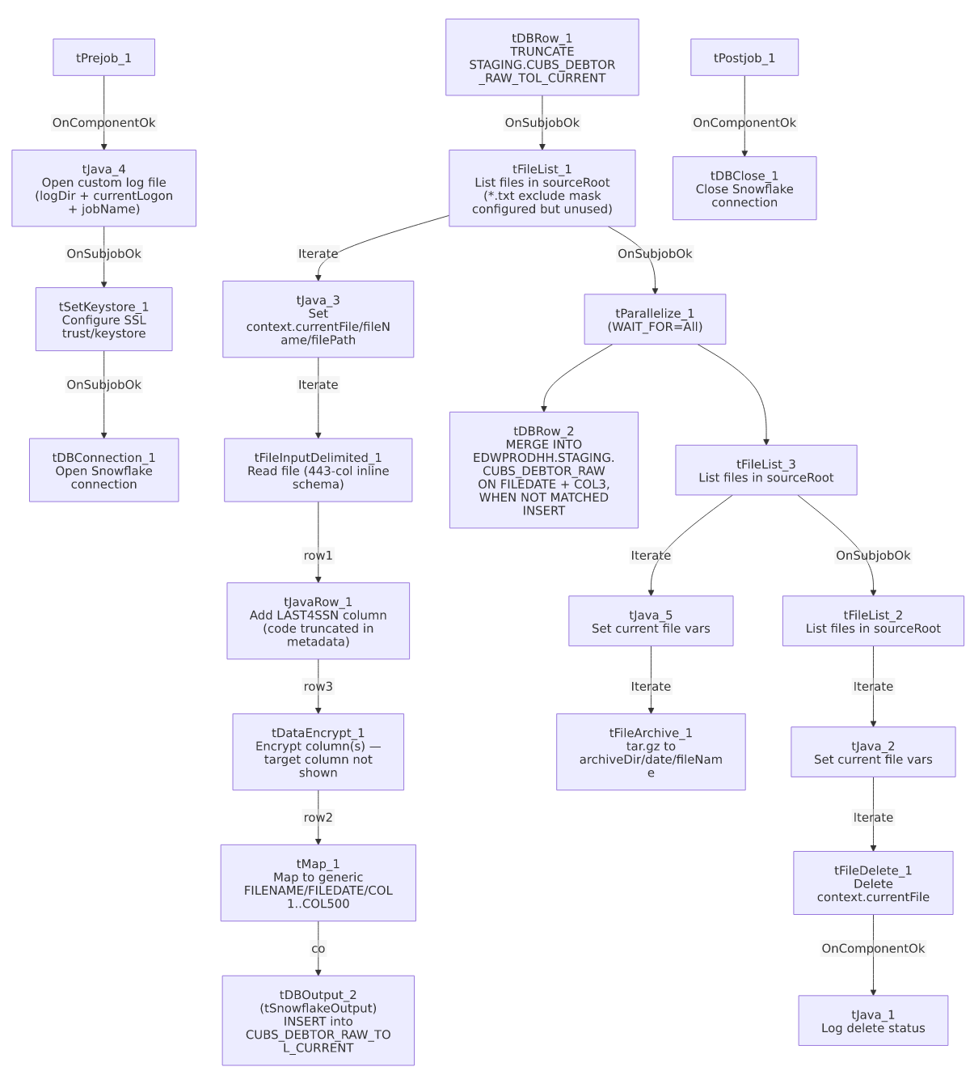

Settings tables

Setup: `tSetKeystore_1`
Setting | Value | What it means
SET_TRUSTSTORE / SET_TRUSTSTORE_KEYSTORE | false / false | Truststore-related toggles left off; the truststore path below is configured but these flags suggest it may not actually be applied — unable to confirm from metadata.
SSL_TRUSTSERVER_TRUSTSTORE | "C:/clientTrustStore.trustStore" | Hardcoded developer-workstation path to a trust store file.
SSL_TRUSTSERVER_PASSWORD | ***REDACTED*** | Truststore password — preserved as redacted.
KEYSTORE_TYPE | PKCS12 | Client keystore format.
SSL_KEYSTORE | context.keystorePath | Resolves via the StandardFolders_0.1 context group in _shared_context.json (candidate values seen: /etc/keys/keystore.p12 and C:/users/jmach/.ssl/keystore.p12 — two different values are present for this variable in the shared context data, suggesting separate environment/user contexts rather than a single resolved value).
SSL_KEYSTORE_PASSWORD / NEED_CLIENT_AUTH | ***REDACTED*** / ***REDACTED*** | Both redacted in the source data.
VERIFY_NAME | true | Hostname verification is enabled for the TLS connection.
This component is unique to this job among the sibling set documented so far** — CHI's job goes straight from tPrejob_1 to tDBConnection_1 with no SSL/keystore setup step.

Source: `tFileList_1` / `tFileList_2` / `tFileList_3`
Setting | Value | What it means
DIRECTORY | context.sourceRoot | Same directory scanned by all three tFileList instances (initial load, then re-listed for archive, then re-listed for delete). Unlike the CHI job, this job does not append context.currentLogon to the path.
LIST_MODE | FILES | Lists files only.
EXCLUDEFILEMASK / IFEXCLUDE | "*.txt" / false | Configured but never applied — every file in the directory is picked up, all three times it's listed. Same non-functional pattern as CHI.
CASE_SENSITIVE | YES | Case-sensitive matching (no practical effect since no mask is applied).

Source: `tFileInputDelimited_1`
Setting | Value | What it means
FILENAME | context.currentFile | The file currently being iterated by tFileList_1.
Main schema | Inline 443-column debtor schema (name, address, phone, balances, legal/violation, letter/notice tracking, SSN, SSN1, _8_TEC_SSN, ASSND_AMT, etc.) | No repository schema name is captured in this job's metadata (only the raw column list), unlike CHI's cited "CUBS-DEBTOR-CHI" reference.
Reject schema | Inline 446-column schema (the 443 main columns + LAST4SSN, errorCode, errorMessage) | Structurally close to a superset of the main schema (adds LAST4SSN plus the two standard reject-tracking columns) rather than a different site's schema entirely (contrast with CHI, whose reject schema pointed at the wrong site, CUBS_DEBTOR_HH). No mismatch of that kind is evident here from the column lists alone.
ROWSEPARATOR / FIELDSEPARATOR / HEADER / ENCODING | \n / \t / 1 (header row present) / ISO-8859-15 | Hardcoded directly on the component (not driven by an EXPORT_DEBTOR_* context group as in CHI).
DIE_ON_ERROR | false | Malformed rows don't fail the job...
Reject flow | Not wired | ...but no connection carries rejected rows anywhere — same silent-drop pattern as CHI.
TEMP_DIR | "C:/Talend-Studio-20211109_1610-V8.0.1/workspace" | Hardcoded developer-workstation path — part of the 210/289-job project-wide pattern in 05_operational_runbook.md.

Transform: `tJavaRow_1`
Setting | Value | What it means
Output schema | 444 columns = the 443-column input schema + LAST4SSN | This step derives a new LAST4SSN field before encryption.
CODE | Truncated in extracted metadata at ~250 characters | Only the first several output_row.<X> = input_row.<X> pass-through assignments are visible (LOGON, DEBTOR, DEBTOR_IDX, CLIENT, NAME1, ...). The statement that computes LAST4SSN (plausibly substring of SSN) is not visible in this extraction. Unable to determine from metadata — verify with team.

Transform: `tDataEncrypt_1`
Setting | Value | What it means
SECRET_TYPE | ***REDACTED*** | Encryption secret-type setting — preserved as redacted.
SECRET_KEY | ***REDACTED*** | Encryption key — redacted; not present as a separate parameter in the CHI sibling's documented settings.
PASSWORD_M1 | ***REDACTED*** | Encryption password — redacted.
CRYPTO_METHOD | AES | Explicit algorithm name (CHI's documented settings didn't list this parameter).
CRYPTO_FILE_PATH | context.cryptoPath | context.cryptoPath is not defined in any context group present in _shared_context.json — same gap flagged for CHI.
ALGO_VERSION | 2 | Encryption algorithm version.
GEN_CRYPTO_FILE_CONTROLLER | false | Does not regenerate the crypto controller file this run.
Target column(s) | Not visible in metadata | The component carries the full 444-column pass-through schema; the specific encrypted field(s) — most plausibly SSN and/or the new LAST4SSN — can't be confirmed from this extraction.

Transform: `tMap_1`
Setting | Value | What it means
DIE_ON_ERROR | true | A mapping/lookup failure here fails the job outright.
Output schema | FILENAME, FILEDATE, COL1...COL500 (502 columns) | Same generic-column target pattern as CHI. Field-level mapping expressions are not captured in this metadata.
ROWS_BUFFER_SIZE | 2000000 | tMap disk-mode buffer threshold.

Target: `tDBOutput_2` (`tSnowflakeOutput`)
Setting | Value | What it means
Table | CUBS_DEBTOR_RAW_TOL_CURRENT | Snowflake staging table for this run's TOL-site batch — the same table truncated by tDBRow_1 at job start.
outputAction | INSERT | Appends rows; relies on the earlier TRUNCATE to avoid duplicate accumulation within a run.
tableAction | NONE | Table is not recreated/altered by this job.
Component type | tSnowflakeOutput, not tSnowflakeOutputBulkExec | The CHI sibling uses the bulk-load variant for this same step; this job uses the plain row-oriented output component instead — a throughput-relevant difference for large files, and possibly just an artifact of when each job variant was last touched (this job's version is 0.4 vs. CHI's 0.1).
Schema | FILENAME, FILEDATE, COL1...COL500, plus a reject/error schema (columnName, rowNumber, category, character, errorMessage, byteOffset, line, sqlState, code) | As with CHI's bulk-output component, an error schema is defined but no REJECT connection is wired in this job's connections — output-level rejects are not captured.

Truncate / merge steps: `tDBRow_1` / `tDBRow_2` (`tSnowflakeRow`)
Setting | Value | What it means
Query 1 (tDBRow_1) | TRUNCATE TABLE STAGING.CUBS_DEBTOR_RAW_TOL_CURRENT; | Clears the TOL-site staging table before the file loop starts.
Query 2 (tDBRow_2) | MERGE INTO EDWPRODHH.STAGING.CUBS_DEBTOR_RAW AS tgt USING STAGING.CUBS_DEBTOR_RAW_TOL_CURRENT AS src ON tgt.FILEDATE = src.FILEDATE AND tgt.COL3 = src.COL3 WHEN NOT MATCHED THEN INSERT (FILENAME, FILEDATE, COL1...COL500) VALUES (src.FILENAME, ..., src.COL500); | Inserts only rows whose (FILEDATE, COL3) combination isn't already present in the cumulative table — a genuine dedup/upsert-style guard, unlike CHI's plain INSERT ... SELECT * append. Note the fully-qualified EDWPRODHH database prefix here, versus the unqualified STAGING.<table> references used everywhere else in this job (see Issues observed).

Archive/cleanup: `tFileArchive_1` / `tFileDelete_1`
Setting | Value | What it means
SOURCE / TARGET (tFileArchive_1) | context.filePath / context.archiveDir+"/"+<CCYYMMDD>+"/"+context.fileName+".tar.gz" | Archives each processed file into a date-stamped folder under context.archiveDir (resolves via StandardFolders_0.1 — candidate values /archive/ or C:/Data/).
SOURCE_FILE | "C:/Talend-Studio-20211109_1610-V8.0.1/workspace/source.csv" | A hardcoded placeholder value for this parameter; overridden at runtime by SOURCE=context.filePath, so it appears to be inert leftover configuration rather than an active hardcoded path. Still flagged per hardcoded_path_findings.
ENCRYPT_FILES / PASSWORD | false / ***REDACTED*** | Archive encryption is disabled, but a password value is still configured (redacted) — vestigial/unused setting.
OVERWRITE | true | An existing archive at the target path is overwritten rather than causing an error.
FILENAME (tFileDelete_1) | context.currentFile | The actual file deleted, since FOLDER=false and FOLDER_FILE=false put the component in single-file-delete mode.
DIRECTORY / PATH (tFileDelete_1) | "C:/Talend-Studio-.../delete_folder" / "C:/Talend-Studio-.../delete_folder or delete_file" | Hardcoded placeholder-looking values (the PATH value literally reads "delete_folder or delete_file", Talend's own default hint text) that appear inactive in this component's current mode (FOLDER=false), but are still flagged as hardcoded paths per hardcoded_path_findings since they are present on the component.
FAILON | false | A delete failure does not fail the job.

Dependencies & configuration
- Called by: Not called by any job's runjob_targets visible in this extraction. Per 06_dependency_matrix.md, the orchestrator CUBS_Raw_Debtor_Load calls the CHI, CO, DC, HH, and PRE debtor-load siblings, but not CUBS_Raw_TOL_Debtor_Load — this job appears to run outside that orchestration chain (independently scheduled, or triggered by a Master job not present in this export). This matches the project-wide caveat already flagged in 06_dependency_matrix.md: "If those sites are triggered some other way... that's undocumented here — verify with team." This job's own runjob_targets is empty — it does not call any other jobs itself.
- Context variables used: archiveDir, logDir, keystorePath (all resolve via the StandardFolders_0.1 context group in _shared_context.json, each with two candidate values — e.g. archiveDir = /archive/ or C:/Data/ — suggesting separate environment entries rather than one settled value); currentFile, fileName, filePath (set internally by this job's own tJava steps from tFileList globalMap entries, not sourced from a context group); cryptoPath, currentLogon, sourceRoot (not found in any context group in `_shared_context.json`, same gap noted for the CHI sibling — presumably supplied by an external caller or a CUBS-specific context group outside this extraction's scope). Unable to determine from this job's own metadata — verify with team, particularly cryptoPath since an unresolved encryption key path would fail the job at tDataEncrypt_1.
- Hardcoded paths: tFileInputDelimited_1.TEMP_DIR, tFileDelete_1.DIRECTORY, tFileDelete_1.PATH, tSetKeystore_1.SSL_TRUSTSERVER_TRUSTSTORE, tFileArchive_1.SOURCE_FILE — five findings total per this job's hardcoded_path_findings, all pointing at the same developer workstation (C:/Talend-Studio-20211109_1610-V8.0.1/... or C:/clientTrustStore.trustStore). Part of the 210/289-job project-wide pattern in 05_operational_runbook.md.

Glossary
Component type | Plain-English meaning
tFileList | Lists files in a directory for the job to iterate over one at a time.
tFileInputDelimited | Reads a delimited (CSV-style) text file according to a schema.
tJavaRow | Runs custom Java code to transform one row into another row, column by column (like a code-based tMap).
tDataEncrypt | Encrypts one or more fields of a row using a configured algorithm/key before it continues downstream.
tMap | Maps/transforms columns from one schema to another.
tSnowflakeOutput | Inserts rows into a Snowflake table (plain/row-oriented, as opposed to the bulk-load variant).
tSnowflakeRow | Runs an arbitrary SQL statement against Snowflake (here, TRUNCATE and a MERGE).
tSnowflakeConnection / tSnowflakeClose | Open and close the Snowflake connection shared by other components in the job.
tSetKeystore | Configures SSL/TLS trust store and client keystore settings used by a subsequent database connection.
tFileArchive | Compresses one or more files into an archive (here, .tar.gz) at a target location.
tFileDelete | Deletes a file, folder, or path.
tParallelize | Forks the flow into multiple branches that run concurrently, optionally waiting for all/any to finish before continuing.
tJava | Runs a block of custom Java code once (here, to capture the current file path into context variables and log status/errors).

Issues observed
- This job is absent from the `CUBS_Raw_Debtor_Load` orchestrator's `tRunJob` targets, even though its four other per-site siblings (CHI, CO, DC, HH) plus PRE are all called from there once each (06_dependency_matrix.md). This job's own runjob_targets is also empty. It's unclear from this metadata whether TOL is triggered by a separate scheduled task, a different orchestrator not present in this export, or is simply not currently wired into any orchestration — worth confirming with the team so the TOL pipeline isn't assumed to run automatically alongside the others.
- Out-of-sequence and copy-paste-suggestive link naming in the main data path. The FLOW links from tFileInputDelimited_1 through to tDBOutput_2 are named row1 → row3 → row2 → co, rather than the sequential row1/row2/row3 pattern seen in CHI. The final link name, co, exactly matches the CO site code used elsewhere in this project's job-naming convention — strongly suggesting this job's main pipeline (or at least its final output link) was copy-pasted from a CUBS_Raw_CO_Debtor_Load-style template and not fully renamed for TOL, similar in kind to the CHI_DBTR-labeled link documented for the CHI sibling, but here the artifact is a leftover site code from a *different* site's job rather than a purpose-relabeled name.
- `tDBRow_2`'s `MERGE` target is fully qualified with the database name `EDWPRODHH`, while every other SQL/table reference in this job (`tDBRow_1`'s `TRUNCATE`, `tDBOutput_2`'s implicit table) uses only `STAGING.<table>` and relies on the active connection's default database. If this job is ever pointed at a differently-named Snowflake database (e.g., a non-prod or QA environment), the hardcoded EDWPRODHH prefix in the MERGE statement would silently target the wrong database (or fail if that database doesn't exist there) while the rest of the job's statements would correctly follow the connection. This is a more serious environment-portability risk than the workstation-path hardcodes, since it lives inside SQL text rather than an obviously-overridable file-path parameter.
- `tJavaRow_1`'s code that derives the new `LAST4SSN` column is truncated in the extracted metadata (cut off after ~250 characters, consistent with all tJava/tJavaRow code blocks in this job). The actual source expression can't be confirmed — it's plausible this pulls the last four digits of the input SSN field (which exists in the source schema), but that is an assumption, not a confirmed fact. Verify directly in Talend Studio.
- No reject flow is wired anywhere in this job — neither from tFileInputDelimited_1 (DIE_ON_ERROR=false, rows silently dropped) nor from tDBOutput_2 (which defines a full error-info schema but has no REJECT connection routing rows to it). Same pattern as CHI and the project-wide finding in 05_operational_runbook.md.
- `tFileList_1`'s exclude mask is configured but never applied (EXCLUDEFILEMASK="*.txt", IFEXCLUDE=false) — every file in context.sourceRoot is picked up regardless of extension, the same non-functional pattern seen in CHI and ADP_Payroll_Load.
- `tFileDelete_1` carries hardcoded `DIRECTORY`/`PATH` placeholder values (.../delete_folder, and literally "delete_folder or delete_file" — Talend's own default hint text) that appear inert given the component's current single-file-delete mode (FOLDER=false, FOLDER_FILE=false, actual target FILENAME=context.currentFile). These are still flagged as hardcoded-path findings and are worth cleaning up so a future change to the component's mode doesn't silently start deleting from/at those literal paths.
- The final target schema uses fully generic `COL1`...`COL500` column names rather than the 443 named business columns read from source — same materially-higher documentation risk noted for CHI: anyone querying CUBS_DEBTOR_RAW_TOL_CURRENT or EDWPRODHH.STAGING.CUBS_DEBTOR_RAW downstream needs to open tMap_1 in Talend Studio to know what a given COLn actually contains.
- `context.sourceRoot`, `context.cryptoPath`, and `context.currentLogon` are not defined in any context group present in `_shared_context.json` — same gap flagged for CHI. context.archiveDir, context.logDir, and context.keystorePath are defined (in StandardFolders_0.1), but each has two different candidate values in the shared context data (e.g., archiveDir = /archive/ vs. C:/Data/), so which one actually applies for a TOL production run can't be determined from this metadata alone.
- Beyond the items above, this job's remaining risk profile (hardcoded developer-workstation paths, unresolved encrypted-field targets, generic column naming) matches the project-wide patterns already catalogued in 05_operational_runbook.md.

