Talend Job: CUBS_Raw_TOL_ETL_Load

Overview
Loads CUBS "ETL" credit/collections-scoring extract files for the TOL site — one row per debtor with bureau/collections attributes (bankruptcy disposition codes, revolving/mortgage/auto trade balances, credit-card/available-credit fields, and scoring outputs like Attune_Score, Propen_Score, Decile, Percentile) — from context.sourceDir into the shared Snowflake raw landing table CUBS_ETL_RAW_CURRENT. Every file found in the source directory is loaded, archived, and then deleted in a separate cleanup pass. This job is structurally near-identical to its CUBS_Raw_CO_ETL_Load/CHI/DC/HH/PRE siblings, but — unlike those four — it reads its input using the `co_etl` repository schema instead of a `tol_etl` schema, which appears to be a copy-paste artifact (see Issues observed).

Detail table
Field | Value
Job name | CUBS_Raw_TOL_ETL_Load
Version | 0.1
Project | EDW2SF
Author | jmach@harriscollect.com
Created | 2024-04-18T09:19:43.790-0700
Last Modified | 2025-11-12T05:59:47.331-0800

Step-by-step data flow
Setup subjob: tPrejob_1 → tJava_1 (OnComponentOk) opens a per-run log file at context.logDir + jobName + "_" + <timestamp> + ".log" and redirects System.out/System.err to it → tSetKeystore_1 (OnSubjobOk) configures SSL trust/keystore from context.keystorePath (all passwords redacted) → tDBConnection_1 (OnSubjobOk) opens the Snowflake connection. As with CUBS_Raw_CO_ETL_Load, this job has no `tPostjob_1`/`tDBClose` component — the Snowflake connection is never explicitly closed within this job's own metadata.
Main load pass (no incoming trigger connection to tFileList_1, so it starts as an independent top-level subjob alongside the setup subjob above):
- tFileList_1 lists files in context.sourceDir, ordered by modified date ascending. An EXCLUDEFILEMASK of "*.txt" is configured but IFEXCLUDE=false, so the exclusion is never applied — every file in the directory is picked up.
- For each file (Iterate), tJava_2 sets context.currentFile/fileName/filePath from the tFileList_1 iteration globals.
- tFileInputDelimited_1 (Iterate) reads that file as tab-delimited, ISO-8859-15 encoded, header row present, using repository schema "...- co_etl" — the same schema label used by `CUBS_Raw_CO_ETL_Load`, not a TOL-specific one (see Issues observed). DIE_ON_ERROR=false; TRIMALL=false.
- tMap_1 (row1, FLOW) re-maps the source columns positionally onto a generic 80-column target shape (FILENAME, FILEDATE, COL1...COL80).
- tFlowMeter_2 (etl, FLOW) counts rows passing through (label left at the default "MyLabel").
- tDBOutput_1 (row2, FLOW) inserts the rows into Snowflake CUBS_ETL_RAW_CURRENT (INSERT, tableAction=NONE) — the same shared raw landing table used by all site _ETL_Load jobs.
- On success (OnComponentOk), tFileArchive_1 archives the just-processed file (context.filePath) to context.archiveDir + "/" + <YYYYMMDD> + "/" + context.fileName + ".tar.gz" (password redacted).
Cleanup pass (triggered by tFileList_1's OnSubjobOk, i.e. only after every file from the main load pass has finished processing):
- tFileList_2 re-lists the same context.sourceDir directory (same unapplied EXCLUDEFILEMASK/IFEXCLUDE mismatch as step 1).
- For each file found (Iterate), tJava_3 sets context.currentFile/fileName/filePath again.
- tFileDelete_1 (Iterate) deletes that file from disk.
- On success (OnComponentOk), tJava_4 logs the delete outcome (CURRENT_STATUS, DELETE_PATH, error message).
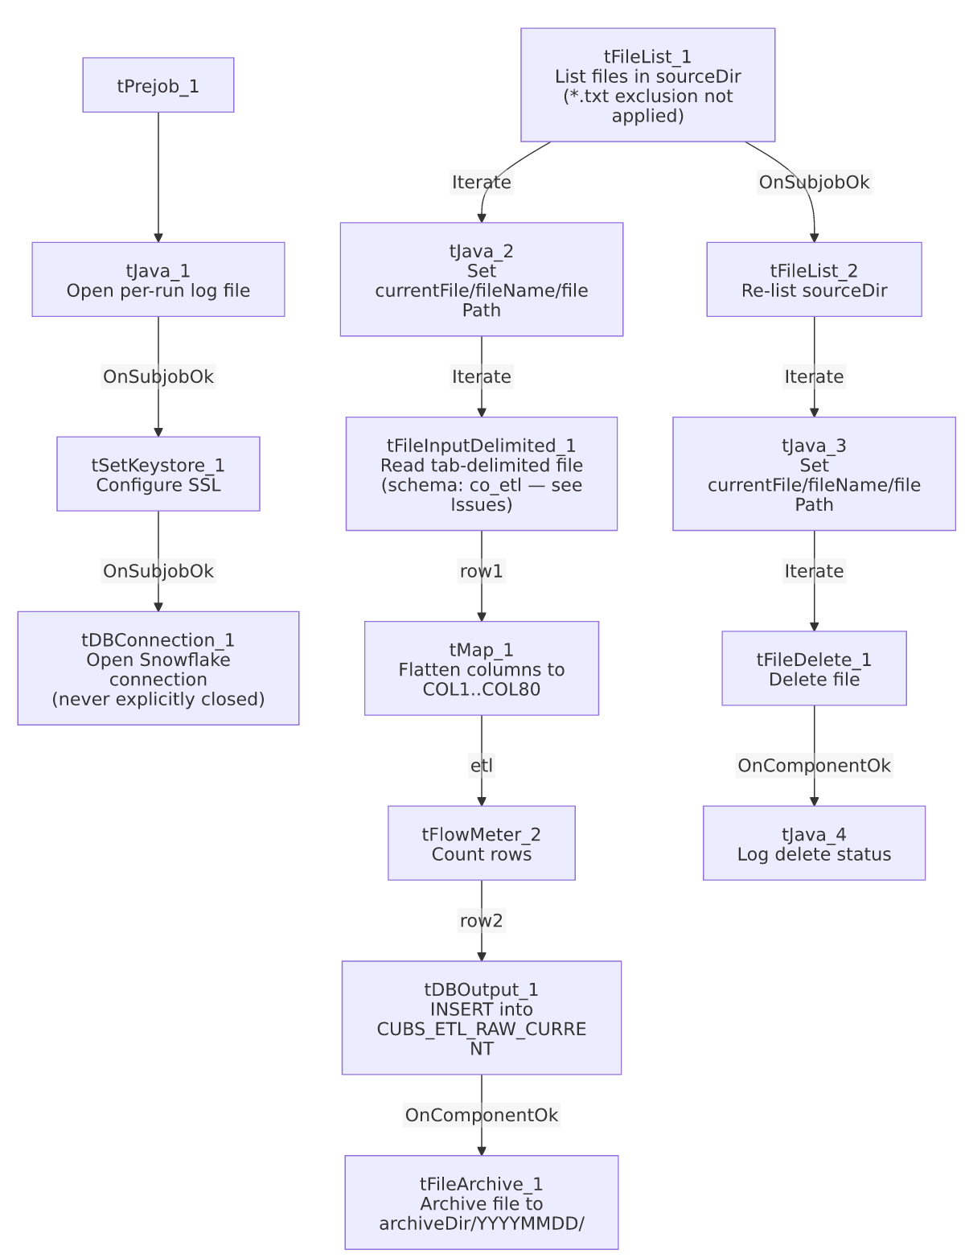

Settings tables

Source: `tFileInputDelimited_1`
Setting | Value | What it means
FILENAME | context.currentFile | The current file from tFileList_1's iteration.
FIELDSEPARATOR / ENCODING | \t / ISO-8859-15 | Tab-delimited extract, ISO-8859-15 (Latin-9) encoded.
HEADER | 1 | One header row skipped.
SCHEMA (main) | Repository schema "...- co_etl" (GUID _jsSQMHyoEe2c-IsTynWu2Q) | Same schema GUID and label used by CUBS_Raw_CO_ETL_Load — not a TOL-specific schema. See Issues observed.
DIE_ON_ERROR | false | Malformed rows don't fail the job...
Reject flow | Not wired | ...but no connection routes rejected rows anywhere — silently dropped, same pattern documented across this job family.
TEMP_DIR | "C:/Talend-Studio-20211109_1610-V8.0.1/workspace" | Hardcoded developer-workstation path — see Dependencies & configuration.

Target: `tDBOutput_1` (`tSnowflakeOutput`)
Setting | Value | What it means
Table | CUBS_ETL_RAW_CURRENT | Destination raw landing table — the same table name used by all site _ETL_Load jobs in this family (CO/CHI/DC/HH/PRE/TOL), differentiated only by FILENAME/FILEDATE values on each row, not by a separate table or site column.
Output action | INSERT | Appends rows; no truncate step precedes it in this job.
Table action | NONE | Table structure is not altered by this job.

`tFileArchive_1`
Setting | Value | What it means
SOURCE | context.filePath | The directory of the just-loaded file.
SOURCE_FILE | "C:/Talend-Studio-20211109_1610-V8.0.1/workspace/source.csv" | Hardcoded developer-workstation default value — see Dependencies & configuration.
TARGET | context.archiveDir + "/" + <YYYYMMDD> + "/" + context.fileName + ".tar.gz" | Per-file, dated archive.
PASSWORD | ***REDACTED*** | Archive is password-protected; actual value not present in extracted metadata.

`tFileDelete_1` (cleanup pass)
Setting | Value | What it means
FILENAME | context.currentFile | File found by the second tFileList_2 listing.
DIRECTORY / PATH | "C:/Talend-Studio-20211109_1610-V8.0.1/workspace/delete_folder" / "...delete_folder or delete_file" | Hardcoded developer-workstation defaults — see Dependencies & configuration.
FAILON | false | A missing/already-deleted file does not fail the job.

`tSetKeystore_1`
Setting | Value | What it means
SSL_KEYSTORE | context.keystorePath | Client keystore path is externalized to context.
SSL_TRUSTSERVER_TRUSTSTORE | "C:/clientTrustStore.trustStore" | Hardcoded truststore path — not context-driven, unlike the keystore itself.
SSL_TRUSTSERVER_PASSWORD / SSL_KEYSTORE_PASSWORD / NEED_CLIENT_AUTH | ***REDACTED*** | Preserved as redacted; real values not present in extracted metadata.

Dependencies & configuration
- Triggers/depends on other jobs: runjob_targets is empty — this job does not call any other job via tRunJob.
- Called by: CUBS_Raw_ETL_Load (1 call), per 06_dependency_matrix.md — consistent with the per-site CUBS_Raw_<Site>_ETL_Load family documented in 01_system_architecture.md. Unlike CO, TOL has no dedicated _Master_Load orchestrator in this metadata.
- Context variables used: archiveDir, currentFile, fileName, filePath, keystorePath, logDir, sourceDir.
- 5 hardcoded developer-workstation paths (tFileInputDelimited_1.TEMP_DIR, tFileArchive_1.SOURCE_FILE, tFileDelete_1.DIRECTORY/PATH, tSetKeystore_1.SSL_TRUSTSERVER_TRUSTSTORE), all under C:/Talend-Studio-20211109_1610-V8.0.1/workspace/... or C:/clientTrustStore.trustStore — same project-wide portability risk documented in 05_operational_runbook.md (210 of 289 jobs share this pattern).

Glossary
Component type | Plain-English meaning
tPrejob / tPostjob | Talend's guaranteed-first / guaranteed-last subjobs for setup and teardown (this job has no tPostjob).
tJava | Runs a block of custom Java code once.
tFileList | Lists files in a directory for the job to iterate over one at a time.
tFileInputDelimited | Reads a delimited (CSV/TSV-style) text file according to a schema.
tMap | Maps/transforms columns from one schema to another.
tFlowMeter | Counts rows passing through a point in the flow, for logging/monitoring.
tSnowflakeOutput / tSnowflakeConnection | Write rows to a Snowflake table / open the Snowflake connection used throughout the job.
tFileArchive / tFileDelete | Zip a processed file to an archive location, then delete the original from the source directory.
tSetKeystore | Configures SSL client keystore/truststore settings ahead of an encrypted database connection.

Issues observed
- This job's input schema is `co_etl`, not a TOL-specific schema. tFileInputDelimited_1.SCHEMA:REPOSITORY_SCHEMA_TYPE is _jsSQMHyoEe2c-IsTynWu2Q - co_etl — the exact same repository schema GUID and label used by CUBS_Raw_CO_ETL_Load. By contrast, the CHI/DC/HH/PRE siblings in this family each reference their own site-specific schema (chi_etl, dc_etl, hh_etl, pre_etl — each with a distinct GUID). This strongly suggests CUBS_Raw_TOL_ETL_Load was cloned from CUBS_Raw_CO_ETL_Load and the schema reference was never repointed to a TOL-specific one. Whether TOL's actual source-file column layout happens to match CO's (making this harmless) or genuinely differs (which could silently misalign columns or truncate/drop TOL-specific fields) is unable to determine from this metadata — verify directly against a real TOL extract file in Talend Studio.
- All six site `_ETL_Load` jobs write into the same shared table, `CUBS_ETL_RAW_CURRENT`, with no site column and tableAction=NONE/INSERT-only (no truncate). Rows from different sites are distinguished only by FILENAME/FILEDATE, and multiple sites' extracts can coexist and accumulate in the same table across runs unless something downstream (e.g. the merge/ETL step not visible in this job's own metadata) filters or clears by filename pattern. This is a project-wide pattern across the family, not unique to TOL, but combined with the schema mix-up above it's worth flagging that a schema mismatch here would land bad data directly into the shared table.
- No `tPostjob_1`/`tDBClose` in this job — the Snowflake connection opened by tDBConnection_1 is never explicitly closed within this job's own metadata, the same gap already flagged in CUBS_Raw_CO_ETL_Load.
- `EXCLUDEFILEMASK="*.txt"` is configured but `IFEXCLUDE=false` on both tFileList_1 and tFileList_2 — the mask is never applied, so every file in context.sourceDir is processed and later deleted, not just the intended extract format. Same unapplied-mask pattern flagged project-wide (e.g. ADP_Payroll_Load, CUBS_Raw_CO_ETL_Load).
- Two-pass list-then-delete design. tFileList_2 re-lists context.sourceDir from scratch only after the entire main load loop finishes (OnSubjobOk), rather than deleting each file immediately after its own successful archive. If a new file lands in context.sourceDir in the window between the two listings, it would be picked up and deleted by the cleanup pass without ever having been loaded. Unable to confirm the exposure window from this metadata; verify with the team.

