Talend Job: CUBS_Raw_Trans_Load

Overview
Loads a single CUBS transaction export file (payments, adjustments, and other posted transaction activity — logon, transaction ID, debtor, transaction code, amount, date, status, client, letter, and campaign fields, ~176 named source columns) from a fixed, context-defined path into the Snowflake raw landing table CUBS_TRANS_RAW_CURRENT. Unlike the per-site CUBS_Raw_<Site>_ETL_Load family, this job has no site suffix and does not loop over a directory of files — it reads exactly one file per run, whose name and format are entirely driven by the EXPORT_TRANS_* context group. Per 06_dependency_matrix.md and job_CO_Master_Load.md, it is called once by CO_Master_Load, which afterward calls two Snowflake stored procedures to merge its output into downstream fact tables.

Detail table
Field | Value
Job name | CUBS_Raw_Trans_Load
Version | 0.1
Project | EDW2SF
Author | jmach@harriscollect.com
Created | Unable to determine from metadata — not present in job JSON (see note below).
Last Modified | Unable to determine from metadata — not present in job JSON (see note below).
*Note: this job's JSON did not include populated created_date/modified_date values (fields present but empty in the extraction, unlike every sibling job in this batch) — verify directly in Talend Studio if these dates are needed.*

Step-by-step data flow
Setup subjob: tPrejob_1 → tJava_1 (OnComponentOk) opens a per-run log file at context.logDir + context.currentLogon + "_" + jobName + "_" + <timestamp> + ".log" (note the log filename includes context.currentLogon, which is not set anywhere in this job's own components — see Issues observed) and redirects System.out/System.err to it → tSetKeystore_1 (OnSubjobOk) configures SSL trust/keystore from context.keystorePath (all passwords redacted) → tDBConnection_1 (OnSubjobOk) opens the Snowflake connection.
Main subjob (no incoming trigger connection from the setup chain, so it runs as an independent top-level subjob alongside setup, per Talend's default parallel-subjob-start semantics):
- tFileInputDelimited_1 reads context.sourceDir + context.EXPORT_TRANS_File — a single, specific file path (not a directory listing) — using field separator, row separator, header-row count, and encoding all pulled from the EXPORT_TRANS_* context group rather than hardcoded values. DIE_ON_ERROR=false. A SCHEMA_REJECT is configured against repository schema "...- CUBS_TRANSACTION", but no reject-flow connection exists from this component (see Issues observed).
- tMap_1 (row1, FLOW) re-maps the source row positionally onto a narrower target shape of FILENAME, FILEDATE, COL1...COL90 (92 columns) — narrower than the ~176 named source columns (see Issues observed).
- tFlowMeter_2 (txn, FLOW) counts rows passing through (label left at the default "MyLabel").
- tDBOutput_1 (row2, FLOW) inserts the rows into Snowflake CUBS_TRANS_RAW_CURRENT (INSERT, tableAction=NONE — no truncate/recreate from within this job).
Teardown subjob: tPostjob_1 → tDBClose_1 (OnComponentOk) closes the Snowflake connection.
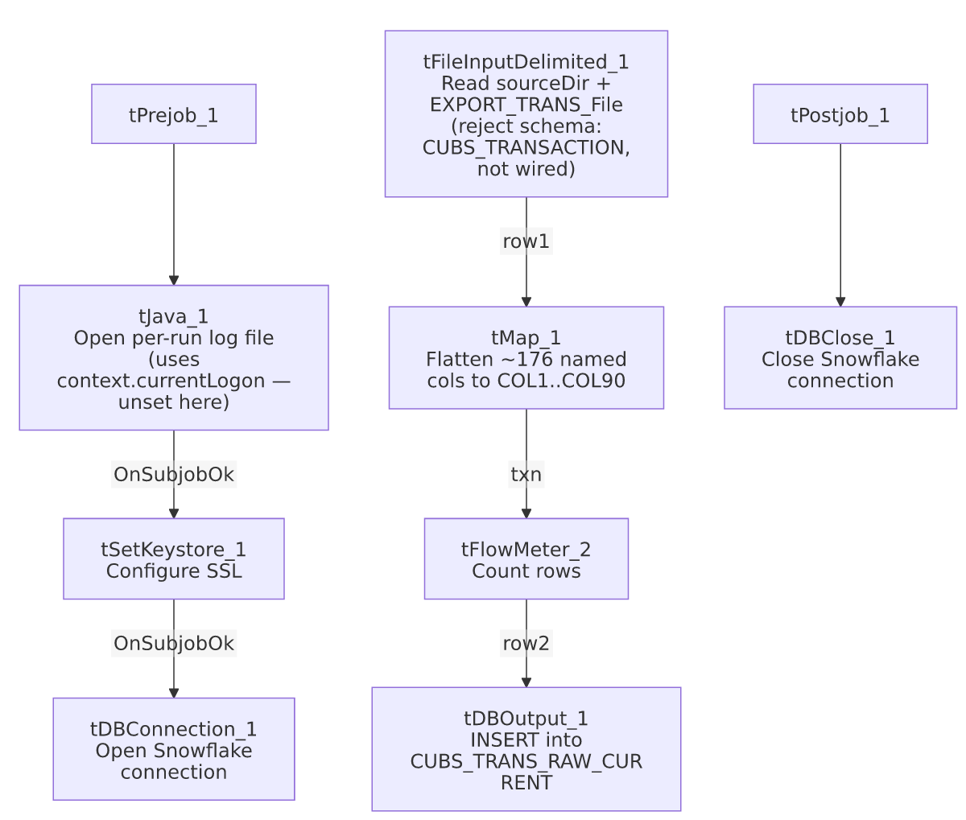

Settings tables

Source: `tFileInputDelimited_1`
Setting | Value | What it means
FILENAME | context.sourceDir + context.EXPORT_TRANS_File | Single fixed file, not a directory iteration — contrasts with the CUBS_Raw_<Site>_ETL_Load family's tFileList loop.
FIELDSEPARATOR / ROWSEPARATOR / HEADER / ENCODING | All driven by context.EXPORT_TRANS_FieldSeparator / RowSeparator / Header / Encoding | Fully context-driven format, unlike most other file-load jobs in this project which hardcode these settings. Per _shared_context.json's default values: \t field separator, \n row separator, 1 header row, US-ASCII encoding.
SCHEMA (main) | Not a repository reference — 176 named columns supplied inline (e.g. _LOGON, _TRANS_ID, _DEBTOR, _TCODE, _TRANS_AMT, _TRANS_DATE, _STATUS, _CLIENT, _LTR_ID, CAMPID, TRANS_REF_ID, REV_TRANS_ID, CANC_ROUTINE, plus errorCode/errorMessage).
SCHEMA_REJECT | Repository schema "...- CUBS_TRANSACTION" | Correctly named for this job (unlike ADP_Payroll_Load's mismatched reject schema) — but see Issues observed regarding it not being wired to anywhere.
DIE_ON_ERROR | false | Malformed rows don't fail the job...
Reject flow | Not wired | ...but no connection carries rejected rows anywhere — silently dropped, same pattern seen project-wide.
TEMP_DIR | "C:/Talend-Studio-20211109_1610-V8.0.1/workspace" | Hardcoded developer-workstation path — see Dependencies & configuration.

Target: `tDBOutput_1` (`tSnowflakeOutput`)
Setting | Value | What it means
Table | CUBS_TRANS_RAW_CURRENT | Destination raw landing table.
Output action | INSERT | Appends rows; no truncate step precedes it in this job.
Table action | NONE | Table structure is not altered by this job.

`tSetKeystore_1`
Setting | Value | What it means
SSL_KEYSTORE | context.keystorePath | Client keystore path is externalized to context.
SSL_TRUSTSERVER_TRUSTSTORE | "C:/clientTrustStore.trustStore" | Hardcoded truststore path — not context-driven, unlike the keystore itself.
SSL_TRUSTSERVER_PASSWORD / SSL_KEYSTORE_PASSWORD / NEED_CLIENT_AUTH | ***REDACTED*** | Preserved as redacted; real values not present in extracted metadata.

Dependencies & configuration
- Triggers/depends on other jobs: runjob_targets is empty — this job does not call any other job via tRunJob.
- Called by: CO_Master_Load (1 call), per 06_dependency_matrix.md — CO_Master_Load runs this job as the start of its Branch B ("transactions") chain, and after it succeeds, calls STAGING.MERGE_INTO_CUBS_TRANS_RAW() and then STAGING.MERGE_INTO_FACTTRANS() against the table this job just loaded (note the merge procedure name MERGE_INTO_CUBS_TRANS_RAW vs. this job's actual target table CUBS_TRANS_RAW_CURRENT — a naming variation, not necessarily a mismatch, but worth confirming both refer to the same table).
- Context variables used: EXPORT_TRANS_Encoding, EXPORT_TRANS_FieldSeparator, EXPORT_TRANS_File, EXPORT_TRANS_Header, EXPORT_TRANS_RowSeparator (from the EXPORT_TRANS_0.1 context group — used by 14 jobs project-wide per 06_dependency_matrix.md), currentLogon (referenced in the log-file name but not set anywhere in this job's own components — see Issues observed), keystorePath, logDir, sourceDir (from StandardFolders_0.1).
- 2 hardcoded developer-workstation paths (tFileInputDelimited_1.TEMP_DIR, tSetKeystore_1.SSL_TRUSTSERVER_TRUSTSTORE) — same project-wide portability risk documented in 05_operational_runbook.md.

Glossary
Component type | Plain-English meaning
tPrejob / tPostjob | Talend's guaranteed-first / guaranteed-last subjobs for setup and teardown.
tJava | Runs a block of custom Java code once.
tFileInputDelimited | Reads a delimited (CSV/TSV-style) text file according to a schema.
tMap | Maps/transforms columns from one schema to another.
tFlowMeter | Counts rows passing through a point in the flow, for logging/monitoring.
tSnowflakeOutput / tSnowflakeConnection / tSnowflakeClose | Write rows to a Snowflake table / open and close the Snowflake connection used throughout the job.
tSetKeystore | Configures SSL client keystore/truststore settings ahead of an encrypted database connection.

Issues observed
- The tMap output (90 generic `COL` slots plus `FILENAME`/`FILEDATE`) is narrower than the ~176 named source columns read by `tFileInputDelimited_1`. This is the opposite situation from the CUBS_Raw_<Site>_ETL_Load family, where the target has *more* COL slots (80) than named source columns (~62), leaving room for everything. Here, if tMap_1 maps source columns to COL1...COL90 positionally in source-column order, roughly 86 named source columns (out of ~176) would never reach CUBS_TRANS_RAW_CURRENT at all. This job's own metadata does not capture the actual per-column mapping expressions inside tMap_1, so it is unable to determine from this metadata whether the drop is intentional (e.g., only the first 90 columns are business-relevant and the rest are legacy/unused) or an oversight that silently discards real transaction data every run. This should be verified directly in Talend Studio by inspecting tMap_1's column mappings before assuming it's safe.
- `context.currentLogon` is referenced in `tJava_1`'s log-filename expression but is never set anywhere in this job's own components. Since this job is called by CO_Master_Load with TRANSMIT_ORIGINAL_CONTEXT=true (per job_CO_Master_Load.md), the value must be supplied by the caller or a scheduler-level default — unable to confirm its value or whether it's ever actually populated from this job's own metadata alone.
- No reject flow is wired from `tFileInputDelimited_1`, despite a correctly-named CUBS_TRANSACTION reject schema being configured. DIE_ON_ERROR=false means malformed rows don't fail the job, but they are also not written anywhere (no file, log, or table) — silently dropped with no record of how many, or which, transaction rows failed to parse.
- This job's `created_date`/`modified_date` fields are empty in the extracted metadata, unlike every other job documented in this batch. Unable to determine the job's actual creation/modification history from this metadata; verify directly in the Talend repository.
- The `EXPORT_TRANS_File` context variable's default value in `_shared_context.json` is a specific, date-stamped, HH-site path (Z:/EDW/2021-11-27/HH/HH-EDW-EXPORT-TRANS.txt), even though this job (per its lack of a site suffix, unlike the CUBS_Raw_<Site>_ETL_Load family) appears intended to be reusable across runs/sites via context override. Whether this default is a stale placeholder left over from initial development, or an environment-specific default that's always overridden before a real run, is unable to determine from metadata — worth confirming this value is never accidentally used in production.
- No `tRunJob` calls out of this job, and it is only called from one place (CO_Master_Load) in the entire 289-job project per 06_dependency_matrix.md — if any of the other five site codes (CHI, DC, HH, PRE, TOL) need their own transaction load, this job alone doesn't show how that happens; consistent with the broader "only CO has a _Master_Load orchestrator" gap already flagged in 05_operational_runbook.md.

