Talend Job: CUBS_Raw_Trans_Load_Special

Overview
This is a self-contained variant of CUBS_Raw_Trans_Load: it truncates the Snowflake CUBS_TRANS_RAW_CURRENT table, loads every transaction export file found in context.sourceDir (rather than one fixed file), and then — unlike the base job, which leaves merging to its caller (CO_Master_Load) — calls both STAGING.MERGE_INTO_CUBS_TRANS_RAW() and STAGING.MERGE_INTO_FACTTRANS() itself, dying or warning based on the final merge's result. It follows the classic truncate-load-merge pattern used elsewhere in this project (e.g. ADP_Payroll_Load), whereas the base CUBS_Raw_Trans_Load does not truncate or merge on its own at all. Per 06_dependency_matrix.md, this job is not called by, and does not call, any other job in this project — it appears to run standalone, likely on its own schedule, as an alternate path for loading transaction data.

Detail table
Field | Value
Job name | CUBS_Raw_Trans_Load_Special
Version | 0.1
Project | EDW2SF
Author | jmach@harriscollect.com
Created | Unable to determine from metadata — not present in job JSON (same gap as sibling CUBS_Raw_Trans_Load).
Last Modified | Unable to determine from metadata — not present in job JSON (same gap as sibling CUBS_Raw_Trans_Load).

Step-by-step data flow
This job starts two independent top-level subjobs (no explicit trigger connects them to each other), per Talend's default parallel-subjob-start semantics:
Subjob A — setup: tPrejob_1 → tJava_1 (OnComponentOk) opens a per-run log file at context.logDir + context.currentLogon + "_" + jobName + "_" + <timestamp> + ".log" (again referencing context.currentLogon, not set anywhere in this job — see Issues observed) → tDBConnection_1 (OnComponentOk) opens the Snowflake connection. There is no explicit trigger link from this subjob to Subjob B below — see Issues observed regarding a possible race condition.
Subjob B — truncate, load, merge:
- tDBRow_1 runs TRUNCATE TABLE CUBS_TRANS_RAW_CURRENT; with no incoming trigger of its own — it is the second independent top-level entry point.
- On success (OnSubjobOk), tFileList_1 lists files in context.sourceDir (no explicit sort — ORDER_BY_NOTHING=true; an EXCLUDEFILEMASK of *.txt is configured but IFEXCLUDE=false, so it's never applied, same unapplied-mask pattern as elsewhere in this project).
- For each file (Iterate), tJava_2 sets context.EXPORT_TRANS_File to the current file name — reusing the same context variable the base CUBS_Raw_Trans_Load job uses for its one fixed file, but here overwritten once per loop iteration.
- tFileInputDelimited_1 (Iterate) reads context.sourceDir + context.EXPORT_TRANS_File using the EXPORT_TRANS_* context-driven format settings (same as the base job). DIE_ON_ERROR=false; a SCHEMA_REJECT of repository schema "...- CUBS_TRANSACTION" is configured but not wired to any reject flow.
- tMap_1 (row1, FLOW) re-maps the source row positionally onto FILENAME, FILEDATE, COL1...COL90 (92 columns).
- tFlowMeter_2 (txn, FLOW) counts rows passing through (label left at default "MyLabel").
- tDBOutput_1 (row2, FLOW) inserts rows into Snowflake CUBS_TRANS_RAW_CURRENT (INSERT, tableAction=NONE).
- Once every file has been processed (tFileList_1's OnSubjobOk), tDBRow_2 runs CALL STAGING.MERGE_INTO_CUBS_TRANS_RAW().
- On success, tDBRow_3 runs CALL STAGING.MERGE_INTO_FACTTRANS();.
- tJavaRow_1 reads its RETVALUE into context.rowCount.
- Two ordered RUN_IF branches follow: tWarn_1 ("<rowCount> rows added to FACTTRANS", a warning, order 1) or tDie_1 ("<rowCount>: an error occurred during MERGE", exit code = context.rowCount, order 2) — the branch conditions themselves aren't captured in this metadata, but the message wording and component types make the success/failure intent clear.
No file archive or delete step exists anywhere in this job — processed files remain in context.sourceDir after the run (see Issues observed).
Teardown subjob: tPostjob_1 → tDBClose_1 (OnComponentOk) closes the Snowflake connection.
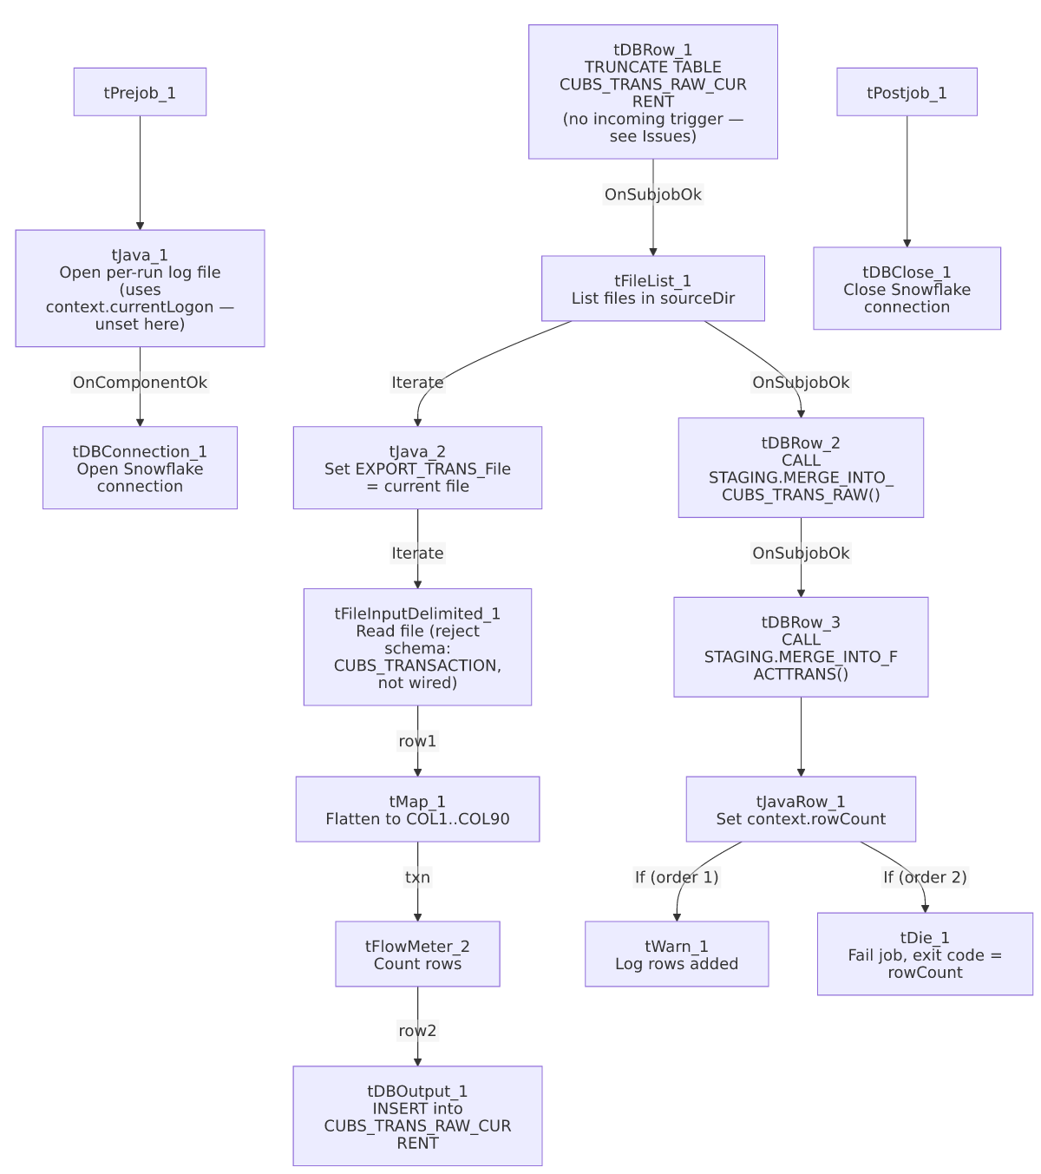

Settings tables

Source: `tFileInputDelimited_1`
Setting | Value | What it means
FILENAME | context.sourceDir + context.EXPORT_TRANS_File | context.EXPORT_TRANS_File is overwritten per file by tJava_2, so this reads a different file on each loop iteration — contrast with the base CUBS_Raw_Trans_Load, which reads one fixed file per run.
FIELDSEPARATOR / ROWSEPARATOR / HEADER / ENCODING | All from context.EXPORT_TRANS_* | Same context-driven format settings as the base job.
SCHEMA (main) | Inline (not repository) — 174 named business columns + errorCode/errorMessage | Missing `CANC_ROUTINE` compared to the base CUBS_Raw_Trans_Load job's otherwise identical 176-column schema — see Issues observed.
SCHEMA_REJECT | Repository schema "...- CUBS_TRANSACTION" (same GUID as base job) | Correctly named, but not wired to a reject flow.
DIE_ON_ERROR | false | Malformed rows don't fail the job...
Reject flow | Not wired | ...but rejected rows are silently dropped, same as the base job.
TEMP_DIR | "C:/Talend-Studio-20211109_1610-V8.0.1/workspace" | Hardcoded developer-workstation path.

`tFileList_1`
Setting | Value | What it means
DIRECTORY | context.sourceDir | Same shared source directory as many other jobs.
ORDER_BY_NOTHING | true | Files are processed in whatever order the filesystem returns them — no explicit sort by name/date, unlike the CUBS_Raw_<Site>_ETL_Load family's modified-date-ascending order.
EXCLUDEFILEMASK / IFEXCLUDE | "*.txt" / false | Exclusion configured but never applied — every file in the directory is picked up, same unapplied-mask pattern flagged elsewhere in this project.

Truncate & merge steps: `tDBRow_1` / `tDBRow_2` / `tDBRow_3`
Setting | Value | What it means
tDBRow_1 query | TRUNCATE TABLE CUBS_TRANS_RAW_CURRENT; | Clears the raw landing table before reloading — a step the base CUBS_Raw_Trans_Load job does not perform itself.
tDBRow_2 query | CALL STAGING.MERGE_INTO_CUBS_TRANS_RAW() | Same procedure name CO_Master_Load calls after running the base CUBS_Raw_Trans_Load — here it's invoked from inside this job instead.
tDBRow_3 query | CALL STAGING.MERGE_INTO_FACTTRANS(); | Merges into the FACTTRANS fact table; RETVALUE is captured into context.rowCount and drives the final warn/die branch.

Target: `tDBOutput_1` (`tSnowflakeOutput`)
Setting | Value | What it means
Table | CUBS_TRANS_RAW_CURRENT | Same destination table as the base CUBS_Raw_Trans_Load job.
Output action / Table action | INSERT / NONE | Appends rows; relies on the preceding TRUNCATE (step 1) to prevent duplicate accumulation, unlike the base job which has no truncate at all.

Result handling: `tJavaRow_1` / `tWarn_1` / `tDie_1`
Setting | Value | What it means
tJavaRow_1 | context.rowCount = input_row.RETVALUE; | Captures the FACTTRANS merge's return value.
tWarn_1 | context.rowCount + " rows added to FACTTRANS" (severity code 42) | Logged on the success branch — a warning, not a failure signal on its own.
tDie_1 | context.rowCount + ": an error occurred during MERGE", exit code = context.rowCount.intValue(), EXIT_JVM=false | On the failure branch, this does fail the job (unlike CO_Master_Load's equivalent FACTTRANS-merge check, which only warns) — see 05_operational_runbook.md, which lists this job among the 16 with explicit tDie/tWarn merge-result logic.

Dependencies & configuration
- Triggers/depends on other jobs: runjob_targets is empty — this job does not call any other job via tRunJob.
- Called by: none found in 06_dependency_matrix.md — unlike its sibling CUBS_Raw_Trans_Load (called once by CO_Master_Load), this job does not appear in the project's tRunJob orchestration graph at all. It likely runs on its own independent schedule outside the CO_Master_Load pipeline — unable to confirm from metadata; verify with the team.
- Context variables used: EXPORT_TRANS_Encoding, EXPORT_TRANS_FieldSeparator, EXPORT_TRANS_File (here reassigned per loop iteration, not read from its context-group default), EXPORT_TRANS_Header, EXPORT_TRANS_RowSeparator, currentLogon (referenced but not set in this job), logDir, rowCount (set internally from the merge result), sourceDir.
- 1 hardcoded developer-workstation path (tFileInputDelimited_1.TEMP_DIR) — same project-wide portability risk documented in 05_operational_runbook.md.

Glossary
Component type | Plain-English meaning
tPrejob / tPostjob | Talend's guaranteed-first / guaranteed-last subjobs for setup and teardown.
tJava / tJavaRow | Run custom Java code once, or once per input row.
tFileList | Lists files in a directory for the job to iterate over one at a time.
tFileInputDelimited | Reads a delimited (CSV/TSV-style) text file according to a schema.
tMap | Maps/transforms columns from one schema to another.
tFlowMeter | Counts rows passing through a point in the flow, for logging/monitoring.
tSnowflakeOutput / tSnowflakeRow / tSnowflakeConnection / tSnowflakeClose | Write rows to a Snowflake table / run an arbitrary SQL statement or stored-procedure call / open and close the Snowflake connection.
tDie / tWarn | End the job with a specific failure message and exit code (tDie), or log a warning without stopping the job (tWarn).

Issues observed
- The truncate-and-load subjob (`tDBRow_1` → `tFileList_1` → ...) has no explicit trigger connection from the setup subjob that opens the Snowflake connection (`tDBConnection_1`). Both start as independent top-level subjobs per this job's own wiring. If Talend's runtime doesn't otherwise guarantee the connection is established before tDBRow_1's TRUNCATE executes, there's a theoretical race condition on startup — unable to determine from this metadata whether Talend's shared-connection component model prevents this in practice; verify directly in Talend Studio.
- This job's input schema is missing the `CANC_ROUTINE` column that the otherwise-identical base CUBS_Raw_Trans_Load job's schema includes (both jobs reference the same CUBS_TRANSACTION reject-schema GUID, and every other business column matches). Whether the real "special" source files genuinely lack this column, or the schema here is simply out of sync with the base job's, is unable to determine from metadata — verify with the team, since a source file that *does* include CANC_ROUTINE would shift all subsequent columns by one position in this job's positional tMap_1.
- No file archive or delete step anywhere in this job. Every other file-processing job in this project's documented set (ADP_Payroll_Load, CUBS_Raw_CO_ETL_Load, CUBS_Raw_TOL_ETL_Load) either zips-and-deletes or deletes the source file after a successful load; this job does neither. Combined with ORDER_BY_NOTHING (no defined processing order) and no incremental filtering, rerunning this job would truncate the table and reprocess every file still sitting in context.sourceDir, including ones already loaded in a prior run — unless something outside this job's own metadata (e.g., an external process) moves or deletes files after they're picked up. Verify with the team before assuming reruns are safe or idempotent.
- `context.currentLogon` is referenced in the log-filename expression but never set anywhere in this job, same gap as the base CUBS_Raw_Trans_Load job.
- No reject flow wired from `tFileInputDelimited_1` despite the correctly-named CUBS_TRANSACTION reject schema — malformed rows are silently dropped with no record, same pattern as the base job.
- This job overlaps significantly in purpose with `CUBS_Raw_Trans_Load` + `CO_Master_Load`'s post-load merge steps, but is not wired into that orchestration at all (06_dependency_matrix.md shows no caller). Whether this job is a deprecated predecessor, an intentional alternate/ad-hoc path (e.g. for a manual reload of multiple files at once), or a currently-scheduled parallel process to CO_Master_Load's transaction chain is unable to determine from metadata — worth confirming with the team, since if both jobs' schedules ever overlap and target the same CUBS_TRANS_RAW_CURRENT table, one job's TRUNCATE could wipe out data the other is mid-way through loading.

