Talend Job: CallDetail_40_Load_History

Overview
Loads call-detail records (campaign, site, call timing, i3_identity, agent/logon and debtor-linkage fields) from the I3 telephony system's i3_CallDetail_40 MSSQL table into the Snowflake I3_CALLDETAIL_40 table — the same source and target tables used by i3_CallDetail_40_Load, but this job has no incremental max-key check, no tWarn/tDie logic, and only Talend's built-in statistics/flow-meter catchers alongside the main flow. Its name ("_History") and the absence of any incremental filtering logic strongly suggest this is a one-time or occasional full-table backfill/history load, run separately from the ongoing incremental i3_CallDetail_40_Load job — but since both write to the identical target table with a plain INSERT and no truncate, running both against overlapping data would duplicate rows (see Issues observed).

Detail table
Field | Value
Job name | CallDetail_40_Load_History
Version | 0.1
Project | EDW2SF
Author | jmach@harriscollect.com
Created | 2022-01-24T09:53:10.617-0800
Last Modified | 2025-09-24T10:59:47.477-0700

Step-by-step data flow
Setup subjob: tPrejob_1 → tDBConnection_1 (OnComponentOk) opens the Snowflake connection → tDBConnection_2 (OnComponentOk) opens the MSSQL connection to context.EDWProdHH_Server/Port/Schema/Database/Login (password redacted; same EDWProdHH_* context-variable naming used by i3_CallDetail_40_Load, even though this reads I3 telephony data, not EDWProdHH data — see that job's own Issues observed for the same naming question).
Main subjob (no incoming trigger from the setup chain, so it runs as an independent top-level subjob alongside setup):
- tDBInput_2 (reusing the shared tDBConnection_2) runs a fixed SELECT against table i3_CallDetail_40, pulling 53 named columns (campaign name, site ID, i3_identity, call timing fields, agent/debtor logon-linkage columns LogOn_New/DimLogOn_New/ClientNumber_New/LogOn_O/DimLogOn_O/ClientNumber_O, PACKET, PRIMY_DEBTOR_NUMBER, etc.). The captured query text is truncated in this metadata after the first several columns, so the full column list and any WHERE clause are not fully visible — no max-key or date-range filter is visible in the captured portion, and there is no preceding max-key lookup component in this job (unlike i3_CallDetail_40_Load's tDBInput_1/tJavaRow_1 pair) — see Issues observed.
- tMap_1 passes the 53 source columns through to a same-shaped, uppercase-named target schema.
- tFlowMeter_3 counts rows passing through (label left at the default "MyLabel"; TSTATCATCHER_STATS enabled, feeding the job's stats/log-catcher components).
- tDBOutput_1 inserts the rows into Snowflake table I3_CALLDETAIL_40 (INSERT, tableAction=NONE — no truncate/recreate).
Separately, tStatCatcher_1 and tFlowMeterCatcher_1 (Talend's built-in job-statistics/flow-meter catchers) feed tLogRow_1/tLogRow_2, which print job statistics and flow-meter counts to the log — these run automatically alongside the main flow and aren't part of the business data path.
Teardown subjob: tPostjob_1 → tDBClose_1 (close Snowflake) → tDBClose_2 (close MSSQL).
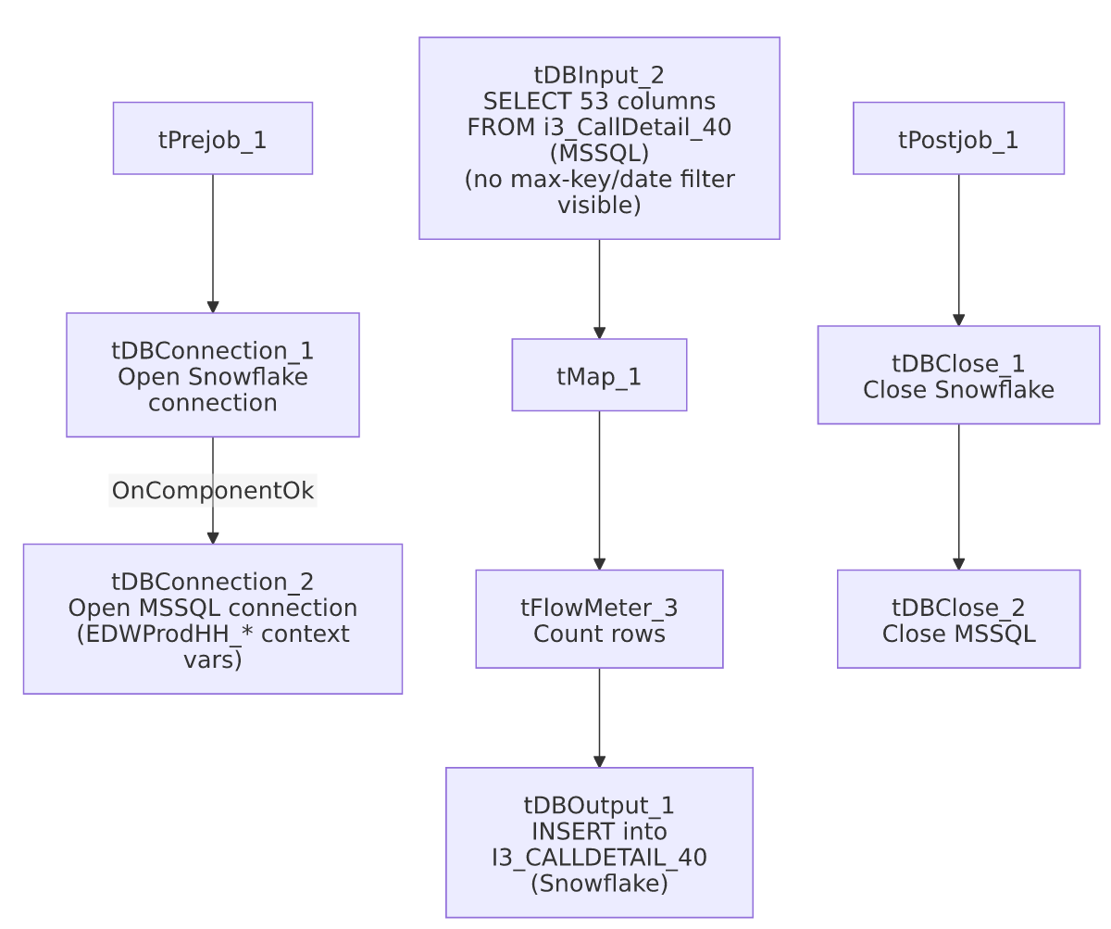

Settings tables

Source: `tDBInput_2` (`tMSSqlInput`)
Setting | Value | What it means
Connection | Shared tDBConnection_2 (USE_EXISTING_CONNECTION=true) | Reuses the job's single MSSQL connection rather than opening a new one.
Table | i3_CallDetail_40 | Same source table read by i3_CallDetail_40_Load.
Query | Fixed SELECT of 53 named columns (call timing, i3_identity, logon/debtor-linkage fields, etc.), with two columns explicitly CAST(... AS numeric(38,0)) | The captured query text is truncated after the visible column list — no WHERE clause is visible in this metadata; see Issues observed.

Target: `tDBOutput_1` (`tSnowflakeOutput`)
Setting | Value | What it means
Table | I3_CALLDETAIL_40 | Same destination table as i3_CallDetail_40_Load — see Issues observed regarding the shared-table/no-truncate risk.
Output action | INSERT | Appends rows — there is no TRUNCATE/staging step in this job.
Table action | NONE | Table is not recreated/altered by this job.

Dependencies & configuration
- Triggers/depends on other jobs: none — runjob_targets is empty, no tRunJob links found.
- Called by: none found in 06_dependency_matrix.md — this job does not appear as a target of any tRunJob link in the project, consistent with it being a standalone/manually-run backfill rather than part of a scheduled orchestration chain.
- Context variables used: EDWProdHH_Server, EDWProdHH_Port, EDWProdHH_Schema, EDWProdHH_Database, EDWProdHH_Login (MSSQL connection details — same naming-convention question flagged in i3_CallDetail_40_Load).
- No hardcoded developer-workstation paths found in this job.

Glossary
Component type | Plain-English meaning
tSnowflakeConnection / tSnowflakeClose | Open/close a Snowflake database connection shared by other components in the job.
tMSSqlConnection / tMSSqlInput / tMSSqlClose | Open a Microsoft SQL Server connection, run a query against it, and close it.
tSnowflakeOutput | Writes rows to a Snowflake table.
tMap | Maps/transforms columns from one schema to another.
tFlowMeter | Counts rows passing a point in the flow for logging/monitoring.
tStatCatcher / tFlowMeterCatcher / tLogRow | Talend's built-in job-statistics and flow-meter capture components, which print execution stats to the log; not part of the business data flow.

Issues observed
- This job and `i3_CallDetail_40_Load` write to the exact same Snowflake target table (`I3_CALLDETAIL_40`) from the exact same MSSQL source table (`i3_CallDetail_40`), both with a plain `INSERT` and no truncate step. If this job is meant as a one-time historical backfill, that's a reasonable design as long as it's run before the incremental job starts (or the incremental job's max-key filter — itself unconfirmed, see i3_CallDetail_40_Load's own Issues observed — genuinely excludes already-loaded rows). If both jobs are ever run against overlapping data (e.g., this history job re-run after the incremental job has already loaded recent data, or vice versa), rows would be duplicated in I3_CALLDETAIL_40 with no dedup mechanism visible in either job's metadata. Unable to confirm the intended run order or frequency from metadata alone — verify with the team.
- No `WHERE` clause is visible in the captured `QUERY` text, and unlike i3_CallDetail_40_Load, this job has no preceding max-key lookup or any other filtering logic at all — consistent with a full-table historical pull, but also meaning every run (if repeated) would reload the entire i3_CallDetail_40 source table. Unable to confirm from metadata whether this job is intended to run only once ("history" backfill) or is scheduled to run repeatedly; if the latter, it would produce full duplicate reloads every time.
- No `tWarn`/`tDie`/`tSendMail` logic — a load failure here would only surface as a generic Talend execution error, with no job-specific message to distinguish it in a shared log, and it is not among the 12 email-alerting or 16 explicit-tDie/tWarn jobs listed in 05_operational_runbook.md.
- Not referenced anywhere in the project's `tRunJob` orchestration graph (06_dependency_matrix.md) — how and when this job is actually triggered (manual run, a scheduler entry outside this metadata, or a one-time historical load that's no longer run at all) is unable to determine from metadata; verify with the team.

