Talend Job: Call_Campaign_Results_Extract

Overview
This is a small, single-pass reporting extract: it queries a Snowflake table of call-campaign performance results (call date/hour, campaign name, call direction, CRC type/description, wrapup code, and aggregate counts of calls, connects, right-party-contacts, and promises) and writes the result straight to a CSV file for downstream consumption. Unlike most jobs in this project, it has no tPrejob/tPostjob, no explicit database-connection-open/close pair, and no tMap — it's a direct query-to-file passthrough with only 3 components total.

Detail table
Field | Value
Job name | Call_Campaign_Results_Extract
Version | 0.1
Project | EDW2SF
Author | jmach@harriscollect.com
Created | 2023-08-22T15:55:40.993-0700
Last Modified | 2025-11-12T06:51:25.242-0800

Step-by-step data flow
- tSetKeystore_1 configures SSL trust/keystore settings from context.keystorePath (passwords redacted).
- On success (OnSubjobOk), tDBInput_1 (a tSnowflakeInput, with no visible connection-opening component of its own in this job — see Issues observed) runs a fixed SELECT of 14 columns from EDWPRODHH.PUB_MBOICH.CALL_CAMPAIGNS_RESULTS.
- tFileOutputDelimited_1 (MAIN, row1) writes the result directly to context.outputDir + "qry_call_campaign_results.csv" — comma-delimited, header row included, no tMap in between (schema flows straight through).
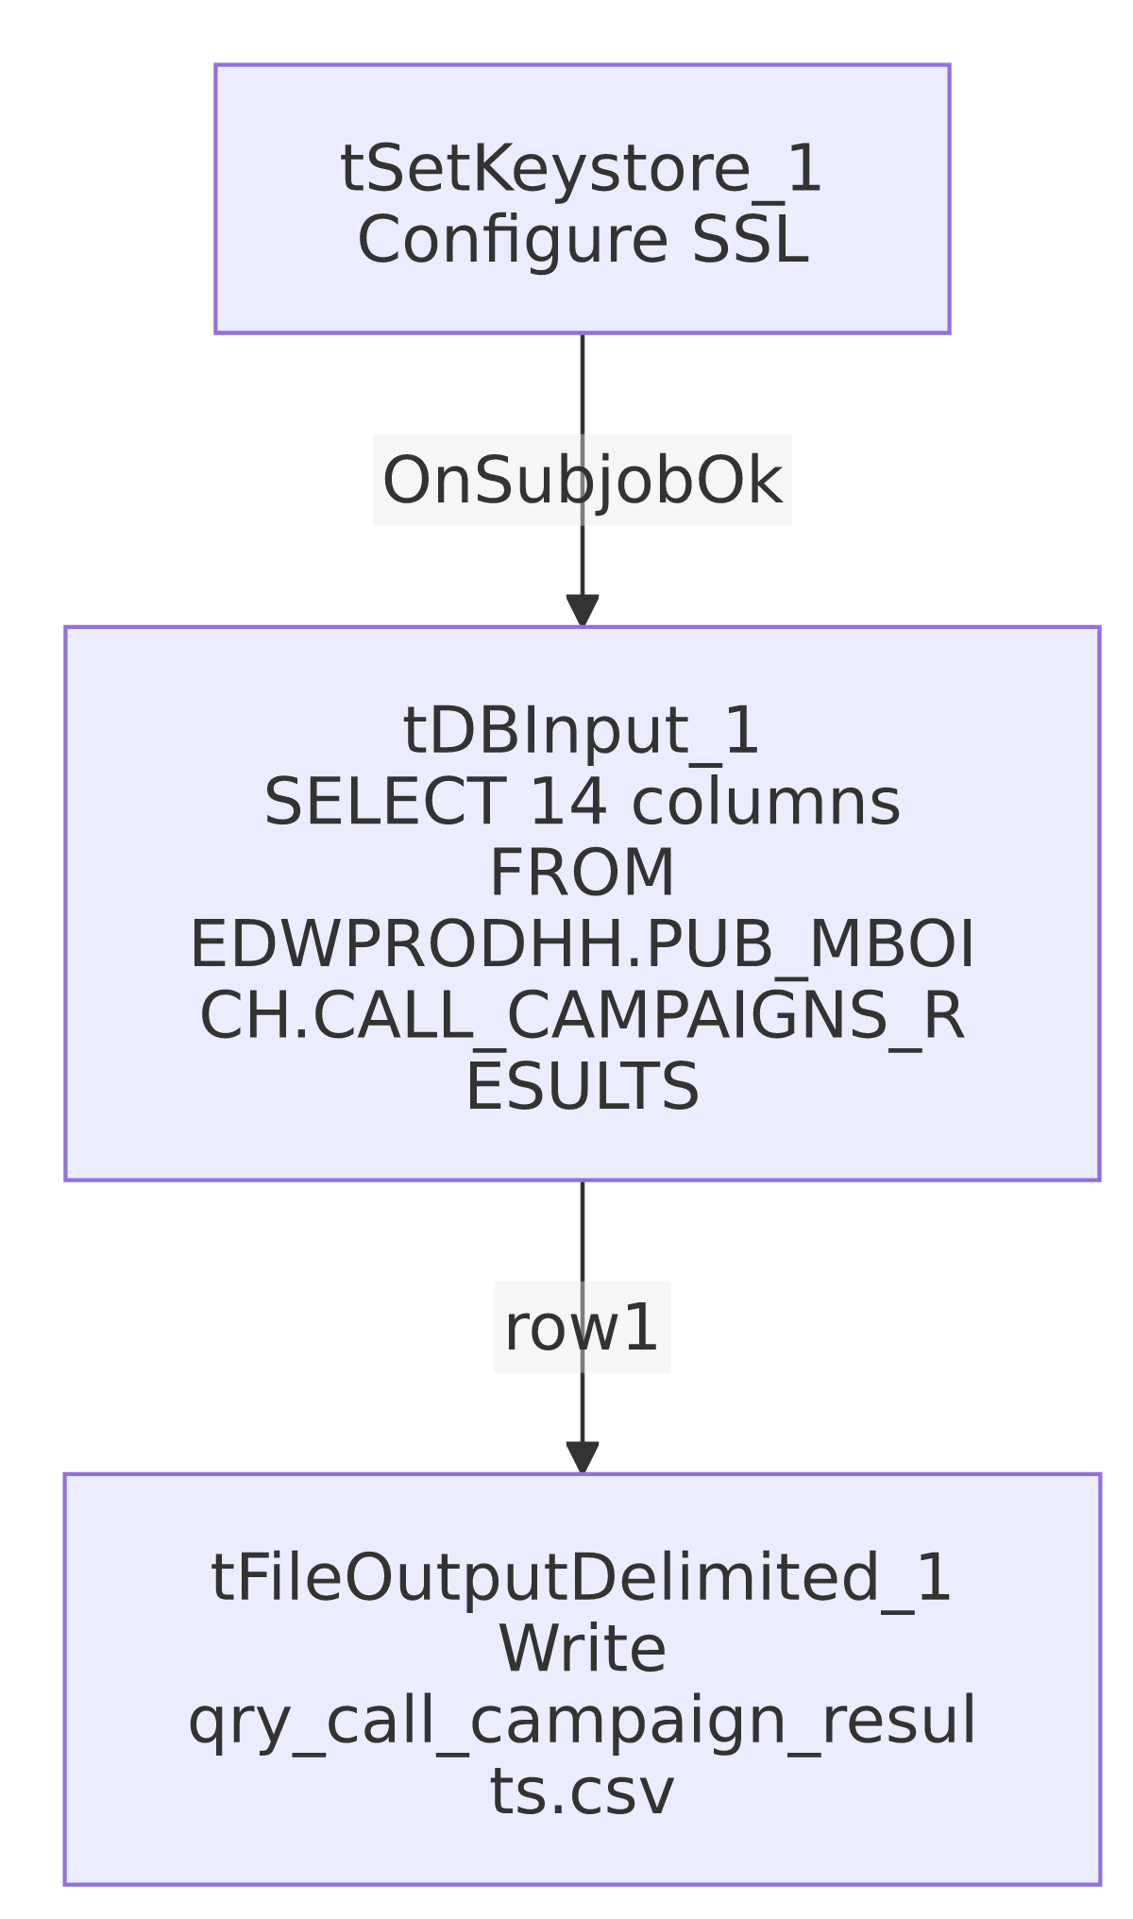

Settings tables

Source: `tDBInput_1` (`tSnowflakeInput`)
Setting | Value | What it means
Query | SELECT CALL_DATE, CALL_HOUR, SHORT_DESCRIPTION, CAMPAIGNNAME, PL_GROUP, CALLDIRECTION, AGE_FROM_MAX_PACKET_LIST_DATE_CATEGORY, CRCTYPE, WRAPUP_CODE, CRCDESCRIPTION, N_CALLS, CONNECTS, RPCS, PROMISES FROM EDWPRODHH.PUB_MBOICH.CALL_CAMPAIGNS_RESULTS; | Reads from a Snowflake database named EDWPRODHH and a schema PUB_MBOICH — a "publish"-style schema whose name looks individually owned (initials-style, similar to PUB_JCHANG flagged in 01_system_architecture.md), not one of the project's documented shared publish schemas (SF_PUB_LW).
Connection | Not captured in this job's own metadata (parameters is empty; no tDBConnection/keystore-linked connection component precedes it besides tSetKeystore_1) | Unable to determine from metadata which account/host this component actually connects with — see Issues observed.

Schema column naming vs. query column naming
Query column | Declared schema column | What it means
CALLDIRECTION | CALL_DIRECTION | Renamed in the schema relative to the source column name.
AGE_FROM_MAX_PACKET_LIST_DATE_CATEGORY | AGE_BRACKET | Renamed to a shorter, friendlier label.
CRCTYPE | CRC_TYPE | Renamed with an added underscore.
These renames work because the result set is bound to the schema positionally, not by name — but see Issues observed for the maintenance risk this creates.

Target: `tFileOutputDelimited_1`
Setting | Value | What it means
FILENAME | context.outputDir + "qry_call_campaign_results.csv" | Fixed output filename; no date-stamp in the name, so each run overwrites the previous file (APPEND=false).
FIELDSEPARATOR / INCLUDEHEADER | , / true | Standard comma-delimited CSV with a header row.
ENCODING | ISO-8859-15 | Latin-9 encoding.

Dependencies & configuration
- Triggers/depends on other jobs: runjob_targets is empty — this job does not call any other job via tRunJob.
- Called by: none found in 06_dependency_matrix.md — this job does not appear in the project's tRunJob orchestration graph.
- Context variables used: keystorePath, outputDir.
- 1 hardcoded developer-workstation path (tSetKeystore_1.SSL_TRUSTSERVER_TRUSTSTORE = "C:/clientTrustStore.trustStore") — same project-wide portability risk documented in 05_operational_runbook.md.

Glossary
Component type | Plain-English meaning
tSnowflakeInput | Runs a query against Snowflake and returns its result rows.
tFileOutputDelimited | Writes rows to a delimited (CSV-style) text file.
tSetKeystore | Configures SSL client keystore/truststore settings ahead of an encrypted database connection.

Issues observed
- No `tDBConnection`/`tDBClose` pair, and `tDBInput_1`'s own `parameters` are empty in this metadata. Every other Snowflake-reading job documented in this batch opens an explicit, named connection component (tDBConnection_1) before querying. Here, tDBInput_1 runs directly after tSetKeystore_1 with no visible connection-establishment step captured — either it opens its own inline connection whose settings simply weren't captured by this extraction, or it silently relies on some other project-level default. Unable to determine from metadata which Snowflake account/role this job actually authenticates as; verify directly in Talend Studio.
- The query reads from `EDWPRODHH.PUB_MBOICH` — a Snowflake database/schema pairing whose schema name (`PUB_MBOICH`) reads as an individual's initials, similar to the PUB_JCHANG connection flagged project-wide in 01_system_architecture.md and 06_dependency_matrix.md as looking individually owned rather than shared platform infrastructure. If this schema is tied to a specific person, this job (and its output file, ultimately used for reporting) could silently break if that person's account or schema access changes — worth confirming ownership with the team.
- Three schema columns are declared with different names than the SQL query's underlying column names (CALLDIRECTION→CALL_DIRECTION, AGE_FROM_MAX_PACKET_LIST_DATE_CATEGORY→AGE_BRACKET, CRCTYPE→CRC_TYPE). Since there's no tMap and the query has no explicit AS aliases for these three, the mapping from query result to schema is purely positional. This works today, but if the underlying CALL_CAMPAIGNS_RESULTS view/table's column order ever changes (even without a name change), this job would silently start writing the wrong values under the wrong column headers in the output CSV, with no error raised. Worth adding explicit AS aliases in the query, or a tMap, to make the mapping name-based and self-documenting.
- No error handling, row-count logging, or completion signal specific to this job's business outcome — no tWarn, tDie, or tSendMail. A query failure or empty result would only surface as a generic Talend execution error (or a silently near-empty CSV), consistent with the majority of jobs in this project per 05_operational_runbook.md.
- The output file has no date-stamp (qry_call_campaign_results.csv, APPEND=false), so each run overwrites the prior file entirely, with no historical copies retained by this job itself.

