Talend Job: Callminer_HH_Metadata_Daily_Extract

Overview
Another small, single-pass reporting extract, structurally identical to Call_Campaign_Results_Extract: it queries a Snowflake view of daily call-metadata records for the "HH" site (agent, call duration/timing, client/account/file numbers, placement balance and days-since-placement, location, campaign/queue names, and result/wrap-up codes — likely sourced from or feeding a Callminer call-recording/analytics integration, per the job name) and writes the result to a dated CSV file for downstream (likely Callminer) consumption. Like Call_Campaign_Results_Extract, it has no tPrejob/tPostjob, no explicit connection-open/close pair, and no tMap — a direct query-to-file passthrough with only 3 components total.

Detail table
Field | Value
Job name | Callminer_HH_Metadata_Daily_Extract
Version | 0.1
Project | EDW2SF
Author | jmach@harriscollect.com
Created | 2026-06-17T10:30:25.663-0700
Last Modified | 2026-06-17T15:53:22.208-0700

Step-by-step data flow
- tSetKeystore_1 configures SSL trust/keystore settings from context.keystorePath (passwords redacted).
- On success (OnSubjobOk), tDBInput_1 (a tSnowflakeInput, with no visible connection-opening component of its own in this job — see Issues observed) runs a fixed SELECT of 26 columns from EDWPRODHH.PUB_RREGMI.VIEW_CUBS_METADATA_DAILYEXPORT, with no WHERE clause visible in the query.
- tFileOutputDelimited_1 (MAIN, row1) writes the result directly to context.outputDir + "CUBs Metadata " + <date 3 days before run date, M.d.YY format> + " Data.csv" — comma-delimited, header row included, no tMap in between (schema flows straight through, column names matching exactly).
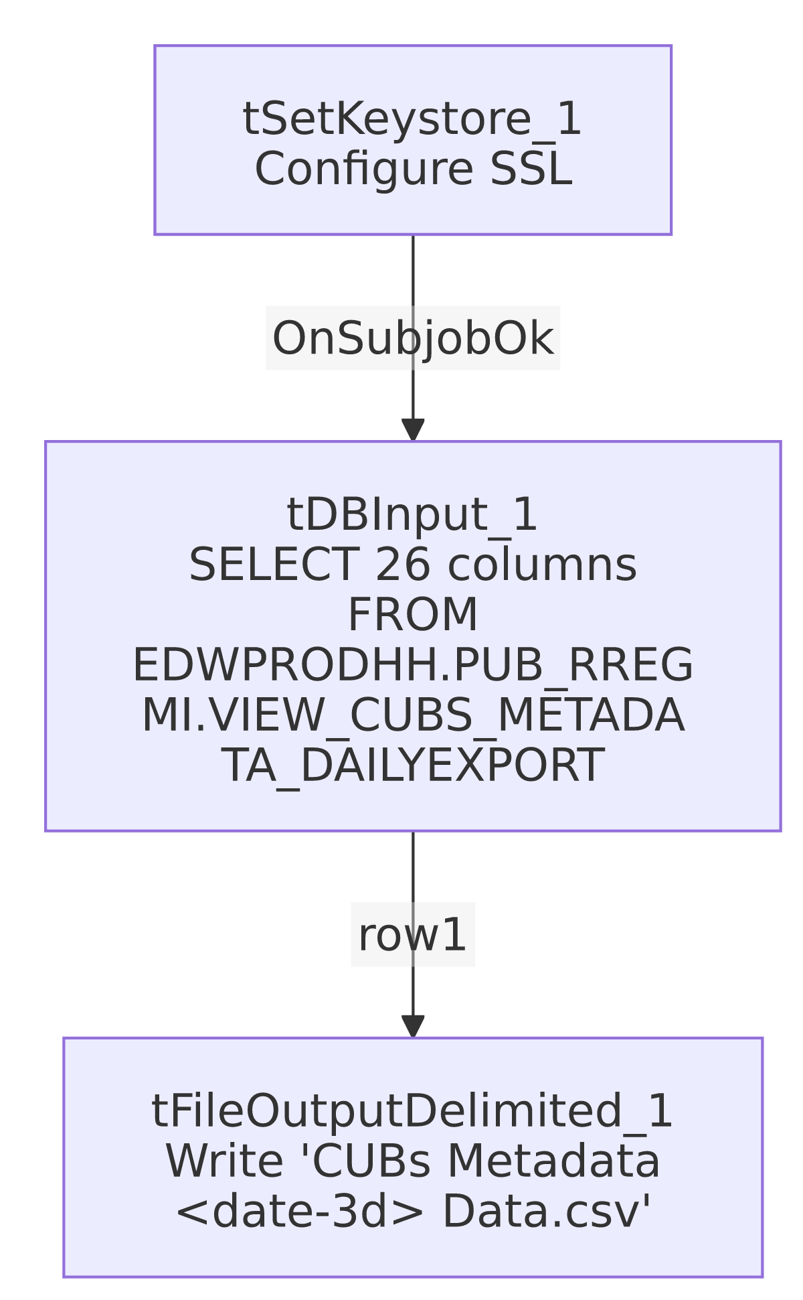

Settings tables

Source: `tDBInput_1` (`tSnowflakeInput`)
Setting | Value | What it means
Query | SELECT AGENTUSERNAME, HHCALLDURATION, CONNECTEDDATE, CONNECTEDDATETIME, CLIENTNUMBER, AGENTNAME, DEPT, DIRECTION, CITY, PLACEBALANCE, STATE, ACCOUNTNUMBER, PLACEDDATE, DAYSSINCEPLACEMENT, FILENUMBER, RPC, ZIP, RESULT, TEAMLEAD, CBRREPORTING, UNITMANAGER, CONVERSATIONID, CAMPAIGN, HHQUEUENAME, HHDIALERCAMPAIGNNAME, LATITUDERESULTCODE FROM EDWPRODHH.PUB_RREGMI.VIEW_CUBS_METADATA_DAILYEXPORT; | Reads a pre-built "daily export" view from Snowflake database EDWPRODHH, schema PUB_RREGMI — another individually-initialed-looking publish schema, same pattern flagged in Call_Campaign_Results_Extract for PUB_MBOICH and project-wide for PUB_JCHANG.
No WHERE clause | — | The query has no date filter of its own; whatever "daily" scoping happens must occur inside the VIEW_CUBS_METADATA_DAILYEXPORT view itself (not visible in this job's metadata) — see Issues observed.
Connection | Not captured in this job's own metadata (db has no connection fields; no tDBConnection precedes it besides tSetKeystore_1) | Same gap as Call_Campaign_Results_Extract — unable to determine which Snowflake account/role this job authenticates as.
Column naming | Query column names match declared schema column names exactly (no renames) | Unlike Call_Campaign_Results_Extract, there is no name mismatch here to flag.

Target: `tFileOutputDelimited_1`
Setting | Value | What it means
FILENAME | context.outputDir + "CUBs Metadata " + TalendDate.formatDate("M.d.YY", TalendDate.addDate(TalendDate.getCurrentDate(), -3, "dd")) + " Data.csv" | The output filename embeds a date 3 days before the job's actual run date (e.g. a run on day N produces a file labeled for day N-3), not the run date itself — see Issues observed.
FIELDSEPARATOR / INCLUDEHEADER | , / true | Standard comma-delimited CSV with a header row.
APPEND | false | Each run creates/overwrites a file for that computed date; since the filename is date-based, re-running on a different day produces a different file rather than overwriting yesterday's.
ENCODING | ISO-8859-15 | Latin-9 encoding.

Dependencies & configuration
- Triggers/depends on other jobs: runjob_targets is empty — this job does not call any other job via tRunJob.
- Called by: none found in 06_dependency_matrix.md — this job does not appear in the project's tRunJob orchestration graph.
- Context variables used: keystorePath, outputDir.
- 1 hardcoded developer-workstation path (tSetKeystore_1.SSL_TRUSTSERVER_TRUSTSTORE = "C:/clientTrustStore.trustStore") — same project-wide portability risk documented in 05_operational_runbook.md.

Glossary
Component type | Plain-English meaning
tSnowflakeInput | Runs a query against Snowflake and returns its result rows.
tFileOutputDelimited | Writes rows to a delimited (CSV-style) text file.
tSetKeystore | Configures SSL client keystore/truststore settings ahead of an encrypted database connection.

Issues observed
- The output filename is computed as "3 days before the run date," but the query itself has no date filter. The 3-day offset is baked into tFileOutputDelimited_1's filename expression only; whether VIEW_CUBS_METADATA_DAILYEXPORT (the Snowflake view being queried) independently filters its own rows to a matching 3-day-lagged window is not visible in this job's metadata. If the view's actual date logic ever drifts from this job's assumed 3-day lag (e.g., the view is changed to reflect a different lag, or no lag at all), the exported file's name would misrepresent the data it actually contains, with no validation in this job to catch the mismatch. Verify the view's definition directly in Snowflake.
- No `tDBConnection`/`tDBClose` pair, and `tDBInput_1`'s own connection settings are not captured in this metadata — same gap noted in Call_Campaign_Results_Extract; unable to determine which Snowflake account/role this job authenticates as from metadata alone.
- The query reads from `EDWPRODHH.PUB_RREGMI` — a schema name that reads as an individual's initials, the same individually-owned-looking pattern flagged for PUB_MBOICH (in Call_Campaign_Results_Extract) and PUB_JCHANG (project-wide, per 01_system_architecture.md). This job depends on that schema remaining available and correctly populated; if ownership of that schema changes, this daily extract could silently break or go stale with no one else aware of the dependency.
- No error handling, row-count logging, or completion signal specific to this job's business outcome — no tWarn, tDie, or tSendMail. A query failure, an empty result, or the view returning the wrong day's data would all produce a CSV with no warning, consistent with the majority of jobs in this project per 05_operational_runbook.md.
- Both `Callminer_HH_Metadata_Daily_Extract` and `Call_Campaign_Results_Extract` were created and (for this job) last modified on the same day, 2026-06-17 — both are very recent additions, and both share the identical minimal 3-component structure (tSetKeystore → tSnowflakeInput → tFileOutputDelimited), suggesting a reusable template for simple Snowflake-to-CSV reporting extracts in this project.

