Talend Job: City_of_Phi_C1A_PDR_Extract

Overview
A small, single-pass reporting extract for the City of Philadelphia partner, following the same minimal shape as Call_Campaign_Results_Extract and Callminer_HH_Metadata_Daily_Extract: it queries a Snowflake table of "C1A" letter print-date-request (PDR) records — print date, letter code/vendor, debtor number, and current/letter month-year fields — and writes the result to a tab-delimited text file. Both the source table name (CITY_OF_PHILADELPHIA_C1A_PDR_SAMPLE) and the output filename (City of Philadelphia C1A-PDR Sample.txt) explicitly include the word "Sample," which is worth confirming with the team (see Issues observed) before assuming this is the live production feed for this partner.

Detail table
Field | Value
Job name | City_of_Phi_C1A_PDR_Extract
Version | 0.1
Project | EDW2SF
Author | jmach@harriscollect.com
Created | 2025-01-06T11:09:13.608-0800
Last Modified | 2025-11-12T06:58:23.902-0800

Step-by-step data flow
- tSetKeystore_1 configures SSL trust/keystore settings from context.keystorePath (passwords redacted).
- On success (OnSubjobOk), tDBInput_1 (a tSnowflakeInput, with no visible connection-opening component of its own in this job) runs a fixed SELECT of 8 columns from CITY_OF_PHILADELPHIA_C1A_PDR_SAMPLE — no database/schema prefix, unlike the fully-qualified EDWPRODHH.PUB_<initials>.<table> pattern used by the other single-query extract jobs in this batch (see Issues observed).
- tFileOutputDelimited_1 (MAIN, row1) writes the result directly to context.outputDir + "City of Philadelphia C1A-PDR Sample.txt" — tab-delimited, header row included, no tMap in between.
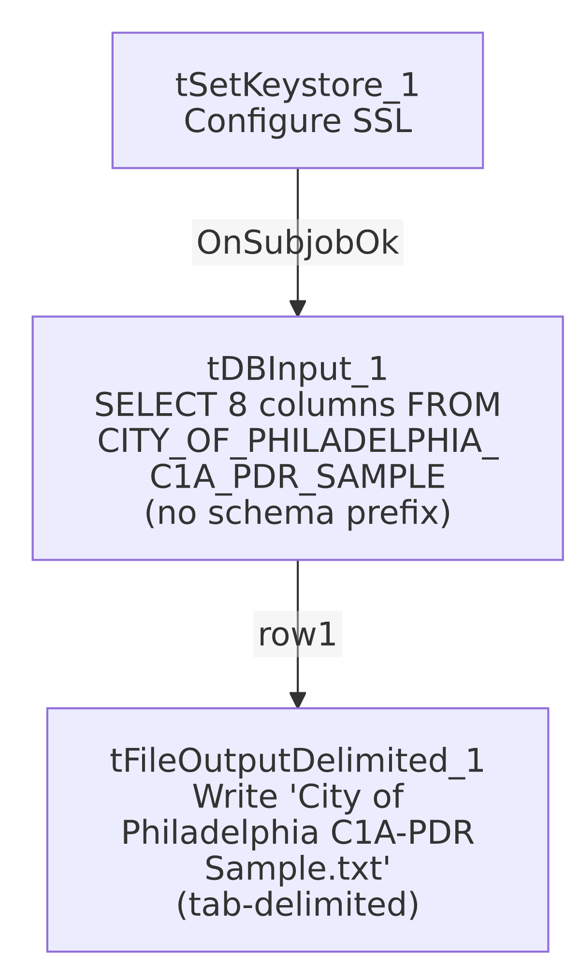

Settings tables

Source: `tDBInput_1` (`tSnowflakeInput`)
Setting | Value | What it means
Query | SELECT PRINT_DATE, LETTER_CODE, LETTER_VENDOR, DEBTORNUMBER, CURRENT_MONTH, CURRENT_YEAR, LETTER_MONTH, LETTER_YEAR FROM CITY_OF_PHILADELPHIA_C1A_PDR_SAMPLE; | Table name has no <database>.<schema>. qualifier, unlike this batch's other extract jobs — depends entirely on the Snowflake session's default database/schema context at run time. See Issues observed.
Connection | Not captured in this job's own metadata (no tDBConnection besides tSetKeystore_1) | Same pattern as the other simple extract jobs in this batch.

Target: `tFileOutputDelimited_1`
Setting | Value | What it means
FILENAME | context.outputDir + "City of Philadelphia C1A-PDR Sample.txt" | Fixed filename with no date-stamp; each run overwrites the previous file (APPEND=false).
FIELDSEPARATOR | \t (tab) | Tab-delimited, not comma — differs from Call_Campaign_Results_Extract/Carle_Asset_Scrub's comma-delimited CSV output.
INCLUDEHEADER | true | Header row included.
ENCODING | ISO-8859-15 | Latin-9 encoding.

Dependencies & configuration
- Triggers/depends on other jobs: runjob_targets is empty — this job does not call any other job via tRunJob.
- Called by: none found in 06_dependency_matrix.md — this job does not appear in the project's tRunJob orchestration graph.
- Context variables used: keystorePath, outputDir.
- 1 hardcoded developer-workstation path (tSetKeystore_1.SSL_TRUSTSERVER_TRUSTSTORE = "C:/clientTrustStore.trustStore") — same project-wide portability risk documented in 05_operational_runbook.md.

Glossary
Component type | Plain-English meaning
tSnowflakeInput | Runs a query against Snowflake and returns its result rows.
tFileOutputDelimited | Writes rows to a delimited (tab- or comma-style) text file.
tSetKeystore | Configures SSL client keystore/truststore settings ahead of an encrypted database connection.

Issues observed
- Both the source table name (`CITY_OF_PHILADELPHIA_C1A_PDR_SAMPLE`) and the output filename (`City of Philadelphia C1A-PDR Sample.txt`) contain the word "Sample." This job's own name (City_of_Phi_C1A_PDR_Extract) does not, which raises the question of whether this is a genuine production extract that happens to read from a table with a leftover "sample/test" name, or whether this job itself is still a sample/proof-of-concept that hasn't been promoted to a final production table/file name. Unable to determine intent from metadata alone — confirm with the team whether CITY_OF_PHILADELPHIA_C1A_PDR_SAMPLE is the actual, current production source for the City of Philadelphia partner before relying on this job's output as a live feed.
- The source table reference has no database/schema qualifier, unlike every other single-query extract job documented in this batch (Call_Campaign_Results_Extract, Callminer_HH_Metadata_Daily_Extract, Carle_Asset_Scrub), all of which fully qualify their source as EDWPRODHH.PUB_<schema>.<table>. This job instead relies on whatever database/schema is the active default for the Snowflake session/role it connects as. If that default ever changes (e.g., a role or account-level default schema update), this job could silently start reading from the wrong table, or fail to find CITY_OF_PHILADELPHIA_C1A_PDR_SAMPLE at all — unable to confirm the session's default context from this metadata; verify directly in Talend Studio or with the Snowflake account admin.
- No `tDBConnection`/`tDBClose` pair, and `tDBInput_1`'s own connection settings are not captured in this metadata — same gap noted in the other simple extract jobs in this batch.
- No error handling, row-count logging, or completion signal specific to this job's business outcome — no tWarn, tDie, or tSendMail. A query failure or an unexpectedly empty result would produce no alert, consistent with the majority of jobs in this project per 05_operational_runbook.md.
- No date-stamp in the output filename (APPEND=false), so each run overwrites the previous extract with no historical copies retained by this job itself.

