Talend Job: Client_NonCUBS_Attributes

Overview
A minimal, two-component reference-data sync: it reads client index, ops-group, client-name-group, and department attributes from the EDWProdHH MSSQL database's DIMCLIENT table (filtered to rows with a non-null CLIENT) and upserts them directly into a Snowflake CLIENT_ATTRIBUTES table, creating that table if it doesn't already exist. Unlike the truncate-then-insert pattern used throughout most of this project's load jobs, this one relies on Snowflake's UPSERT to merge changes in place, with no separate merge/stored-procedure step. The job's name implies a "Non-CUBS" client filter, but the query itself has no such condition beyond excluding null CLIENT values — see Issues observed.

Detail table
Field | Value
Job name | Client_NonCUBS_Attributes
Version | 0.1
Project | EDW2SF
Author | jmach@harriscollect.com
Created | 2022-05-27T09:17:32.482-0700
Last Modified | 2025-09-24T11:09:14.902-0700

Step-by-step data flow
This job has no tPrejob/tPostjob and no separate connection-open/close components — both components manage their own connections inline.
- tDBInput_1 opens its own MSSQL connection (USE_EXISTING_CONNECTION=false) to context.EDWProdHH_Server/Port/Schema/Database/Login (password redacted) and runs SELECT CLIENT_IDX, OPS_GROUP, CLIENTNAMEGROUP, DIMDEPARTMENT FROM DIMCLIENT WHERE CLIENT IS NOT NULL;.
- tDBOutput_1 (FLOW, row1) upserts the 4 columns into Snowflake table CLIENT_ATTRIBUTES (outputAction=UPSERT, tableAction=CREATE_IF_NOT_EXISTS).
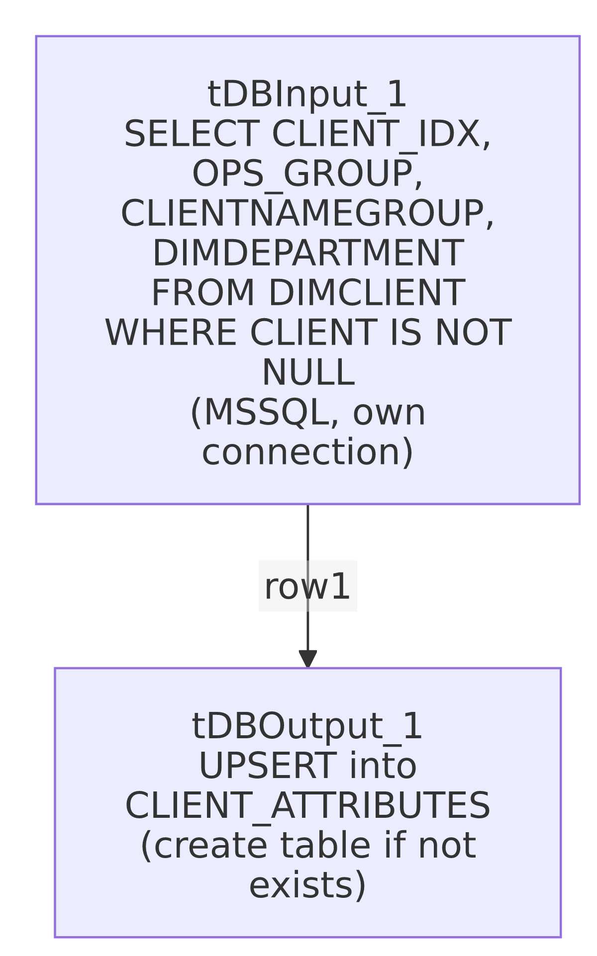

Settings tables

Source: `tDBInput_1` (`tMSSqlInput`)
Setting | Value | What it means
Connection | Own inline connection (USE_EXISTING_CONNECTION=false) to context.EDWProdHH_* | Opens its own MSSQL connection rather than sharing one with another component — this job has no other MSSQL-using components.
Table / Query | DIMCLIENT / SELECT CLIENT_IDX, OPS_GROUP, CLIENTNAMEGROUP, DIMDEPARTMENT FROM DIMCLIENT WHERE CLIENT IS NOT NULL; | Pulls 4 client-reference attributes from the EDWProdHH operational database's client dimension table, excluding rows with a null CLIENT value. No other filter (e.g. nothing visibly restricting to "non-CUBS" clients specifically) is present in the captured query — see Issues observed.

Target: `tDBOutput_1` (`tSnowflakeOutput`)
Setting | Value | What it means
Table | CLIENT_ATTRIBUTES | Destination table — note the table name itself doesn't include "NonCUBS" either, only the job's own name does.
Output action | UPSERT | Matches and updates existing rows / inserts new ones, rather than truncate-and-reload — implies rows are matched on some key (likely CLIENT_IDX, the only non-nullable column in the target schema) though the actual key column(s) used for the match are not captured in this metadata.
Table action | CREATE_IF_NOT_EXISTS | Creates the table automatically on first run if it doesn't already exist — unlike most other jobs in this project, which assume the target table is pre-created (tableAction=NONE).

Dependencies & configuration
- Triggers/depends on other jobs: runjob_targets is empty — this job does not call any other job via tRunJob.
- Called by: none found in 06_dependency_matrix.md — this job does not appear in the project's tRunJob orchestration graph.
- Context variables used: EDWProdHH_Server, EDWProdHH_Port, EDWProdHH_Schema, EDWProdHH_Database, EDWProdHH_Login (from the EDWProdHH_0.1 context group, used by 47 jobs project-wide per 06_dependency_matrix.md).
- No hardcoded developer-workstation paths found in this job.

Glossary
Component type | Plain-English meaning
tMSSqlInput | Opens a Microsoft SQL Server connection and runs a query against it, returning result rows.
tSnowflakeOutput | Writes rows to a Snowflake table — here configured to upsert (update-or-insert) rather than plain insert, and to auto-create the table if missing.

Issues observed
- The job's name (`Client_NonCUBS_Attributes`) implies a filter to non-CUBS clients specifically, but the captured query has no such condition — it only excludes rows where CLIENT IS NOT NULL. Whether "non-CUBS" scoping happens implicitly (e.g., DIMCLIENT in EDWProdHH only ever contains non-CUBS clients by design, so no explicit filter is needed) or is missing from this job entirely is unable to determine from metadata alone. Verify with the team what "non-CUBS" is expected to mean here and whether DIMCLIENT's population already guarantees it.
- `UPSERT` is used without a captured key-column specification. The target schema's only non-nullable business column is CLIENT_IDX, which is the most likely match key, but this job's own metadata does not explicitly record which column(s) Snowflake uses to determine "update" vs. "insert" for this component. If the actual key configuration in Talend Studio differs from CLIENT_IDX alone, rows could be merged incorrectly (e.g., duplicated or overwritten unexpectedly) — verify directly in Talend Studio.
- No error handling, row-count logging, or completion signal specific to this job's business outcome (no tWarn/tDie/tSendMail) — a load failure would only surface as a generic Talend execution error, consistent with the majority of jobs in this project per 05_operational_runbook.md.
- No `tPrejob`/`tPostjob` and no explicit logging setup (unlike most other jobs in this batch, which open a per-run log file via a tJava component in a tPrejob chain) — this job produces no dedicated log file of its own; any diagnostic output would rely entirely on the Talend runtime's default logging.

