Talend Job: Collector_Payment_Detail_Load

Overview
Loads collector-level payment detail — transaction ID, date posted, transaction code, commission rate/amount, pay amount, collector initials, debtor, client ID, split percentage, and credit month/year — from an Excel workbook found in a dedicated "HOPE archive" directory into the Snowflake COLLECTOR_PAYMENT_DETAIL table, creating the table automatically if it doesn't already exist. This is the project's only job using the HOPE_Archive1_0.1 context group (per 06_dependency_matrix.md), and it reads an Excel file rather than a delimited text file or a direct database query — consistent with HOPE (a MySQL-based system per 01_system_architecture.md) apparently being fed into this warehouse via a manually- or externally-produced spreadsheet export rather than a live database connection.

Detail table
Field | Value
Job name | Collector_Payment_Detail_Load
Version | 0.1
Project | EDW2SF
Author | jmach@harriscollect.com
Created | 2022-02-18T13:02:08.242-0800
Last Modified | 2025-09-24T11:07:58.699-0700

Step-by-step data flow
Setup subjob: tPrejob_1 → tDBConnection_1 (OnComponentOk) opens the Snowflake connection.
Main subjob (no incoming trigger connection to tFileList_1, so it runs as an independent top-level subjob alongside setup):
- tFileList_1 lists files in context.HOPE_archive1_FilePath, ordered by modified date ascending. An EXCLUDEFILEMASK of "*.txt" is configured but IFEXCLUDE=false, so it's never applied (same unapplied-mask pattern seen project-wide).
- For each file (Iterate), tJava_1 sets context.HOPE_archive1_File = context.HOPE_archive1_FilePath + "/" + <current file>.
- tFileInputExcel_1 (Iterate) reads that file as an Excel 2007+ workbook, all sheets (ALL_SHEETS=true, AFFECT_EACH_SHEET=false — all sheets treated as one continuous input), with a password (redacted — the source file may be password-protected), header row count and first/last column range all driven by context.HOPE_archive1_*. Both the main and reject schemas reference the same repository schema, labeled simply "...- metadata". DIE_ON_ERROR=false.
- tDBOutput_1 (FLOW, row1) inserts the 12 business columns into Snowflake COLLECTOR_PAYMENT_DETAIL (INSERT, tableAction=CREATE_IF_NOT_EXISTS — no truncate step precedes it).
No file archive or delete step exists anywhere in this job — processed files remain in context.HOPE_archive1_FilePath after the run (see Issues observed).
Teardown subjob: tPostjob_1 → tDBClose_1 (OnComponentOk) closes the Snowflake connection.
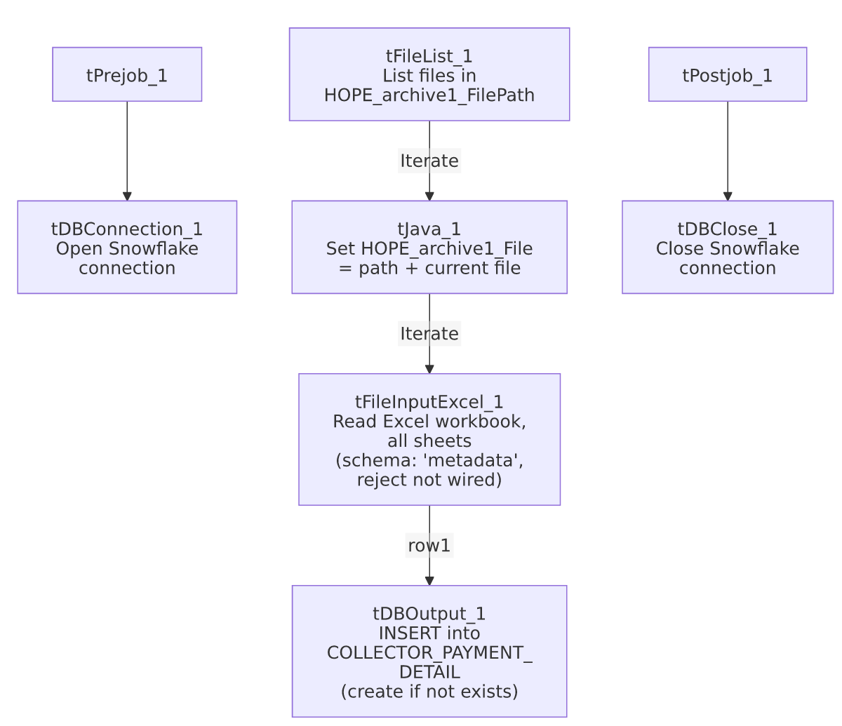

Settings tables

Source: `tFileInputExcel_1`
Setting | Value | What it means
FILENAME | context.HOPE_archive1_File | The current file from tFileList_1's iteration.
VERSION_2007 / ALL_SHEETS | true / true | Reads a modern .xlsx-style workbook, pulling data from every sheet in it.
PASSWORD | ***REDACTED*** | Source workbook may be password-protected; actual value not present in extracted metadata.
HEADER / FIRST_COLUMN / LAST_COLUMN / ENCODING / separators | All from context.HOPE_archive1_* | Fully context-driven read range and format, similar in spirit to CUBS_Raw_Trans_Load's context-driven EXPORT_TRANS_* settings.
SCHEMA (main) & SCHEMA_REJECT | Both reference the same repository schema, labeled "...- metadata" | An unusually generic schema label for a payment-detail-specific job — see Issues observed. Using the identical schema for both main and reject (rather than a mismatched one, as seen in ADP_Payroll_Load) is logically consistent, since a reject row has the same columns plus error fields.
DIE_ON_ERROR | false | Malformed rows don't fail the job...
Reject flow | Not wired | ...but no connection carries rejected rows anywhere — silently dropped, same pattern seen project-wide.

Target: `tDBOutput_1` (`tSnowflakeOutput`)
Setting | Value | What it means
Table | COLLECTOR_PAYMENT_DETAIL | Destination table.
Output action | INSERT | Appends rows; no truncate precedes it.
Table action | CREATE_IF_NOT_EXISTS | Table is created automatically on first run if missing.

Dependencies & configuration
- Triggers/depends on other jobs: runjob_targets is empty — this job does not call any other job via tRunJob.
- Called by: none found in 06_dependency_matrix.md — this job does not appear in the project's tRunJob orchestration graph.
- Context variables used: HOPE_archive1_DecimalSeparator, HOPE_archive1_Encoding, HOPE_archive1_File, HOPE_archive1_FilePath, HOPE_archive1_FirstColumn, HOPE_archive1_Header, HOPE_archive1_LastColumn, HOPE_archive1_ThousandSeparator — all from HOPE_Archive1_0.1, a context group used by only this one job in the entire 289-job project (per 06_dependency_matrix.md).
- No hardcoded developer-workstation paths found in this job.

Glossary
Component type | Plain-English meaning
tPrejob / tPostjob | Talend's guaranteed-first / guaranteed-last subjobs for setup and teardown.
tJava | Runs a block of custom Java code once.
tFileList | Lists files in a directory for the job to iterate over one at a time.
tFileInputExcel | Reads an Excel spreadsheet (one or more sheets) according to a schema.
tSnowflakeOutput / tSnowflakeConnection / tSnowflakeClose | Write rows to a Snowflake table / open and close the Snowflake connection used throughout the job.

Issues observed
- No file archive or delete step, and no truncate before loading. This job's tDBOutput_1 is a plain INSERT with no preceding TRUNCATE, and there is no tFileArchive/tFileDelete component anywhere in the job. If a file is not removed from context.HOPE_archive1_FilePath by some external process after this job reads it, rerunning the job (or its next scheduled run finding the same file still present) would insert the same rows again into COLLECTOR_PAYMENT_DETAIL with no deduplication. Unable to confirm from this metadata whether an external process manages file cleanup — verify with the team before assuming reruns are safe.
- The repository schema used for both the main and reject inputs is labeled simply `"metadata"`, not something payment-detail-specific. This is not necessarily wrong (schemas can be legitimately shared/reused across similar Excel-import jobs), but it makes it harder to tell from the schema name alone whether this exact schema is dedicated to this job or shared with other, undocumented Excel-import jobs that might be affected by a schema change here. Verify in the Talend repository whether "metadata" is used elsewhere.
- No reject flow wired from `tFileInputExcel_1`, despite a reject schema being configured. DIE_ON_ERROR=false means malformed rows don't fail the job, but they're also not written anywhere (no file, log, or table) — silently dropped with no record of how many, or which, rows failed to parse.
- `ALL_SHEETS=true` reads every sheet in the source workbook as one combined input. If the source Excel file ever includes a summary/pivot/notes sheet in addition to the raw data sheet(s), that extra sheet's content would also be read against the same schema — likely producing malformed rows (silently dropped, per the point above) rather than a job failure, but worth confirming the source file's sheet layout is consistently just data sheets.
- No error handling, row-count logging, or completion signal specific to this job's business outcome (no tWarn/tDie/tSendMail) — a load failure would only surface as a generic Talend execution error, consistent with the majority of jobs in this project per 05_operational_runbook.md.

