Talend Job: Copy_of_i3_DialerCallListTOL_Load_Backup

Overview
This job extracts dialer call-list assignment data (debtor, campaign, phone numbers, call-attempt counters, etc.) from an MSSQL table via a "EDWProdHH"-labeled connection, writes it to a local CSV file, re-reads that same file, enriches it with a DIMLOGON lookup from Snowflake, stages it, and merges it into a Snowflake warehouse table for the I3 dialer system. Despite its name (`...TOL..._Backup`), every table, file, and target name in this job's own metadata references "CO", not "TOL" — see Issues observed; this is very likely a backup/renamed copy of a CO-site job, not an actual TOL loader.

Detail table
Field | Value
Job name | Copy_of_i3_DialerCallListTOL_Load_Backup
Version | 0.2
Project | EDW2SF
Author | jmach@harriscollect.com
Created | 2025-11-11T10:11:47.759-0800
Last Modified | 2025-11-11T10:28:13.392-0800 (~17 minutes after creation)

Step-by-step data flow
Setup subjob: tPrejob_1 → tJava_1 opens a per-run log file at context.logDir + jobName + "_" + <timestamp> + ".log" → on success, tDBConnection_2 opens the MSSQL connection using context.EDWProdHH_* variables (password and Active Directory auth redacted) → on success, tSetKeystore_1 configures SSL trust/keystore from context.keystorePath (all passwords redacted) → on success, tDBConnection_1 opens the Snowflake connection.
Main subjob:
- tDBRow_1 runs TRUNCATE TABLE STAGING.I3_DIALERCALLLIST_CO; on Snowflake.
- On success, tDBInput_1 runs a fixed (truncated in this metadata) SELECT against MSSQL table DialerCalllist_CO, pulling I3_IDENTITY, ACCOUNT AS DEBTORNUMBER, LOGON, a derived DEBTOR_IDX, CAMPAIGN, DEBTORNAME, address fields, phone fields, and call-history fields — 38 columns total.
- tMap_1 joins that MSSQL flow against tDBInput_2 (tSnowflakeInput reading Snowflake table DIMLOGON, columns DIMLOGON/LOGON/DESCRIPTION) as a lookup, adding a DIMLOGON surrogate key column to the output.
- tFlowMeter_3 counts rows passing through (labeled "MyLabel", not renamed for this job).
- tFileOutputDelimited_1 writes the enriched rows to a hardcoded local file /output/i3_dialercalllistCO.csv (comma-delimited, no header, split every 10,000 rows).
- On tDBInput_1's subjob success (in parallel with the write above logically completing), tFileList_1 lists files in the hardcoded directory /output/ and, for each, tFileInputDelimited_1 re-reads the just-written CSV (DIE_ON_ERROR=true).
- tMap_2 passes the re-read rows through to a wider 64-column target schema (adds LOAD_DTTM, STATUS, ATTEMPTS, HHCUSTVAR1-3, HHCUSTINT1, and a dozen I3_ATTEMPTS*/I3_* call-detail counters not present in the original 38-column extract — these appear to be defaulted/derived in the map, not sourced from the MSSQL query).
- tDBOutput_1 inserts the rows into Snowflake table I3_DIALERCALLLIST_CO (INSERT, no table-recreate action; lands in the STAGING schema truncated in step 1, based on tDBRow_1's target).
- On tFileList_1's subjob success, tParallelize_1 starts two branches concurrently:
- tDBRow_2 runs a MERGE INTO DW.I3_DIALERCALLLIST_CO from STAGING.I3_DIALERCALLLIST_CO, keyed on I3_IDENTITY, updating all columns on match and inserting on no-match (defaults I3_UPLOAD_ID to 0 via COALESCE). This component has no outgoing connections and no result-capture/branch logic — see Issues observed.
- tFileList_2 lists files in /output/ again and tFileDelete_1 deletes each one found (iterating the same directory the CSV was written to).
Teardown subjob: tPostjob_1 → tDBClose_1 (close Snowflake) → tDBClose_2 (close MSSQL).
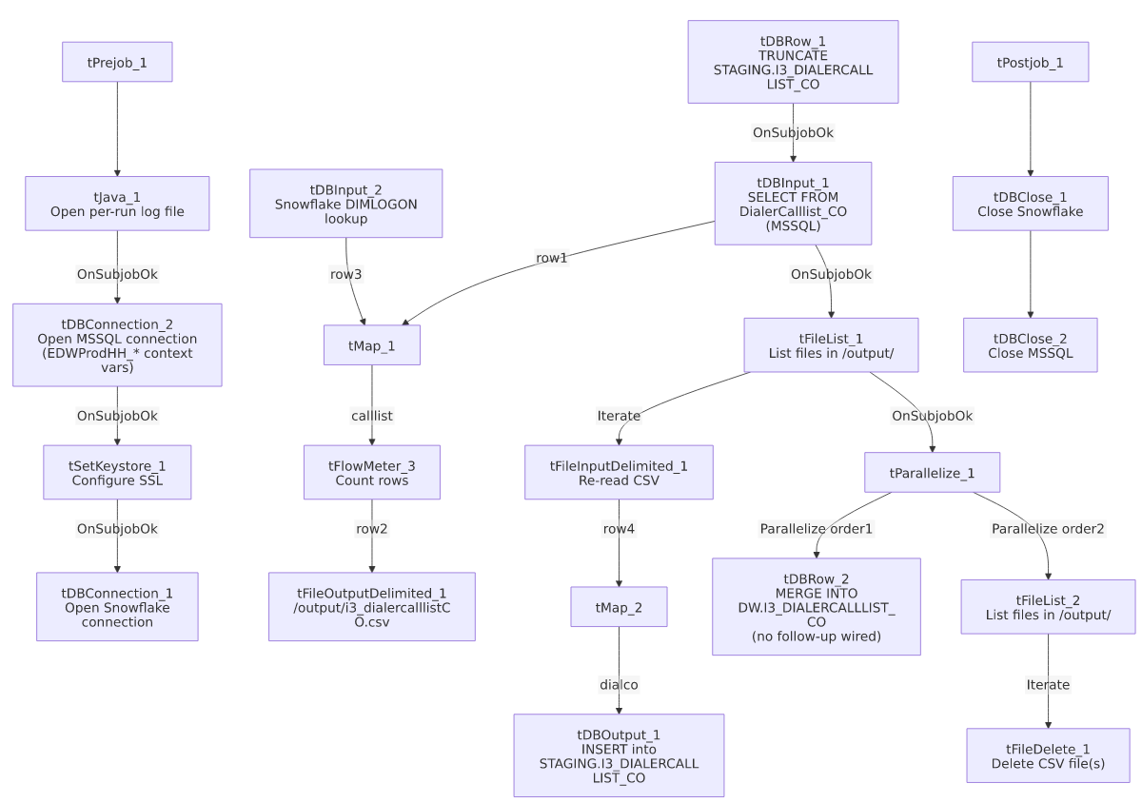

Settings tables

Source: `tDBInput_1` (`tMSSqlInput`)
Setting | Value | What it means
Connection | Shared tDBConnection_2 (EDWProdHH context vars) | Reuses the job's single MSSQL connection.
Table | DialerCalllist_CO | Source table name explicitly says "CO", reinforcing the site mismatch noted in Overview.
Query | Fixed SELECT of 38 named columns (identity, debtor/campaign identifiers, address, phone fields, call-history flags) — captured text is truncated after the visible column list | The full WHERE clause (if any) is not visible in this metadata.
ENCODING | ISO-8859-15 | Non-UTF-8 encoding, consistent with other legacy-source jobs in this project.

Lookup: `tDBInput_2` (`tSnowflakeInput`)
Setting | Value | What it means
Table | DIMLOGON | Small dimension table (DIMLOGON, LOGON, DESCRIPTION) joined in tMap_1 to attach a DIMLOGON surrogate key based on LOGON.

Intermediate file: `tFileOutputDelimited_1` / `tFileInputDelimited_1`
Setting | Value | What it means
FILENAME (write) | "/output/i3_dialercalllistCO.csv" | Hardcoded literal path (not a context.* variable), unlike most other jobs in this project which route through context.sourceDir/context.archiveDir (StandardFolders_0.1 — see 06_dependency_matrix.md).
SPLIT / SPLIT_EVERY | true / 10000 | Output may be split into multiple part-files if row count exceeds 10,000.
FILENAME (read) | globalMap.get("tFileList_1_CURRENT_FILEPATH") | Re-reads whatever file(s) tFileList_1 found in /output/ — not guaranteed to be only the file just written if other files are also present in that directory.
DIE_ON_ERROR (read) | true | A malformed row in the re-read step fails the job outright.

Target: `tDBOutput_1` (`tSnowflakeOutput`)
Setting | Value | What it means
Table | I3_DIALERCALLLIST_CO | Loaded via INSERT, tableAction: NONE; lands in the STAGING schema per the preceding TRUNCATE STAGING.I3_DIALERCALLLIST_CO.

Merge step: `tDBRow_2` (`tSnowflakeRow`)
Setting | Value | What it means
Query | MERGE INTO DW.I3_DIALERCALLLIST_CO AS tgt USING STAGING.I3_DIALERCALLLIST_CO AS src ON (tgt.I3_IDENTITY = src.I3_IDENTITY) — updates all columns on match, inserts on no-match, defaults I3_UPLOAD_ID via COALESCE(src.I3_UPLOAD_ID,0) | Standard staging→warehouse upsert, keyed on I3_IDENTITY.
Follow-up wiring | None — no outgoing connection from this component | Unlike this project's other merge steps (e.g. ADP_Payroll_Load, CO_Master_Load), the merge's success/failure is never captured or logged; see Issues observed.

Cleanup: `tFileDelete_1`
Setting | Value | What it means
FILENAME | globalMap.get("tFileList_2_CURRENT_FILEPATH") | The actual file(s) deleted are whatever tFileList_2 iterates in /output/.
DIRECTORY | "C:/Talend-Studio-20211109_1610-V8.0.1/workspace/delete_folder" | Hardcoded developer-workstation path — reads like leftover default/template text rather than a real target, since FILENAME is what actually drives the delete.
PATH | "C:/Talend-Studio-20211109_1610-V8.0.1/workspace/delete_folder or delete_file" | Same — the literal string even contains the word "or", suggesting an unedited placeholder value never replaced with a real path.

Dependencies & configuration
- Triggers/depends on other jobs: none — no tRunJob links found.
- Context variables used: EDWProdHH_Server, EDWProdHH_Port, EDWProdHH_Schema, EDWProdHH_Database, EDWProdHH_Login (MSSQL connection), keystorePath, logDir. Notably, no `context.sourceDir`/`context.archiveDir`-style variable is used — the working directory /output/ is hardcoded instead (see Settings tables).
- 4 hardcoded paths found: tSetKeystore_1.SSL_TRUSTSERVER_TRUSTSTORE (C:/clientTrustStore.trustStore), tFileInputDelimited_1.TEMP_DIR, and tFileDelete_1.DIRECTORY/PATH (all C:/Talend-Studio-20211109_1610-V8.0.1/workspace/...) — same portability risk documented project-wide in 05_operational_runbook.md.

Glossary
Component type | Plain-English meaning
tMSSqlConnection / tMSSqlInput / tMSSqlClose | Open a Microsoft SQL Server connection, run a query against it, and close it.
tSnowflakeConnection / tSnowflakeInput / tSnowflakeOutput / tSnowflakeRow / tSnowflakeClose | Open/close a Snowflake connection, read a table, write rows to a table, or run an arbitrary SQL/merge statement against Snowflake.
tMap | Maps/transforms and optionally joins (lookup) columns from one or more input schemas to an output schema.
tFlowMeter | Counts rows passing a point in the flow for logging/monitoring.
tFileOutputDelimited / tFileInputDelimited | Write or read a delimited (CSV-style) text file according to a schema.
tFileList | Lists files in a directory for the job to iterate over one at a time.
tFileDelete | Deletes a file (or, per its own config fields, potentially a folder) from disk.
tParallelize | Runs its downstream branches at the same time rather than one after another.
tSetKeystore | Configures SSL trust/keystore settings used by subsequent secure connections.

Issues observed
- The job name says "TOL" and "Backup", but every table and file name in this job's own metadata says "CO". The source table is DialerCalllist_CO, the output CSV is i3_dialercalllistCO.csv, and the staging/warehouse targets are STAGING.I3_DIALERCALLLIST_CO / DW.I3_DIALERCALLLIST_CO. Nothing in this job's metadata references TOL at all. This is almost certainly a backup/renamed copy of a CO-site dialer-call-list job — if run as scheduled under its current name, it would reload CO's call-list data, not TOL's. Verify with the team whether this job is intentionally inert (a kept-around backup, not meant to run), or whether it's mistakenly live and duplicating/conflicting with whatever job actually loads CO's dialer call list on its own schedule.
- The `MERGE INTO DW.I3_DIALERCALLLIST_CO` step (`tDBRow_2`) has no outgoing connection and no result-capture logic — unlike this project's other merge steps (ADP_Payroll_Load, CO_Master_Load) which capture RETVALUE and branch to a tWarn/tDie, a failure here would only surface as a generic Talend execution error with nothing job-specific logged.
- `tFileDelete_1`'s `DIRECTORY` and `PATH` parameters read like unedited default/template text (".../delete_folder" and ".../delete_folder or delete_file"), not real paths — the actual file(s) deleted are driven by the FILENAME parameter instead. This is consistent with the job being a hastily-made "Copy_of_..." backup rather than a carefully configured production job.
- The working directory `/output/` is a hardcoded literal, not a context.* variable — unlike the vast majority of file-handling jobs in this project which route through StandardFolders_0.1's shared context variables (see 06_dependency_matrix.md). If /output/ doesn't exist or isn't writable on whatever host runs this job, it would fail immediately.
- The MSSQL connection is configured via `context.EDWProdHH_*` variables even though the source table (DialerCalllist_CO) is I3 dialer/telephony data, not EDWProdHH operational data — the same naming ambiguity already flagged in i3_CallDetail_40_Load's doc; verify with the team which physical database context.EDWProdHH_Database points to here.
- Created and last modified about 17 minutes apart on the same day (2025-11-11), consistent with this being a quick one-off copy/backup operation rather than an iteratively developed job — supports treating it as a snapshot rather than an actively maintained pipeline component.

