Talend Job: DC_Call_Contact_Exceptions_1

Overview
Queries two "rolling 7 days" exception views in Snowflake for the DC site — one tracking call-attempt-count exceptions, one tracking right-party-contact (RPC) exceptions — and writes each result set to its own timestamped CSV file in context.outputDir. This is the report-generation half of a two-job pair: the companion job DC_Call_Contact_Exceptions_2 (documented separately) archives, emails, and cleans up the files this job produces, though no direct tRunJob link ties the two together in this metadata.

Detail table
Field | Value
Job name | DC_Call_Contact_Exceptions_1
Version | 0.1
Project | EDW2SF
Author | jmach@harriscollect.com
Created | 2023-12-07T10:51:00.908-0800
Last Modified | 2025-11-16T21:34:34.339-0800

Step-by-step data flow
Setup subjob: tPrejob_1 → tSetKeystore_1 configures SSL trust/keystore from context.keystorePath (all passwords redacted) → on success, tDBConnection_1 opens the Snowflake connection. (Unlike most other jobs in this project, there is no tJava step opening a dedicated per-run log file.)
Main subjob — tParallelize_1 starts two independent branches:
- Call-exceptions branch: tDBInput_1 runs SELECT DATE, PACKET_IDX, COUNT_OF_COMMUNICATION_ATTEMPTS, ROLLING_SEVEN_DAYS_COMMUNICATION_ATTEMPTS FROM EDWPRODHH.PUB_MBOICH.DC_ROLLING_SEVEN_DAYS_CALLS_EXCEPTIONS; → tFileOutputDelimited_1 writes the 4-column result to context.outputDir + "DC_ROLLING_7_DAYS_CALL_EXCEPTIONS_" + <CCYYMMDD> + ".csv" (comma-delimited, header included, CSV_OPTION=true).
- RPC-exceptions branch: tDBInput_2 runs SELECT DATE, PACKET_IDX, COUNT_OF_RPC, ROLLING_SEVEN_DAYS_RPCS FROM EDWPRODHH.PUB_MBOICH.DC_ROLLING_SEVEN_DAYS_RPCS_EXCEPTIONS; → tFileOutputDelimited_2 writes the 4-column result to context.outputDir + "DC_ROLLING_7_DAYS_RPC_EXCEPTIONS_" + <CCYYMMDD> + ".csv" (comma-delimited, header included, but `CSV_OPTION=false`, unlike its sibling — see Issues observed).
Both source queries reference EDWPRODHH.PUB_MBOICH.<view> — a Snowflake database/schema pair reached over this job's Snowflake connection, not the MSSQL EDWProdHH connection label used elsewhere in this project (see 01_system_architecture.md); this appears to be a published Snowflake copy/mart named after the source system rather than the source system itself.
Teardown subjob: tPostjob_1 → tDBClose_1 closes the Snowflake connection.
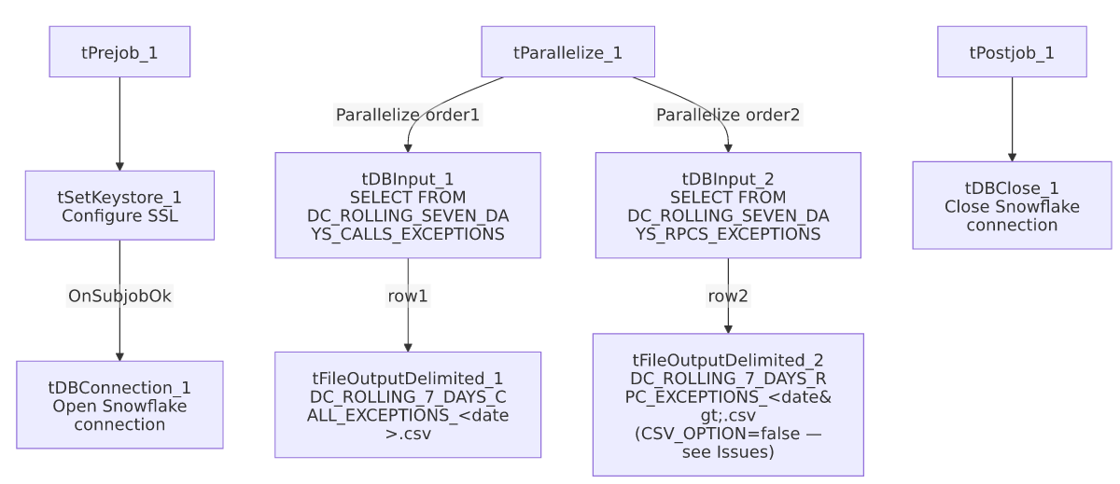

Settings tables

Source 1: `tDBInput_1`
Setting | Value | What it means
Query | SELECT DATE, PACKET_IDX, COUNT_OF_COMMUNICATION_ATTEMPTS, ROLLING_SEVEN_DAYS_COMMUNICATION_ATTEMPTS FROM EDWPRODHH.PUB_MBOICH.DC_ROLLING_SEVEN_DAYS_CALLS_EXCEPTIONS; | Reads a pre-computed exception view (call-attempt counts vs. a rolling 7-day threshold) rather than computing the rolling window itself.

Source 2: `tDBInput_2`
Setting | Value | What it means
Query | SELECT DATE, PACKET_IDX, COUNT_OF_RPC, ROLLING_SEVEN_DAYS_RPCS FROM EDWPRODHH.PUB_MBOICH.DC_ROLLING_SEVEN_DAYS_RPCS_EXCEPTIONS; | Same pattern, for right-party-contact exceptions.

Output files: `tFileOutputDelimited_1` / `tFileOutputDelimited_2`
Setting | Value | What it means
FILENAME | context.outputDir + "DC_ROLLING_7_DAYS_CALL_EXCEPTIONS_" + date + ".csv" / context.outputDir + "DC_ROLLING_7_DAYS_RPC_EXCEPTIONS_" + date + ".csv" | Dated filenames distinguish the two reports.
INCLUDEHEADER | true (both) | Both files include a header row.
CSV_OPTION | true (report 1) / `false` (report 2) | Inconsistent between the two otherwise-identical output components — see Issues observed.

Dependencies & configuration
- Triggers/depends on other jobs: none — no tRunJob links found. This job's output is consumed by DC_Call_Contact_Exceptions_2, but that relationship is not expressed via tRunJob in either job's metadata — presumably an external scheduler runs them in sequence.
- Context variables used: keystorePath, outputDir.
- 1 hardcoded path: tSetKeystore_1.SSL_TRUSTSERVER_TRUSTSTORE (C:/clientTrustStore.trustStore) — same pattern documented project-wide in 05_operational_runbook.md.

Glossary
Component type | Plain-English meaning
tSnowflakeConnection / tSnowflakeInput / tSnowflakeClose | Open a Snowflake connection, run a query and return its rows, and close the connection.
tFileOutputDelimited | Writes rows to a delimited (CSV-style) text file according to a schema.
tParallelize | Runs its downstream branches at the same time rather than one after another — here, the two report queries run concurrently.
tSetKeystore | Configures SSL trust/keystore settings used by the subsequent Snowflake connection.

Issues observed
- The two output components have inconsistent `CSV_OPTION` settings — tFileOutputDelimited_1 (call exceptions) has CSV_OPTION=true while tFileOutputDelimited_2 (RPC exceptions) has CSV_OPTION=false, despite both otherwise being configured identically (comma separator, header row, ISO-8859-15 encoding). Depending on how Talend's CSV mode differs from its plain delimited mode for quoting/escaping special characters, the two sibling reports could be formatted subtly differently — verify this is intentional.
- No dedicated per-run log file is opened (no tJava step in the setup subjob), unlike the majority of other jobs in this project (e.g. ADP_Payroll_Load, CO_Master_Load) — this job's own execution detail relies entirely on whatever the scheduler's own log captures.
- No `tDie`/`tWarn`/`tSendMail` logic in this job — a query or file-write failure here would only surface as a generic Talend execution error; per 05_operational_runbook.md, this job is not among the 16 with explicit tDie/tWarn logic.
- No `tRunJob` link connects this job to `DC_Call_Contact_Exceptions_2`, which archives, emails, and deletes the very files this job writes. If the two are meant to run back-to-back, that sequencing is enforced entirely outside Talend (a scheduler); verify with the team, since a timing gap or out-of-order run could cause _2 to archive/email stale or partial files.

