Talend Job: DC_Call_Contact_Exceptions_2

Overview
This is the archive/email/cleanup half of a two-job pair for the DC site's rolling-7-day call and RPC exception reports: it zips whatever is in context.outputDir into a dated archive, emails a notification (claiming the reports are attached) to context.mailRecipients, then deletes the archive and every remaining file in context.outputDir. The companion job DC_Call_Contact_Exceptions_1 (documented separately) is presumably what populates context.outputDir with the actual report CSVs, though no tRunJob link ties the two together in this metadata.

Detail table
Field | Value
Job name | DC_Call_Contact_Exceptions_2
Version | 0.1
Project | EDW2SF
Author | jmach@harriscollect.com
Created | 2023-12-08T13:55:11.260-0800
Last Modified | 2025-08-28T08:57:16.221-0700

Step-by-step data flow
This job is a single linear chain with no explicit tPrejob/tPostjob/database connection components:
- tFileArchive_1 zips SOURCE=context.outputDir (with SOURCE_FILE hardcoded to a literal C:/Talend-Studio-.../workspace/source.csv and ALL_FILES=false — see Issues observed) to TARGET=context.archiveDir + "DC_ROLLING_7_DAY_EXCEPTION_RPTS_" + <CCYYMMDD> + ".zip".
- On success, tSleep_2 pauses for 35 seconds.
- On success, tSendMail_1 emails context.mailRecipients (from svc_analytics@harriscollect.com, display name "H & H Analytics") with subject "DC Rolling 7 Days Exception Reports" and body text claiming "Today's DC rolling 7-day call and contact exception reports are attached." DIE_ON_ERROR=true, so a failed send fails the job.
- On success, tSleep_1 pauses for another 35 seconds.
- On success, tFileDelete_1 deletes the archive file just created (globalMap("tFileArchive_1_ARCHIVE_FILEPATH")); FAILON=false, so a failed delete does not fail the job.
- On success, tFileList_1 lists files in context.outputDir, and for each one found, tFileDelete_2 deletes it (FAILON=false).
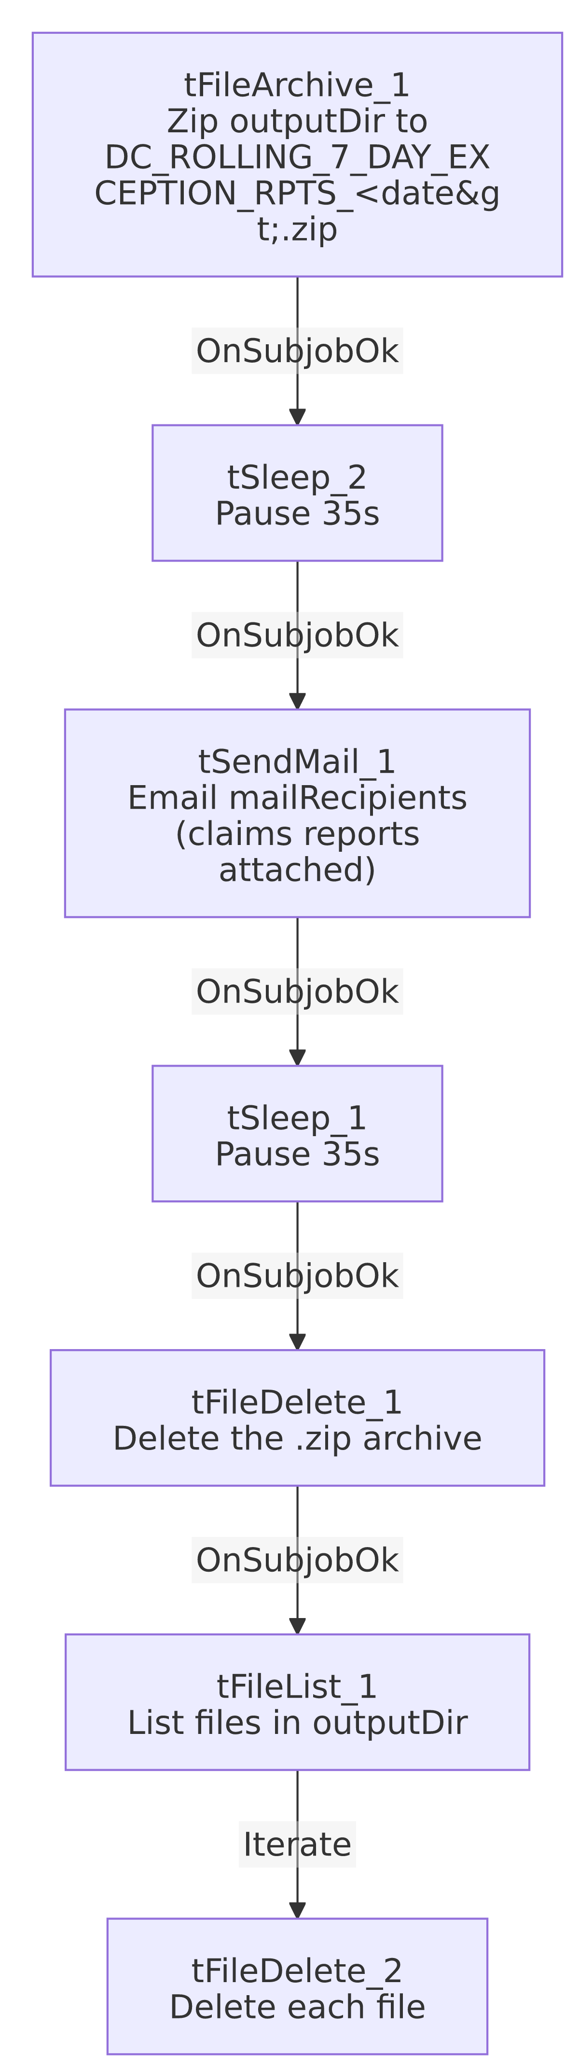

Settings tables

Archive: `tFileArchive_1`
Setting | Value | What it means
SOURCE | context.outputDir | The directory presumably populated by DC_Call_Contact_Exceptions_1.
SOURCE_FILE | "C:/Talend-Studio-20211109_1610-V8.0.1/workspace/source.csv" | Hardcoded literal filename that does not match the actual report filenames (DC_ROLLING_7_DAYS_CALL_EXCEPTIONS_<date>.csv / DC_ROLLING_7_DAYS_RPC_EXCEPTIONS_<date>.csv) produced by DC_Call_Contact_Exceptions_1 — see Issues observed.
ALL_FILES | false | Archives a specific file (per SOURCE_FILE), not everything in SOURCE — makes the SOURCE_FILE mismatch potentially consequential.
TARGET | context.archiveDir + "DC_ROLLING_7_DAY_EXCEPTION_RPTS_" + date + ".zip" | Dated archive filename.
OVERWRITE | true | Re-running the job replaces any existing archive of the same name.

Email: `tSendMail_1`
Setting | Value | What it means
TO / FROM | context.mailRecipients / svc_analytics@harriscollect.com
SUBJECT / MESSAGE | "DC Rolling 7 Days Exception Reports" / "Today's DC rolling 7-day call and contact exception reports are attached." | Body text asserts an attachment.
CHECK_ATTACHMENT | false | Talend's own attachment-existence check is disabled; this extraction's captured parameters show no separate attachment-file list — unable to determine from this metadata whether any file is actually attached to the email. See Issues observed.
DIE_ON_ERROR | true | A failed send fails the job outright (this job would surface as a Talend job failure, not silently skip ahead to cleanup).

Cleanup: `tFileDelete_1` / `tFileList_1` + `tFileDelete_2`
Setting | Value | What it means
tFileDelete_1 FILENAME | globalMap("tFileArchive_1_ARCHIVE_FILEPATH") | Deletes the zip archive just created (after both sleeps and the email have completed).
tFileList_1 DIRECTORY | context.outputDir | Lists whatever remains in the output directory.
tFileDelete_2 FILENAME | globalMap("tFileList_1_CURRENT_FILEPATH") | Deletes each file found — presumably the original report CSVs, now that they're archived and (allegedly) emailed.
FAILON (both deletes) | false | A failed delete does not fail the job — stale files could silently persist.

Dependencies & configuration
- Triggers/depends on other jobs: none — no tRunJob links found. This job consumes files that DC_Call_Contact_Exceptions_1 is presumably responsible for producing, but that dependency is not expressed via tRunJob in either job.
- Context variables used: outputDir, archiveDir, mailRecipients.
- 5 hardcoded paths: tFileArchive_1.SOURCE_FILE, and DIRECTORY/PATH on both tFileDelete_1 and tFileDelete_2 (all C:/Talend-Studio-20211109_1610-V8.0.1/workspace/...) — same portability risk documented project-wide in 05_operational_runbook.md. Per that runbook, this job is also one of the 12 project-wide jobs that send email on completion.

Glossary
Component type | Plain-English meaning
tFileArchive | Zips a file or directory to a target archive path.
tSendMail | Sends an email.
tSleep | Pauses execution for a fixed number of seconds before continuing.
tFileDelete | Deletes a file (or, per its own config fields, potentially a folder) from disk.
tFileList | Lists files in a directory for the job to iterate over one at a time.

Issues observed
- `tFileArchive_1`'s `SOURCE_FILE` is a hardcoded literal (`.../workspace/source.csv`) that doesn't match the actual report filenames the companion job DC_Call_Contact_Exceptions_1 writes (DC_ROLLING_7_DAYS_CALL_EXCEPTIONS_<date>.csv, DC_ROLLING_7_DAYS_RPC_EXCEPTIONS_<date>.csv). With ALL_FILES=false, this could mean the archive step is silently not capturing the intended report files at all (or the field is vestigial and Talend's actual runtime behavior differs from what this static parameter suggests) — verify directly in Talend Studio whether the resulting .zip actually contains the day's reports.
- The email body claims "reports are attached," but no attachment-file parameter is visible in this job's extracted `tSendMail_1` metadata. CHECK_ATTACHMENT=false only disables an existence check; it doesn't confirm whether an attachment list is configured elsewhere (a table-type parameter that may not have been captured by this extraction). Unable to determine from metadata whether recipients actually receive the reports as files, or only the notification text — verify directly in Talend Studio.
- Two fixed 35-second `tSleep` steps with no explanatory comment in the metadata — likely intended to let the archive/SMTP operations settle before the next step, but a fixed sleep isn't robust if either operation takes longer than 35 seconds under load.
- Both `tFileDelete` steps have `FAILON=false`, so a failed delete doesn't fail the job — stale archive or report files could silently accumulate in outputDir/archiveDir without anyone being alerted.
- No `tRunJob` link connects this job to `DC_Call_Contact_Exceptions_1`. If an external scheduler doesn't guarantee _1 fully completes before _2 starts, this job's cleanup step (tFileDelete_2, deleting everything in outputDir) could delete files a still-running _1 is mid-write on, or its archive step could zip an incomplete set of reports. Verify the actual scheduling relationship with the team.

